*Razaq Aribidesi*

*University of Pennsylvania*

*Final participation portfolio*

Coding Notebook

Table of Contents

Origins of MATLAB 8

MATLAB Interface 8

Working at the command line 9

Using LiveScripts 9

General notes on MATLAB syntax and peculiarites 10

Statements and Expressions 10

Naming conventions for variables 11

Comments, suppression, and separation 11

Procedural programming order 11

Errors and Warnings 12

Using the Editor 12

Functions 12

Scripts 13

Clearing the workspace and figures 13

Working directory and paths 14

Interrupting code execution 14

MATLAB documentation and help 14

Built-in MATLAB functions 15

Basics of vectors: 1- D arrays 16

Creating vectors with slice notation 16

Creating vectors with linspace() and logspace() 16

Other vectors 17

Accessing vector indices 17

Replacing indices and adding indices to vectors 18

Removing vector indices 20

Concatenating vectors 21

Operations on vectors 21

TOPIC 2: Introduction to arrays: vectors, matrices, and more 22

Revisiting vectors 23

Example 23

Column vectors 24

Determining the number of entries in a vector 25

Precedence 26

Arrays 28

Dimensions of an array 29

Matrices 30

Constructing matrices 30

Accessing array indices 33

Overwriting indices 35

Array mathematics 36

Addition and Subtraction 37

Multiplication 37

Division 40

Application: solving a set of linear equations 43

One approach: substitution 46

Another approach: matrix representation 47

More general representation 48

TOPIC 3: Systems of equations, functions, and more 49

Array mathematics (continued) 49

Addition and Subtraction 49

Multiplication 49

Division 53

Application: solving a set of linear equations 55

One approach: substitution 58

Another approach: matrix representation 59

More general representation 60

Example application: fluid flow in a Y-channel 61

Functions 64

Functions vs. scripts 65

Examples of function declarations 65

Function rules 66

Function headers 67

Function naming conventions 68

Example 68

Example: systems of nonlinear systems of equations 68

TOPIC 4: Loops and logic 70

Introductory remarks 70

Example - Fibonacci sequence 71

FOR loops 72

Anatomy of a for loop 73

Additional (pecular) notes 76

Nested for loops 78

Example - back to the Fibonacci sequence 78

WHILE loops 79

Relational operators 79

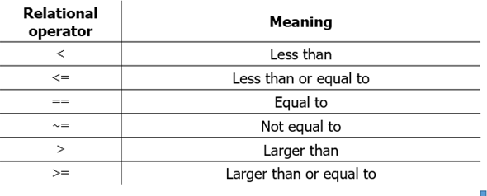 79

Logical operators 80

Examples 80

Anatomy of a while loop 81

Example: simulating the roll of two dice 82

Example: back again to the Fibonacci sequence 82

Vector preallocation 83

For loops vs. vectorization 85

TOPIC 5: Conditionals and Boolean Operators 88

Loops (continued): for and while loops 88

Vector preallocation 88

For loops vs. vectorization 91

Recall: while loops iterate as long as a logical condition is true 93

Conditional statements 94

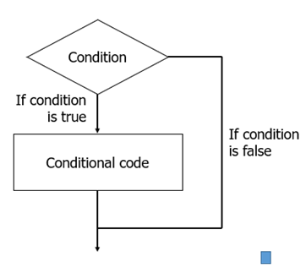 94

Anatomy of a simple if statement 94

Nested if statements 95

Anatomy of an if-elseif-else statement 96

Boolean operators 98

Examples: scalars 100

Examples: element-wise on vectors 100

Precedence revisited 101

Boolean operators and conditional statements 104

Logical statements and while loops 105

TOPIC 6: Building solutions to problems, part 1 106

Recap of topics covered so far: 106

Using scientific computing to approach problems 110

PRO: a roadmap for building computational solutions 110

Troubleshooting and debugging techniques 111

Getting started with building computational solutions to problems. 113

Practice problem 1: modeling the motion of a projectile 113

Practice problem 2: numerical methods and root-finding 118

Visual depiction of the Newton-Raphson algorithm 118

Derivation of the Newton-Raphson method 120

Question 1 120

Question 2 125

TOPIC 7: Building solutions to problems, part 2 126

Tinkering with fundamental MATLAB operations 126

1) Functions 126

2) Conditional statements 127

3) for loops 128

4) while loops 128

Practice problem 2: numerical methods and root-finding 129

Visual depiction of the Newton-Raphson algorithm 129

Derivation of the Newton-Raphson method 131

Question 1 131

TOPIC 8: Revisiting arrays, pt. 1: useful math and logical arrays 133

Revisiting arrays: useful structures for storing and processing numerical information 133

Reminder: Vector indexing 133

Matrix (and array) indexing 134

Adding, subtracting, multiplying and dividing arrays and their elements 135

Other useful mathematical operations on arrays 136

Useful built-in arrays 139

Logical Arrays 140

Logical numbers 140

 141

Logical arrays: vectors, matrices, etc. with logical numbers 141

Practice Problem: tic tac toe 143

TOPIC 9: Revisiting arrays, pt. 2: logical arrays and more 144

Logical Arrays (cont'd) 144

Indexing with logical arrays 145

Logical array indexing rules 146

Examples with vectors 146

Examples with matrices 147

Mathematical operations using logical arrays 149

Built-in logical functions 151

Changing the shape of arrays 153

Rotating and flipping arrays 153

Reshaping arrays 155

TOPIC 10: Revisiting arrays, pt. 3: improving computational efficiency 155

Logical arrays 155

Reminder: logical indexing and reshaping arrays 155

Logical arrays vs. if-else statements 162

Always preallocate arrays 166

Sparse arrays 168

TOPIC 11: Revisiting arrays, pt. 4; function handles 171

Practice Problem: process engineering in a medical environment 171

Increasing computation efficiency with arrays (continued from last time): 179

Always preallocate arrays 179

Sparse arrays 181

Revisiting functions 184

Function handles 186

Example: force on a spring 188

TOPIC 12: Function handles and recursion 190

Reminder: function handles 190

Practice problem: a root-finding numerical solver 191

Anonymous functions 193

Recursion 196

Example: Revisiting the fibonacci sequence 197

Example: calculate the factorial of a number 198

TOPIC 13: Plotting in MATLAB 199

Plotting in 2D 202

plot() - the "workhorse" plotting function 202

Overlaying plots 205

Specifying plot attributes inline 208

Colors 209

Basic axis formatting 210

Important note regarding LiveScript files 216

Plots as objects 217

Getting axes or figure properties 219

Setting axes and figure properties 222

Graphics handles 224

Linear vs log axes 237

Error bars 245

Additional 2D plotting functions 251

Closing graphics objects -- SURPRISINGLY USEFUL 267

Multiple axes in a single figure window 267

Plotting in 3D 272

plot3 272

Practice Problem: adventure summary 278

TOPIC 14: Data types in MATLAB 286

Practice problem: Legendre polynomials and recursion 286

Recall: different data types 289

Data types (classes) in MATLAB 289

Bits, bytes, and memory 289

Binary vs. base 10 290

Bit size and numbers 290

MATLAB defaults to double precision 292

Characters arrays and strings 293

Cell arrays 294

Back to the practice problem: making more efficient 297

TOPIC 15: Working with text 299

Practice problem: reactor cooling 299

Reminder: characters and strings 308

Reminder: cell arrays 309

Working with text 310

Loading text 310

Character arrays 315

String arrays 317

Character and string functions 318

Converting numbers to characters 319

Practice Problem: analyzing song lyrics 320

TOPIC 16: Working with text, pt 2 320

Reminder: working with text 320

Practice Problem: analyzing song lyrics 323

Practice Problem: the central dogma of molecular biology 324

TOPIC 17: Text and structure arrays 337

Practice Problem: the central dogma of molecular biology 337

Writing text data to a file 358

Structure arrays 358

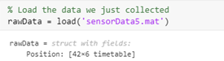 358

Creating a structure array 359

Relation to graphics objects 361

Example: visualizing "particle" movement 364

TOPIC 18: Intro to audio and image processing 371

Numeric data, audio, and images 371

Importing data and reading files 371

Exporting data and writing files 372

What is a "signal?" 372

Introduction to audio processing 372

Stereo vs. mono sound 376

Filtering a 1-D signal 377

Creating audio signals 382

Introduction to image processing 383

Color images 384

Loading multiple signal files 386

Example: removing the cat from the image 387

TOPIC 19: Revisiting images and graphics 388

Reminder: audio processing 388

Reminder: image processing 389

Basic image filtering 396

Binary (logical) images 399

Revisiting plotting and graphics 416

Animating objects 420

Keyboard callbacks 423

TOPIC 20: Simulations and Callbacks (cont'd) 426

Revisiting simulations 426

Practice problem: simulating an infectious disease 426

TOPIC 21: Callbacks and simple interfaces 440

Miscellaneous information: changing the directory and accessing all files in the current folder 440

Reminder: keyboard callbacks (key press) 441

Keyboard callbacks (key release) 443

Mouse callbacks 445

Storing data in an interface with guidata 451

Example: Revisiting Tic Tac Toe 454

Creating figure UI objects using uicontrol 458

TOPIC 22: Calculus in MATLAB 461

Practice problem: diagnosing sickle cell disease 461

Calculus in MATLAB 463

1-D Differentation 463

Example: Usain Bolt and the 100 m 464

Visualizing and creating multi-dimensional derivatives 467

Visualizing velocity fields: quiver plots 468

Visualizing velocity fields: surface plots 469

Multi-dimensional differentiatial calculus 472

Integration 477

Engineering example: controllers 480

TOPIC 23: Differential equation solvers and other numerical methods 485

Solving ordinary differential equations (ODEs) 485

Taylor series approximations 486

Euler method: simple approximation of an ODE solution 488

Predictor-corrector method: better approximation of a solution 490

Runge-Kutta solutions to differential equations 492

Differential equation solvers in MATLAB 494

Example: chemical reaction kinetics 497

ODEs of higher orders 499

Supplying additional arguments to ode45 502

Example problem: creating an interactive physics simulator 503

TOPIC 24: Symbolic variables, equations, and functions 508

Symbolic math in MATLAB 509

Declaring symbolic numbers and variables 509

Symbolic expressions and functions 511

Plotting symbolic functions 513

Solving equations of one variable 518

Solving sets of linear equations 519

Solving sets of nonlinear equations 521

Calculus 525

Differential equations 527

Example problem: Harmonic oscillator 529

TOPIC 25: Animations 534

Reminder: animating simple graphical objects 534

Reminder: the flow of information in an interface 536

Animations 538

Revisiting image processing 539

Images as graphical handles objects 540

Image transparency 542

Creating your own .png images with transparency data 546

Object animation 547

Animation with timer objects 551

Example problem: rock simulator 553

Example problem: drag and drop 559

Functions 560

Topic 1 Functions: 560

Topic 3 Functions: 561

Topic 7 Functions 562

Topic 8 Functions 562

Topic 11 Functions 563

Topic 12 Functions 565

Topic 14 (Legrange Function) 567

Topic 15 Functions 567

Topic 19 Functions 569

Topic 20 Functions 570

Topic 21 Functions 571

Topic 23 Functions 583

Functions for Topic 23 stored here: 583

Topic 24 Functions: 586

Topic 25 Functions 587

## Origins of MATLAB

MATLAB (Matrix Laboratory) is descended in part from the programming language FORTRAN, which was designed to support formula translation.

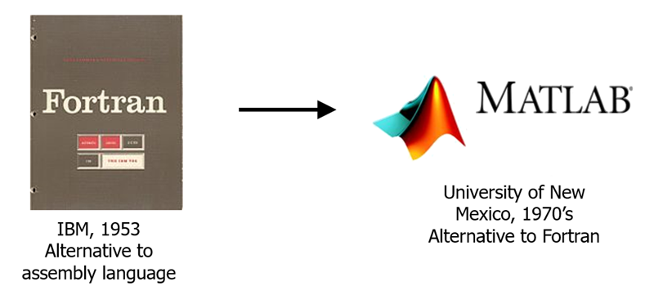

MATLAB is a high-level language that automatically interprets your instructions (code) into machine-level computation.Computation, ultimately performed at the transistor scale, is a physical process that takes time. For this class, our focus is on computational solutions to problems. We want code that is:

1. **Correct**: it robustly does what we want
2. **Computationally efficient**: it does what we want quickly
3. **Clear**: it is easy to understand and adapt what we are doing

## MATLAB Interface

The MATLAB interface is fully customizable, in that you can organize the following modules. The organization of these is a user preference.

* **Workspace:** this shows the variables stored and able to be called
* **Command Window:** depicts errors, notifications, and previously called lines of code. Also contains the command line (>>) in which bits of code can be tested. Scripts and functions may also be called using the command line.
* **Editor:** compose and view livescripts, scripts, and functions.
* **Command history:** lists previously called commands and functions.
* **Current Folder:** depicts the files and folders in the current directory.
* **Directory:** current directory (if you contain a script or function if you are going to call it).

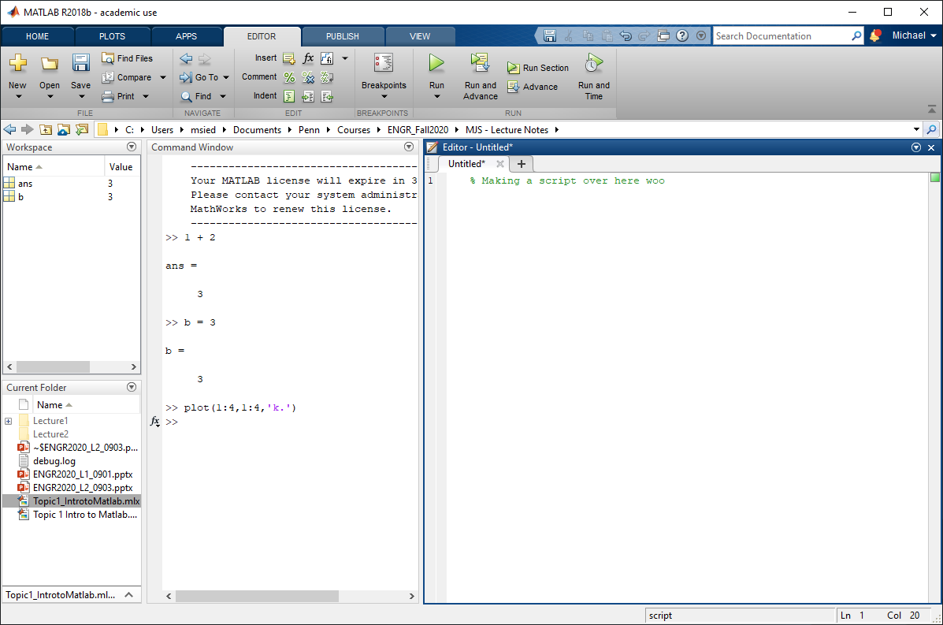

### Working at the command line

The command line is useful for testing snippets of code or calling scripts or functions. Note that using a single "code block" in the LiveScript lecture notes *effectively* accomplishes the same thing. Note where the output is visible.

disp('hello world')

hello world

* Try inputting some values
* Note that when you enter something into the command line, the variable is stored in the workspace.
* ans contains the last output. **Avoid calling ans**, as it is very easy to lose track of what the last value called was. **Instead, use a statement to define a variable such that the value of that variable can be called.**

### Using LiveScripts

For lecture notes, we will use LiveScripts to organize material and interactively run through code.

* LiveScripts are organized into sections. To "run" the active section, press cntl + Enter
* To clear outputs from code, right-click and select "clear all outputs."

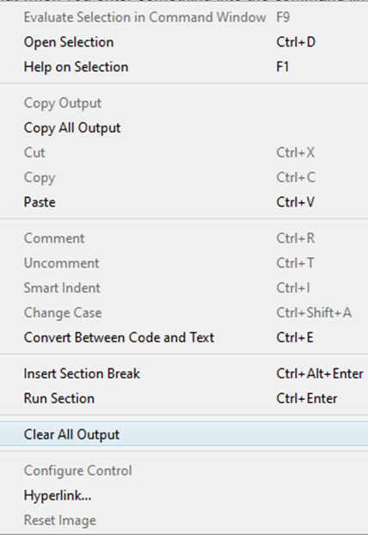

## General notes on MATLAB syntax and peculiarites

### Statements and Expressions

Expressions and statements are the fundamental building blocks of code. Expressions are located on the right side of a statement.

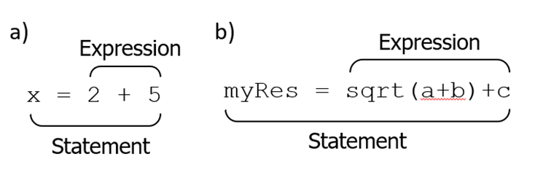

The above reads as:

* a) "2 and 5 are added and stored in variable x"
* b) "the square root of the sum of variables a and b is added to c and stored in varilable myRes"

These statements would execute:

b = 2

x = b + 5

y = sqrt(x)

These statements would not execute:

2 = b

b + 5 = x

sqrt(x) = y

### Naming conventions for variables

In the above examples, a **scalar** is stored in a **variable** that becomes visible in the **Workspace**. When creating variables, the following naming conventions should be followed:

1. Must consist of only the letters a-z, the digits 0-9, and underscores (_)
2. Must start with a letter
3. Should not overwrite built-in functions
4. Should not overwrite built-in variables

### Comments, suppression, and separation

Comments are initiated by percent signs (%). Comments are vary important for helping **you** and others understand your code.

%This is a comment, they are useful

Some resources quote "one comment for every three lines of code" - this is dependent on the code. Some code contains more characters than productive syntax. When in doubt, add comments for clarity. When using MATLAB in Windows, large swaths of highlighted code can be *commented* using "ctrl" + "r" and *uncommented* using "ctrl" + "t".

A semicolon (;) placed at the end of a statement suppresses output to the command line

x = 2+5; %This comment is suppresed

y = 2+3 %This comment is not suppresed

y = 5

**It is good practice when starting to have one statement per line**, for ease of visualization. However, commas can be used to combine statements on a single line without suppression

x = 2 + 5, y = x+3

x = 7

y = 10

### Procedural programming order

We will primarily use MATLAB as a procedural programming interface. Lines of contiguous code are executed in the order written and the results of expressions are placed into the statement variable.

% First, the scalar 3 is placed in variable x

x = 3;

% Second, variable x (equal to 3) is squared, 2 is added, and the result

% is placed back into variable x (now equal to 11)

x = x^2 + 2;

% Third, variable x (equal to 11) and 5 are added and placed in variable y

y = x + 5

y = 16

### Errors and Warnings

An extremely useful feature of MATLAB is that it alerts you (and stops running) when your code has an **error**. For example, typing sin into the command line and running the code produces the following error.

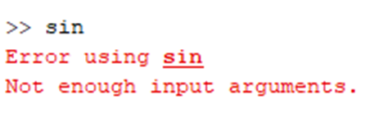

The nature of the error text provides insight into what went wrong. In this case, sin is the built-in sine function in MATLAB and the error occurs because we are not providing enough input arguments to that function.

**Warnings**, on the other hand, do not interrupt the code but alert that user of a potential oversight or computational inefficiency. Errors and warnings correspond to red and yellow lines in the right bar of a MATLAB script file, as well as annotations in the text. In this LiveScript file, the following warning is observed by hovering the cursor over the warning alert.

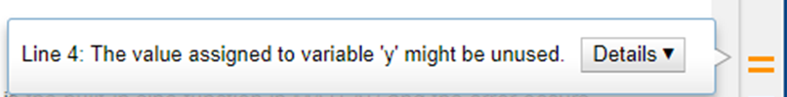

### 

### Using the Editor

Assemblages of code can be composed in the editor window and stored as an .m file for more permanence. These assemblages of code are referred to as either functions or scripts.Functions start with the function declaration whereas scripts are just assemblages of statements.

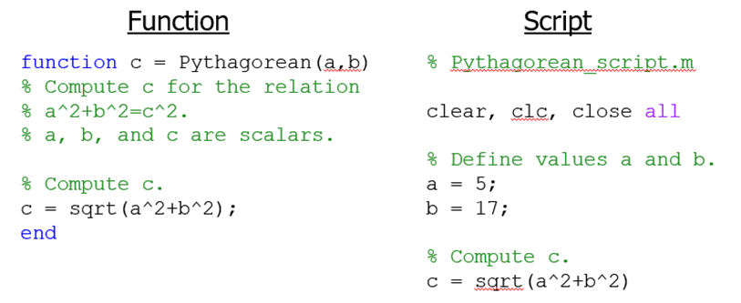

### Functions

Functions usually take inputs and return outputs. In the above function:

* The function is called by the name Pythagorean
* Inputs a and b are provided as scalar numbers
* The value of c is returned

**NOTE: when incorporating functions into LiveScripts, all functions are stored at the end of the LiveScript document.**

Functions can be invoked (i.e. "called") from the command line or another function.

Pythagorean(1,1)

ans = 1.4142

result = Pythagorean(1,1)

result = 1.4142

**Note: when you assign variables in a LiveScript, the variable is stored in the Workspace.**

* Variables created within a function stay within the function - only function outputs are returned
* For example, the command line call result = Pythagorean(2,5) yields the variable result in the user workspace, but the variables in the function (a, b, and c) are nowhere to be found

### Scripts

Scripts and command line calls operate in the user workspace and the variables generated can be seen by the command line and other scripts (but not functions). Scripts are saved as .m files.

* New scripts or functions can be created by clicking the "New" button in the MATLAB interface.
* To open a script or function, either a) navigate to a .m file in the directory and click to open it, or b) type open <name of function> into the command line.

NOTE: you can open some preexisting functions in MATLAB. **DO NOT MODIFY THESE.**

### Clearing the workspace and figures

It is useful to purge the workspace memory at the beginning of a script using the clear command to avoid accidental use of old variables.

* clear: clears the Workspace. Can also be used to clear specific variables
* clc: purges the command line
* close all: closes all figure windows

% Example code demonstrating the clear command. a is cleared from the

% workspace below

a = 5;

b = 3;

clear a

### Working directory and paths

MATLAB can see the contents (e.g. files, scripts, and functions) in a set of pre-installed folders (i.e. paths) and your current working folder. You can see a list of all paths MATLAB can see by inputting path at the command line. When invoking an .m file from a path that MATLAB can't see, it will query you if you would like to "Change Folder" or "Add to Path" - **usually "Change Folder" is the best selection**.

**To avoid unnecessary headaches, you are encouraged to create a new folder for each homework assignment or project.**

### Interrupting code execution

Runaway code (code that does not terminate naturally) can be interrupted:

* ctrl + c (Windows)
* command + period (Mac)
* The "Pause" and "Stop" buttons in the editor can also be used.

% Example of infinite loop. Try interrupting the code. Be careful with

% infinite loops!

a = 1;

while a ~= 1

end

### MATLAB documentation and help

MATLAB has extensive help documentation. Some routes to the help documentation include:

* Enter help <term> on the command line (*the first thing I often try*)
* Help symbol, F1, or the help search bar in MATLAB
* The “Google method” -> google "MATLAB" and then what you are looking for.

**One goal of this course is that these notes will be a useful "help" resource for you in your future classes.**

You can also open the reference documentation for a function from a link in the command line.

help sin

**sin** Sine of argument in radians.

**sin**(X) is the sine of the elements of X.

See also asin, sind, sinpi.

Documentation for sin

Other functions named sin

The following is the reference documentation for the sin function.

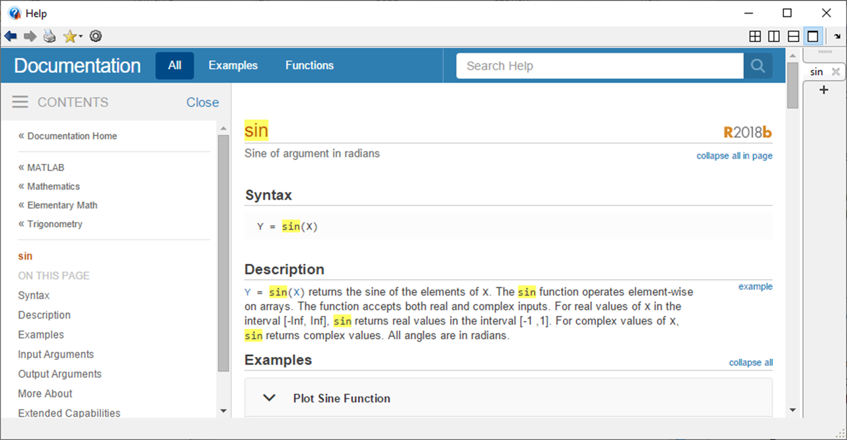

Note that the related functions (“See Also” section) at the end of each help page are useful for discovering functionality.

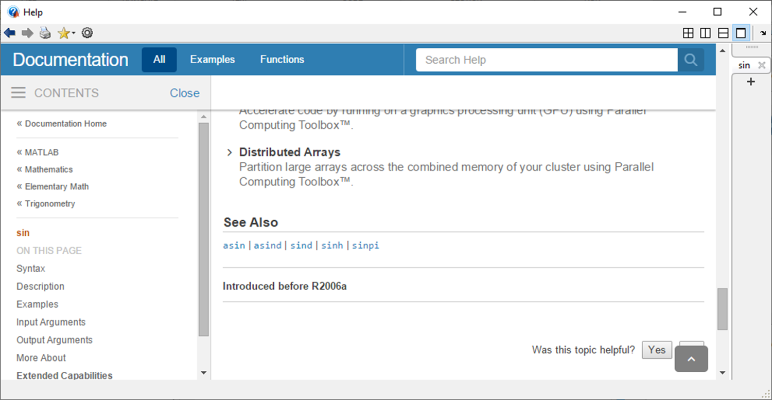

### Built-in MATLAB functions

MATLAB has thousands of built-in functions for evaluating common mathematical and statistical functions. You will use these and **many** other functions both in this class and during the rest of your time at Penn. When in doubt, just check the help documentation.

sin(x), cos(x), exp(x), log(x), atan(x), cosh(x), sinh(x), mean(x), sum(x), ...

a = sin(2*pi)

a = -2.4493e-16

b = sum([3, 4, 5])

b = 12

## Basics of vectors: 1- D arrays

MATLAB is well-suited to work with arrays, which you can think of as sequences of numbers, where the **value** and **index** of each entry define the array. A 1-D array is known as a **vector** in MATLAB.

% Explicityly define an array with 5 numbers

x = [1, 3, 9, 11, -10.2];

An explicit description of a vector is useful when the vector components are irregular.

### Creating vectors with slice notation

An often quicker way to produce vectors is to use the colon (:) operator. This enables you to create a vector by defining the **lower bound, upper bound, and increment size.**

% Create an array with numbers 1 though 15

x = 1:15;

% Create an array starting at 4 and increasing by 2 to 28

y = 4:2:28;

% Create an array starting at -1.3 and increasing by 0.1 to the value 1.3

z = -1.3:0.1:1.3;

Note: MATLAB will not include values above the upper bound specified in the slice notation. Note the values in the following array.

a = 1:2:6;

### Creating vectors with linspace() and logspace()

Another way to create vectors is to use linspace() and logspace() when the **number of increments** is more important than the increment size.

* linspace creates a vector of uniformly spaced components in linear space

% Create a vector with 5 elements uniformly spaced between (and including) 1 and 5

a = linspace(1,5,5)

a = 1×5

1 2 3 4 5

* logspace creates a vector of uniformly spaced components in (base-10) logarithmic space

% Create a vector with 5 elements uniformly spaced logarithmically between

% (and including) 10^1 and 10^5

b = logspace(1,5,5)

b = 1×5

10 100 1000 10000 100000

### Other vectors

In addtion to the above, many other types of vectors can be created. Here are a few more, useful examples.

* **Empty** vector

c = []

c =

[]

* **Ones** vector

d = ones(1,5)

d = 1×5

1 1 1 1 1

* **Zeros** vector

f = zeros(1,5)

f = 1×5

0 0 0 0 0

### Accessing vector indices

Individual vector indices or groups of vector indices may be accessed/extracted. For the following assume we have defined the following vector in memory:

x = [5, 9, 4, 1, 7, 3, 4, 8];

* Access the first vector index:

y = x(1)

y = 5

* Access a range of vector indices:

x(1:3)

ans = 1×3

5 9 4

x(6:8)

ans = 1×3

3 4 8

* Access the last vector index

x(end)

ans = 8

* Access the second-to-last vector index

x(end-1)

ans = 4

* Access discrete indices in any order

x([3, 6, 1])

ans = 1×3

4 3 5

### Replacing indices and adding indices to vectors

The existing contents of a vector may be replaced and indices may be added. Assume we have defined the following vector in memory, which we will continuously modify:

x = [1, 2, 3]

x = 1×3

1 2 3

* Replace the first index

x(1) = 5

x = 1×3

5 2 3

* Replace the first and second indices

x(1:2) = [8,9]

x = 1×3

8 9 3

* Replace the first and third indices

y = [8, 9, 3]

y = 1×3

8 9 3

y([1,3]) = [5,1]

y = 1×3

5 9 1

* Replace the ultimate and penultimate indices

y(end-1:end) = [6,8]

y = 1×3

5 6 8

* Add a scalar after the last index

z = [2, 6, 8]

z = 1×3

2 6 8

z(end+1) = 4

z = 1×4

2 6 8 4

* Add multiple numbers to the end of the vector

z(end+1:end+2) = [5,7]

z = 1×6

2 6 8 4 5 7

* Replace all odd indices with a scalar

z(1:2:end) = 1

z = 1×6

1 6 1 4 1 7

* Replace all even indices with a scalar

z(2:2:end) = 4

z = 1×6

1 4 1 4 1 4

* Add an index more than one index after the ultimate index

z(end+2) = 7

z = 1×8

1 4 1 4 1 4 0 7

The rules for replacing vector indices are thus:

1. Scalars can replace a single index or multiple indices
2. Vectors can replace multiple indices of a vector if the length of the replacement equals the number of indices

x = [5, 2, 1, 8]

x = 1×4

5 2 1 8

### Removing vector indices

Vector indices may be removed by specifying an empty set (empty vector).

x = [5, 3, 9, 4, 1, 6]

x = 1×6

5 3 9 4 1 6

* Remove the first index

x(1) = []

x = 1×5

3 9 4 1 6

* Remove odd indices

x(1:2:end) = []

x = 1×2

9 1

### Concatenating vectors

Multiple vectors may be combined via concatenation, provided both vectors are oriented correctly (both row vectors).

x = [9, 5, 8, 2]

x = 1×4

9 5 8 2

* Concatenate same vector

x(1) = []

x = 1×3

5 8 2

* Concatenate multiple vectors

x(1:2:end) = []

x = 8

### Operations on vectors

You can perform mathematical operations on arrays just as you can scalar values (in most cases).

* You can **add** and **subtract** two arrays in MATLAB as long as they are the same size - if they are not the same size you will get an error.

x = [1 2 3 4 5];

y = [7 8 9 10 11];

% element-wise addition adds corresponding elements

z = x + y;

* Multiplication and division are different -- simply using * and / will perform matrix multiplication and division (which we will explore later)
* Instead, **use a period (.) to perform element-wise multiplication and division**

z1 = x.*y; % element-wise multiplication

z2 = x./y; % element-wise division

Almost all of MATLAB’s built-in functions will accept arrays as arguments and perform operations on these arrays in an element-wise manner.

x = 1:10:1000;

% Compute the square root of each element in the array x

y = sqrt(x);

We will see later that **vectorization** in this way is more computationally efficient than using loops to operate on each element. In addition, operations can be performed on the output from each function.

% create an array of values

x = 0:0.01:3.2;

% evaluate an expression on every element in % the array x producing a new array called y

y = exp(5*x).*sin(x);

% produce a plot

plot(x, y)

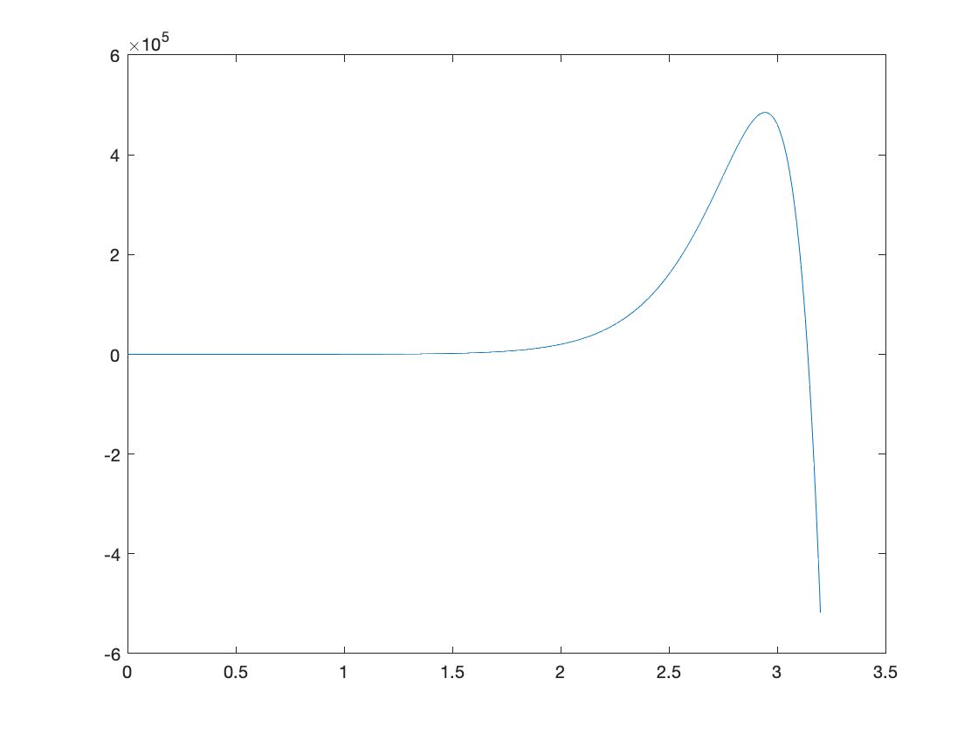

# TOPIC 2: Introduction to arrays: vectors, matrices, and more

ENGR105, 9/8/20

## Revisiting vectors

Previously, we learned how to *create vectors*, *access vector elements*, and *delete vector elements*. We did this for *row* vectors, the default orientation of vectors formed by slice notation, linspace, etc.

For example, consider operations on the following row vector, which has one row and four columns.

% Create an example vector

x = 1:2:8

x = 1×4

1 3 5 7

% Call indices 1 and 4 of vector x

x([1,4])

ans = 1×2

1 7

% Delete the element associated with the index 4

x(4) = []

x = 1×3

1 3 5

% Create new vectors via concatenation

x1 = [x,x]

x1 = 1×6

1 3 5 1 3 5

x2 = [x,linspace(1,3,6)]

x2 = 1×9

1.0000 3.0000 5.0000 1.0000 1.4000 1.8000 2.2000 ⋯

Why are we doing this?

1. Array operations are a fundamental component of using MATLAB.
2. If you know how to create vectors and matrices, you can "easily" solve engineering problems (goal for this week).
3. Practice using "logic" and math concepts to try to create something new in the most efficient way possible.

### Example

Starting with vector x, defined below, perform the following steps:

x = [1,4,2,5,6,4,3,1,4,2,5,6,4,3,1,4,2,5,6,4,3];

1. Delete very 4th entry starting with the first.
2. Square every odd element.
3. Move the last 5 entries to the front

% Step 1

x(1:4:end) = [];

% Step 2

x(1:2:end) = x(1:2:end).^2;

% Step 3

%end is an inclusive range

%we concatinate a new vector that starts with the last 5 numbers and

%carries on to the first 5 numbers

x = [x(end-4:end), x(1:end-5)]

x = 1×15

1 4 25 6 16 16 2 25 4 9 1 4 5 ⋯

### Column vectors

*Column* vectors can be created via direct input (i.e. explicitly defining the vector) or the transpose (') command.

* Column vector created using semicolons

x = [5; 4; 6; 9]

x = 4×1

5

4

6

9

* Column vector created using the **transpose**

% Creating a new column vector

y1 = (1:4)';

% Creating a new vector by taking the transpose of an existing one

y2 = x'

y2 = 1×4

5 4 6 9

Live row vectors, a created column vector may be addressed using single index notation to refer to rows.

* Single index notation: specifying an index or range of indices using a vector. This is exactly what we used proviously.

x = [5; 2; 1; 8]

x = 4×1

5

2

1

8

% Replacing the first element

x(1) = 9

x = 4×1

9

2

1

8

% Replacing the first two elements

x(1:2) = [4, 3]

x = 4×1

4

3

1

8

% Replacing the second-to-last element

x(end-1) = 9

x = 4×1

4

3

9

8

% Deleting the first and third elements

x([1,3]) = []

x = 2×1

3

8

In other words, the same index notation is used for both row and column vectors. Though we will often use row vectors because these are the default orientation, it is important to remember that the vector you have created has a particular orientation.

### Determining the number of entries in a vector

It is sometimes helpful to know the length of a vector in order to perform operations based on its size. Use the length() command to determine the number of entries in a vector.

x = [5, 2, 1, 4, 9, 1]

x = 1×6

5 2 1 4 9 1

L = length(x)

L = 6

You can use length() to operate on, e.g. the first half of a vector, even if you don't know it's size beforehand.

% Return the first half of the vector

x(1:length(x)/2)

ans = 1×3

5 2 1

Reminder: if you assign a scalar to a vector, as below, the scalar will assigned to all indices of the specified vector.

x(1:length(x)/2) = 50;

x

x = 1×6

50 50 50 4 9 1

### Precedence

Note a detail in the above code:

1:length(x)/2

ans = 1×3

1 2 3

This is not the same as the following, due to precedence.

%Divides the original vector length in half

(1:length(x))/2

ans = 1×6

0.5000 1.0000 1.5000 2.0000 2.5000 3.0000

This is because MATLAB follows an order of operations for vector and array operations.

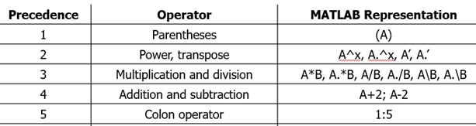

The colon operator takes the lowest precedence and so the following are equivalent:

1:length(x)/2

ans = 1×3

1 2 3

1:(length(x)/2)

ans = 1×3

1 2 3

We can add to the classic order of operations mnemonic: "Please Excuse My Dear Aunt Sally's Colon"

Operation precedence may be overidden using parentheses.

a = 1;

b = 2;

c = 3;

d = 4;

Consider the following examples

* Statements are evaluated from left to right with multiplication and division being executed first

a+b*c/d

ans = 2.5000

* Here, the parentheses specify that addition should be executed first (overriding mathematical precedence)

(a+b)*c/d

ans = 2.2500

* Upholds the execution order prescribed by mathematical operator precedence, the use of parentheses is unnecessary

a+(b*c)/d

ans = 2.5000

Parentheses can be included to improve the clarity of an expression even if not modifying precedence

* z1 = 2*pi*x^2*y+1;
* z2 = 2*pi*(x^2*y)+1;

z1 and z2 give the same result, but it is easier to see the relationships between pre-factors and independent variables in z2

## Arrays

A *vector* is only one type of *array*. MATLAB stands for Matrix Laboratory because the MATLAB system is designed to efficiently work with data arranged in arrays of all sizes, especially 2-D *matrices*. In fact, all numbers in MATLAB are stored as arrays:

* **Scalar**: (1x1 array)

a1 = 1;

disp(a1)

1

* **Vector**: (1xN array) or (Nx1 array). In this case, there are either N rows or N columns

a2 = [1,5,9];

disp(a2)

1 5 9

a3 = [1;5;9];

disp(a3)

1

5

9

* **2D matrix**: (MxN array). That is, a 2D matrix consists of M rows and N columns. In this case, there are 2 rows and 3 columns.

%remember the semicolon makes the vector an array

a4 = [1,5,9;9,5,1];

disp(a4)

1 5 9

9 5 1

* **Multidimensional matrix**: (MxNx...xP array). A 3D+ array consists of rows, columns, "pages", "volumes", etc. In this case there are 2 rows, 3 columns, and 2 "pages."

a5(:,:,1) = [1,5,9;9,5,1];

a5(:,:,2) = [2,3,4;4,3,2];

disp(a5)

(:,:,1) =

1 5 9

9 5 1

(:,:,2) =

2 3 4

4 3 2

### Dimensions of an array

The length(), size(), and numel() commands are useful for evaluating the properties of an array.

* As seen above, length() is useful for vectors --it returns the number of elements in the vector. This command operates independently of the vector being a row or column vector.

length(a2)

ans = 3

length(a3)

ans = 3

* Using length on a matrix is less useful -- in general, it returns the greatest dimension of the array

length(a4)

ans = 3

* To evaluate the dimensions of an arbitrary-sized array, use the size() function. This functions returns a **vector**:

size(a4)

ans = 1×2

2 3

This can be read as, "a4 is a 2x3 matrix." The first entry represents the number of rows of a4, the second entry represents the number of columns.

* size() can be used for higher-order arrays also

size(a5)

ans = 1×3

2 3 2

This can be read as, "a5 is a 2x3x2 matrix." The first entry represents the number of rows of a4, the second entry represents the number of columns.

* The numel() command returns the total number of indices ("number of elements") in the array.

numel(a4)

ans = 6

## Matrices

For now, we will focus on 2D matrices. For simplicity we will call these "matrices," but it is implied that we mean 2D matrices or 2D arrays. You will work with matrices a lot in your linear algebra courses, as well as advanced engineering courses.

* *Relevant UPenn Course*: ENM 240 Differential Equations and Linear Algebra
* *Relevant UPenn Course*: MATH 240: Calculus, pt. III

### Constructing matrices

Matrices may be explicitly constructed by inputting row and column values as a list. A semicolon divides rows.

A = [2, 5, 9; 6, 8, 3]

A = 2×3

2 5 9

6 8 3

Matrices may also be constructed from existing vectors using concatenation. **Note the orientation of the vectors.**

a = [1, 2, 3];

b = [4, 5, 6];

% Concatenate vertically

A1 = [a;b]

A1 = 2×3

1 2 3

4 5 6

% Concatenate horizontally

A2 = [a,b]

A2 = 1×6

1 2 3 4 5 6

a = [1; 2; 3];

b = [4; 5; 6];

% Concatentate

B1 = [a;b]

B1 = 6×1

1

2

3

4

5

6

**NOTE: Dimensions must match along the plane of concatenation**

For vectors:

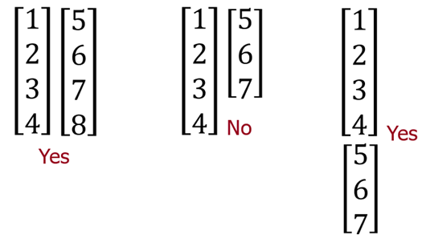

For matrices:

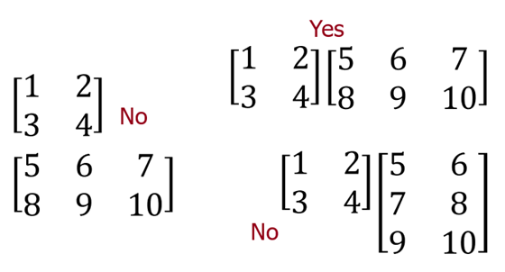

Takeaway: **be aware of the dimensions of the vectors and matrices you are working with.**

% Concatenate vectors

a = [1 2 3; 4 5 6]

a = 2×3

1 2 3

4 5 6

b = [7 8 9; 10 11 12]

b = 2×3

7 8 9

10 11 12

% Concatenate matrices

C1 = [a;b]

C1 = 4×3

1 2 3

4 5 6

7 8 9

10 11 12

C2 = [a,b]

C2 = 2×6

1 2 3 7 8 9

4 5 6 10 11 12

### Accessing array indices

Specific indices from a 2D matrix can be accessed by row and column indexing in the form **Matrix(row, column).**

A = [1:3;4:6;7:9]'

A = 3×3

1 4 7

2 5 8

3 6 9

A(3,1)

ans = 3

A(1,3)

ans = 7

In the above, we took the **transpose** of a matrix. This swaps the row and column index of every element. For example, the following 2x3 matrix becomes a 3x2 matrix.

B = [1:3;4:6]

B = 2×3

1 2 3

4 5 6

B'

ans = 3×2

1 4

2 5

3 6

**Useful**: Full rows or columns can be selected using the colon operator (:).

A = [1:3;4:6;7:9]'

A = 3×3

1 4 7

2 5 8

3 6 9

% Return a column vector of all rows in the first column

A(:,1)

ans = 3×1

1

2

3

%Colon returns all columns in that row?

% Return a row vector of all columns in the second row

A(2,:)

ans = 1×3

2 5 8

Submatrices may also be extracted.

% Return a submatrix of entries in first and second rows and columns

A(1:2,1:2)

ans = 2×2

1 4

2 5

% Return a submatrix of entries in first and second rows and all columns

A(1:2,:)

ans = 2×3

1 4 7

2 5 8

In my opinion, row and column indexing is preferred because it is more intuitive. However, array indices may also be accessed using a single subscript indexing (“unwound” matrix). Indices are evaluated starting in the upper left hand corner and parsed by column.

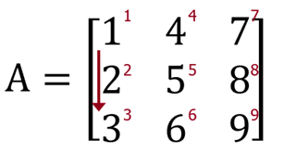

A(5)

ans = 5

A range of entries may be called to return a row vector of the corresponding elements.

A(1:5)

ans = 1×5

1 2 3 4 5

Note: the colon operator (:) may be used to unwind the entire matrix into a *column vector*.

A(:)

ans = 9×1

1

2

3

4

5

6

7

8

9

The diagonal components of a matrix may be called using the diag() command. Often, these elements are important for engineering applications - e.g. normal stresses from a stress tensor.

% Diagonal components of A

diag(A)

ans = 3×1

1

5

9

### Overwriting indices

Specific indices of the matrix may be directly overwritten using row/column or single subscript notation.

A = [1:3;4:6;7:9]'

A = 3×3

1 4 7

2 5 8

3 6 9

% Replace the entry in the third row, first column

A(3,1) = 50

A = 3×3

1 4 7

2 5 8

50 6 9

% Replace all entries in the "upper left of the matrix"

A(1:2,1:2) = 0

A = 3×3

0 0 7

0 0 8

50 6 9

If a matrix index is assigned a value outside of the original matrix size, indices of "unknown value" will be padded with 0’s

A(4,4) = 33

A = 4×4

0 0 7 0

0 0 8 0

50 6 9 0

0 0 0 33

Array indices at any index location can be specified even if the array does not exist.

% C has not be previously defined

C(3,3,3) = 1

C =

C(:,:,1) =

0 0 0

0 0 0

0 0 0

C(:,:,2) =

0 0 0

0 0 0

0 0 0

C(:,:,3) =

0 0 0

0 0 0

0 0 1

## Array mathematics

### Addition and Subtraction

General rules for addition and subtraction for arrays of any dimension (e.g. vectors or matrices)

1. Scalars may be added to/subtracted from any array - **the scalar value is added to all elements of the array**
2. Arrays added to arrays must have the **same dimensions** and elements in correlated index locations can be added or subtracted.

% Create new matrix

A = [1,5;2,3]

A = 2×2

1 5

2 3

% Add 2 to every element

% Create new array by reordering the first and second row

B = [A(2,:);A(1,:)]

B = 2×2

2 3

1 5

% Matrix addition

Remember: matrix dimensions must agree. In other words, the matrices must have the same dimensions.

### Multiplication

General rules for matrix/array multiplication:

1. Arrays may be multiplied by a **scalar**.
2. **Arrays of the same dimensions** may be multiplied index-by-index using the array multiplier/vectorization (.*)
3. The matrix product (*) may be evaluated for matrices if the "inner dimensions" of the original matrices match and the resulting matrix will have dimensions equal to the outer dimensions of the matrices being multiplied.

**Case 1: multiplication by a scalar**

A

A = 2×2

1 5

2 3

**Case 2: element-by-element multiplication**. Arrays of the same dimensions may be multiplied index-by-index using the array multiplier/vectorization (.*)

A

A = 2×2

1 5

2 3

B

B = 2×2

2 3

1 5

**Case 3: matrix multiplication**. For A*B, the **columns of A must equal the rows of B**.

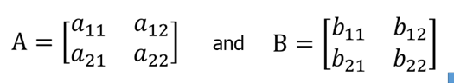

The element in the first row and first column of A*B is:

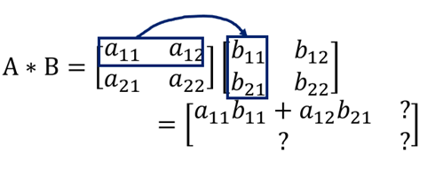

The element in the first row and second column of A*B is:

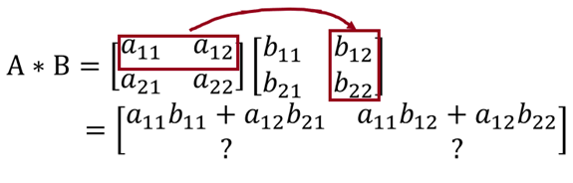

Filling in the matrix:

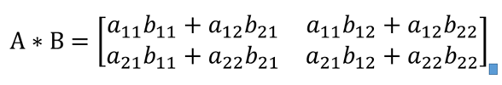

A = [1,4;2,3]

A = 2×2

1 4

2 3

B = [1,2;3,4]

B = 2×2

1 2

3 4

% Matrix multiplication

A*B

ans = 2×2

13 18

11 16

**Remember: A*B is not usually the same as B*A**

% Matrix multiplication with multiplication order reversed.

B*A

ans = 2×2

5 10

11 24

**Pro tip:** if you feel stressed about this, write out each entry systematically! You will work a lot more with matrices in your linear algebra courses.

**Remember**: the dimensions of the matrix product are equal to the outer dimensions of the original matrices and the inner dimensions must match

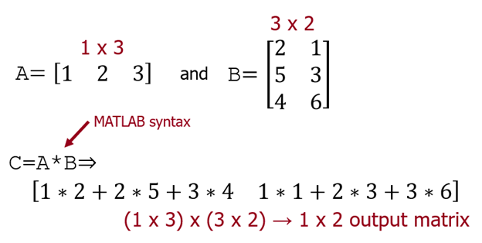

B = [2,1;5,3;4,6]

B = 3×2

2 1

5 3

4 6

A = 1:3

A = 1×3

1 2 3

% To perform matrix multiplication, ensure the columns of the first matrix

% match the rows of the second

A*B

ans = 1×2

24 25

### Division

**Division of a scalar by an array** necessitates an array operator.

A = [1 2; 4 8]

A = 2×2

1 2

4 8

B = 16./A

B = 2×2

16 8

4 2

**NOTE**: B = 16/A will return an error.

**NOTE**: Matrix division has a different interpretation than scalar division. Right division is different than left division.

**Element-wise division:**

* *Right* division: A./B is equivalent to A(i,j)/B(i,j)
* *Left* division: A.\B is equivalent to B(i,j)/A(i,j)

% Define matrix A and vector b

A = [2,4;2,6]

A = 2×2

2 4

2 6

B = [1,2;1,3]

B = 2×2

1 2

1 3

% Perform right division

% Perform left division

**Left matrix division**. Consider the following matrix equation, in which matrix **A** is multiplied by vector **x** to give vector **b**.

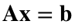

Note on dimensions: assuming A is square (e.g. 2x2), then **x** and **b** must be (e.g. 2x1) column vectors. To solve for **x**, you must perform left division of matrix **A**, or left multiply by the inverse of **A**.



The above works because 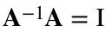, where  is the identity matrix, and 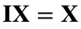 (by definition).

% Define matrix A and vector b

A = [2,4;2,6]

A = 2×2

2 4

2 6

b = [5;4]

b = 2×1

5

4

% Perform left division

A\b

ans = 2×1

3.5000

-0.5000

inv(A)*b

ans = 2×1

3.5000

-0.5000

**Right matrix division**. Consider the following matrix equation, in which matrix **A** is multiplied by vector **x** to give vector **b**.

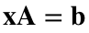

Note on dimensions: assuming A is square (e.g. 2x2), then **x** and **b** must be (e.g. 1x2) row vectors. To solve for **x**, you must perform right division of matrix **A**, or right multiply by the inverse of **A**.



A = [2,4;2,6]

A = 2×2

2 4

2 6

b = [5,4]

b = 1×2

5 4

% Perform right division

b/A

ans = 1×2

5.5000 -3.0000

b*inv(A)

ans = 1×2

5.5000 -3.0000

## Application: solving a set of linear equations

You are likely familiar with canonical linear equations of the form y=mx+b or ax+by=c, which define a straight line in 2D space. Consider a set of two linear equations:

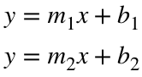

In engineering applications, you are often interested in solving a set of linear equations. There are three possibilities:

**There is one solution.**

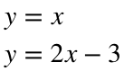

% x vectors

x = 0:.1:10;

% Create a figure window of a defined size

figure('Position',[0,0,300,300]);

plot(x,x,'k-',x,2*x-3,'r-')

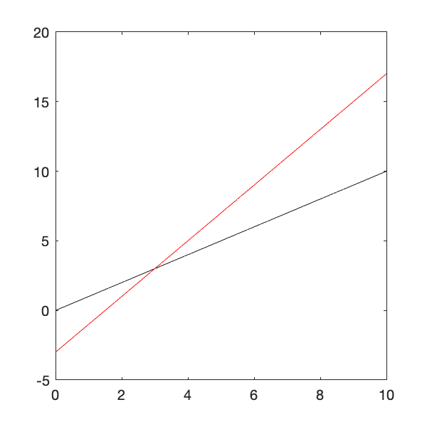

**There are no solutions.**

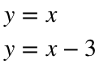

% Create a figure window of a defined size

figure('Position',[0,0,300,300]);

plot(x,x,'k-',x,x-3,'r-')

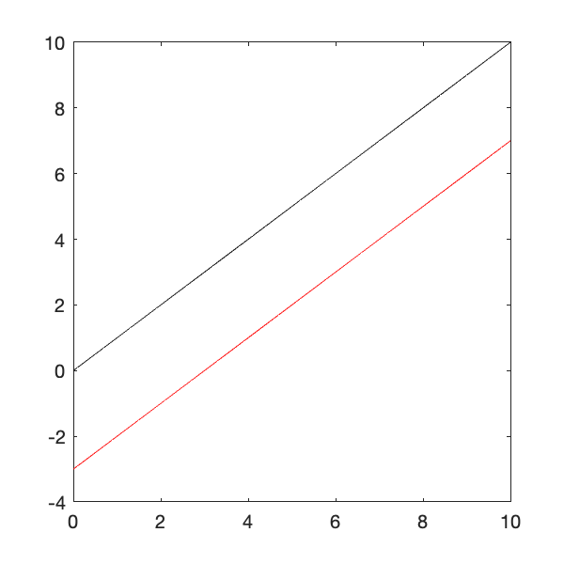

**There are infinite solutions.**

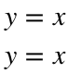

% Create a figure window of a defined size

figure('Position',[0,0,300,300]);

plot(x,x,'k-',x,x,'r-')

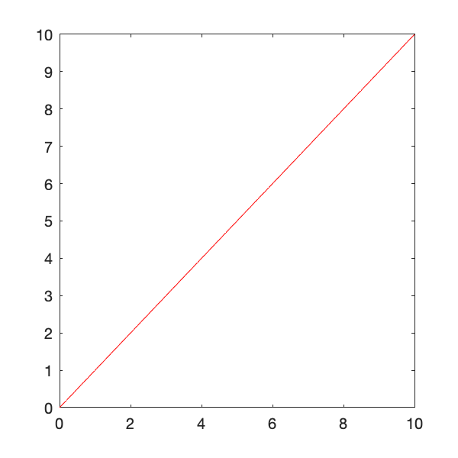

We will focus on systems that have one solution. Further study in linear algebra will provide conditions on matrix **A** and vector **b** that will enable you to determine the number of solutions.

### One approach: substitution

Consider the two equations defined above. To solve, perform the following steps.



1) Set equations equal

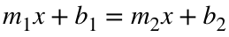

2) Solve for x

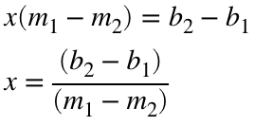

3) Substitute to solve for y

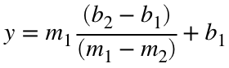

This is fine, but requires equations in the above form and can get tedious.

### Another approach: matrix representation

Rearranging the above system of equations:

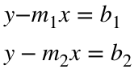

Double check the matrix multiplication rules above. Based on the rules of matrix multiplication, the above set of equations can be represented in matrix form:

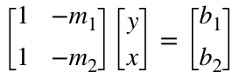

Or:

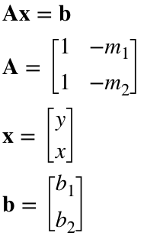

This is the case above corresponding to **left matrix division**. Thus, we can simply solve for y and x by performing a left division:

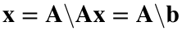

**Example 1**. Solve the following system of equations.



% Step 1: convert to matrix format

A = [1,-1;1,-2]; %Coefficient matrix defined above

b = [0;-3]; % Constant matrix

% Step 2: solve for x and y

Thus, the solution exists at x = 3 and y = 3.

### More general representation

More often, you will encounter systems with more than two variable. Thus, it is more convenient to think of a system of linear equations in the following form, where there are n variables and n equations.

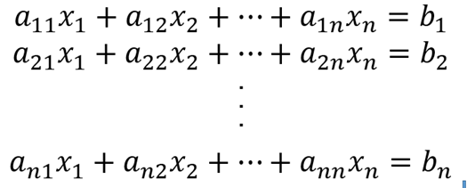

The above can be represented compactly in matrix form:

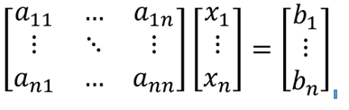

Or again as:



**Note: matrix A is slightly different than defined previously.** This is a more general form.

**Example 2.** Solve the following system of equations.

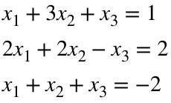

% Step 1: convert to matrix format

A = [1,3,1;2,2,-1;1,1,1]; %Coefficient matrix defined above

b = [1;2;-2]; % Constant matrix

% Step 2: solve for x

Thus, the solution to this problem is 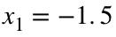, 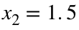, 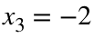.

# TOPIC 3: Systems of equations, functions, and more

ENGR105, 9/10/20

## Array mathematics (continued)

### Addition and Subtraction

General rules for addition and subtraction for arrays of any dimension (e.g. vectors or matrices)

1. Scalars may be added to/subtracted from any array - **the scalar value is added to all elements of the array**
2. Arrays added to arrays must have the **same dimensions** and elements in correlated index locations can be added or subtracted.

% Create new matrix

A = [1,5;2,3]

% Add 2 to every element

A + 2

% Create new array by reordering the first and second row

B = [A(2,:);A(1,:)]

% Matrix addition

A + B

Remember: matrix dimensions must agree. In other words, the matrices must have the same dimensions.

### Multiplication

General rules for matrix/array multiplication:

1. Arrays may be multiplied by a **scalar**.
2. **Arrays of the same dimensions** may be multiplied index-by-index using the array multiplier/vectorization (.*)
3. The matrix product (*) may be evaluated for matrices if the "inner dimensions" of the original matrices match and the resulting matrix will have dimensions equal to the outer dimensions of the matrices being multiplied.

**Case 1: multiplication by a scalar**

% Create same matrices as last time

A = [1,5;2,3]

A = 2×2

1 5

2 3

B = [A(2,:);A(1,:)]

B = 2×2

2 3

1 5

A

A = 2×2

1 5

2 3

A*5

ans = 2×2

5 25

10 15

**Case 2: element-by-element multiplication**. Arrays of the same dimensions may be multiplied index-by-index using the array multiplier/vectorization (.*)

A

A = 2×2

1 5

2 3

B

B = 2×2

2 3

1 5

A.*B

ans = 2×2

2 15

2 15

**Case 3: matrix multiplication**. For A*B, the **columns of A must equal the rows of B**.



The element in the first row and first column of A*B is:



The element in the first row and second column of A*B is:



Filling in the matrix:



A = [1,4;2,3];

B = [1,2;3,4];

% Matrix multiplication

A*B

ans = 2×2

13 18

11 16

**Remember: A*B is not usually the same as B*A**

% Matrix multiplication with multiplication order reversed.

B*A

ans = 2×2

5 10

11 24

**Pro tip:** if you feel stressed about this, write out each entry systematically! You will work a lot more with matrices in your linear algebra courses.

**Remember**: the dimensions of the matrix product are equal to the outer dimensions of the original matrices and the inner dimensions must match



B = [2,1;5,3;4,6]

B = 3×2

2 1

5 3

4 6

A = 1:3

A = 1×3

1 2 3

% To perform matrix multiplication, ensure the columns of the first matrix

% match the rows of the second

A*B

ans = 1×2

24 25

### Division

**Division of a scalar by an array** necessitates an array operator.

A = [1 2; 4 8]

A = 2×2

1 2

4 8

B = 16./A

B = 2×2

16 8

4 2

**NOTE**: B = 16/A will return an error.

**NOTE**: Matrix division has a different interpretation than scalar division. Right division is different than left division.

**Element-wise division:**

* *Right* division: A./B is equivalent to A(i,j)/B(i,j)
* *Left* division: A.\B is equivalent to B(i,j)/A(i,j)

% Define matrix A and vector b

A = [2,4;2,6];

B = [1,2;1,3];

% Perform right division

A./B

ans = 2×2

2 2

2 2

% Perform left division

A.\B

ans = 2×2

0.5000 0.5000

0.5000 0.5000

**Left matrix division**. Consider the following matrix equation, in which matrix **A** is multiplied by vector **x** to give vector **b**.



Note on dimensions: assuming A is square (e.g. 2x2), then **x** and **b** must be (e.g. 2x1) column vectors. To solve for **x**, you must perform left division of matrix **A**, or left multiply by the inverse of **A**.



The above works because , where  is the identity matrix, and  (by definition).

% Define matrix A and vector b

A = [2,4;2,6]

A = 2×2

2 4

2 6

b = [5;4]

b = 2×1

5

4

% Perform left division

A\b

ans = 2×1

3.5000

-0.5000

inv(A)*b

ans = 2×1

3.5000

-0.5000

**Right matrix division**. Consider the following matrix equation, in which matrix **A** is multiplied by vector **x** to give vector **b**.



Note on dimensions: assuming A is square (e.g. 2x2), then **x** and **b** must be (e.g. 1x2) row vectors. To solve for **x**, you must perform right division of matrix **A**, or right multiply by the inverse of **A**.



A = [2,4;2,6]

A = 2×2

2 4

2 6

b = [5,4]

b = 1×2

5 4

% Perform right division

b/A

ans = 1×2

5.5000 -3.0000

b*inv(A)

ans = 1×2

5.5000 -3.0000

## Application: solving a set of linear equations

You are likely familiar with canonical linear equations of the form y=mx+b or ax+by=c, which define a straight line in 2D space. Consider a set of two linear equations:



In engineering applications, you are often interested in solving a set of linear equations. There are three possibilities:

**There is one solution.**



% x vectors

x = 0:.1:10;

% Create a figure window of a defined size

figure('Position',[0,0,300,300]);

plot(x,x,'k-',x,2*x-3,'r-')



**There are no solutions.**



% Create a figure window of a defined size

figure('Position',[0,0,300,300]);

plot(x,x,'k-',x,x-3,'r-')



**There are infinite solutions.**



% Create a figure window of a defined size

figure('Position',[0,0,300,300]);

plot(x,x,'k-',x,x,'r-')



We will focus on systems that have one solution. Further study in linear algebra will provide conditions on matrix **A** and vector **b** that will enable you to determine the number of solutions.

### One approach: substitution

Consider the two equations defined above. To solve, perform the following steps.



1) Set equations equal



2) Solve for x



3) Substitute to solve for y



This is fine, but requires equations in the above form and can get tedious.

### Another approach: matrix representation

Rearranging the above system of equations:



Double check the matrix multiplication rules above. Based on the rules of matrix multiplication, the above set of equations can be represented in matrix form:



Or:



This is the case above corresponding to **left matrix division**. Thus, we can simply solve for y and x by performing a left division:



**Example 1**. Solve the following system of equations.



% Step 1: convert to matrix format

A = [1,-1;1,-2] %Coefficient matrix defined above

A = 2×2

1 -1

1 -2

b = [0;-3] % Constant matrix

b = 2×1

0

-3

% Step 2: solve for x and y

Thus, the solution exists at x = 3 and y = 3.

### More general representation

More often, you will encounter systems with more than two variable. Thus, it is more convenient to think of a system of linear equations in the following form, where there are n variables and n equations.



The above can be represented compactly in matrix form:



Or again as:



**Note: matrix A is slightly different than defined previously.** This is a more general form.

**Example 2.** Solve the following system of equations.



% Step 1: convert to matrix format

A = [1,3,1;2,2,-1;1,1,1]; %Coefficient matrix defined above

b = [1;2;-2]; % Constant matrix

% Step 2: solve for x

x = A\b

x = 3×1

-1.5000

1.5000

-2.0000

Thus, the solution to this problem is , , .

### Example application: fluid flow in a Y-channel

As an engineer, you might be interested in designing fluid flow in different systems. You will learn how to analyze these systems in your fluid mechanics and transport phenomena courses.

* *Relevant UPenn Course*: BE 350 Introduction to Biotransport Processes
* *Relevant UPenn Course*: CBE 350 Fluid Mechanics
* *Relevant UPenn Course*: MEAM 302 Fluid Mechanics

Consider the Y-junction in the following schematic. Since this system is physical, you the geometry of the channels and the input and output pressures. Specifically, all channels have a circular cross section with radius 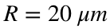. Channel lengths are 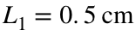, 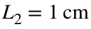, 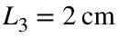. Pressures at the ports are 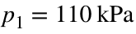, 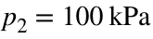, and 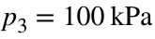. The fluid is water with viscosity 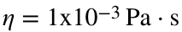.

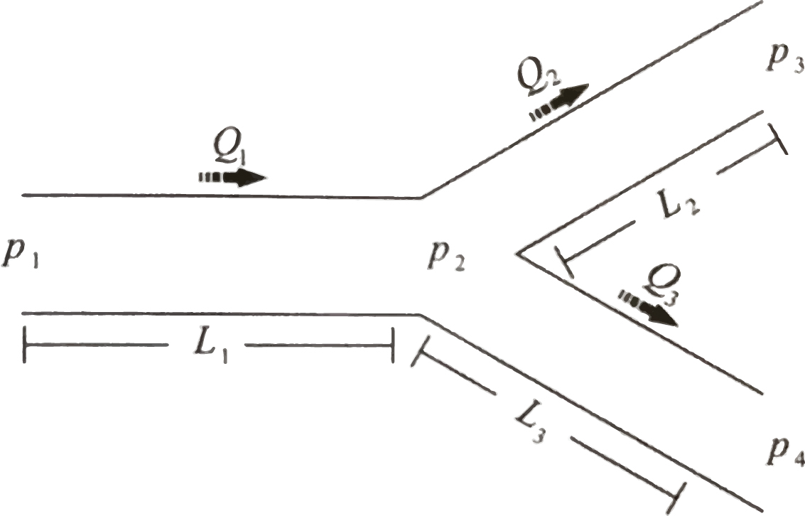

You are interested in determining the flow rates through each fluidic segment. From you (to be completed, future) engineering coursework, you know that you can describe this system as incompressible flow using Hagen-Poiseuille relations incorporating the equivalent hydraulic resistance. In this system, the hydraulic resistance of channel segment can be defined as follows:

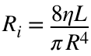

**Step 1: write down the physical parameters you know and draw a schematic.**

% Known physical parameters in this system

eta = 1*10^-3; %viscosity, Pa*s

L1 = 0.5*10^-2; % m

L2 = 1*10^-2; % m

L3 = 2*10^-2; % m

R = 20*10^-6; % m

% Calculate fluidic resistance of each channel segment

R1 = 8*eta*L1/(pi*R^4)*10^-12; % kPa*s/mm^3

R2 = 8*eta*L2/(pi*R^4)*10^-12; % kPa*s/mm^3

R3 = 8*eta*L3/(pi*R^4)*10^-12; % kPa*s/mm^3

**Step 2: state assumptions and write down equations describing the system**. In this case, we are assuming steady, incompressible flow, yielding the following equations:

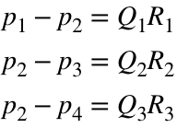

Because the system is incompressible, we know from conservation of mass:

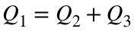

In addition, we know the input pressure (perhaps supplied by a pump) and the output pressures (atmospheric pressure):

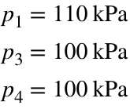

**Step 3: solve system of equations.** Here, we have 7 variables and 7 equations. We can solve the problem using the matrix representation approach by first writing all of the equations in the form 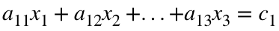.

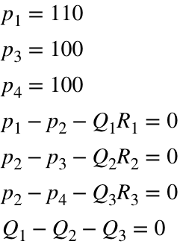

Converting this a matrix (**NOTE: I have taken care to ensure all units are properly matched**):

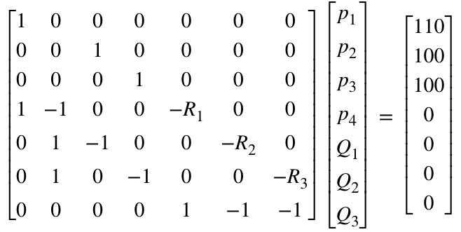

This can be solved using the matrix division we talked about last time.



clear A b % Clear previously used terms from workspace

% Define matrix A

A(4,1:7)=[1,-1,0,0,-R1,0,0]; % We specify columns 1:7 because the matrix A is not yet defined

A(5,:)=[0,1,-1,0,0,-R2,0];

A(6,:)=[0,1,0,-1,0,0,-R3];

A(7,:)=[zeros(1,4),1,-1,-1];

A([1,16,24]) = 1; % Use single index notation to specify sparse 1 values

disp(A)

1.0000 0 0 0 0 0 0

0 0 1.0000 0 0 0 0

0 0 0 1.0000 0 0 0

1.0000 -1.0000 0 0 -79.5775 0 0

0 1.0000 -1.0000 0 0 -159.1549 0

0 1.0000 0 -1.0000 0 0 -318.3099

0 0 0 0 1.0000 -1.0000 -1.0000

% Define matrix b

b = [110,100,100,zeros(1,4)]'; % Note the transpose: we need b to be a column vector

disp(b)

110

100

100

0

0

0

0

% Solve system of equations

x = A\b;

disp(x)

110.0000

105.7143

100.0000

100.0000

0.0539

0.0359

0.0180

Thus, in one line of code, we obtain the solution to this set of 7 linear equations. In this case, the solution is as follows.

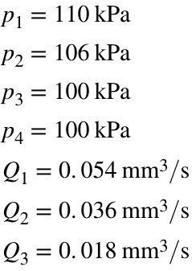

*Side challenge*: can you create matrix A, above, in four lines of code or less?

## Functions

Recall: assemblages of code can be composed in the editor window and stored as an .m file for more permanence. These assemblages of code are referred to as either functions or scripts. Functions start with the function declaration whereas scripts are just assemblages of statements.

### Functions vs. scripts

* The following refers to .m files created to contain a function or a script.



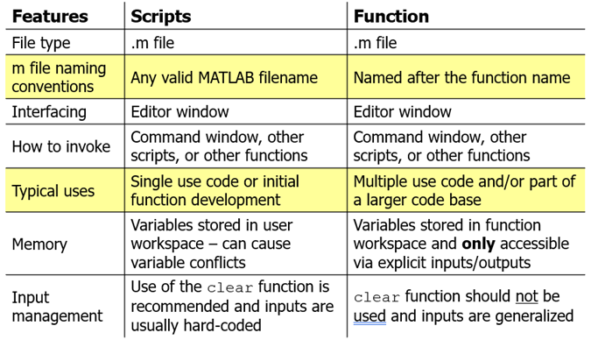

**"Where" do we create functions?**

* To run on the command line, you need to create a function in a new .m file.
* When using the LiveScript, each individual function is saved at the end of the .mlx document.

### Examples of function declarations

**Note:** function **declarations** go at the top of a .m file and may only be preceded by comments.

* No inputs and no outputs

function myFunc or function myFunc()

* One input and one output

function out1 = myFunc(in1)

* Multiple outputs and no inputs

function [out1,out2,out3] = myFunc()

* Three outputs and two inputs

function [out1,out2,out3] = myFunc(in1,in2)

**NOTE:** the number of inputs does not need to match the number of outputs.

### Function rules

1. When creating an .m file to contain the function, name the .m file the same as the function name.
2. Do not use a variable within a function that has the same name as the function.
3. Do not hard-code inputs.
4. Use only one function per .m file
5. All function outputs should be calculated at some point within the function
6. Use end at the conclusion of a function.
7. For ease of visualizing, indent the contents of a function.

**Do not hard-code inputs.** A poor example of a generalized function

function out = mySquareRoot(a)

% Returns the square root of a scalar,

% vector, or multidimensional array

% input, a, to out

% Defining the input a

a = 5;

% Calculates the square root

% of the input

out = sqrt(a);

end

The purpose of a function is to take in variables and manipulate them according to certain rules. The function will always return the same (usually incorrect) result if you redefine the input variables inside the function.

**Variable names only matter to the function.**

* Names matter within a function.

function [p,s] = myFunction(a,b,c)

% p and s are computed within the function

p = a+b;

s = b*c;

end

* Order of inputs matters outside the function

% call_myFunction.m

% Define variables

m = 2;

n = 3;

q = 4;

[g,h] = myFunction(m,n,q);

% Order of input matters when calling a function

m = 2;

n = 3;

q = 4;

[g1,h1] = myFunction(m,n,q)

g1 = 5

h1 = 12

[g2,h2] = myFunction(q,m,n)

g2 = 6

h2 = 6

**Note:** "**what happens in a function, stays in a function** *(unless passed as an input or output).*" If we were to call p or s, MATLAB would give an error because those variables are only stored in the local function memory. Unless you specify a variable to be returned as an output, you cannot call it from the command line.



### Function headers

It is customary to describe the purpose, inputs, outputs, author, and creation/modification date of a function right after the function definition.

function out = mySquareRoot(a)

% Returns the square root of a scalar,

% vector, or multidimensional array

% input, a, to out

% M. Siedlik

% 9/6/2020

% Calculates the square root

% of the inputout = sqrt(a);

out = sqrt(a);

end

It is a best practive to describe units and/or list inputs/outputs with specific descriptions of their assumptions and limitations. In general, **more (clear) information is better**.

* The first line of a function is referred to as the “H1 line” and is searchable by MATLAB using lookfor.
* The first contiguous block of text is returned as the help query for the function.

### Function naming conventions

1. Must consist of only the letters a-z, the digits 0-9, and underscores (_)
2. Must start with a letter
3. The filename of functions should adopt the function name. The following would be saved as myFunc.m.

function output = myFunc(input1, input2)

**NOTE:** Camel caps and underscores are easier to distinguish than long strings of lowercase characters

* piratePathA and pirate_path_A are easier to interpret than piratepatha

Programmers often start low level functions with a lowercase character - e.g. supportFunction or doSmallThing

### Example

Create a function to output the odd entries of an input vector.

% Define a vector to input into the function

u = linspace(1,10,8)

u = 1×8

1.0000 2.2857 3.5714 4.8571 6.1429 7.4286 8.7143 10.0000

% Call the function and store output as variable.

v_odd = returnOddElements(u)

v_odd = 1×4

1.0000 3.5714 6.1429 8.7143

### Example: systems of nonlinear systems of equations

Nonlinear systems have many solution methods based on the nature of the equations and the application. For example, to solve the following set of nonlinear equations.

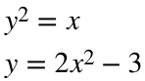

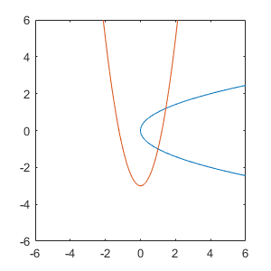

* We can invoke MATLAB's nonlinear equation solver fsolve(), which demands equations of the form F(x,y…)=0
* Rearranging the equations to this form:

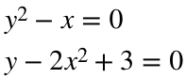

* Renaming the variables for convenience:

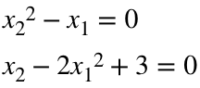

To solve, we first define a function that contains a description of the equations that will eventually be called by fsolve().

function F = eqnSet(x)

% System of two non linear equations

% F(1) and F(2): "equation" 1 and 2, respectively

% x(1) and x(2): variable 1 and 2, respectively

F(1) = x(2)-2*x(1)^2+3;

F(2) = x(2)^2-x(1);

end

**Note**: the 0’s have been replaced by F’s and mathematical subscripts have been changed to indexing subscripts

The set of equations can now be solved using fsolve()- this code is contained in a function block in this LiveScript document or in a separate m-file.

* Since we have two valid solutions (which we know because we plotted the functions first), we must call fsolve() twice.
* In each case we will provide different initial guess conditions that promote convergence to the two different solutions.

% Determine solution 1

sol_1 = fsolve(@eqnSet,[0,0])

Equation solved.

fsolve completed because the vector of function values is near zero

as measured by the value of the function tolerance, and

the problem appears regular as measured by the gradient.

<stopping criteria details>

sol_1 = 1×2

1.0000 -1.0000

Notes on the above code:

* sol_1: a 1x2 vector containing the first intersection point (*x*and *y*, respectively).
* @eqnSet: the first input into the fsolve(), this tells the function where the equations are located.
* [0,0]:the second input in fsolve(), this specifies our initial guess as to where the first intersection is located.
* fsolve() will attempt to converge to a solution until some stopping criteria (threshold) is met.

% Determine solution 2

sol_2 = fsolve(@eqnSet,[1,1])

Equation solved.

fsolve completed because the vector of function values is near zero

as measured by the value of the function tolerance, and

the problem appears regular as measured by the gradient.

<stopping criteria details>

sol_2 = 1×2

1.4498 1.2041

**NOTE**: the @ symbol is called a function handle and is a way to pass one function into another function. We will discuss this more later.

# TOPIC 4: Loops and logic

ENGR105, 9/15/20

## Introductory remarks

We have accomplished a lot so far -- we've created arrays of varying sizes, manipulated the entries in these arrays through indexing and array mathematics, and learned how to package collections of code into functions.

We've worked a lot with **vectors**, in particular. We have created *row* or *column* vectors through explicitly defining entries, using slice/colon (:) notation to create vectors with a defined increment size between entry values, using linspace() to create vectors with a defined number of increments, and so forth.

% Explicitly define a vector

a = [5,3,2,6,2,1]

a = 1×6

5 3 2 6 2 1

% Create a vector with entries starting at 1 and incrementing by 2 until 9

b = 1:2:9

b = 1×5

1 3 5 7 9

% Create a vector consisting of 5 evenly spaced values between (and

% including) 1 and 8;

c = linspace(1,8,5)

c = 1×5

1.0000 2.7500 4.5000 6.2500 8.0000

### Example - Fibonacci sequence

The above methods are very efficient and should be used when possible. However, in other cases we may wish to create vectors with entries defined by *more sophisticated patterns*. For example, consider the Fibonacci sequence, an infinite sequence defined by the following rules, that you may recall from previous math classes or popular culture.

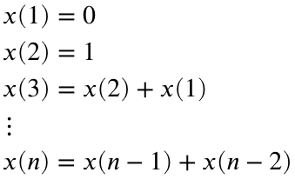

Using what we've learned so far, **create a vector x containing the first 10 elements of the Fibonacci sequence**.

% The first two entries are explicitly defined

x(1) = 0;

x(2) = 1;

% The next eight entries must be calculated individually based upon the

% previous two values

x(3) = x(1) + x(2);

x(4) = x(2) + x(3);

x(5) = x(3) + x(4);

x(6) = x(4) + x(5);

x(7) = x(5) + x(6);

x(8) = x(6) + x(7);

x(9) = x(7) + x(8);

x(10) = x(8) + x(9);

disp(x)

0

1

1

2

3

5

8

13

21

34

Or alternatively, by doing the math "in your head" and explicitly defining a vector:

% Explicitly define a fibonacci vector, x

x = [0,1,1,2,3,5,8,13,21,34]

x = 1×10

0 1 1 2 3 5 8 13 21 34

In both cases, this process was extremely tedious and impractical for creating larger vectors or those with more complicated rules.

**Note**: always proofread your code before running (and submitting an assignment!). Just like when writing a paper, it is easy to make "typos" that could dramatically affect the output of your code.

## FOR loops

Fortunately, loops allow us to more easily repeat statements, repeatedly invoke functions, or manipulate multidimensional data. The first type of loop we will discuss is a **for** loop, which enable us to repeat tasks **for** a **fixed number of iterations**. A **for** loop has the following form:

for index = <values>

<statements>

end

% Iterate for k equaling each value in the row vector

% [1,2,3,4,5,6,7,8,9,10]

for k = 1:10

% For each iteration of the for loop, display the value of the index,

% k, squared.

disp(k^2)

end

1

4

9

16

25

36

49

64

81

100

### Anatomy of a for loop

* The **for** command indicates that the statements to follow should be repeated
* The variable **index** is the loop counter that sequentially takes the values contained in a row vector **<values>**.
* Any number of **statements** (i.e. productive code) may be contained within the loop and will be executed each time the **for** loop iterates. **The statement operations often depend on the index**, k.
* The **end** statement returns control to **for** until **index** has iterated through all entries in the **<values>** vector.

**Note**: we indent the contents of the for loop for ease of visualization.

The procedure that occurs when a for loop is called may also be explained visually:

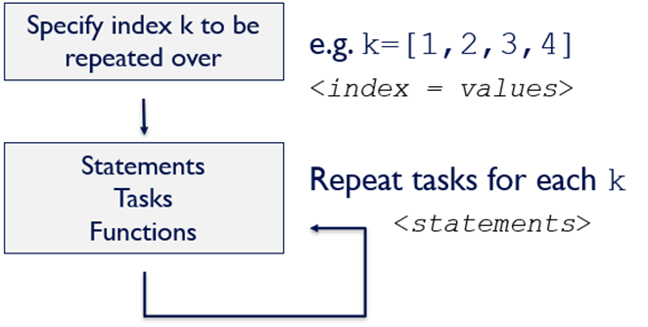

In other words, for loops are used when the number of repeats are known a priori.

**Note**: There is nothing special about the row vector <values> - it may be created in any of the ways we have discussed so far. The most common scenario involves iterating from index 1 by 1 to some end value by specifiying the colon (:) operator.

**The following are examples of using for loops to create a new vector.**

**1) Defining entries *by the index of the for loop*.**

% jj takes the values of 1 in the first iteration, 2 in the second

% iteration, etc.

for jj = 1:5

% The value of the computation 2*jj is stored in the jj-th location of

% vector v, which grows during each iteration of the for loop

v(jj) = 2*jj

end

v = 2

v = 1×2

2 4

v = 1×3

2 4 6

v = 1×4

2 4 6 8

v = 1×5

2 4 6 8 10

disp(v)

2 4 6 8 10

**Note**: The above example is simply a more compact way of doing the vector operations that we have already mastered.

**2) Indexing a generalized vector using a for loop and length().**

General vectors may be fully parsed by creating a loop counter based on the length of the vector

% An arbitrary vector

v0 = [5, -2, 4, 1];

for jj = 1:length(v0)

% In the jj-th position of v1, store the value at the jj-th position of

% v0 multiplied by 2.

v1(jj) = 2*v0(jj)

end

v1 = 10

v1 = 1×2

10 -4

v1 = 1×3

10 -4 8

v1 = 1×4

10 -4 8 2

disp(v0)

5 -2 4 1

disp(v1)

10 -4 8 2

In the above case, length(v0) is equivalent to 4.

**3) Growing vectors using a for loop and end+1 assignments**

Recall vector operations using end:

v = 1:4;

% Return the last element of v

v(end)

ans = 4

v(end+1) = 1

v = 1×5

1 2 3 4 1

The above approach may be used to sequentially populate an initially empty vector.

v = [];

%Vector v is initialized as an empty set and is grown by adding to its

%end-ith + 1 index within the for loop

for jj = 1:.1:2

%jj takes the values of 1 in the first iteration, 1.1 in the second

%iteration, 1.2 in the third iteration, etc. – note that non-integer

%values cannot be used to index a vector

v(end+1) = 2*jj;

end

v

v = 1×11

2.0000 2.2000 2.4000 2.6000 2.8000 3.0000 3.2000 3.4000 3.6000 3.8000 4.0000

Note: non-integes values cannot be used to index a vector. Also, this examaple is for visualizing the **for** loop. A general rule-of-thumb is to use vectorization when possible. For example, the above output could be generated from **one line of code:**

v = 2*(1:.1:2)

v = 1×11

2.0000 2.2000 2.4000 2.6000 2.8000 3.0000 3.2000 3.4000 3.6000 3.8000 4.0000

**4) Indexing vectors using a for loop and incrementing counter.**

In this alternate formulation, a counter is initialized/incremented in lieu of adding to the end + 1 index of vector v

n = 0;

% n is a counter the increments by 1 in every iteration of the for loop and

% identifies the vector index into which jj is placed

for jj = 1:.1:2

%n is incremented by 1 in each iteration of the loop

n = n+1; %counter

v(n) = 2*jj;

end

v

v = 1×11

2.0000 2.2000 2.4000 2.6000 2.8000 3.0000 3.2000 3.4000 3.6000 3.8000 4.0000

### Additional (pecular) notes

for index = <values>

<statements>

end

Recall that the vector to be looped through (<values> above) is a row vector. Technically index will take on every column entity in the <values> array.

* If <values> is a **column vector**, the loop will perform once and index will take on the entire column vector

%For the values it must take in a row verctor

for jj = (1:5)'

jj

end

jj = 5×1

1

2

3

4

5

Compared to the "normal case" of <values> being a row vector:

for jj = (1:5)

jj

end

jj = 1

jj = 2

jj = 3

jj = 4

jj = 5

* If <values> is a matrix, the loop will iterate according to the number of columns and index will take on each column of the matrix as a column vector.

M = [5, 3; 1, 9]

M = 2×2

5 3

1 9

for jj = M

jj

end

jj = 2×1

5

1

jj = 2×1

3

9

* If <values> is a matrix, and you want index to take on all entries of the matrix, you could use the unwinding command (:) mentioned previously. In this case, M is unwrapped and transposed to yield a row vector.

for jj = M(:)'

jj

end

jj = 5

jj = 1

jj = 3

jj = 9

### Nested for loops

Multiple for loops may used such that one for loop is run *inside* of another for loop, yielding *nested for loops*. In the following example, the "inside" for loop runs to completion for each loop of the "outside" for loop.

v = [];

p = [];

for jj = 1:3

for kk = 1:3

v(end+1) = jj;

p(end+1) = kk;

end

end

disp(v)

1 1 1 2 2 2 3 3 3

disp(p)

1 2 3 1 2 3 1 2 3

In the above case, the nested for loop circulates 3 times before passing back to the next iteration of the higher level for loop.

**Note**: we indent the contents of each for loop for ease of visualization.

### Example - back to the Fibonacci sequence

Previously, we wanted to create a vector containing the first 10 elements of the Fibonacci sequence.



This can be done much more efficiently using a **for** loop.

% Populate an array containing the first ten numbers of the sequence.

n = 10;

% Empty the vector x - we used it previously

x = [];

x(1) = 0;

x(2) = 1;

% Create each subsequent entry by taking the sum of the previous two

% entries

for k = 3:n

x(k) = x(k-1) + x(k-2);

end

% Display the vector

disp(x)

0 1 1 2 3 5 8 13 21 34

**Question: what if we want to display all numbers in the Fibonacci sequence that are less than 100?** This is tedious because we do not know beforehand how many entries that corresponds to.

**Takeaway**: for loop are good when you know the number of iterations to perform. **while** loops are better when you do not know the number of repeats a priori.

## WHILE loops

while loops are a type of iteration in which a sequence of instructions may be repeated as long as some condition is true. To understand while loops, we first need to discuss *relational and logic operators* in MATLAB.

In both cases, true is equivalent to 1 and false is equivalent to 0.

### Relational operators

Relational operators compare values (or vectors, matrices, arrays) and yield a true (1) or false (0) result.

### 

% Examples

3>4;

3<4;

3<= 0;

3<3;

### Logical operators

Logical operators are commands that yield a true (1) or false (0) result.

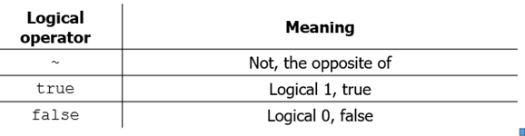

true

ans = *logical*

1

~true

ans = *logical*

0

true == ~false

ans = *logical*

1

### Examples

The logical state (true or false) can be stored in a variable, just as one stores a number.

% Logical statement examples

% Relational operators can also operate on variables

The true/false output may also be incorporated into mathematical expressions.

s = true>false

s = *logical*

1

b = true + true

b = 2

c = 5 + (2==2)*5

c = 10

### Anatomy of a while loop

**while** loops take the following form:

while <logical statement>

<statements>

end

ind = 1;

% ind is incremented within the loop and terminates the while loop after 4

% iterations, when ind < 5 is no longer true.

while ind<5

% The incremetnation of ind is not suppressed with a semicolon so that

% you can see the line of code that are run in each iteration.

ind = ind+1

end

ind = 2

ind = 3

ind = 4

ind = 5

* The while continues execution of the loop **as long as its <logical statement> evaluates to true.**
* the <logical statement> can be any set of numbers, relational operators, commands, or even functions that yield a logical output.
* Usually the <logical statement> is dependent upon the state of some variable that is modified in the <statements> within the loop.
* As with a for loop, any number of <statements> may be contained within the loop and will be executed each time the while loop iterates.
* The end statement returns control to while as long as <logical statement> is true.
* **Warning**: **if <logical statement>is always true, than your code will become an infinite loop!** And MATLAB might crash.

The procedure that occurs when a while loop is called may also be explained visually:

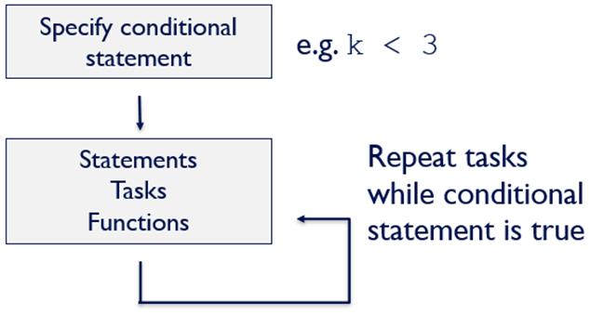

### Example: simulating the roll of two dice

The following code is an example of simulation to observe the number of rolls until two dice are rolled with the same value.

% Variable to store the number of rolls until the same dice reading is

% observed

r2s = 0;

% Initialize while loop logical. As long as contRoll is true, we will

% "continue rolling"

### Example: back again to the Fibonacci sequence

Previously, we wanted to create a vector containing all elements of the Fibonacci sequence less than 100.



This can be done much more efficiently using a **while** loop.

% Max value of entries in Fibonacci sequence

n = 100;

% Define first two entries

x(1) = 0;

x(2) = 1;

% Iterate as long as the last element is less than 100.

**Note**: why do we remove the last element in this example? We remove it because the loop ends when the last element of the vector is greater than 100. Since we do not want *any* of the vector elements to be greater than 100, we must remove the last entry.

### Vector preallocation

Preallocation is the process of creating a data structure (e.g. a vector) of final size (usually padded with zeros) before modifying the contents. This reduces the computational time by eliminating the operations associated with resizing the array.

**Preallocation is a best practice to use whenever possible -- it is important if you use a for loop to populate a vector.**

Consider the Fibonacci sequence example using the for loop, in which we populated a vector with the first 10 entries of the Fibonacci sequence.

% Populate an array containing the first ten numbers of the sequence.

n = 10;

% Empty the vector x - we used it previously

x = [];

x(1) = 0;

x(2) = 1;

% Create each subsequent entry by taking the sum of the previous two

% entries

for k = 3:n

x(k) = x(k-1) + x(k-2);

end

Let's calculate the time required to produce this Fibonacci vector of *differing lengths, with* and *without* preallocation.

To perform this analysis, we are going to:

1. For sequence length, we will determine the time required to calculate the Fibonacci sequence, with and without preallocation
2. Repeat with a greater number of Fibonacci elements.
3. Plot *sequence (vector) length* vs. *computation time*.

% Define vector containing the number of entries in each successive

% Fibonacci vector.

N = round(logspace(0,8,20))

N = 1×20

1 3 7 18 48 127 336 886 2336 6158 16238 42813 112884 297635 784760 2069138 5455595 14384499 37926902 100000000

% Preallocate vectors to store time information

t_no = zeros(1,length(N));

t_yes = zeros(1,length(N));

% Calculate the time for each vector of length N(m)

for m = 1:length(N)

% Calculate Fibonacci sequence vector without preallocation

x = [];

tic

% Define first two entries

x(1) = 0;

x(2) = 1;

% Create each subsequent entry by taking the sum of the previous two

% entries

for k = 3:N(m)

x(k) = x(k-1) + x(k-2);

end

t_no(m) = toc;

% Calculate Fibonacci sequence vector with preallocation

tic;

x = zeros(1,N(m));

% Define first two entries

x(1) = 0;

x(2) = 1;

% Create each subsequent entry by taking the sum of the previous two

% entries

for k = 3:N(m)

x(k) = x(k-1) + x(k-2);

end

t_yes(m) = toc;

end

Plotting the above simulation results. Note the addtions to the code to produce a more professional plot. We will discuss plotting in detail later in the semester.

% Define dimensions of plot

figure('Position',[0,0,500,300]);

% Plot the functions

plot(N,t_no,'ko-',N,t_yes,'ro-','LineWidth',1.5,'MarkerFaceColor','auto')

% Graphical parameters

set(gca, 'XScale', 'log') % "log" axes - x

set(gca, 'YScale', 'log') % "log" axes - y

set(gca,'XMinorTick','on')

xlim([10^0,10^8]); % range of x values on plot

ylim([10^-6,10^2]); % range of y values on plot

xlabel('N - number of vector elements');

ylabel('Compuatational time (s)');

legend('No preallocation','Preallocation','Location','northwest')

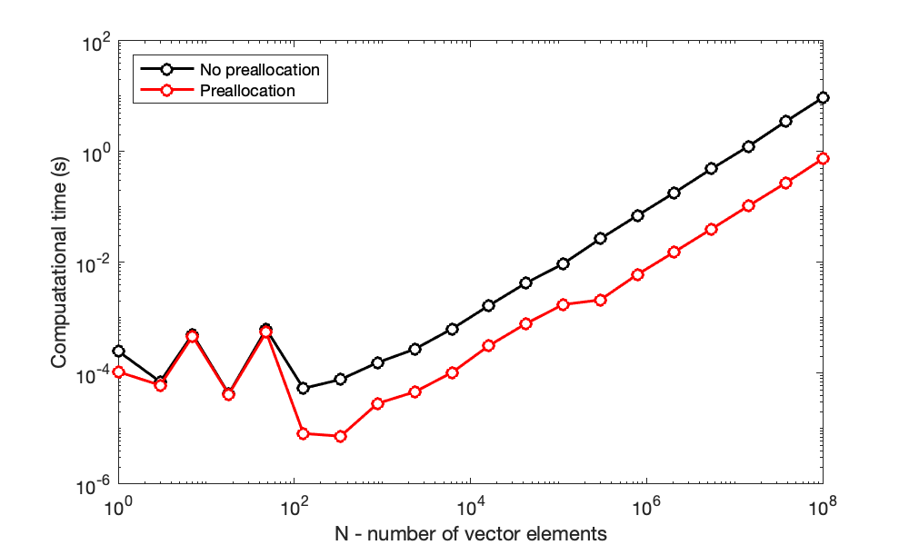

**Major takeaway**: you can save an **order of magnitude** of computational time using **preallocation**.

### For loops vs. vectorization

As described above, loops can be very useful for repeating many tasks a known or unknown number of times. In the case of for loops, we performed examples that could also be accomplished with vectorization, *i.e.* operating on a vector. Which of these approaches is better? To evaluate this, let's compare the computational time for each.

Specifically, let's calculate **b(k) = a(k)*a(k)**, where a is some vector. That is, we want to create a vector b in which each entry in the vector is the square of the corresponding entry in the vector a.

**1) Using a for loop.**

for k = 1:length(a)

b(k) = a(k)*a(k);

end

**2) Vectorization (e.g. using an element-wise operation)**

b = a.^2;

b = a.*a;

To perform this analysis, we are going to:

1. Create a vector of a known length.
2. Calculate the time required to perform the above operation on that vector using either a for loop or with vectorization.
3. Repeat with a longer vector.
4. Plot *vector length* vs. *computation time*.

% Define vector containing number of entries in potential vector.

N = round(logspace(0,8,20))

N = 1×20

1 3 7 18 48 127 336 886 2336 6158 16238 42813 112884 297635 784760 2069138 5455595 14384499 37926902 100000000

% Preallocate vectors to store information

t_for = zeros(1,length(N));

t_vec = zeros(1,length(N));

% Calculate the time for each vector of length N(m)

for m = 1:length(N)

% Create vector of random numbers with dimension 1xN(m)

a = rand(1,N(m));

% Calculate time for for loop

tic

% Preallocate for loop vector

b_for = zeros(1,N(m));

% Calculate each entry in b by looping through all of vector a

for n = 1:N(m)

b_for(n) = a(n)^2;

end

t_for(m) = toc;

% Calculate time for vectorization

tic

% Calculate all entries in b by element-wise exponentiation

b_vec = a.^2;

t_vec(m) = toc;

% Clear b vectors for next iteration

clear b_for b_vec

end

Plotting the above simulation results. Note the addtions to the code to produce a more professional plot. We will discuss plotting in detail later in the semester.

% Define dimensions of plot

figure('Position',[0,0,500,300]);

% Plot call and graphical commands

plot(N,t_for,'ko-',N,t_vec,'ro-','LineWidth',1.5,'MarkerFaceColor','auto')

set(gca, 'XScale', 'log')

set(gca, 'YScale', 'log')

set(gca,'XMinorTick','on')

xlim([10^0,10^8]);

ylim([10^-6,10^2]);

xlabel('N - number of vector elements');

ylabel('Compuatational time (s)');

legend('for loop','Vectorization','Location','northwest')

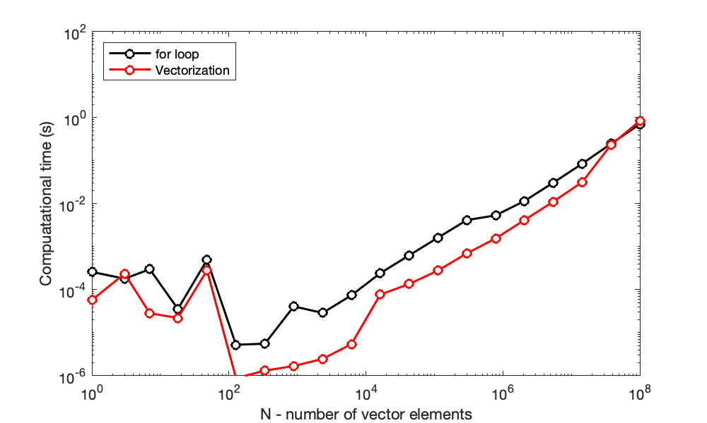

**Major takeaway**: you can save an **order of magnitude** of computational time using **vectorization** rather than a for loop (even with preallocation!).

**Remember**: we want code that is correct, clear, and computationally efficient.

# TOPIC 5: Conditionals and Boolean Operators

ENGR105, 9/17/20

### Loops (continued): for and while loops

As a reminder, for loops enable us to repeat tasks for a fixed number of iterations. In the example last time, we used a for loop to create a vector containing the first 10 elements of the Fibonacci sequence.

% Populate an array containing the first ten numbers of the sequence.

n = 10;

% Empty the vector x - we used it previously

x = [];

x(1) = 0;

x(2) = 1;

% Create each subsequent entry by taking the sum of the previous two

% entries

for k = 3:n

x(k) = x(k-1) + x(k-2);

end

% Display the vector

disp(x)

0 1 1 2 3 5 8 13 21 34

On the other hand, while loops are a type of iteration in which a sequence of instructions may be repeated while some condition is true. Last time, we used a while loop to create a vector containing all elements of the Fibonacci sequence less than 100.

% Max value of entries in Fibonacci sequence

n = 100;

% Define first two entries

x(1) = 0;

x(2) = 1;

% Iterate as long as the last element is less than 100.

while x(end) < n

% If the last element is less that 100, add the next element of the

% Fibonacci sequence to the vector

x(end+1)=x(end)+x(end-1);

end

x(end)=[]; % Remove last element

disp(x)

0 1 1 2 3 5 8 13 21 34 55 89

### Vector preallocation

Preallocation is the process of creating a data structure (e.g. a vector) of final size (usually padded with zeros) before modifying the contents. This reduces the computational time by eliminating the operations associated with resizing the array.

**Preallocation is a best practice to use whenever possible -- it is important if you use a for loop to populate a vector.**

Consider the Fibonacci sequence example using the for loop, in which we populated a vector with the first 10 entries of the Fibonacci sequence.

% Populate an array containing the first ten numbers of the sequence.

n = 10;

% Empty the vector x - we used it previously

x = [];

x(1) = 0;

x(2) = 1;

% Create each subsequent entry by taking the sum of the previous two

% entries

for k = 3:n

x(k) = x(k-1) + x(k-2);

end

Let's calculate the time required to produce this Fibonacci vector of *differing lengths, with* and *without* preallocation.

To perform this analysis, we are going to:

1. For sequence length, we will determine the time required to calculate the Fibonacci sequence, with and without preallocation
2. Repeat with a greater number of Fibonacci elements.
3. Plot *sequence (vector) length* vs. *computation time*.

% Define vector containing the number of entries in each successive

% Fibonacci vector.

N = round(logspace(0,8,20))

N = 1×20

1 3 7 18 48 127 336 886 2336 6158 16238 42813 112884 297635 784760 2069138 5455595 14384499 37926902 100000000

% Preallocate vectors to store time information

t_no = zeros(1,length(N));

t_yes = zeros(1,length(N));

% Calculate the time for each vector of length N(m)

for m = 1:length(N)

% Calculate Fibonacci sequence vector without preallocation

x = [];

tic

% Define first two entries

x(1) = 0;

x(2) = 1;

% Create each subsequent entry by taking the sum of the previous two

% entries

for k = 3:N(m)

x(k) = x(k-1) + x(k-2);

end

t_no(m) = toc;

% Calculate Fibonacci sequence vector with preallocation

tic;

x = zeros(1,N(m));

% Define first two entries

x(1) = 0;

x(2) = 1;

% Create each subsequent entry by taking the sum of the previous two

% entries

for k = 3:N(m)

x(k) = x(k-1) + x(k-2);

end

t_yes(m) = toc;

end

Plotting the above simulation results. Note the addtions to the code to produce a more professional plot. We will discuss plotting in detail later in the semester.

% Define dimensions of plot

figure('Position',[0,0,500,300]);

% Plot the functions

plot(N,t_no,'ko-',N,t_yes,'ro-','LineWidth',1.5,'MarkerFaceColor','auto')

% Graphical parameters

set(gca, 'XScale', 'log') % "log" axes - x

set(gca, 'YScale', 'log') % "log" axes - y

set(gca,'XMinorTick','on')

xlim([10^0,10^8]); % range of x values on plot

ylim([10^-6,10^2]); % range of y values on plot

xlabel('N - number of vector elements');

ylabel('Compuatational time (s)');

legend('No preallocation','Preallocation','Location','northwest')

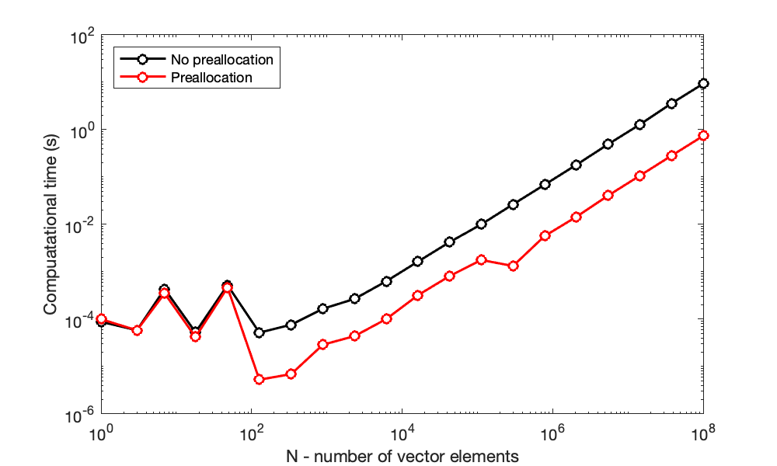

**Major takeaway**: you can save an **order of magnitude** of computational time using **preallocation**.

### For loops vs. vectorization

As described above, loops can be very useful for repeating many tasks a known or unknown number of times. In the case of for loops, we performed examples that could also be accomplished with vectorization, *i.e.* operating on a vector. Which of these approaches is better? To evaluate this, let's compare the computational time for each.

Specifically, let's calculate **b(k) = a(k)*a(k)**, where a is some vector. That is, we want to create a vector b in which each entry in the vector is the square of the corresponding entry in the vector a.

**1) Using a for loop.**

for k = 1:length(a)

b(k) = a(k)*a(k);

end

**2) Vectorization (e.g. using an element-wise operation)**

b = a.^2;

b = a.*a;

To perform this analysis, we are going to:

1. Create a vector of a known length.
2. Calculate the time required to perform the above operation on that vector using either a for loop or with vectorization.
3. Repeat with a longer vector.
4. Plot *vector length* vs. *computation time*.

% Define vector containing number of entries in potential vector.

N = round(logspace(0,8,20))

N = 1×20

1 3 7 18 48 127 336 886 2336 6158 16238 42813 112884 297635 784760 2069138 5455595 14384499 37926902 100000000

% Preallocate vectors to store information

t_for = zeros(1,length(N));

t_vec = zeros(1,length(N));

% Calculate the time for each vector of length N(m)

for m = 1:length(N)

% Create vector of random numbers with dimension 1xN(m)

a = rand(1,N(m));

% Calculate time for for loop

tic

% Preallocate for loop vector

b_for = zeros(1,N(m));

% Calculate each entry in b by looping through all of vector a

for n = 1:N(m)

b_for(n) = a(n)^2;

end

t_for(m) = toc;

% Calculate time for vectorization

tic

% Calculate all entries in b by element-wise exponentiation

b_vec = a.^2;

t_vec(m) = toc;

% Clear b vectors for next iteration

clear b_for b_vec

end

Plotting the above simulation results. Note the addtions to the code to produce a more professional plot. We will discuss plotting in detail later in the semester.

% Define dimensions of plot

figure('Position',[0,0,500,300]);

% Plot call and graphical commands

plot(N,t_for,'ko-',N,t_vec,'ro-','LineWidth',1.5,'MarkerFaceColor','auto')

set(gca, 'XScale', 'log')

set(gca, 'YScale', 'log')

set(gca,'XMinorTick','on')

xlim([10^0,10^8]);

ylim([10^-6,10^2]);

xlabel('N - number of vector elements');

ylabel('Compuatational time (s)');

legend('for loop','Vectorization','Location','northwest')

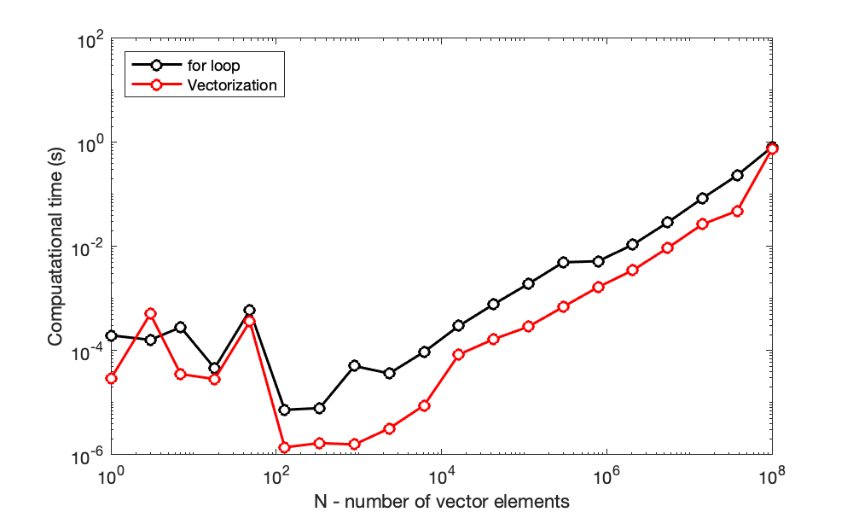

**Major takeaway**: you can save an **order of magnitude** of computational time using **vectorization** rather than a for loop (even with preallocation!).

**Remember**: we want code that is correct, clear, and computationally efficient.

### Recall: while loops iterate as long as a logical condition is true

Loops can be used to repeat statements of code either for a defined number of iterations (as in a **for** loop) or as long as a logical condition is met (as in a **while** loop). In the case of while loops, below, the logical condition can be any relational or logical operation that equates to true. When the logical condition is no longer true, the loop ends.

while <logical condition>

<statements>

end

Another potentially useful programming tool that makes use of a <logical condition> is the **conditional statement**, also known as an if/then statement or a **decision**.

## Conditional statements

Much of programming is focused on conditionals – the concept of *if this*…then *do that*. A visual representation of a conditional statement is shown below, in which conditional code is only carried out if a logical condition is true.

## 

### Anatomy of a simple if statement

In MATLAB, conditional statements have the following form.

if <logical condition>

<statements>

end

* The if command indicates that the <statements> that follow should only be executed if the logical condition is **true**.
* The <logical condition> is any statement that evaluates to a logical result.
* Statements included after the if command will execute if the <logical condition> is true.
* The end statement indicates the termination point of any statements that should be executed if the <logical condition> is true

**Example**. Establish a variable with a value and overwrite the value if some statement is true.

a = 20;

% The output of b is first established as NaN (nothing special about this

% choice)

b = NaN; % "not a number"

if a >10

%b would be displayed if the condition is met

b = 25;

end

disp(b)

25

**Example**. Evaluate the sum of a vector to determine if a variable should change value

% Declare vector and variable to store a value

v = [1, 5, 3];

res = 5;

% Overwrite a variable if the condition is true

if sum(v)>10

res = 25;

end

disp(res)

5

**Note**: Conditional statements must be one-sided – MATLAB will only evaluate the first relational operator of a series or bounded set of logical expressions

var1 = 40;

var2 = 12;

if 10 <var1<30

var2 = 2*var2;

end

disp(var2)

24

### Nested if statements

if statements, like forand while loops, can be nested. An end statement is needed for each if statement

p = 6;

q = 15;

res = NaN;

% If condition one is true, "enter" the first if statement

if p>5

if q ==15

res = p*q

end

end

res = 90

disp(res)

90

**Note**: each instance of an if statement and the statements within are indented, just like with loops and function.

### Anatomy of an if-elseif-else statement

More complex sets of conditions can be evaluated using the if-elseif-else construction

if <logical condition>

<statements>

elseif <logical condition #2>

<statements>

else

<statements>

end

* Both the if and elseif statements require a separate <logical condition>.
* The else statement is a catch all and should not include a <logical condition>. If the <logical condition> associated with the if statement and all elseif statements equate to false, then the code following the else statement will execute.

A visual representation for an if-elseif-else statement can be seen below. This visual representation is known as a **decision tree**.

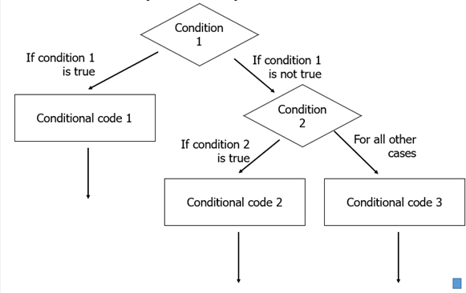

**Note**: there can be many elseif statements in an if statement, though they are not required.

**Example**. if-elseif-else statement for one of my typical mornings.

if 'I am out of coffee'

'Go back to sleep, it will be a terrible day'

elseif 'I am out of nutella'

'Be grumpy'

elseif 'My garbage is full'

'Question why I did not take it out yesterday'

else

'Drink coffee, eat nutella, clean up, nbd'

end

**Example**. "Catching" one condition with if and all other conditions with else.

var1 = 1;

var2 = 2;

% "If var1 equals var2, then assign "true" to out. Otherwise, assign

% "false" to out.

if var1 == var2

out = true;

else

out = false;

end

disp(out)

0

Note: this code is demonstrational. The same output can be achieved using the single expression:

out = var1==var2;

disp(out)

0

**Example**. Assign value to variable based on input variable.

% Classic problem: if my cereal is bad, the solution is clearly to add

% chocolate to it.

cerealGrade = 95;

if cerealGrade < 60

chocolateAdded = 20;

elseif cerealGrade < 70

chocolateAdded = 15;

elseif cerealGrade < 80

chocolateAdded = 10;

elseif cerealGrade <90

chocolateAdded = 5;

else

chocolateAdded = 0;

end

disp([cerealGrade,chocolateAdded])

95 0

**Note**: The decision statement will terminate after the first condition is met. If computing with large data sets, catch the most common decision with the first if statement when possible.

The above code can be made more compact (*and easier to read*) so that it does not require the use of the else statement.

cerealGrade = 95;

chocolateAdded = 0;

%reduces the amoung of code becasue the end statement does not need to be

%included

if cerealGrade < 60

chocolateAdded = 20;

elseif cerealGrade < 70

chocolateAdded = 15;

elseif cerealGrade < 80

chocolateAdded = 10;

elseif cerealGrade <90

chocolateAdded = 5;

end

disp([cerealGrade,chocolateAdded])

95 0

In the above, chocolateAdded is assigned a value of 0 before the decision and is only overwritten if one of the if or elseif statements reads true.

## Boolean operators

Boolean (logical) operators can be used in conjunction with while loops and conditionals (if and elseif) to yield more complex terminating behaviors.

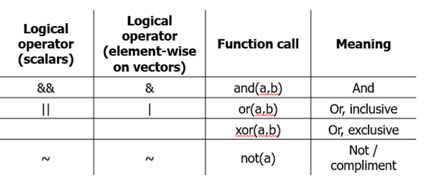

The above operators can be stated as:

* **And**: if both a and b are true, the a&b is true.
* **Or**: if at least one of a and b is true, then a|b is true.
* **Xor**: if only one of a and b is true, then xor(a,b) is true.
* **Not**. If a is true, then ~a is false. If a is false, then ~a is true.

The behavior of logical operators can be compactly described in **truth tables**.

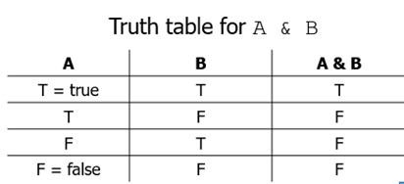

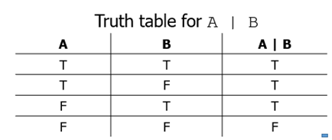

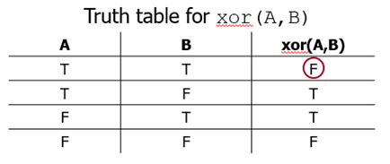

### Examples: scalars

When the scalar operations are used, the logical operator simply compares the two scalar values and returns true (1) or false (0).

% Examples using And

res1 = (1<2) && (4==5)

res1 = *logical*

0

Alpha = (1<2) && (4<5)

Alpha = *logical*

1

% Examples using Or

var_2 = true || false

var_2 = *logical*

1

ind = (1<2) || (4==5)

ind = *logical*

1

% Examples using xOr

ip = xor(1<2,4<5)

ip = *logical*

0

### Examples: element-wise on vectors

When the element-wise operations are used, the **output is a logical vector** where each entry is a result of the comparison between the values in corresponding indices from the two input vectors.

a = [1,0,0,1]

a = 1×4

1 0 0 1

b = [1,1,0,0]

b = 1×4

1 1 0 0

a & b

ans = *1×4 logical array*

1 0 0 0

**Note**: when performing element-wise logical operations, be sure to use the correct (single) operators.

### Precedence revisited

Boolean operators may be combined to yield interesting decisions. Combinations of operators are executed left to right with **and() commands having higher precedence than or()** commands. An updated precedence table can be seen here.

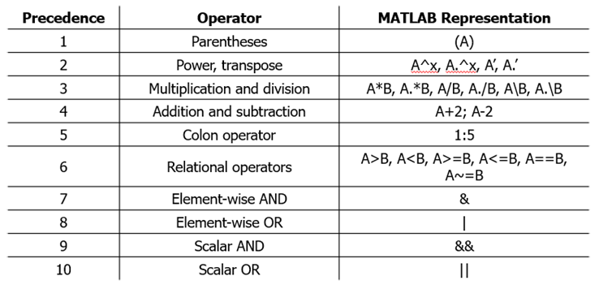

**Example**. Assume variables a through f represent scalar numbers *(e.g.* true or false). What will the following code return for each possible combination?

switchState = a>b | c>d & e>f

The value of switchState as a function of all possible combinations of values a through f can be represented as a truth table.

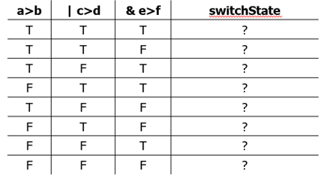

The **and()** operation is performed **first**, based on higher precedence.

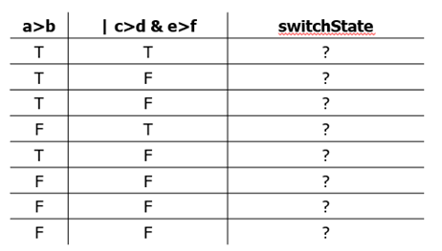

Taking **or()** of column one and then "and column" two yields the switchState given any combination of inputs a through f.

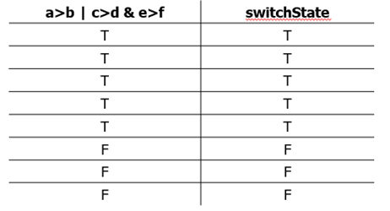

Or, to summarize:

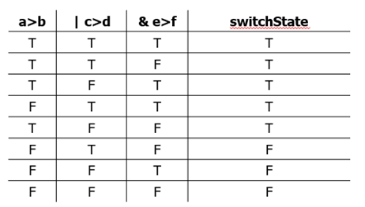

**Example**.

A = true;

B = false;

C = false;

Due to precedence, the above code is equivalent to the following, which has unnecessary parentheses ...

out

out = *logical*

0

And different from the following, in which precedence has been overriden.

### Boolean operators and conditional statements

Logical operators may be used to remove nested if statements. Consider the example above:

p = 6;

q = 15;

res = NaN;

if p > 5

if q == 15

res = p*q;

end

end

disp(res)

90

By using a logical operator, we can simplify this code.

if p>5 && q==15

res = p*q

end

res = 90

disp(res)

90

**Example**. Consider the following code.

% Declare initial variable

res = false;

a = 15;

b = 20;

c = 30;

% If this condition is true, change the value of res

if a<20 && b==20 || c>20

res = true;

end

disp(res)

1

**Remember**: precedence order is important. The above is read:

1. a < 20 is true, b == 20 is true, c > 30 is true.
2. Thus, (a < 20) AND (b == 20) is true
3. Thus, ((a < 20) AND (b == 20)) OR c>20 is true.

### Logical statements and while loops

Logical statements may also be used to continue or stop while loop execution.

% Assign initial values to variables variables

a = 15;

b = 17;

% As long as AT LEAST ONE of the current values of a or b is greater than

% 5, the loop will continue. That is, the loop will stop when BOTH a and b

% are less than 5.

while a(end)>5 || b(end)>5

%generates random numbers from 1 to 20 and adds them to the vector.

a(end+1) = randi([1 20]);

b(end+1) = randi([1 20]);

end

disp([a',b'])

15 17

20 14

20 15

6 5

17 9

9 8

6 7

10 4

10 18

2 16

11 2

14 8

16 12

7 19

7 7

16 7

7 6

2 10

15 9

1 19

14 14

14 1

4 17

18 2

3 14

8 15

16 7

2 9

13 11

11 7

3 17

11 7

14 5

16 7

11 18

12 4

5 16

18 2

20 9

15 17

9 10

9 12

18 5

19 11

13 16

9 15

5 16

8 14

9 16

14 3

13 20

9 14

14 2

9 7

19 19

19 5

19 4

12 1

11 14

20 5

5 3

With this, we now have some basic

**Next time**: we will use loops and conditionals to practice solving some problems.

# TOPIC 6: Building solutions to problems, part 1

ENGR105, 9/22/20

### Recap of topics covered so far:

1. MATLAB syntax and basics: using MATLAB to perform calculations
2. Scalars, vectors, and matrices: storing, accessing, and manipulating numerical information
3. Functions and scripts: creating useful collections of code
4. for and while loops: creating code that efficiently repeats tasks
5. Conditionals: incorporating decision making into your code

**1) MATLAB syntax and basics: using MATLAB to perform calculations**

We've learned how to use MATLAB as a tool for performing simple mathematical calculations.

% Using comments to explain our code, we can perform basics tasks, look up

% information about functions, etc.

1 + 2

ans = 3

% We have learned how to use the resources in MATLAB to perform basic

% calculations

5*tan(pi/4)

ans = 5.0000

a = 15; % Assigning a scalar variable

b = 13+2/a; % Creating a statement based on the previous variable

disp(b) % Display the newly defined variable

13.1333

**2) Scalars, vectors, and matrices: storing, accessing, and manipulating numerical information**

MATLAB excels with and is optimized for performing operations on vector, matrices, and higher order arrays. We have learned how to create vector, matrices, etc., access their components through indexing, and perform array mathematics. This is the basis for **vectorization** of solutions.

% Create vectors

a = 1:5;

b = linspace(1,4,5);

c = zeros(3,3);

c(1:9) = randi(5,[1,9]);

disp(a)

1 2 3 4 5

disp(b)

1.0000 1.7500 2.5000 3.2500 4.0000

disp(c)

2 2 1

1 5 2

4 2 5

% Access elements in the vectors and matrix

a([1:2,end])

ans = 1×3

1 2 5

b(randi(5,[1,10]))

ans = 1×10

4.0000 4.0000 2.5000 3.2500 3.2500 1.7500 1.0000 3.2500 4.0000 1.0000

c([1,3],[1,3])

ans = 2×2

2 1

4 5

% Perform array math

a+b % vector addition

ans = 1×5

2.0000 3.7500 5.5000 7.2500 9.0000

a.*b % element-wise multiplication

ans = 1×5

1.0000 3.5000 7.5000 13.0000 20.0000

(a')*b % matrix multiplication

ans = 5×5

1.0000 1.7500 2.5000 3.2500 4.0000

2.0000 3.5000 5.0000 6.5000 8.0000

3.0000 5.2500 7.5000 9.7500 12.0000

4.0000 7.0000 10.0000 13.0000 16.0000

5.0000 8.7500 12.5000 16.2500 20.0000

a(1:3)+c(1,:) % Adding subvectors derived from original array

ans = 1×3

3 4 4

**3) Functions and scripts: creating useful collections of code**

We have created assemblages of code to run a series of tasks. Scripts are simply collections of multi-line code. Functions perform collections of code, take inputs, and return outputs to the base MATLAB workspace.

An example function declaration:

function [out1,out2] = myFunction(input1,input2,input3)

This example function takes **three** inputs and returns **two** outputs.

**4) for and while loops: creating code that efficiently repeats tasks**

* **for** loops are useful when one knows (or can calculate) the number of iterations to perform ahead of time.

a = zeros(1,10); % Preallocate vector to store values

% Perform 10 iterations, each iteration calculate square root of different

% random number

for k = 1:10

a(k) = sqrt(randi(k));

end

disp(a)

1.0000 1.4142 1.7321 1.7321 1.4142 1.4142 2.4495 2.4495 1.4142 2.4495

* **while** loops are useful when one does not know how many iterations must be performed.

% Create a vector containing all multiples of 13 less than 300;

a = 13; % vector to store integer multiples of 13. Start by populating first (obvious) case

num = 1; % counter to determine next multiple

while a(end) < 300

num = num + 1;

a(end+1) = num*13;

end

a(end) = []; % Delete the last entry because it will be over 200;

disp(a)

13 26 39 52 65 78 91 104 117 130 143 156 169 182 195 208 221 234 247 260 273 286 299

**5) Conditionals: incorporating decision making into your code**

Like while loops, conditionals use **logical and relational operators** to determine which piece of conditional code will be executed. This provides instructions that enables your code to *decide* how to proceed.

% Generate two random numbers

a = randi(5);

b = randi(5);

if a==b % if variables are equal

disp(a*b*ones(1,a*b))

elseif a<b % if b is greater than a

disp(b*ones(1,a))

else % if a is greater than b

disp(a*ones(1,b))

end

3

## Using scientific computing to approach problems

The above syntax and programming capabilities are tools for solving scientific problems. We are ultimately interest in applying these tools (and other syntax, computational capabilities, and programming concepts) to solve problems.

**NOTE**: developing a solution to a problem often seems **daunting** at first. As you are getting started with scientific computing, approach new problems in a **systematic** way, breaking the overall task into simpler sub-tasks. One systematic approach is discussed here.

### PRO: a roadmap for building computational solutions

**1) P**lan, **P**repare, and **P**seudocode

The first thing to do, before writing any code, is to develop a plan breaking down the steps that your code should accomplish to produce the desired solution.

* Identify the problem being solved and propose the type of computational solution necessary.
* Identify what is known, what should be calculated, and what is to be solved for or output. Write out equations and draw pictures by hand.
* While you may start by writing or sketching this on paper (I do this), convert your handwritten notes and thoughts into **MATLAB comments**.
* Lay out your comments spatially in a script (.m) file or Livescript code. The spatial layout of your comments should indicate the **order of tasks** you want to perform.
* Your comments should be **pseudocode**: they should be written in English and convey what you want your code to accomplish.

***\*\* Your pseudocode is the foundation for your solution \*\****

**2)** w**R**ite **R**ough (increments of code) and **R**efine

The second thing to do, once you have produced pseudocode, is to start filling in sections of code *in increments*, with rough code that simply works. That is, build your computational

* Do **NOT** try to "hit a home run" on your first attempt by generating perfect code immediately.
* Systematically fill in pieces of code, ensure that they run properly and as expected.
* Start with rough (potentially inefficient) code that simply produces the correct output.
* Deal with errors and malfunctions as necessary.
* Use your rough code in one section to start the next section.
* Consistently refine your code throughout this process.
* If your ultimate goal is to produce a complex piece of code involving functions, start by writing all functions as scripts to ensure that each function performs as you expect

***\*\* Your rough code, built upon the pseudocode foundation, is the "core structure" and "meat" of your solution \*\****

**3) O**ptimize and improve

The final thing to do is to convert your rough code into an optimal solution.

* Ensure that all functions are packaged properly and clear.
* Ensure your code is clear and well-commented.
* Ensure your code is operating as computationally efficient as possible. Look for ways to increase performance (e.g. vectorization vs. for loops, preallocation, etc.)

***\*\* Your optimized solution "polishes" the code structure and foundation you have built \*\****

### Troubleshooting and debugging techniques

When you start developing a computational solution to a problem, expect errors and issues to arise. Anticipating potential errors will help you more quickly overcome them and produce working code.

***Potential errors and issues include:***

***1) Your code does not run***

*Debugging techniques and tips:*

* The issue is most likely either MATLAB syntax or a function being used improperly.
* Use the error information to identify where in your code the issue is happening.
* Unsuppress outputs (remove ;) to print the results of computations to the command line.
* Insert a **breakpoint** to step through a script or function. Compare the computations to what you expect.
* If you are making a function, start by creating it as a script. Once that runs properly, expand that code into a function.
* Use disp() to output a variable to the command line.
* Run sections of code at a time to observe how the expect outputs change through the script.
* Comment large sections of code to isolate where the error is occuring.

*Example:*

a = [5,2,1];

b = zeros(3,1);

% Goal: produce a plot

plot(a,b)

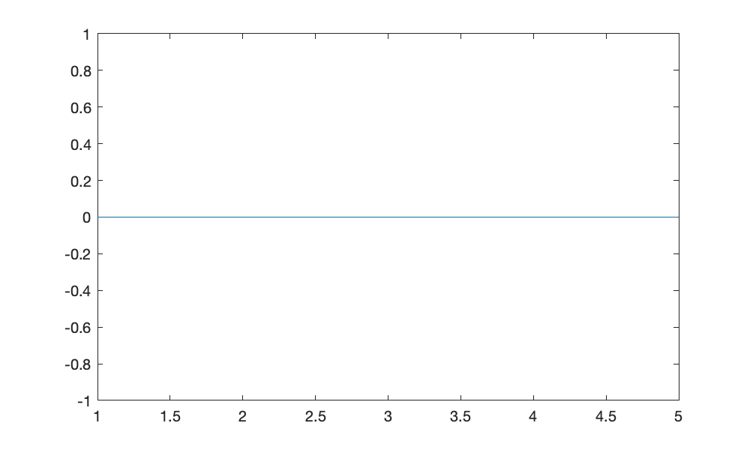

***2) Your code runs but the output is not in the correct form***

*Debugging techniques and tips:*

* The issue is most likely MATLAB syntax -- you might be using a function incorrectly, incorrectly produced an array of the wrong size, etc.
* Compare the output from your code at various points to determine where values deviate from what is expected.
* Unsuppress outputs (remove ;) or use disp() to print the results of computations to the command line.
* Insert a **breakpoint** to step through a script or function. Compare the computations to what you expect.

*Example:*

% Goal: create matrix through matrix multiplication

a = 1:5;

b = ones(5,1);

a*b

ans = 15

***3) Your code runs and produces the correct form of output, but it is not physical or realistic***

*Debugging techniques and tips:*

* As above, the issue is most likely MATLAB syntax -- you might have mis-entered an equation, misused an operator, etc.
* Compare the output from your code at various points to determine where values deviate from what is expected.
* Unsuppress outputs (remove ;) or use disp() to print the results of computations to the command line.
* Insert a **breakpoint** to step through a script or function. Compare the computations to what you expect.

*Example:*

% % Goal: calculate the terminal velocity of a falling object (positive is

% % down)

g = 9.81; % m/s^2

d = 0.001; % diameter, m

mu = 10^-3; % Pa*s

pm = 1000; % kg/m^3

ps = 1050; % kg/m^3

Vt = g*d^2/(12*mu)*(ps - pm)

Vt = 0.0409

### Getting started with building computational solutions to problems.

We will practice applying what we have learned to four different example problems representing a few different applications of scientific computing.

1. Modeling the motion of a projectile
2. Creating a numerical method to find the root of an equation
3. Programming a gameplay algorithm

## Practice problem 1: modeling the motion of a projectile

In your introductory physics courses, you studied kinematics and the motion of projectiles. Such analyses may apply in many circumstances, including a system in which a ball is thrown at some angle relative to the ground, as seen below.

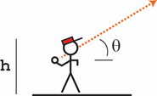

Consider a **2 m** tall athlete who can easily throw the ball **30 m/s**. Assume the ball is released at the top of the player's head. **Determine and plot the maximum height of the ball and the distance thrown (assuming the ball doesn't bounce) as a function of the angle by which the ball is thrown.**

**PRO, Step 1: P**lan, **P**repare, and **P**seudocode

Helpful tasks:

* When faced with a problem, it is helpful to first take a step back, take a deep breath, and write down what we know. In this case, we know from a force balance on the ball immediately after it is thrown that the ball's acceleration, velocity, and position can be represented by the following equations (neglecting any air resistance):

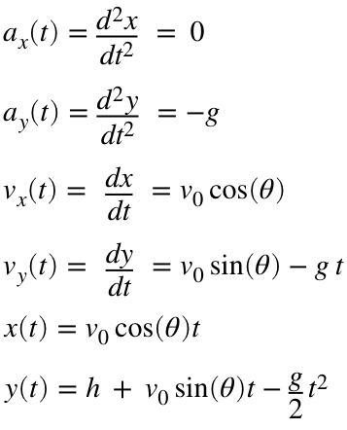

* We know the equations describing our system. **How can we calculate the max height and distance thrown?**

**Distance thrown**. To calculate the distance the ball travels in the air. we first find the time at which the ball lands by setting y(t) to zero and solving for t.

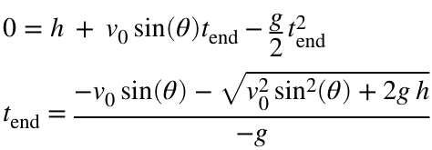

The above is obtained simply by using the quadratic formula. Substituting t_end into x(t) produces the distance the ball travels.

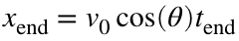

**Maximum height**. To calculate the maximum height of the ball, calculate when the y component of the velocity (or the derivative of the y position) is zero, as this will be the peak of the trajectory.

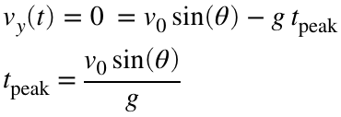

Substituting into the equation for y(t), we determine the maximum height of the ball.

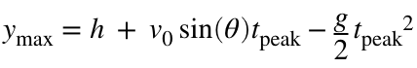

**Note**: *(as seen above)* before producing a computational solution, it is useful to set up the problem by writing out (by hand) all of the known variables and equations describing the system.

* What is the objective of our code? In this case, we want to calculate two values as a function of an input angle and then repeat that calculation for multiple input angles. Thus, you may envision eventually using **some iteration**.
* We now know all the equations that we need to solve this problem, but how is that converted into code? Write out the **pseudocode** for what the script may look like.

%step 1: specify angle

%step 2: constants

% Repeat for all angles

%step 3: calculate distance for each theta

%step 4: calculate maximum height

**PRO, Step 2:** w**R**ite **R**ough (increments of code) and **R**efine

Helpful tasks:

* Starting with your pseudocode, roughly fill in code.
* While we eventually may want to use a loop, write out all the code as a script with one "test input."

% %step 1: specify angle

% th = 45; %in degrees

% th_r = th*pi/180;%radians

%

% %step 2: constants

% g = 9.81; %m/s^2

% h = 2; %height

% v0 = 30; %initial velocity

%

% %step 3: calculate distance for theta

% t_end = (-v0*sin(th_r) - sqrt(v0^2*sin(th_r)^2 + 2*g*h))/(-g);

% x_end = v0 *cos(th_r)*t_end

%

% %step 4: caculate max height

% t_peak = v0*sin(th_r)/g;

% y_peak = h + v0*sin(th_r)*t_peak - g/2*t_peak

%step 1: specify angle

th = 45; %in degrees

th_r = th*pi/180;%radians

%preallocationg

x_end = zeros(1,length(th));

y_peak = zeros(1,length(th));

%step 2: constants

g = 9.81; %m/s^2

h = 2; %height

v0 = 30; %initial velocity

for k = 1:length(th)

%step 3: calculate distance for theta

t_end = (-v0*sin(th_r(k)) - sqrt(v0^2*sin(th_r(k))^2 + 2*g*h))/(-g);

x_end(k) = v0 *cos(th_r(k))*t_end;

%step 4: caculate max height

t_peak = v0*sin(th_r(k))/g;

y_peak(k) = h + v0*sin(th_r(k))*t_peak - g/2*t_peak^2;

end

plot(th,x_end,'k.')

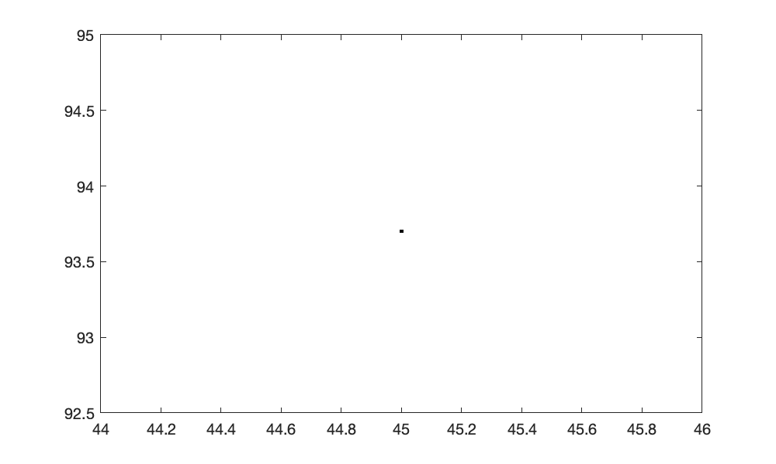

**PRO, Step 3: O**ptimize and improve

There are a number of issues to optimize here:

* Constants are being defined inside the for loop
* For loops are generally more inefficent that vectorization

% %step 1: specify angle

th = 45; %in degrees

th_r = th*pi/180;%radians

% %step 2: constants

g = 9.81; %m/s^2

h = 2; %height

v0 = 30; %initial velocity

%

% %step 3: calculate distance for theta

t_end = (-v0*sin(th_r) - sqrt(v0^2*sin(th_r)^2 + 2*g*h))/(-g);

x_end = v0 *cos(th_r)*t_end

x_end = 93.7013

% %step 4: caculate max height

t_peak = v0*sin(th_r)/g;

y_peak = h + v0*sin(th_r)*t_peak - g/2*t_peak;

plot(th,x_end,'k-')

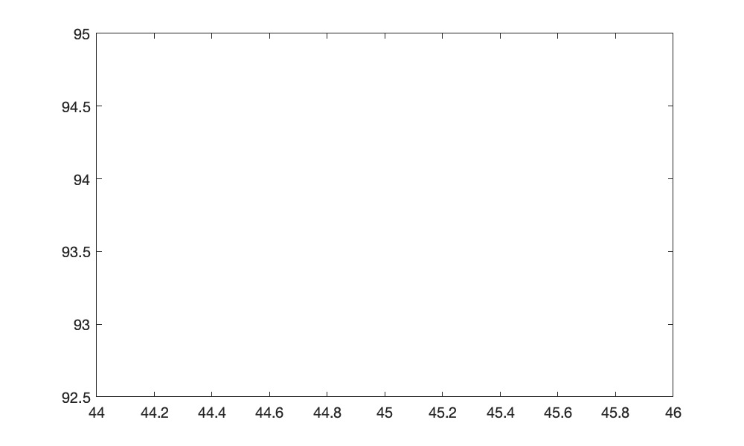

## Practice problem 2: numerical methods and root-finding

Numerical analysis is the domain of mathematics and computer science that creates, analyzes, and implements algorithms for solving numerically the problems of continuous mathematics. Numerically solving a complex math problem often involves iterating or following a given algorithm until it converges (hopefully) upon a solution, within some defined tolerance.

One such application of numerical methods is root-finding, the algorithms for which may quickly find the root (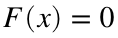) for some arbitrary function 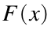. Say we have a (potentially very nonlinear) function for which we want to find  quickly. The Newton-Raphson method searches for the root of a function by iteratively following where the tangent of a function crosses the x axis.

Specifically, **the Newton-Raphson method has the following algorithm:**

1. Pick an initial guess () of the root of a function.
2. At that x value, calculate the tangent to the curve of the function.
3. Find where the tangent to the curve intersects the x axis.This x value becomes .
4. At this new x value, repeat steps 2-3.
5. When the new x value is not much different than the previous x value (as determined by some pre-defined tolerance), conclude that you have found an approximation for the root of the function. That is, you found a numerical approximation for the x value for which .

### Visual depiction of the Newton-Raphson algorithm

**Iteration 1:** Make an initial guess, calculate where the tangent line at that point intersects x axis.

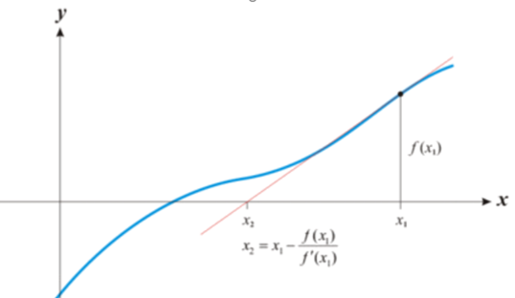

**Iteration 2:** Using this new x value, repeat the process

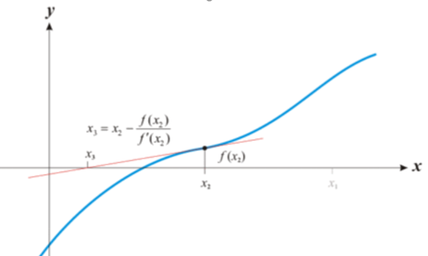

**Iteration 3:** The algorithm is beginning to converge on the root of .

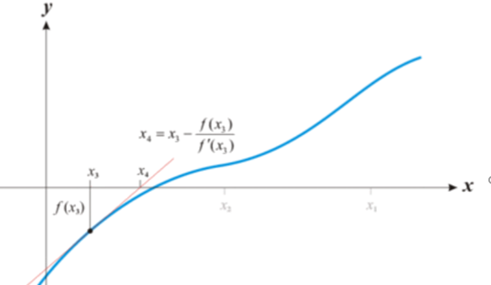

In these images,  is the current guess for the root and 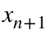 is the next input in this iterative process. When  -> , we have found the root of the function.

### Derivation of the Newton-Raphson method

1) The tangent line of the function at some point *x* can be written generally as:

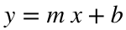

2) The slope, *m*, is simply the derivative of the function at xn:

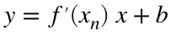

3) At *x* = xn, y = *f(*xn*)*, which allows us to solve for *b*



4) Substituting, we can write an equation for the tangent line in terms of 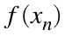,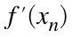,:

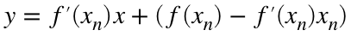

5) In this algorithm, we solve for *y* = 0 for the tangent line. Thus, at y=0, and *x* = xn+1:



6) Rearranging the previous for xn+1 produces the Newton-Raphson equation:

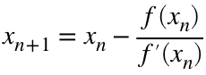

**Thus, we have derived a numerical method for iterating until we converge on the root of a function.**

### Question 1

**Use the Newton-raphson method to find the roots to the following equation:**

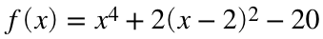

**PRO, Step 1: P**lan, **P**repare, and **P**seudocode

Helpful tasks:

* We know the equation we want to solve for, can we plot it to get an idea of where the roots might be?
* We know the equation and the algorithm, can we write explicitly write out what the algorithm will look. That is, here:

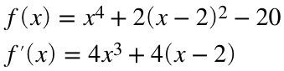

* We know the algorithm, but how is that converted into code? Write out pseudocode for what the script will look like.

% Step 1: specify 1 angle%

% Step 2: constants% Repeat for all angles%

% Step 3: calculate distance for each theta%

% Step 4: calculate maximum height

**PRO, Step 2:** w**R**ite **R**ough (increments of code) and **R**efine

Helpful tasks:

* Starting with your pseudocode and what you know about the function, roughly fill in code.

%Step 1: specify angle

th = 0:0.005:90; %degrees

th_r = th*pi/180; %radians

%Preallocate vector

x_end = zeros(1,length(th));

y_peak = zeros(1,length(th));

%Step 2: constants

g = 9.81; %m/s^2

h = 2; %m

v0 = 30; %m/s

%repeat for each theta

for k = length(th)

%repeat for all angles

%step 3: calculate distance for each theta

t_end = (-v0*sin(th_r(k)) - sqrt(v0^2*sin(th_r(k))^2 + 2*g*h))/(-g);

x_end(k) = v0*cos(th_r(k))*t_end;

%Step 4L calculate maximum height

t_peak = v0*sin(th_r(k))/g;

y_peak(k) = h + v0*sin(th_r(k))*t_peak - g/2*t_peak^2;

end

%plot the distance

plot(th,x_end,'k.')

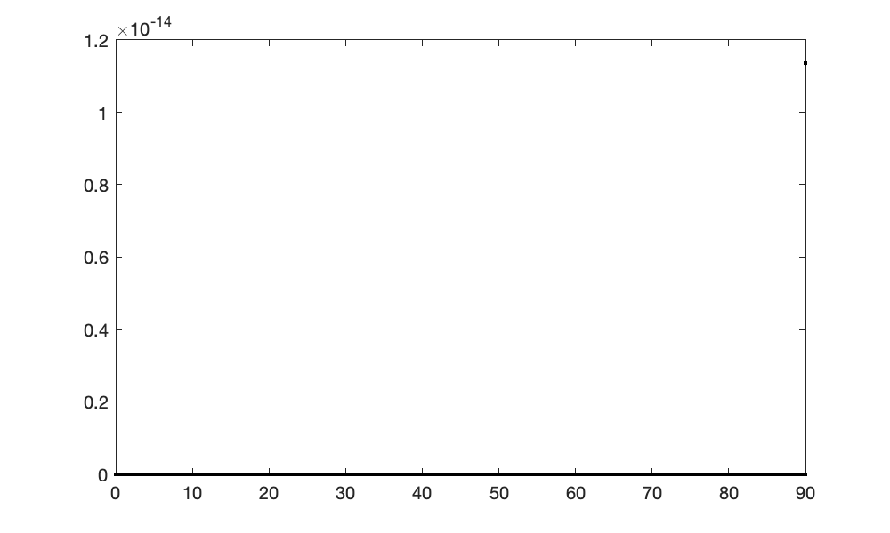

% Plot the height of the ball

plot(th,y_peak,'k.')

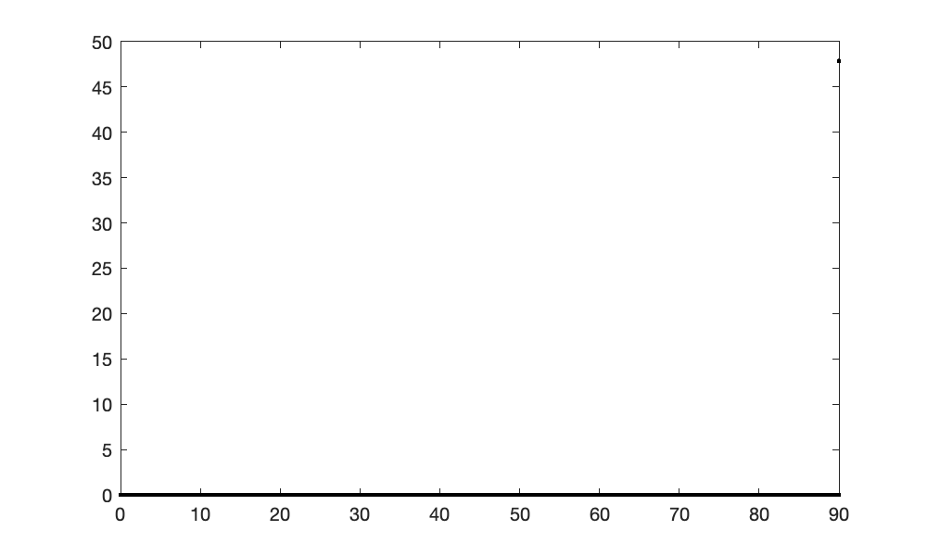

**PRO, Step 3: O**ptimize and improve

We don't actually know how many loop iterations to perform ahead of time. Refine the code so that it is in the form of a while loop.

%Step 1: specify angle

th = 0:0.005:90; %degrees

th_r = th*pi/180; %radians

%Preallocate vector

x_end = zeros(1,length(th));

y_peak = zeros(1,length(th));

%Step 2: constants

g = 9.81; %m/s^2

h = 2; %m

v0 = 30; %m/s

% Step 3: Calculate distance thrown - element-wise

t_end = (-v0*sin(th_r) - sqrt(v0^2*sin(th_r).^2 + 2*g*h))/(-g);

x_end = v0*cos(th_r).*t_end;

% Step 4: calculate maximun height

t_peak = v0*sin(th_r)/g;

y_peak = h + v0*sin(th_r).*t_peak - g/2*t_peak.^2;

%plot the distance

plot(th,x_end,'k.')

xlabel('Angle thrown (degrees)')

ylabel('Distance thrown (m)')

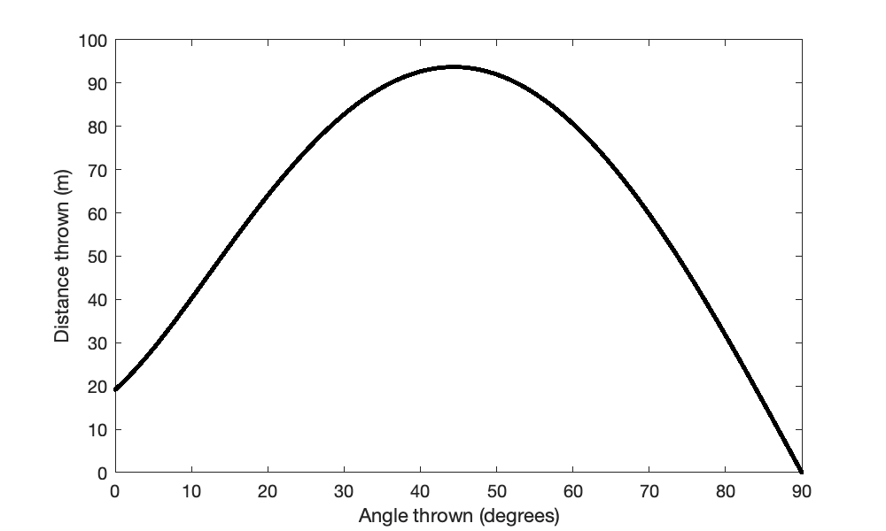

% Plot the height of the ball

plot(th,y_peak,'k.')

xlabel('Angle thrown (degrees)')

ylabel('Heigth thrown (m)')

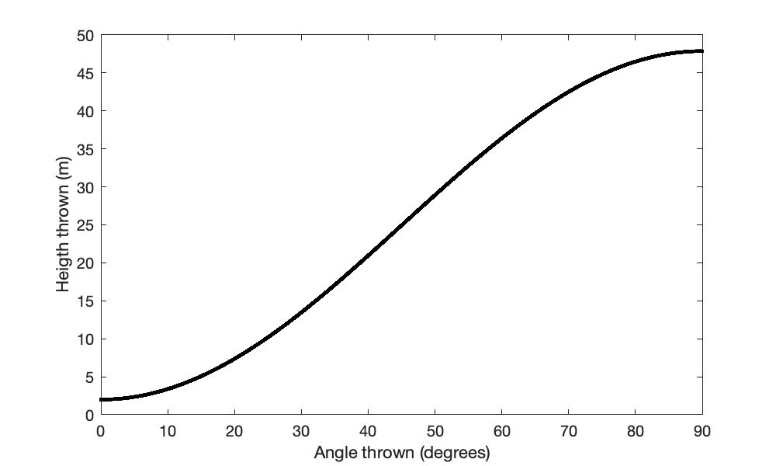

Note: this example has two roots. The root to which the function converges is dependent on the initial guess of the root location

### Question 2

**Use the Newton-raphson method to create a function for numerically approximating the square root of any number.**

**PRO, Step 1: P**lan, **P**repare, and **P**seudocode

Helpful tasks:

* We know the equation we want to solve for, let's convert it into a form that is easily used with Newton-raphson

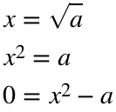

In other words, we want to find the root for the following equation:

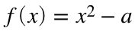

* We know the equation and the algorithm, can we write explicitly write out what the algorithm will look. That is, here:

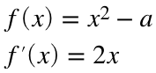



* We know the algorithm, but how is that converted into code? Write out pseudocode for what the script will look like.

% Step 1: specify initial guess

% Step 2 L Iterate until xn -> xn+1;

% Step 3L xn + 1 from xn

% Step 4: compare xn and xn+1 to determine if loop should continue

# TOPIC 7: Building solutions to problems, part 2

ENGR105, 9/24/20

## Tinkering with fundamental MATLAB operations

***Practice problem:***

* We want to simulated rolling one dice until three of one number in a row show up.
* Repeat this simulation 1000 times.
* Plot the frequency that each side (1-6) is the side that comes up 3 times in a row. Plot the distribution of turns required to achieve three in a row.

### 1) Functions

* **What are functions good for?** Functions are ideal for consolidating your code into a standalone collection that can be executed in response to some inputs into the code.
* **When should you use a function?** You should use a function when need to repeat tasks with different inputs. Functions provide an organized way to perform a series of tasks with only the input specified.
* **How do inputs and outputs work?** You specify these in the function declaration -- when you call your function, you should match the form of your declaration. **See practice code.**
* **What if you do not care about all outputs?** You can disregard inputs with ~.

%The final form of the practice problem from class

% Preallocate storage vectors

numTurns = zeros(1,1000); % Store requred number of turns from k-th game

diceFaceValue = zeros(1,1000); % Store final dice face value from the k-th game

for k = 1:1000

[numTurns(k), diceFaceValue(k)] = diceRollSimulator(3,6);

end

histogram(diceFaceValue)

ylabel('Number of games')

xlabel('Final dice face value')

title('Result from 1000 simulations: histogram of final dice values that end the game')

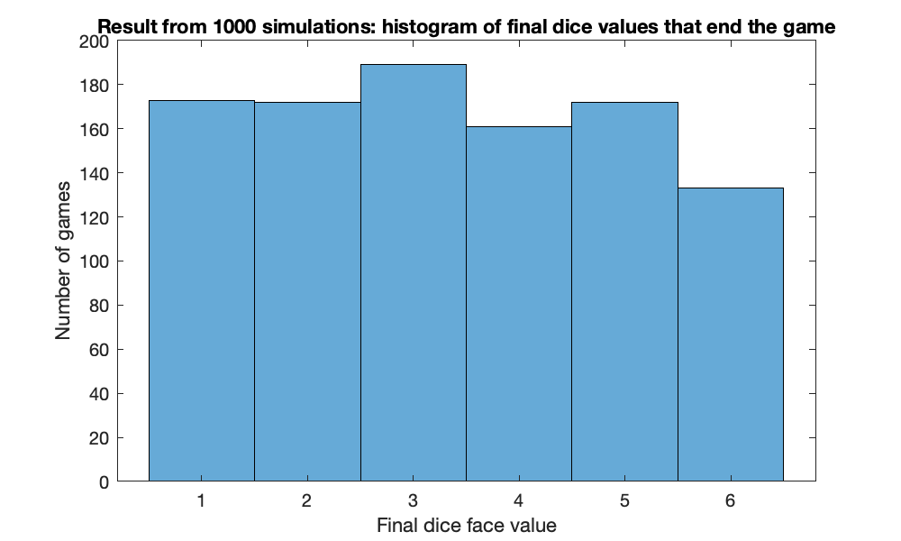

### 2) Conditional statements

* **How does the flow of information through conditional statements work?** Conditional statements provide structure that enables certain lines of code to run only if some logical condition is met.
* **When should you have an else statement?** You should include an else statement if you wish certain lines of code to run if all conditional statements provided in an if-elseif-else statement are not true.

% Plot 2 - plot distributuion of number of turns

histogram(numTurns)

ylabel('number of games')

xlabel('Number of turns required')

title('Result from 1000 simulations: histogram of final dice values that end the game')

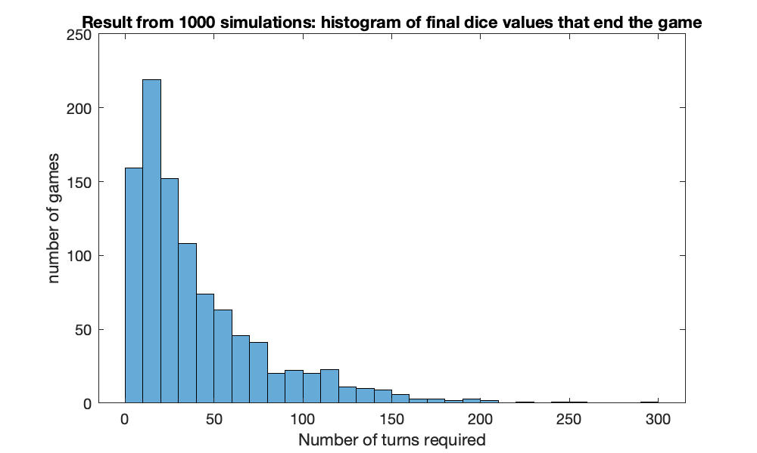

### 3) for loops

* **When do you use for loops?** Use a for loop when you know (or can calculate) how many iterations must be performed.
* **How does the index vector work?** The index vector simply specifies which values the loop index will take in each iteration. **See practice code.**

### 4) while loops

* **When do you use while loops?** Use a while loop when you do not know ahead of time how many loop iterations to perform.
* **How do you keep track of iterations (or specific iterations)?** Use a counter! This is a variable initialized outside of the loop that can be incremented in each iteration performed. **See practice code.**
* How does a stopping condition relate to what is happening in the loop?

%work while a conditional statement is true

n = 0;

a = 0;

while n<5

%keep track of when n is odd to perform tasks

if mod(n,2) == 1

a = a+1;

end

n = n+1;

end

## Practice problem 2: numerical methods and root-finding

Numerical analysis is the domain of mathematics and computer science that creates, analyzes, and implements algorithms for solving numerically the problems of continuous mathematics. Numerically solving a complex math problem often involves iterating or following a given algorithm until it converges (hopefully) upon a solution, within some defined tolerance.

One such application of numerical methods is root-finding, the algorithms for which may quickly find the root () for some arbitrary function . Say we have a (potentially very nonlinear) function for which we want to find  quickly. The Newton-Raphson method searches for the root of a function by iteratively following where the tangent of a function crosses the x axis.

Specifically, **the Newton-Raphson method has the following algorithm:**

1. Pick an initial guess () of the root of a function.
2. At that x value, calculate the tangent to the curve of the function.
3. Find where the tangent to the curve intersects the x axis.This x value becomes .
4. At this new x value, repeat steps 2-3.
5. When the new x value is not much different than the previous x value (as determined by some pre-defined tolerance), conclude that you have found an approximation for the root of the function. That is, you found a numerical approximation for the x value for which .

### Visual depiction of the Newton-Raphson algorithm

**Iteration 1:** Make an initial guess, calculate where the tangent line at that point intersects x axis.



**Iteration 2:** Using this new x value, repeat the process



**Iteration 3:** The algorithm is beginning to converge on the root of .



In these images,  is the current guess for the root and  is the next input in this iterative process. When  -> , we have found the root of the function.

### Derivation of the Newton-Raphson method

1) The tangent line of the function at some point *x* can be written generally as:



2) The slope, *m*, is simply the derivative of the function at xn:

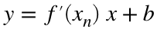

3) At *x = xn, y = f(xn)*, which allows us to solve for *b*



4) Substituting, we can write an equation for the tangent line in terms of ,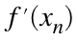,:



5) In this algorithm, we solve for *y* = 0 for the tangent line. Thus, at y=0, and *x* = xn+1:



6) Rearranging the previous for xn+1 produces the Newton-Raphson equation:



**Thus, we have derived a numerical method for iterating until we converge on the root of a function.**

### Question 1

**Use the Newton-raphson method to find the roots to the following equation:**



**PRO, Step 1: P**lan, **P**repare, and **P**seudocode

Helpful tasks:

* We know the equation we want to solve for, can we plot it to get an idea of where the roots might be?
* We know the equation and the algorithm, can we write explicitly write out what the algorithm will look. That is, here:



* We know the algorithm, but how is that converted into code? Write out pseudocode for what the script will look like.

% Step 1: specify initial guess

% Step 2: iterate until xn -> xn+1

% Step 3: xn + 1 from xn

% Step 4: compare xn and xn+1 to dtermine if loop should continue

**PRO, Step 2:** w**R**ite **R**ough (increments of code) and **R**efine

Helpful tasks:

* Starting with your pseudocode and what you know about the function, roughly fill in code.

% "Rough Solution:" use a for loop to solve this problem

% Step 1: specify initial guess

xn = 3;

% Step 2: interate until xn -> xn+1

for k = 1:5

%Step 3: evaluate function

fn = xn^4 + 2*(xn-2)^2 - 20;

% Step 3a: evaluate derivative

f_prime_n = 4*xn^3 + 4*(xn-2);

% Step 3b: calculate next x value

xnplus1 = xn -fn/f_prime_n;

% Step 4: update xn

xn = xnplus1;

end

disp(xn)

2.1141

**PRO, Step 3: O**ptimize and improve

We don't actually know how many loop iterations to perform ahead of time. Refine the code so that it is in the form of a while loop.

% Improved solution: use a while loop to iterate until convergence

% We will start by revisiting on Monday. The first is the approach we were

% heading towards in class before we ran out of time: using an if statement

% inside the while loop.

% Step 1: specify initial guess and other variables

xn = 3; % initial guess

keepIterating = 1; % Variable that specifies if we should keep iterating.

% We will set the value to zero if we meet some stopping criteria.

% Step 2: iterate until xn -> xn+1

while keepIterating

% Step 3: evaluate function

fn = xn^4 + 2*(xn-2)^2 - 20;

%Step 3a: evaluate derivative

f_prime_n = 4*xn^3 + 4*(xn-2);

%Step 3b: calculate the next value of xn

xnplus1 = xn - fn/f_prime_n;

% Step 4: Evaluate if we have reached a stopping criteria. Note the

% form of this relational expression

if abs(xn - xnplus1) < 10^-5

% One approach: use an if statement

keepIterating = 0;

end

% Step 5: update xn and repeat

xn = xnplus1;

end

disp(xn)

2.1141

# TOPIC 8: Revisiting arrays, pt. 1: useful math and logical arrays

ENGR105, 9/29/20

## Revisiting arrays: useful structures for storing and processing numerical information

We have mostly discussed 1-D (vectors) and 2-D (matrices) arrays, but MATLAB works with N-dimensional arrays. Remember that all of the array concepts we discuss also apply to higher order arrays.

### Reminder: Vector indexing

Vectors may be indexed using discrete vector indices or single index subscripts.

% Define initial vector

v = [5 3 4 6 8]

v = 1×5

5 3 4 6 8

% Define subsequent vectors through vector indexing

p = v([1 5 4 2])

p = 1×4

5 8 6 3

q = v(1:2)

q = 1×2

5 3

r = v(end-2:end)

r = 1×3

4 6 8

s = v(end:-1:end-3)

s = 1×4

8 6 4 3

t = v(1:2:end)

t = 1×3

5 4 8

### Matrix (and array) indexing

Arrays may be indexed with reference to row, column, page, … etc. subscripts or using single index subscripts.

% Define initial matrix

M = [5 2 4; 3 7 5]

M = 2×3

5 2 4

3 7 5

% Create subsequent matrices through indexing

B = M(1:2,1:2)

B = 2×2

5 2

3 7

C = M(:,1)

C = 2×1

5

3

D = M([1,2],[2,3])

D = 2×2

2 4

7 5

F = M(1,end-1:end)

F = 1×2

2 4

G = M(end:-2:1)

G = 1×3

5 7 3

### Adding, subtracting, multiplying and dividing arrays and their elements

We have learned how to perform mathematical operations on vectors and matrices, from element-wise multiplication and addition to matrix multiplication and division.

% Perform array math

B + D % matrix addition

ans = 2×2

7 6

10 12

B.*D % element-wise multiplication

ans = 2×2

10 8

21 35

B*M % matrix multiplication

ans = 2×3

31 24 30

36 55 47

### Other useful mathematical operations on arrays

**Using arrays with built-in functions**. As was the case with vectors - many built-in MATLAB functions operate on any N-dimensional arrays element by element. For example, if A is a 2x2 matrix, tan(A) will be 2x2 with each element being the tangent of the corresponding element of A.

A = [pi/4,3*pi/4;5*pi/4,7*pi/4]

A = 2×2

0.7854 2.3562

3.9270 5.4978

% Tangent operation on entire array

tan(A)

ans = 2×2

1.0000 -1.0000

1.0000 -1.0000

The same holds true for most of the common, built-in MATLAB functions (*e.g.* abs(A), sin(A), log10(A))

**Array sums**. Recall that sum() of any vector yielded the sum of all elements in that vector.

a = 1:3

a = 1×3

1 2 3

sum(a)

ans = 6

N-dimensional arrays may be summed across any of the dimensions or the entire array using the same function. For an N-dimensional array: the sum along the N-th dimension may be invoked using sum(A,N), where N is the dimension number

* Dimension "1": rows
* Dimension "2": columns
* Dimension "3": pages (and so on)

% Create matrix

A = [1:3;4:6]

A = 2×3

1 2 3

4 5 6

% Sum across each row of A

sum(A,1)

ans = 1×3

5 7 9

% Sum across each column of A

sum(A,2)

ans = 2×1

6

15

The **sum of all elements in the array** may be output by nesting N number of sum calls (ex. sum(sum(A)) for a 2D matrix) - the sum starts with the innermost dimension for the most highly-nested sum call.

sum(sum(A))

ans = 21

You may also achieve the previous by unwrapping the matrix to a vector via sum(A(:))

sum(A(:))

ans = 21

**Cumulative array sums**. cumsum() sums cumulatively along a *vector* or *some dimension of an array* - unless a dimension is specified, it works on the first non-singleton dimension.

a = 1:4

a = 1×4

1 2 3 4

%adds to the next index as it goes through

cumsum(a)

ans = 1×4

1 3 6 10

A

A = 2×3

1 2 3

4 5 6

cumsum(A,2)

ans = 2×3

1 3 6

4 9 15

**Array products**. prod() calculates the product of array elements using the specified dimension. If no dimension is input, it takes the product along the first non-singleton dimension.

% Vector example

a

a = 1×4

1 2 3 4

prod(a)

ans = 24

% Matrix example

A

A = 2×3

1 2 3

4 5 6

prod(A,2)

ans = 2×1

6

120

**Cumulative array products**. cumprod() calculates the cumulative product of array elements along a vector or some dimension of an array - unless a dimension is specified, it works on the first non-singleton dimension.

% Vector example

a

a = 1×4

1 2 3 4

cumprod(a)

ans = 1×4

1 2 6 24

% Array example

A

A = 2×3

1 2 3

4 5 6

cumprod(A,2)

ans = 2×3

1 2 6

4 20 120

**Note**: many other mathematical functions may be able to operate along rows, columns, or other dimension. Always check the MATLAB help documentation to determine how to input the dimension of interest.

### Useful built-in arrays

MATLAB includes a lot of pre-defined matrices that may be scaled to fit your needs. Generally, there are two ways to specify the dimensions of these matrices:

* A single dimension (n) creates an nxn square matrix
* Two dimensions (n, m) create a nxm matrix

Some pre-defined matrices support N-dimensional arrays (ex. rand(m,n,p)and randi(m,n,p))

% Create an array with all zeros

zeros(3,2)

ans = 3×2

0 0

0 0

0 0

% Create a matrix with all ones

ones(4)

ans = 4×4

1 1 1 1

1 1 1 1

1 1 1 1

1 1 1 1

% Create a matrix with equal row, column, and diagonal sums

magic(3)

ans = 3×3

8 1 6

3 5 7

4 9 2

% Create an identity matrix

eye(3)

ans = 3×3

1 0 0

0 1 0

0 0 1

% Create a matrix of random integers

randi(4,[2,3])

ans = 2×3

1 4 2

3 1 3

## Logical Arrays

### Logical numbers

Recall that we can use relational operators compare values and yield a true (1) or false (0) numerical result.

### 

% Relational operator examples

an_1 = 5==2

an_1 = *logical*

0

c = 5==2

c = *logical*

0

% Relational operators can also operate on variables

dog = 4;

cat = 9;

animal = dog==cat

animal = *logical*

0

**Note**: each of these variables is a **scalar of logical *class***. Each variable and number in MATLAB is of a certain data type. The logical data type specifies that a variable can have one of two possible values: either 1 (true) or 0 (false).

### Logical arrays: vectors, matrices, etc. with logical numbers

A logical array is any n-dimensional array that contains only logical type numbers – logical 0 (false) or logical 1 (true). In practice, **logical arrays are most often created by subjecting an array to a relational operator**.

% Define arrays

M = [1,5,8;9,4,3]

M = 2×3

1 5 8

9 4 3

A = [7,2,6;3,0,5]

A = 2×3

7 2 6

3 0 5

In each of the following examples, **an array is created with the same size as the array subjected to the relational operator**. However, the entries are either 0 or 1, depending on if the **relational statement is true or false when each corresponding element of the original array is operated on.**

% Creating logical arrays by performing relational operations

V = M == 5

V = *2×3 logical array*

0 1 0

0 0 0

% Logical matrix based on A, specify which elements are greater than 6

r3 = A > 6

r3 = *2×3 logical array*

1 0 0

0 0 0

% Create logical matrix indicating which elements in M are greater than the

% corresponding elements in A

out = M>A

out = *2×3 logical array*

0 1 1

1 1 0

**Note**: as above, the output from each of these is an array of the **logical** class. A logical variable can only take two values: 0 or 1. We will talk more about data types and classes next week.

A logical array can also be specified by passing an array through the logical() command - although this is more rarely used in practical application. In the following, the original vector is converted to a logical vector -- all nonzero elements are converted logical 1.

v = [6,4,0,1]

v = 1×4

6 4 0 1

g2 = logical(v)

g2 = *1×4 logical array*

1 1 0 1

## Practice Problem: tic tac toe

**Rules of tic tac toe**:

* The game starts with an empty 3x3 grid.
* Players take turn picking spots (with their marker, usually entering either "x" or "o") in the grid.Thus, there are a possible 9 turns before either one of the players wins or the game ends in a draw.
* If any player gets three spots in a row (horizontal, vertical, or diagonal), she or he wins.

**Goal**: produce a script that "plays" tic tac toe.

**Simpler (initial) goal**: produce a two player version of tic tac toe.

%choose x or o's to be 1 or zeros and then gerate random matrices

%in order to check how you win you need to check if all indices in a

%row/column/diagonal equal each other

%step 1: define initial variables

gameboard = zeros(3);

%create array to keep track of positions

availablePos = 1:9;

%Repeat: alternate between players

player = 1; %player 1

%checks who's turn it is

gameStillGoing = 1;

%iterate until someone has one, or game is a draw

availablePos

availablePos = 1×9

1 2 3 4 5 6 7 8 9

while gameStillGoing

%Step 2: make a move, play position

%populate using single index notation

%logical corresponding to valid move

invalidMove = 1;

while invalidMove

playPos = input("Select a position to play...")

invalidMove = prod(availablePos ~= playPos)

end

%Update gameboard

gameboard(playPos) = player;

%Step 3: display gameboard

disp(gameboard)

%Step 4: evaluate stopping condition

gameStillGoing = checkEndGame(gameboard, player);

%step 5 change player

player = mod(player,2) + 1;

end

playPos = 1

invalidMove = 0

1 0 0

0 0 0

0 0 0

playPos = 2

invalidMove = 0

1 0 0

2 0 0

0 0 0

playPos = 4

invalidMove = 0

1 1 0

2 0 0

0 0 0

playPos = 3

invalidMove = 0

1 1 0

2 0 0

2 0 0

playPos = 7

invalidMove = 0

1 1 1

2 0 0

2 0 0

1wins

# TOPIC 9: Revisiting arrays, pt. 2: logical arrays and more

ENGR105, 10/1/20

## Logical Arrays (cont'd)

Last time, we talked about how logical arrays can be created by relating arrays with relational operators.

% Define arrays

M = [1,5,8;9,4,3]

M = 2×3

1 5 8

9 4 3

A = [7,2,6;3,0,5]

A = 2×3

7 2 6

3 0 5

In each of the following examples, **an array is created with the same size as the array subjected to the relational operator**. However, the entries are either 0 or 1, depending on if the **relational statement is true or false when each corresponding element of the original array is operated on.**

% Creating logical arrays by performing relational operations

v = M == 5

v = *2×3 logical array*

0 1 0

0 0 0

% Logical matrix based on A, specify which elements are greater than 6

r3 = A > 6

r3 = *2×3 logical array*

1 0 0

0 0 0

### Indexing with logical arrays

Logical arrays can be used to index "regular" arrays.

% Define vector

v = [5,2,4]

v = 1×3

5 2 4

% Define logical vector

a = logical([1 0 1])

a = *1×3 logical array*

1 0 1

**NOTE**: This is different than "regular" vector indexing. You are not creating a new vector by specifying the index to "call". You are specifying which "true" indices (as determined by the position in the logical array that is 1 (true)) to include in the final matrix.

Using *logical indexing*, we "select" elements based on the indices in the logical array that are true.

res = v(a) %since first and third entries are true you return those

res = 1×2

5 4

**NOTE**: when using logical indexing, the index vector must be of the logical data type.

In this example, this is equivalent to the *vector indexing* that we have done previously:

res = v([1,3]) %enables us to select elemants that satisfy a condition

res = 1×2

5 4

### Logical array indexing rules

1. An array may be indexed with logical class 0’s and 1’s
2. Only the elements of the array that were indexed as 1’s are returned or modified
3. The logical array that specifies the indices must be the same size as the array being indexed*

### Examples with vectors

% Define two arrays

v = [6,5,2]

v = 1×3

6 5 2

p = [9,5,3]

p = 1×3

9 5 3

% Perform logical indexing

r = v(p==3)

r = 2

s = v(v>3)

s = 1×2

6 5

% Create new vector consisting only of entries of p less than 4

val2 = p(p<=4)

val2 = 3

% Overwrite all entries whose value is greater than 3

v(v>3) = 7

v = 1×3

7 7 2

% Delete entries from v based on logical indexing

v(p<6) = []

v = 7

**Note**: in all of these cases, **we modify the above vectors** or **create subvectors** without explicitly determing which elements fulfill some criteria before the operation. In this sense, the relational operator use is similar in spirit to while loops, in which we do not know ahead of time how many iterations to perform.

### Examples with matrices

% Create example matrices

M = [3,7,6;5,4,2]

M = 2×3

3 7 6

5 4 2

A = [1,8,0;5,9,2]

A = 2×3

1 8 0

5 9 2

When using logical matrices, note the output is a ***vector***. It does not make sense to display the output as a matrix because some elements may not be present (all elements corresponding to false).

res = M(A>2)

res = 3×1

5

7

4

**Remember**. Logical indexing must be performed with logical arrays.

%T = M(A)

out = M(logical(A))

out = 5×1

3

5

7

4

2

% Two more examples

G = A(M==A)

G = 2×1

5

2

vals = A(M==7 | A==9)

vals = 2×1

8

9

In addition to **returning vectors** based upon logical indexing, matrix elements can be overwritten or redefined using logical indexing.

% Redefine matrices

M = [3,7,6;5,4,2]

M = 2×3

3 7 6

5 4 2

A = [1,8,0;5,9,2]

A = 2×3

1 8 0

5 9 2

% Set all elements less than 4 to be 9.

M(M<4) = 99

M = 2×3

99 7 6

5 4 99

% Specify element positions in M corresponding to those in which either A <

% 2 or A > 7 to equal 5

M(A<2 | A>7) = 5

M = 2×3

5 5 5

5 5 99

% Delete elements from A that are greater than 5

A(A>5) = []

A = 1×4

1 5 0 2

### Mathematical operations using logical arrays

Logical arrays formed by relational criteria may be used to selectively perform mathematical operations.

% Define vectors

v = [6,5,2]

v = 1×3

6 5 2

p = [9,5,3]

p = 1×3

9 5 3

% Create a vector with nonzero elements defined by the relational operator

res = (v>5).*p

res = 1×3

9 0 0

% Note the importance of precedence!

res2 = v>5.*p

res2 = *1×3 logical array*

0 0 0

**Example**. In signal processing applications, we are often interested in *causal signals*, *i.e.* those that are zero for all times 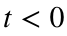. Consider the causal 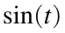 function.

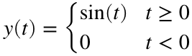

We can plot this by using the element-wise multiplication of a logical vector multiplied by the sine function.

% time vector

t = -20:.1:20;

% Produce a plot of the causal signal y(t)

plot(t,sin(t).*(t>=0),'k-')

% Define plotting parameters

xlabel('t')

ylabel('y(t)')

axis square % The plot window becomes square

ylim([-1,1]) % Set the y limits

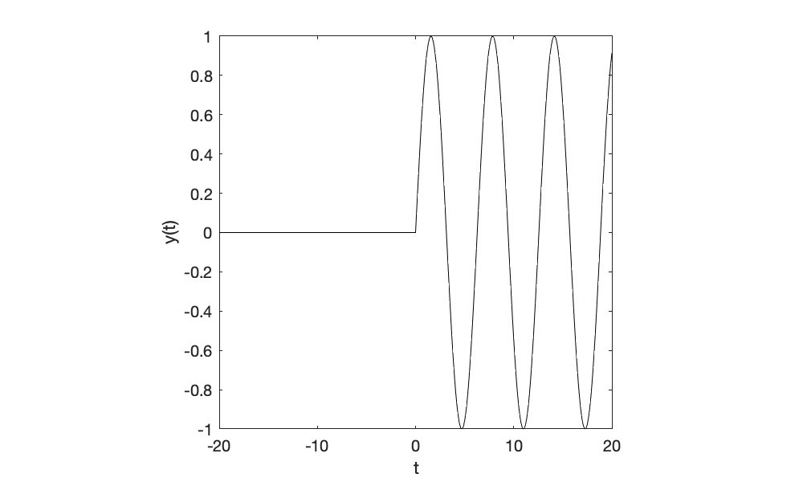

**Example**. Say we want to produce a half wave rectification of sine function.

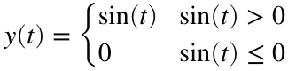

% time vector

t = -20:.1:20;

% Produce a plot of the causal signal y(t)

plot(t,sin(t).*(sin(t)>0),'k-')

% Define plotting parameters

xlabel('t')

ylabel('y(t)')

axis square % The plot window becomes square

ylim([-1,1]) % Set the y limits

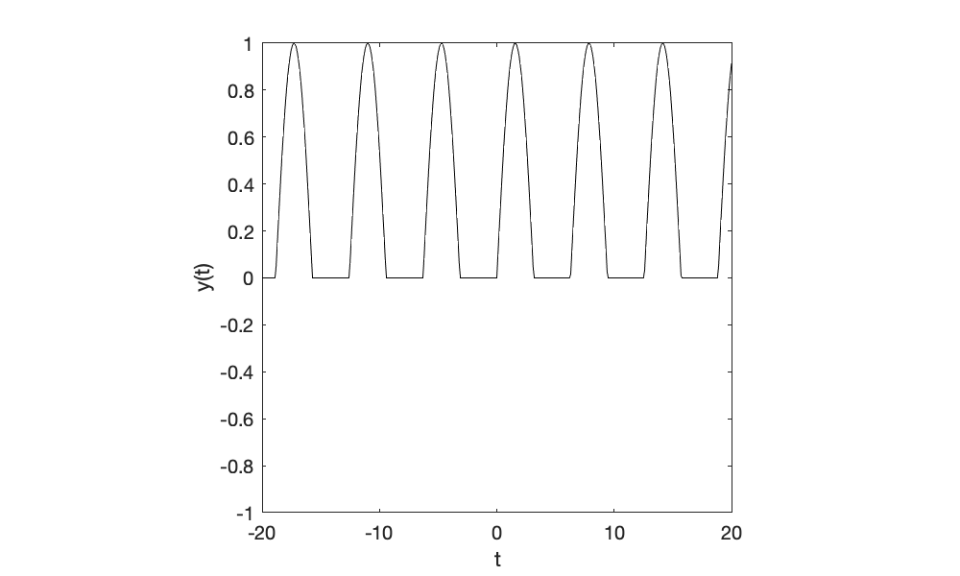

**Note**: in both of the cases, multiplying the function by a logical array of the same size was a quick and efficient way to specify regions to be zero.

### Built-in logical functions

* any() takes in an array or logical array and returns a scalar and logical true if any array values are true.

x = (1:4)>3

x = *1×4 logical array*

0 0 0 1

% TRUE if any element is true

any(x)

ans = *logical*

1

* all() takes in an array or logical array and returns a scalar and logical true only if all values are true

x = (1:4)>3

x = *1×4 logical array*

0 0 0 1

% TRUE if all elements are true

all(x)

ans = *logical*

0

* isscalar() takes an input and returns true if that input is a scalar.

x = 1:4

x = 1×4

1 2 3 4

% TRUE if any element is true

isscalar(x)

ans = *logical*

0

* isempty() takes an input and returns true if that input is an empty set ([]).

x = 1:4

x = 1×4

1 2 3 4

% TRUE if any element is true

isempty(x)

ans = *logical*

0

* isnan() takes an input and returns true if that input is not a number (NaN).

x = nan(1,3)

x = 1×3

NaN NaN NaN

% Element-wise evaluation -> a corresponding index is 1 if that entry is

% NaN

isnan(x)

ans = *1×3 logical array*

1 1 1

**Note**: MATLAB has many other built-in logical functions. These can be found at:

<https://www.mathworks.com/help/matlab/ref/is.html>

## Changing the shape of arrays

We have seen a few built-in functions for reshaping arrays, such as using the transpose ('). As a reminder, the transpose function rotates a matrix over its main diagonal, as seen here. This works for vectors and matrices.

% Create matrix

z = magic(3)

z = 3×3

8 1 6

3 5 7

4 9 2

z'

ans = 3×3

8 3 4

1 5 9

6 7 2

**Note**: transpose is not defined for >2D arrays in MATLAB.

### Rotating and flipping arrays

MATLAB permits array rotations using the rot90 and reflections using fliplr, flipud,and flip.

% Display matrix

z

z = 3×3

8 1 6

3 5 7

4 9 2

% Rotate matrix 90 degrees counter clockwise

rot90(z)

ans = 3×3

6 7 2

1 5 9

8 3 4

% Flip matrix "up and down," that is the last row becomes the first

flipud(z)

ans = 3×3

4 9 2

3 5 7

8 1 6

% This is equivalent to reversing the row order, but requires less code

z(end:-1:1,:)

ans = 3×3

4 9 2

3 5 7

8 1 6

% Flip matrix "left and right," that is the last column becomes the first

fliplr(z)

ans = 3×3

6 1 8

7 5 3

2 9 4

% This is equivalent to reversing the column order, but requires less code

z(:,end:-1:1)

ans = 3×3

6 1 8

7 5 3

2 9 4

% Flip the matrix along the specified dimension. This could work for higher

% order arrays

% 1: flip rows

% 2: flip columns

flip(z,1)

ans = 3×3

4 9 2

3 5 7

8 1 6

### Reshaping arrays

An array may be reshaped using the reshape(), which requires that the product of the reshaped dimensions equals the product of the original array dimensions.

z

z = 3×3

8 1 6

3 5 7

4 9 2

z2 = reshape(z,1,9)

z2 = 1×9

8 3 4 1 5 9 6 7 2

**Note**: the indices of the initial and reshaped matrix are determined from single index (“unwrapped”) subscripts

# TOPIC 10: Revisiting arrays, pt. 3: improving computational efficiency

ENGR105, 10/6/20

## Logical arrays

### Reminder: logical indexing and reshaping arrays

Last time, we talked about how logical arrays can be used to index vectors and matrices, incorporated into mathematical statements, and how arrays can be reshaped and restructured.

* We can perform **relational** and **logical** **operations on arrays** to create **logical vectors** for use in logical indexing or logical array math.

% Create a test arrays

a = 1:7

a = 1×7

1 2 3 4 5 6 7

% Use logical indexing to select all elements greater than 3

a(a>3)

ans = 1×4

4 5 6 7

% Use array math to set all elements that are NOT greater than 3 to 0.

a.*(a>3)

ans = 1×7

0 0 0 4 5 6 7

* There are useful built-in logical functions for evaluating if **none, some, or all** entries in a logical vector are true or false.

%b is a logical vector so only has 0 and 1

b = a > 1

b = *1×7 logical array*

0 1 1 1 1 1 1

% Evaluate if at least one entry is true

any(b)

ans = *logical*

1

% Evaluate if all entries are true

all(b)

ans = *logical*

0

% Evaluate if no entries are true

all(-b)

ans = *logical*

0

* We can also **restructure** and **rotate** arrays using built-in functions.

% Reshape array of elements larger than 3 into a 2x2 array.

b = reshape(a(a>3),2,2)

b = 2×2

4 6

5 7

% Rotate matrix 90 degrees ccw

rot90(b)

ans = 2×2

6 7

4 5

% Reverse the rows

flipud(b)

ans = 2×2

5 7

4 6

% Reverse the columns

fliplr(b)

ans = 2×2

6 4

7 5

**Plotting example**. Assume we collected data points at many different time points and we wish to plot only a subset of these.

% Measured time points

t = 1:1000;

% Data points where each entry is the data point measured at the

% corresponding entry in the time vector.

dataPts = rand(1,length(t));

% Plot data

%plot for times less that 500

plot(t(t<500),dataPts(t<500),'k.')

axis square

ylim([0,1]) % y limit

xlim([0,length(t)]) % x limit

xlabel('time') % data label for x axis

ylabel('data value') % data label for y axis

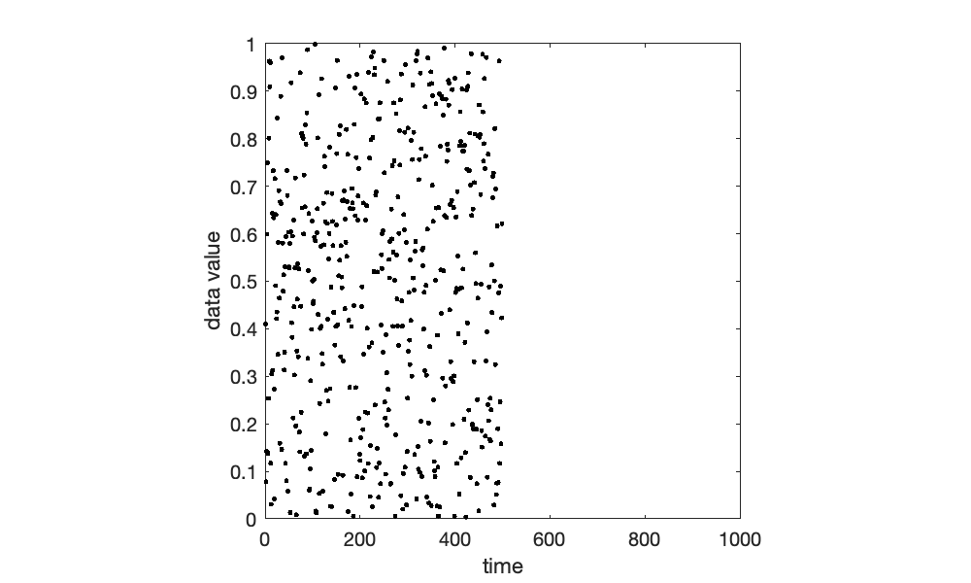

* Q1: plot data from times **less than 500 -> logical indexing**

% Plot data at t < 500

plot(t(t<500),dataPts(t<500),'k.')

axis square

ylim([0,1]) % y limit

xlim([0,length(t)]) % x limit

xlabel('time') % data label for x axis

ylabel('data value') % data label for y axis



* Q2: plot data points with **values greater than 0.5 -> logical indexing**

% Plot data with values greater than 0.5

plot(t(dataPts>0.5),dataPts(dataPts>0.5),'k.')

axis square

ylim([0,1]) % y limit

xlim([0,length(t)]) % x limit

xlabel('time') % data label for x axis

ylabel('data value') % data label for y axis

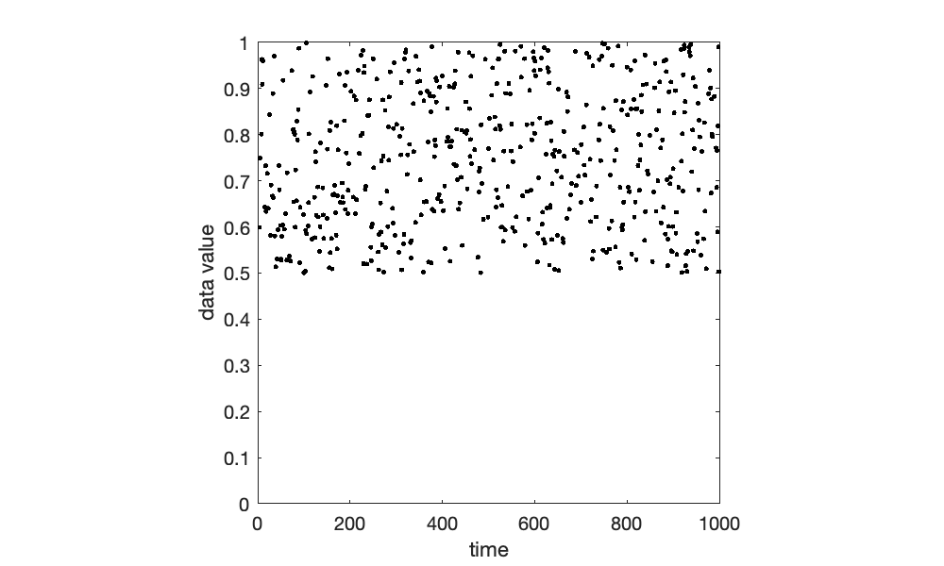

* Q3: plot data points with with values **greater than 0.7 set to 0 -> logical math**

% Plot data with values greater than 0.7 set to 0

plot(t,dataPts.*(dataPts<=0.7),'k.')

axis square

ylim([-0.1,1]) % y limit

xlim([0,length(t)]) % x limit

xlabel('time') % data label for x axis

ylabel('data value') % data label for y axis

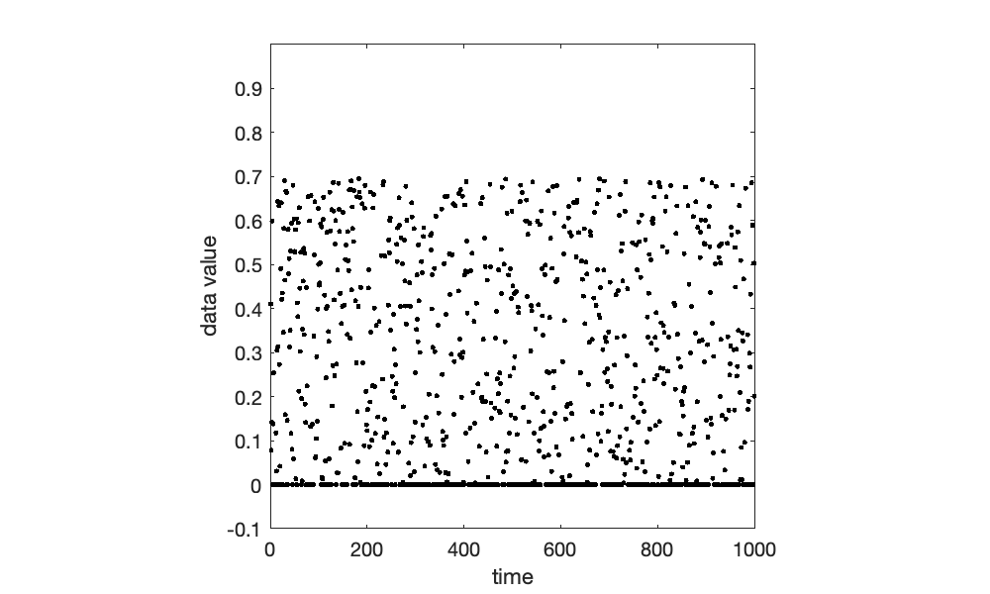

**NOTE**: in all of these example, note the agreement between the "x" and "y" inputs into the plot() function.

**Question**: produce the following piece-wise signal.

*Relevant UPenn Course: BE 301: Signals and Systems*

*Relevant UPenn Course: MEAM 321 Dynamic Systems and Control*

*Relevant UPenn Course: CBE 360 Chemical Process Control*

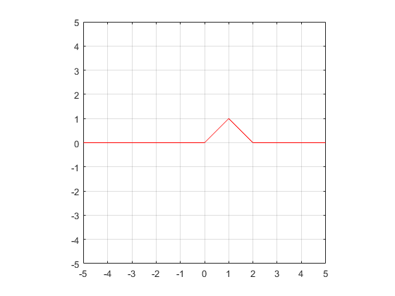

% Create the time vector

t = -5:0.1:5;

% Create the signal vector

x = t.*(t>=0).*(t<1) + (2-t).*(t>=1).*(t<2);

% Plot

plot(t,x,'r-')

axis square

ylim([-5,5])

xlim([-5,5])

grid on % Display the grid

xticks(-5:5) % Explicitly define the x tick marks

yticks(-5:5)

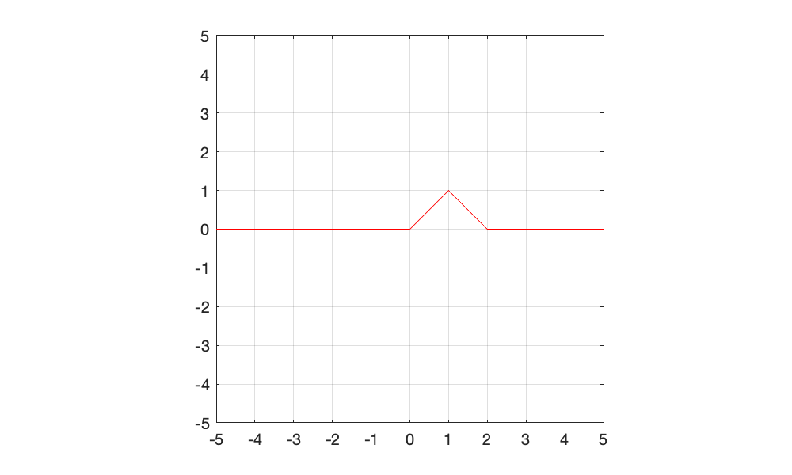

### Logical arrays vs. if-else statements

**Example #1**. The bonus for barkers selling peanuts at a baseball game is set at $0.02/pack if at least 100 packs were sold, $0.04/pack of at least 200 packs were sold, and $0.06/pack if at least 300 packs were sold. Calculate the bonus for four barkers who sold individually sold 57, 299, 161, and 429 packs of peanuts at a game.

% Create vector, each entry corresponds to a different seller's packs sold

packsSold = [57, 299, 161, 429];

So far, our strategy to accomplish this would be to create if-else statements nested in a loop.

bonus = zeros(1,4);

% Calculate bonuses.

for jj = 1:length(packsSold)

% If >=100 and <200 packs sold

if packsSold(jj)>=100 && packsSold(jj)<200

bonus(jj) = .02*packsSold(jj);

% If >=200 and <300 packs sold

elseif packsSold(jj)>=200 && packsSold(jj)<300

bonus(jj) = .04*packsSold(jj);

% If >300 packs sold

elseif packsSold(jj)>=300

bonus(jj) = .06*packsSold(jj);

end

end

disp(bonus)

0 11.9600 3.2200 25.7400

A more concise (and easy to understand) way to calculate this would be to use logical array operations and math to perform all of the above calculations in one MATLAB statement.

% Calculate bonus using logical indexing

%make a logic based function that only multiplies agains thtings that were

%true

bonus2 = ...

0.02*packsSold.*(packsSold>= 100 & packsSold<200) + ...

0.04*packsSold.*(packsSold>= 200 & packsSold<300) + ...

0.06*packsSold.*(packsSold>= 300);

disp(bonus2)

0 11.9600 3.2200 25.7400

In this example, we add together three logical vectors (corresponding to each of the bonus conditions) that are multiplied by the corresponding dollar bonus.

**Example #2**. Employees of a business are paid at a rate of $19/hr and receive overtime (time and a half) above 40 hours/week. Calculate the pay for employees who worked 45, 21, 19, 61, and 39 hours last week.

%define verctor containing employee hours

employeeHours = [45, 21, 19, 61, 39];

%calculate pay in one statement

eployeePay = 10*employeeHours + 19*0.5*(employeeHours-40).*(employeeHours>40)

eployeePay = 1×5

497.5000 210.0000 190.0000 809.5000 390.0000

%at the end there is a logical that only multiplies if there is more than

%40 hours

**Example #3**. Instead of four people selling peanuts, you have N barkers selling packs of peanuts at sporting events in your multi-national event management corporation. Compare the computational time using if-else statements and logical arrays for determining the bonus pay each barker should receive, as a function of N, the number of barkers. Assume employees can sell 1 - 500 packs at a given event.

% Vector containing different numbers of barkers. We will calculate the

% time to calculate the bonus for increasing N using if-else vs. logical arrays

N = round(logspace(1,6,100));

% Preallocate vectors to store computational time

t_ifElse = zeros(1,length(N));

t_logicalMath = zeros(1,length(N));

% Calculate computational time for vector of different numbers of barkers

for k = 1:length(N)

% Generate vector containing packs sold. Each entry corresponds to the

% packs sold by a different employee.

packsSold = randi(500,[1,N(k)]);

% Calculate time using conditional statement

tic;

% Preallocate bonus array

bonus1 = zeros(1,length(packsSold));

% Calculate bonus received for each employee

for jj = 1:length(packsSold)

% If >=100 and <200 packs sold

if packsSold(jj)>=100 && packsSold(jj)<200

bonus(jj) = .02*packsSold(jj);

% If >=200 and <300 packs sold

elseif packsSold(jj)>=200 && packsSold(jj)<300

bonus(jj) = .04*packsSold(jj);

% If >300 packs sold

elseif packsSold(jj)>=300

bonus(jj) = .06*packsSold(jj);

end

end

t_ifElse(k) = toc;

% Calculate time using logical array operations and math

tic;

% Calculate bonus in one statement

bonus2 = ...

0.02*packsSold.*(packsSold>=100 & packsSold<200) + ...

0.04*packsSold.*(packsSold>=200 & packsSold<300) + ...

0.06*packsSold.*(packsSold>=300);

t_logicalMath(k) = toc;

end

% Define dimensions of plot

figure('Position',[0,0,500,300]);

% Plot the functions

plot(N,t_ifElse,'ko-',N,t_logicalMath,'ro-','LineWidth',1.5,'MarkerFaceColor','auto')

% Graphical parameters

set(gca, 'XScale', 'log') % "log" axes - x

set(gca, 'YScale', 'log') % "log" axes - y

set(gca,'XMinorTick','on')

xlim([10^1,10^6]); % range of x values on plot

ylim([10^-6,10^0]); % range of y values on plot

xlabel('N - number of vector elements');

ylabel('Compuatational time (s)');

legend('If-else','Array math','Location','northwest')

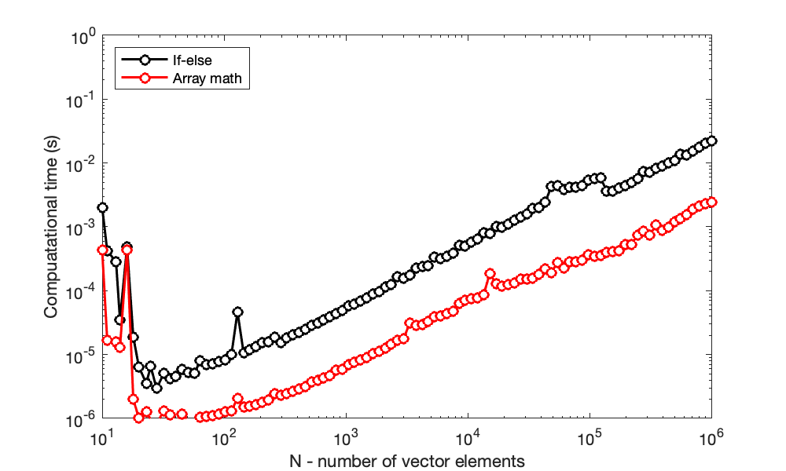

**Takeaway**: creating simple statements using logical arrays can be more efficient and easier to understand.

### Always preallocate arrays

As we saw with vectors, preallocation is the process of creating an array of the final size (usually padded with zeros) before modifying each element of the array. **Consider the computational time associated with creating an NxN multiplication table** using for loops for different numbers of N.

That is, what we want to create:

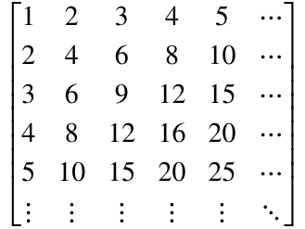

% Determine range of N

N = logspace(0,3,4);

% Preallocate vectors to store computational time

t_no = zeros(length(N),1);

t_yes = zeros(length(N),1);

% For each number of elements considered

for k = 1:length(N)

% Calculate time without preallocation

tic;

% For each row

for jj = 1:N(k)

% For each column

for mm = 1:N(k)

% Each entry is the produce of the rows and columns of the

% multiplication table

multTable(jj,mm) = jj*mm;

end

end

t_no(k) = toc;

% Calculate time without preallocation

tic;

% Preallocate array

multTable = zeros(N(k),N(k));

% For each row

for jj = 1:N(k)

% For each column

for mm = 1:N(k)

% Each entry is the produce of the rows and columns of the

% multiplication table

multTable(jj,mm) = jj*mm;

end

end

t_yes(k) = toc;

% Delete multiplication table so that it can be created from scratch on

% the next loop

clear multTable

end

% Define dimensions of plot

figure('Position',[0,0,500,300]);

% Plot the functions

plot(N,t_no,'ko-',N,t_yes,'ro-','LineWidth',1.5,'MarkerFaceColor','auto')

% Graphical parameters

set(gca, 'XScale', 'log') % "log" axes - x

set(gca, 'YScale', 'log') % "log" axes - y

set(gca,'XMinorTick','on')

xlim([10^0,10^4]); % range of x values on plot

ylim([10^-6,10^0]); % range of y values on plot

xlabel('N - number of vector elements');

ylabel('Compuatational time (s)');

legend('No preallocation','Preallocation','Location','northwest')

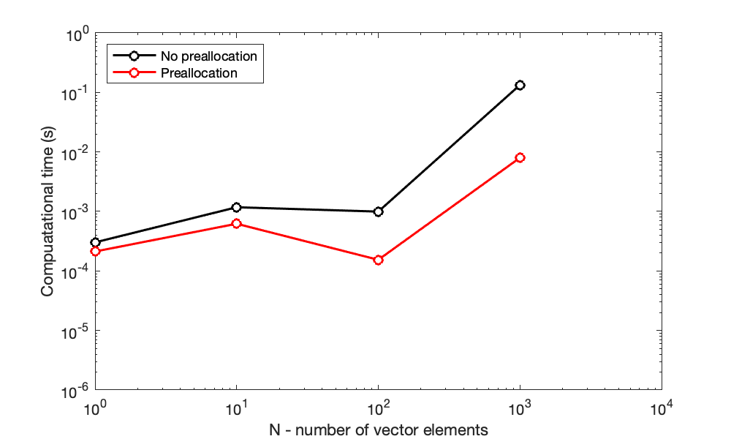

**Side note**: the above multiplication table can be create **much more efficiently** using **matrix multiplication** instead of nested for loops.

multTable = (1:10)'*(1:10)

multTable = 10×10

1 2 3 4 5 6 7 8 9 10

2 4 6 8 10 12 14 16 18 20

3 6 9 12 15 18 21 24 27 30

4 8 12 16 20 24 28 32 36 40

5 10 15 20 25 30 35 40 45 50

6 12 18 24 30 36 42 48 54 60

7 14 21 28 35 42 49 56 63 70

8 16 24 32 40 48 56 64 72 80

9 18 27 36 45 54 63 72 81 90

10 20 30 40 50 60 70 80 90 100

### Sparse arrays

Sparse matrices -- large arrays with few nonzero entries -- are encountered in a broad set of engineering disciplines, with applications including solving PDEs, search algorithms, atomistics, and FEA.

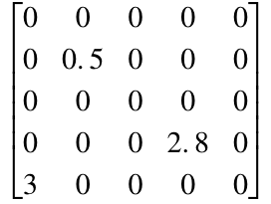

Consider a sparse matrix of dimensions 1000 x 2000 elements - that correlates to 2 million data points. Assume that this matrix contains non-zero values at the following indices:

* (row 3, column 4) = 15
* (row 100, column 1500) = 5
* (row 1000, column 2000) = 9

This matrix may be established using a conventional matrix indexing:

A = zeros(1000,2000);

A(3,4) = 15;

A(100,1500) = 5;

A(1000,2000) = 9;

Sparse matrices can be stored efficiently as a matrix of 0’s with nonzero values stored by their row, column, and value – this can save significant memory space. In the above example, this matrix could also be established using a sparse matrix syntax:

B = sparse([3,100,1000],...

[4,1500,2000],...

[15,5,9],1000,2000);

Or, the original non-sparse matrix A could also be converted to a sparse matrix:

B = sparse(A);

**The sparse matrix offers considerable savings for memory**. Information about each variable can be depicted using the whos command.

whos A B

Name Size Bytes Class Attributes

A 1000x2000 16000000 double

B 1000x2000 16056 double sparse

In this case, variable A requires 16 MB of memory to create the **full matrix**, whereas variable B (**the sparse array**) only requires 16 kB! Dramatic savings in memory can be observed when most of the elements are zero.

**At what number of nonzero elements do sparse matrices lose this advantage?** Let's plot the memory associated with a matrix variable for different numbers of nonzero elements in a 100x100 matrix.

% Define a matrix intially with all zeros

A = zeros(100,100);

% Preallocate vector to store memory

mem_Full = zeros(1,numel(A));

mem_Sparse = zeros(1,numel(A));

% Repeat for all elements

for k = 1:numel(A)

A(k) = randi(5);

A_sparse = sparse(A);

matrixInfo = whos('A','A_sparse');

mem_Full(k) = matrixInfo(1).bytes;

mem_Sparse(k) = matrixInfo(2).bytes;

end

% Plot the functions

plot(1:numel(A),mem_Full/100,'k-',1:numel(A),mem_Sparse/100,'r-')

% Graphical parameters

axis square

xlim([0,10^4]); % range of x values on plot

ylim([0,2*10^3]); % range of y values on plot

xlabel('N - number of nonzero matrix elements');

ylabel('Memory required (kilobytes)');

legend('Full matrix','Sparse matrix','Location','northwest')

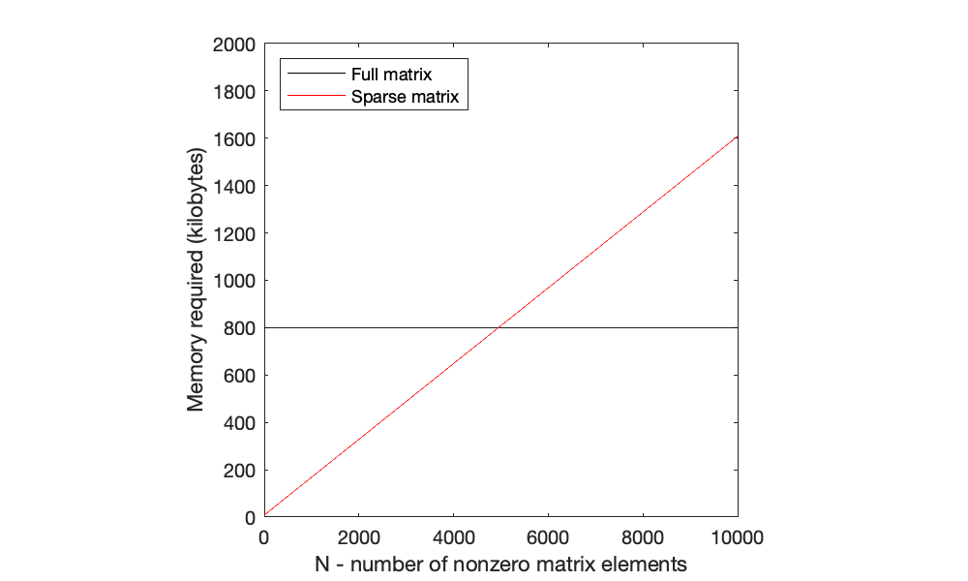

In addtion to memory, a similar dramatic savings in computational time when working with sparse arrays can be observed by using tic and toc, as we have done previously.

**Note**: if you need to convert a sparse matrix to a full matrix, this can be accomplished using full().

# TOPIC 11: Revisiting arrays, pt. 4; function handles

ENGR105, 10/8/20

What makes a good computational solution:

1. **Correct**: it works for all (or at least a specific set) of conditions
2. **Clear**: it is well-commented, concise, easy to understand, readable
3. **Computationally efficient**: it performs a task quickly while minimizing any unnecessary operations

### Practice Problem: process engineering in a medical environment

As a process engineer in a hospital, your task is to produce a computational framework for assigning doses of drugs to patients based upon their current (relative to prior) blood pressure. As described in the following schematic, your script should extract information from a starting matrix, perform some computations, and produce two output matrices.

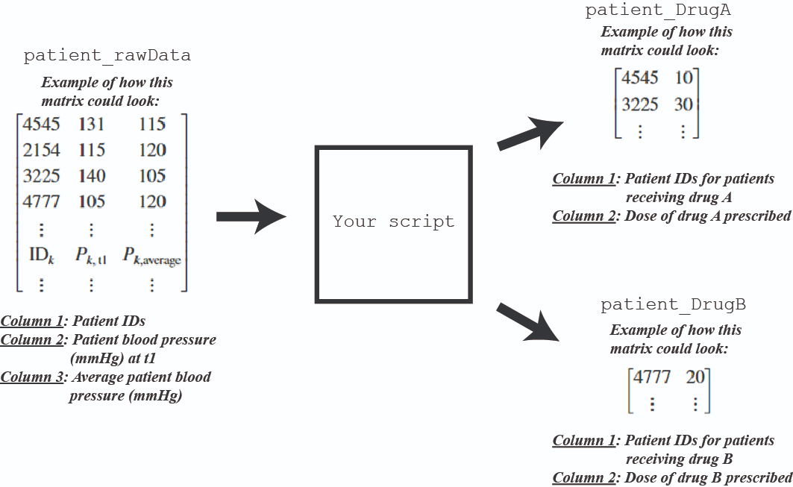

In this problem, the input is an **Nx3 matrix**, where **N is the number of patients with the aforementioned illness** (where N changes daily). Call this matrix: **patient_rawData**

Furthermore, assume each patient in the database has the same medical condition: that patient’s **systolic blood pressure (relative to that patient’s baseline)** determines if that patient should receive **drug A, drug B,** or **no medication**. The decision tree describing how doses are assigned to *each* patient is below:

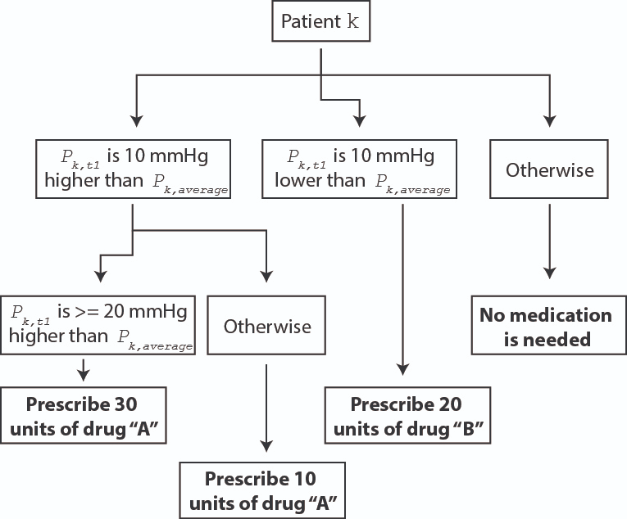

**Goal: Create a script** to convert **patient_rawData** into two new matrices: one matrix (**patient_DrugA** ) for all patients receiving **drug A**, and another matrix (**patient_DrugB**) for all patients receiving **drug B**.

* Both **patient_DrugA** and **patient_DrugB** should have two columns. As with **patient_rawData**, each row in **patient_DrugA** and **patient_DrugB** should correspond to a unique patient.
* For both **patient_DrugA** and **patient_DrugB**, the first column should contain the patient IDs and the second column should contain the doses of drug to be administered to the corresponding patients.
* **patient_DrugA** should only contain patients who should be assigned Drug A and **patient_DrugB** should only contain patients who should be assigned Drug B.
* If a patient should not be prescribed either drug, then they should **NOT** show up in either **patient_DrugA** or **patient_DrugB.**

Pre-solution code: before solving this problem, let's create a "test" patient_raw Data matrix:

% Create a test matrix of containing simulated patient information

N = 10; % Number of patients

% Input matrix containing patient information

patient_rawData = [(1:N)',randi(50,[N,2])+100];

disp(patient_rawData)

1 139 138

2 134 137

3 142 116

4 101 120

5 139 119

6 149 125

7 141 141

8 122 130

9 112 133

10 135 109

**Solution 1**

* **Define output matrices as empty initially**
* **Add the appropriate patient ID and dose (determined from code) to "next row" of output matrices**

% Step 1: Define output arrays - we will populate these as we sequentially

% go through each for loop.

patient_DrugA = [];

patient_DrugB = [];

% Step 2: For each patient, compare their blood pressure at time t1 to

% their average blood pressure to determine if they should receive meds

% Use a FOR loop because we know how many iterations to perform -> one for

% each row of patient_rawData because each row in patient_rawData

% corresponds to one patient

for k = 1:size(patient_rawData, 1)

% NOTE: the columns contain the following information:

% patient_rawData(k,1): four-digit patient ID

% patient_rawData(k,2): P_t1: blood pressures of patients at time t1

% patient_rawData(k,3): P_avg: average recent patient blood pressures

% if P_t1 - P_avg >= 10, determine if a dose of 10 or 30 should be

% applied

if patient_rawData(k,2) - patient_rawData(k,3) >= 10

% if P_t1 - P_avg >= 20 -> assign to patient_DrugA and presribe a dose

% of 30

if patient_rawData(k,2) - patient_rawData(k,3) >= 10

% Add a row to patient_DrugA, with the first entry being the

% patient ID and the second being a dose of 30

patient_DrugA(end+1,1:2) = [patient_rawData(k,1), 30];

% if P_t1 - P_avg >= 10 -> assign to patient_DrugA and presribe a dose

% of 10

else

% Add a row to patient_DrugA, with the first entry being the

% patient ID and the second being a dose of 10

patient_DrugA(end+1,1:2) = [patient_rawData(k,1), 10];

end

% if P_t1 - P_avg < 10 -> assign to patient_DrugB and presribe a dose

% of 20

elseif patient_rawData(k,2) - patient_rawData(k,3) <= -10

% Add a row to patient_DrugA, with the first entry being the

% patient ID and the second being a dose of 10

patient_DrugB(end+1, 1:2) = [patient_rawData(k,1), 20];

end

end

disp(patient_DrugA)

3 30

5 30

6 30

10 30

disp(patient_DrugB)

4 20

9 20

**Common issues**

* **Array indexing.** Be careful with the indexing inside of the for loop. This will define which entries of the output matrices are populated.
* **If-elseif statements vs. nested if statements:** in general, try to avoid nested if statements. These are fine if they are clear, but my experience has been that simpler if-elseif statements can more concisely convey a piece of code.
* **For loop syntax.** The index of the for loop does not need to be defined prior to the for loop. Also, specifying the loop to be performed for the loop index equaling one number is not valuable -- we want to specify a vector over which the index may be repeated.
* **For loops vs. while loops**. When should you use one vs. the other? If you use a while loop when a for loop is more appropriate, it may cause unintended confusion.
* **Built-in array functions**. What are the advantages and disadvantages of different ones? When should you use length() vs. size(). In general, I am against memorizing functions. However, these two are extremely useful if used correctly.

In other words, just solving a problem is not the only thing that matters. It also matters *how* you solve the problem.

**Solution 2**

* **Preallocate output matrices with the same number of rows as patient_rawData**
* **Add the appropriate patient ID and dose (determined from code) to the next row using a counter**
* **Delete all empty (ununsed) rows**

% Step 1: Define output arrays - we will populate these as we sequentially

% go through each for loop.

patient_DrugA = zeros(size(patient_rawData,1),2);

patient_DrugB = zeros(size(patient_rawData,1),2);;

%create counters to keep track or rows for the patients

rowA = 1;

rowB = 1;

% Step 2: For each patient, compare their blood pressure at time t1 to

% their average blood pressure to determine if they should receive meds

% Use a FOR loop because we know how many iterations to perform -> one for

% each row of patient_rawData because each row in patient_rawData

% corresponds to one patient

for k = 1:size(patient_rawData, 1)

% NOTE: the columns contain the following information:

% patient_rawData(k,1): four-digit patient ID

% patient_rawData(k,2): P_t1: blood pressures of patients at time t1

% patient_rawData(k,3): P_avg: average recent patient blood pressures

% if P_t1 - P_avg >= 10, determine if a dose of 10 or 30 should be

% applied

if patient_rawData(k,2) - patient_rawData(k,3) >= 10

% if P_t1 - P_avg >= 20 -> assign to patient_DrugA and presribe a dose

% of 30

if patient_rawData(k,2) - patient_rawData(k,3) >= 10

% Add a row to patient_DrugA, with the first entry being the

% patient ID and the second being a dose of 30

patient_DrugA(end+1,1:2) = [patient_rawData(k,1), 30];

% if P_t1 - P_avg >= 10 -> assign to patient_DrugA and presribe a dose

% of 10

else

% Add a row to patient_DrugA, with the first entry being the

% patient ID and the second being a dose of 10

patient_DrugA(end+1,1:2) = [patient_rawData(k,1), 10];

end

% if P_t1 - P_avg < 10 -> assign to patient_DrugB and presribe a dose

% of 20

elseif patient_rawData(k,2) - patient_rawData(k,3) <= -10

% Add a row to patient_DrugA, with the first entry being the

% patient ID and the second being a dose of 10

patient_DrugB(end+1, 1:2) = [patient_rawData(k,1), 20];

end

end

disp(patient_DrugA)

0 0

0 0

0 0

0 0

0 0

0 0

0 0

0 0

0 0

0 0

3 30

5 30

6 30

10 30

disp(patient_DrugB)

0 0

0 0

0 0

0 0

0 0

0 0

0 0

0 0

0 0

0 0

4 20

9 20

**Solution 3**

* **Use logical indexing to directly create the output matrices**
* **This is the "vectorization" equivalent**

% Create matrix for patients recieiveing drug A

%create submatrix consisting only of patients that need Drug A

patient_DrugA = patient_rawData(patient_rawData(:,2) - patient_rawData(:,3) >= 10,:);

%Use logival array indexing to determine the dose of drugs each patient

%should recive. Create a new column to clculate doses based on the

%patient's blood pressure and avg blood pressure

patient_DrugA(:,4) = 10 + 20*(patient_DrugA(:,2) - patient_DrugA(:,3) >= 20);

%Delete the unnecessary columns -> we do not want columns corresponding to patient blood pressure or the avg blood pressure.

patient_DrugA(:,2:3) = [];

%Step 2: Create matrix for patients recieving drub B

%Create a column vector consisting of only patients that will need drub B

patient_DrugB = patient_rawData(patient_rawData(:,2) - patient_rawData(:,3) <= 10,1);

%use logival array indexing to deremine the dose of drugs each person

%should receive. Create a new column containing the dose 20 -- all

patient_DrubB(:,2) = 20;

disp(patient_DrugA)

3 30

5 30

6 30

10 30

disp(patient_DrugB)

1

2

4

7

8

9

For fun, we can **compare the computational time for each of these solutions** using the approach we have discussed previous. To conserve space, only the output is shown here.

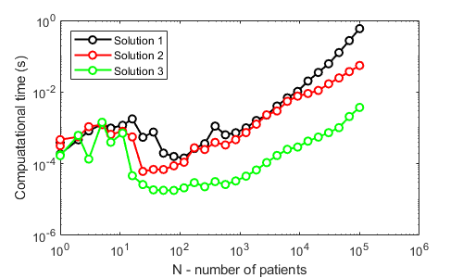

**Takeaways**

* **Clear comments and pseudocode** go a long way towards helping you understand a problem and develop a clear, robust solution.
* Avoid nested if statements, if possible.
* Understanding a decision tree is critical for developing an if statement, but also for producing a solution using logical arrays.
* **Pay particular attention to the *form*** of the output.
* **Vectorized solutions (e.g. using logical arrays) are simpler, faster, and easier to read.**

## Increasing computation efficiency with arrays (continued from last time):

### Always preallocate arrays

As we saw with vectors, preallocation is the process of creating an array of the final size (usually padded with zeros) before modifying each element of the array. **Consider the computational time associated with creating an NxN multiplication table** using for loops for different numbers of N.

That is, what we want to create:



% Determine range of N

N = logspace(0,3,4);

% Preallocate vectors to store computational time

t_no = zeros(length(N),1);

t_yes = zeros(length(N),1);

% For each number of elements considered

for k = 1:length(N)

% Calculate time without preallocation

tic;

% For each row

for jj = 1:N(k)

% For each column

for mm = 1:N(k)

% Each entry is the produce of the rows and columns of the

% multiplication table

multTable(jj,mm) = jj*mm;

end

end

t_no(k) = toc;

% Calculate time without preallocation

tic;

% Preallocate array

multTable = zeros(N(k),N(k));

% For each row

for jj = 1:N(k)

% For each column

for mm = 1:N(k)

% Each entry is the produce of the rows and columns of the

% multiplication table

multTable(jj,mm) = jj*mm;

end

end

t_yes(k) = toc;

% Delete multiplication table so that it can be created from scratch on

% the next loop

clear multTable

end

% Define dimensions of plot

figure('Position',[0,0,500,300]);

% Plot the functions

plot(N,t_no,'ko-',N,t_yes,'ro-','LineWidth',1.5,'MarkerFaceColor','auto')

% Graphical parameters

set(gca, 'XScale', 'log') % "log" axes - x

set(gca, 'YScale', 'log') % "log" axes - y

set(gca,'XMinorTick','on')

xlim([10^0,10^4]); % range of x values on plot

ylim([10^-6,10^0]); % range of y values on plot

xlabel('N - number of vector elements');

ylabel('Compuatational time (s)');

legend('No preallocation','Preallocation','Location','northwest')

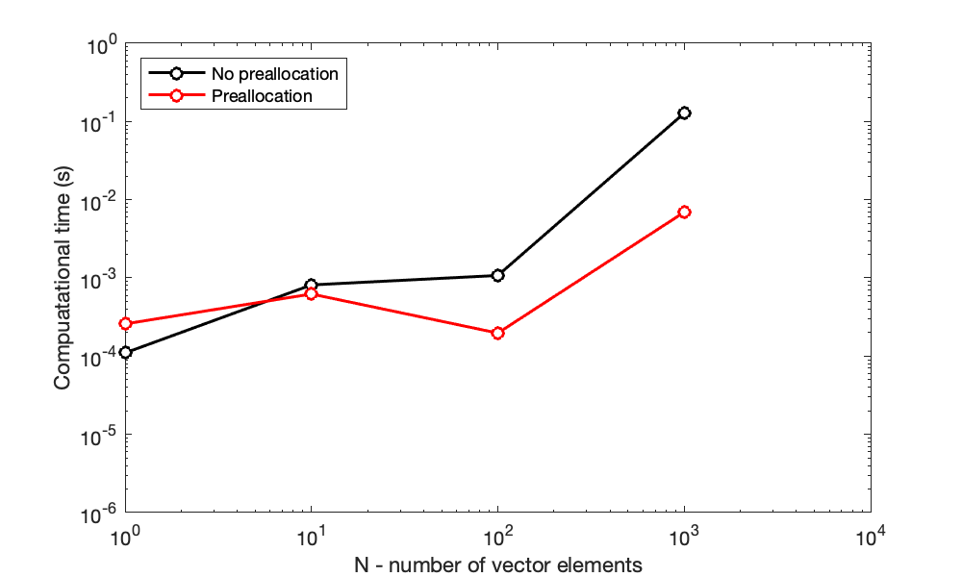

**Side note**: the above multiplication table can be created **much more efficiently** using **matrix multiplication** instead of nested for loops.

multTable = (1:10)'*(1:10)

multTable = 10×10

1 2 3 4 5 6 7 8 9 10

2 4 6 8 10 12 14 16 18 20

3 6 9 12 15 18 21 24 27 30

4 8 12 16 20 24 28 32 36 40

5 10 15 20 25 30 35 40 45 50

6 12 18 24 30 36 42 48 54 60

7 14 21 28 35 42 49 56 63 70

8 16 24 32 40 48 56 64 72 80

9 18 27 36 45 54 63 72 81 90

10 20 30 40 50 60 70 80 90 100

### Sparse arrays

Sparse matrices -- large arrays with few nonzero entries -- are encountered in a broad set of engineering disciplines, with applications including solving PDEs, search algorithms, atomistics, and FEA.



Consider a sparse matrix of dimensions 1000 x 2000 elements - that correlates to 2 million data points. Assume that this matrix contains non-zero values at the following indices:

* (row 3, column 4) = 15
* (row 100, column 1500) = 5
* (row 1000, column 2000) = 9

This matrix may be established using a conventional matrix indexing:

A = zeros(1000,2000);

A(3,4) = 15;

A(100,1500) = 5;

A(1000,2000) = 9;

Sparse matrices can be stored efficiently as a matrix of 0’s with nonzero values stored by their row, column, and value – this can save significant memory space. In the above example, this matrix could also be established using a sparse matrix syntax:

B = sparse([3,100,1000],...

[4,1500,2000],...

[15,5,9],1000,2000);

Or, the original non-sparse matrix A could also be converted to a sparse matrix:

B = sparse(A);

**The sparse matrix offers considerable savings for memory**. Information about a variable can be depicted using the whos command.

whos A B

Name Size Bytes Class Attributes

A 1000x2000 16000000 double

B 1000x2000 16056 double sparse

In this case, variable A requires 16 MB of memory to create the **full matrix**, whereas variable B (**the sparse array**) only requires 16 kB! Dramatic savings in memory can be observed when most of the elements are zero.

**At what number of nonzero elements do sparse matrices lose this advantage?** Let's plot the memory associated with a matrix variable for different numbers of nonzero elements in a 100x100 matrix.

% Define a matrix intially with all zeros

A = zeros(100,100);

% Preallocate vector to store memory

mem_Full = zeros(1,numel(A));

mem_Sparse = zeros(1,numel(A));

% Repeat for all elements

for k = 1:numel(A)

A(k) = randi(5);

A_sparse = sparse(A);

matrixInfo = whos('A','A_sparse');

mem_Full(k) = matrixInfo(1).bytes;

mem_Sparse(k) = matrixInfo(2).bytes;

end

% Plot the functions

plot(1:numel(A),mem_Full/100,'k-',1:numel(A),mem_Sparse/100,'r-')

% Graphical parameters

axis square

xlim([0,10^4]); % range of x values on plot

ylim([0,2*10^3]); % range of y values on plot

xlabel('N - number of nonzero matrix elements');

ylabel('Memory required (kilobytes)');

legend('Full matrix','Sparse matrix','Location','northwest')



Since sparse variables need to also store information about the nonzero indices, these variables will require more space when more entries are full. In addtion to memory, a similar dramatic savings in computational time when working with sparse arrays can be observed by using tic and toc, as we have done previously.

**Note**: if you need to convert a sparse matrix to a full matrix, this can be accomplished using full().

## Revisiting functions

As we have seen so far in this class, functions are **named assemblages of code** that perform specific tasks. By encapsulating sections of code in functions, we can call the function to efficiently repeat the enclosed tasks, while potentially changing any number of inputs.

Functions:

* Take in inputs (from none to many)
* Return outputs (from none to many)
* Are created with a function declaration (at the end of the LiveScript document or in a separate .m file)

function myFunction

function out1 = myFunction(in1,in2,in3)

function [out1,out2] = myFunction(in1,in2,in3)

function myFunction(in1,in2,in3)

In terms of precedence, commas in a function declaration can be thought of as having the lowest precedence. That is, commas separate inputs, even if the inputs themselves are complicated expressions.

A = 1:4

A = 1×4

1 2 3 4

B = A > 2

B = *1×4 logical array*

0 0 1 1

% Sum over all rows

sum(((A>2) | A == 1),1)

ans = 1×4

1 0 1 1

Consider the function square_add1, below, which has 2 inputs and 1 output. This function is stored at the end of this LiveScript document.

function res1 = square_add1(a,b)

% Example function. In this case there are two inputs and one

% output.

res1 = a^2 + b^2 + 1;

end

Functions are properly called by matching the form of the function declaration in your script.

val1 = 1;

val2 = 2;

% Call function

x = square_add1(val1,val2)

x = 6

**Note**: the definition of inputs a, b, and c are unique to the function itself and **can't be seen by the memory workspace** from which the function was invoked.

A common struggle when learning about functions is (unintentionally) **not capturing all of the outputs when invoking the functions**. Consider the function addMultiply.

function [res1,res2] = addMultiply(a,b,c)

% Example function

res1 = a+b+c;

res2 = a*b*c;

end

The following would **only capture the first output** of addMultiply (res1 in the function declaration) and store it in ans (the default variable when no assignment is described) as no output assignment is declared.

addMultiply(val1,val2,val3)

If only one output is desired, use a **tilde** to **suppress the undesirable output.** The tilde in this case says "this first output is defined/required by the function, but I don't want it…I just want the second output"

[~,b] = addMultiply(val1,val2,val3)

### Function handles

Functions can be passed as variables and referenced/invoked by using this new variable. A variable that has been assigned to a function is referred to as a function handle. Consider our previous function.

function res1 = square_add1(a,b)

% Example function. In this case there are two inputs and one

% output.

res1 = a^2 + b^2 + 1;

end

To create a function handle, use the @ symbol. This indicates that the variable is a function handle and not a data type. The following is an example of assigning the function square_add1 to the function handle a

% Create a function handle

f1 = @square_add1;

% Use the function handle. Note the scalar inputs are passed to the

% function in the same way as before.

y = f1(1,2)

y = 6

**Important feature: function handles enable us to pass a function as an input** into another function.

function res2 = operateOnKnownValues(fxn)

% This function takes an input function and prescribes to set inputs: 1

% and 2

res2 = fxn(1,2);

end

% Create function handle for new function

f2 = @operateOnKnownValues

f2 = *function_handle with value:*

@operateOnKnownValues

% Input square_add1 into new function

z = f2(@sum)

z = 1

You can create function handles for **built-in functions** in addition to custom functions.

% Create a vecotr

A = 1:4

A = 1×4

1 2 3 4

% Create function handle for sum() function

f1 = @sum;

f1(A)

ans = 10

**Example**. Create function handles for the following two functions that are created at the end of this document.

function res3 = exampleA(fxn,A)

% Example function: input 1 is a function, input 2 is an array

res3 = fxn(A) + 1;

end

% Function handle for example A

f2 = @exampleA

f2 = *function_handle with value:*

@exampleA

function res4 = exampleB(fxn,A)

% Example function: input 1 is a function, input 2 is an array

res4 = fxn(A) - 1;

end

% Function handle for example B

f3 = @exampleB

f3 = *function_handle with value:*

@exampleB

% Call example function, input sum and A. The following two are equivalent

out1 = f3(@sum,A)

out1 = 9

out2 = f2(f1,A)

out2 = 11

% NOTE: an error will occur if you input a function and not a function

% handle

% out3 = f2(sum,A)

### Example: force on a spring

In your physics, chemistry, and engineering courses, you will likely encounter Hooke's law, which relates the displacement of the end of a spring (i.e. the stretching or compression of the spring) to the force required to cause that deformation:

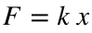

This equation describes a linear dependence of the force on the material deformation. An elastic body or material for which this equation can be assumed is said to be linear-elastic or **Hookean**.

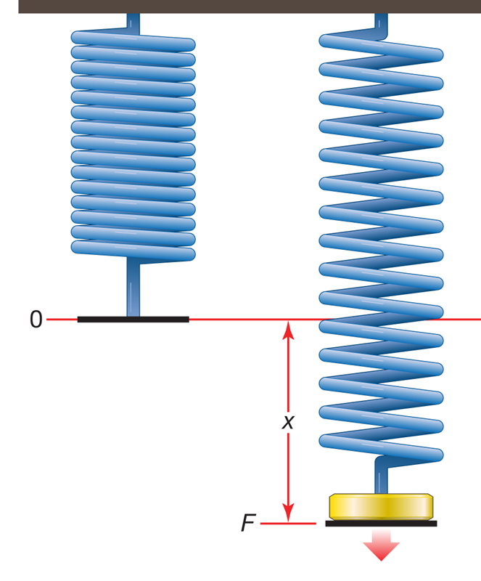

Consider the function springForce1, which computes the force on a Hookean spring based on its displacement

function force = springForce1(delta)

% Calculate the force required to cause a deformation of delta

% Spring constant = 0.5

force = 0.5*delta;

end

The function can be assigned to a function handle and invoked with an input for delta from the command line, a script, or another function

% Create function handle

a = @springForce1;

% Call function

myForce = a(4)

myForce = 2

However, **nonlinear springs are also common**, as even the most linear spring can be deformed enough such that a nonlinear relationship between force and deformation becomes apparent. Consider force-displacement relationship for another spring.

function force = springForce2(delta)

% Calculate the force required to cause a deformation of delta

% in a nonlinear spring

force = .2*delta^2 + .5*delta;

end

Using function handles, we could easily create a modular representation of two springs in parallel.

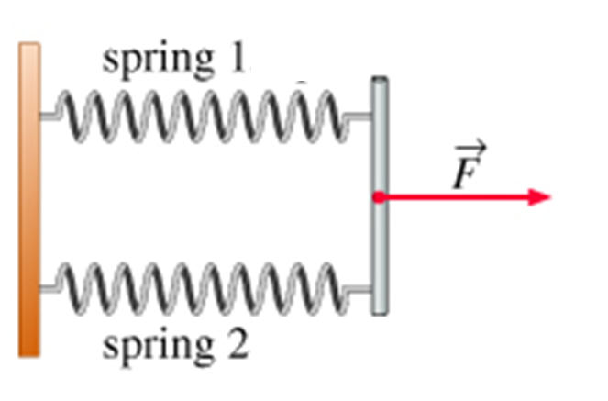

In this case, the net force is determined as the sum of the contributions from each spring, which could be encoded into a separate function.

function force = parallelSprings(spring1,spring2,delta)

% Force for two springs loaded in parallel config.

% spring1 = handle to force/deflection eqn for spring 1

% spring2 = handle to force/deflection eqn for spring 2

% delta = displacement of springs

force = spring1(delta) + spring2(delta);

end

% Evaluate the total force when spring 1 and 2 are arranged in parallel

force = parallelSprings(@springForce1,@springForce1,5)

force = 5

**Note**: in this way, we use functions to create a framework in which we can easily change different components.

**The following functions are used to introduce function handles.**

# 

# TOPIC 12: Function handles and recursion

ENGR105, 10/13/20

### Reminder: function handles

Functions can be passed as variables and referenced/invoked by using this new variable. A variable that has been assigned to a function is referred to as a function handle. Function handles may be created with **user-defined** or **built-in** functions.

% Create function handle with product function

a = @prod;

a([3,2,1,2])

ans = 12

b = @mod;

% Create function handle with modulus function

b(3,2)

ans = 1

Function handles are **useful** because these enable us to **pass one function into another function**. Consider the following function.

function fxn1(f,x)

% Example function

output = f(x);

disp(strcat('The output of this function is ',num2str(output)));

end

% Create a function handle

f1 = @sum;

% Define a vector

c = 1:4

c = 1×4

1 2 3 4

% Call function that takes the handle and vector as inputs

fxn1(f1,c)

The output of this function is...10

Where else have we seen function handles? **We saw them when solving systems of nonlinear equations (Topic 3 / Lecture 4).**

% Determine solution 1

sol_1 = fsolve(@eqnSet,[0,0])

Here, eqnSet contained a set of nonlinear equations to be solved:

function F = eqnSet(x)

% System of two non linear equations

% F(1) and F(2): "equation" 1 and 2, respectively

% x(1) and x(2): variable 1 and 2, respectively

F(1) = x(2)-2*x(1)^2+3;

F(2) = x(2)^2-x(1);

end

How does fsolve take in a function handle to solve the set of equations? Let's consider a more familiar example.

### Practice problem: a root-finding numerical solver

**Create a function** that uses the Newton-Raphson method to find the root of any arbitrary (well-behaved) input function. **Apply this function** to find the root of the following equation, where 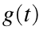 could represent a *temporal concentration profile*, signal, or other *time-dependent function*.

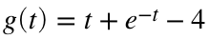

**Checking in**: what does it mean to find the *root of an equation*? It means solving for when that function is **equal to zero**.

% Time vector

t = 0:0.1:5; % Time vector

g = t + exp(-t)-4; % Function g(t)

plot(t,g,'k-')

axis square

xlabel('t')

ylabel('g(t)')

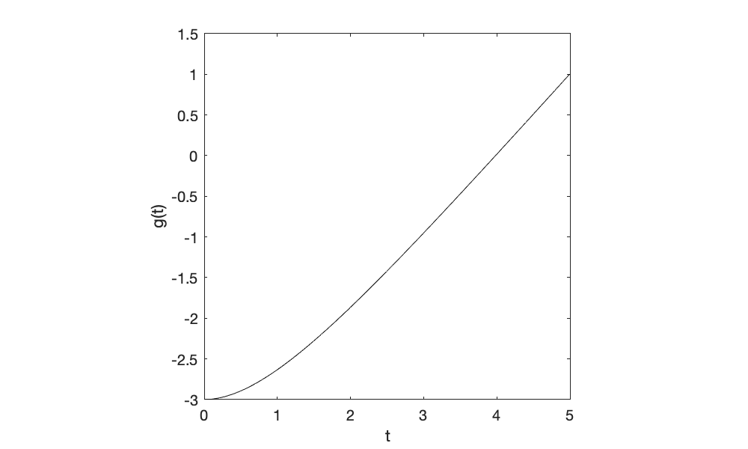

Start by remembering our systematic approach.

**PRO:**

1. **P**lan, **P**repare, and **P**seudocode
2. w**R**ite **R**ough (increments of code) and **R**efine
3. **O**ptimize and improve

**Step 1: Plan, prepare, pseudocode**

Recall from earlier, the Newton-Raphson method is an iterative algorithm for finding a root (based on an initial guess) of any well-behaved function. The Newton-Raphson equation is given by the following:



In **Topic 7 / Lecture 8**, we found the root of the following 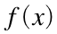 by creating a script that applies the Newton-Raphson method.



% Script for using the Newton-Raphson method to solve for f(x)

% Step 1: specify initial guess

xn = 5; % initial guess

xprev = inf; % Variable to store previous xn value -> ensure it is

% not xn to enter while loop

% Step 2: iterate until xn -> xn+1

while abs(xn - xprev) > 10^-5

% Step 3: evaluate function at xn

fn = xn^4 + 2*(xn-2)^2 - 20;

% Step 3a: evaluate derivative at xn

f_prime_n = 4*xn^3 + 4*(xn-2);

% Instead of calculating the "next" x value, store the previous xn

% value

xprev = xn;

% Step 3b: update xn to next value for the iteration

xn = xn - fn/f_prime_n;

end

disp(xn)

2.1141

**Step 2:** w**R**ite **R**ough (increments of code) and **R**efine (to code a new application)

%Determine root of original f(x)

rootF = newtonSolve(@originalEqn, 5, 10^-5)

rootF = 2.1141

**Apply this function to the problem here:**

rootG = newtonSolve(@originalEqn, 5, 10^5)

rootG = 3.7832

newEqn(rootG)

ans = 1×2

-0.1940 0.9773

**We have thus created our first function that works as a numerical solver!**

### Anonymous functions

Function handles can also be used to store **anonymous functions**. Anonymous functions are **not "only" the built-in function** or **a custom function stored in a .m file**, but are associated with a variable. These are useful for smaller/repeatable computations that don't demand a full function and accessibility from multiple functions. Anonymous functions may take in one to multiple inputs, can only return one output, and begin with a list of input variables @(var1,var2,…,varN).

* Example operating on a **scalar**:

% Anonymous function of a single input operating on a

% scalar.

myFunc = @(x) x^2 + 2*x + 1;

res1 = myFunc(1)

res1 = 4

* Example on a **vector**:

% Anonymous function of a single input operating on a

% vector.

myFunc = @(x) x.^2 + 2.*x + 1;

res2 = myFunc([1:4])

res2 = 1×4

4 9 16 25

* Example with **multiple inputs**:

% Anonymous function of a multiple inputs operating on

% scalars.

%x and y are the inputs

myFunc = @(x,y) x^2 + 2*y +1;

res3 = myFunc(1,3)

res3 = 8

% Anonymous function of a multiple inputs operating on

% vectors.

myFunc = @(x,y) x.^2 + 2.*y +1;

res4 = myFunc([1,2,2,1],4:7);

* Example using **built-in function**

mod2 = @(x) mod(x,2);

mod2(3)

ans = 1

**Note**: this is different from a "simple" function handle based only on a built-in function. Here, we define a function handle that only takes *one* input. Previously, the function handle must take *two* inputs.

**Example**. Plot the following equation, 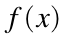, over the domain 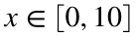 for 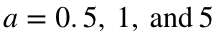.

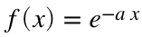

% Plot x vector

x = 0:0.1:10;

% Define function handle

f = @(a) exp(-a*x)

f = *function_handle with value:*

@(a)exp(-a*x)

% Plot function for each a

plot(x,f(0.5),'k-')

hold on % plot on the same set of axis

plot(x,f(1),'r-')

hold on % plot on the same set of axis

plot(x,f(5),'b-')

hold off % turn "off" plotting on the same set of axis

axis square

legend('a = 0.5','a = 1', 'a = 5')

xlabel('x')

ylabel('f(x)')

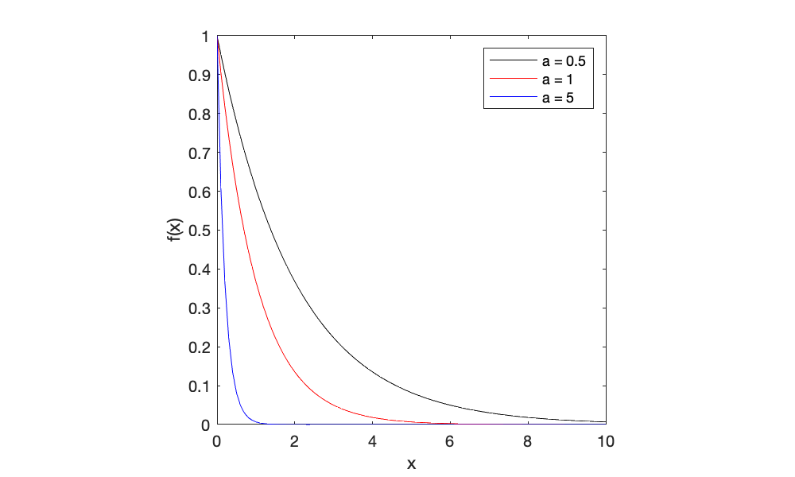

**Note**: anonymous functions (and function handles) can help reduce the frequency of recurring errors.

## Recursion

To *repeat tasks* in a computational environment, one could either use loops (as we have seen before) or call a **recursive function**. Recursive functions call themselves. When a function calls itself, it "opens" a new implementation of the function that is distinct from the original invocation. Consider the function recursiveAdd, defined at the end of this LiveScript document.

function out = recursiveAdd(in)

% Adds a number to the input up to

% a value of 5

if in<5

in = in + 1;

out = recursiveAdd(in); % Recursive call

else

out = in; % the base conditionstops the recursion

end

end

The following schematic indicates what will happen when this is called:

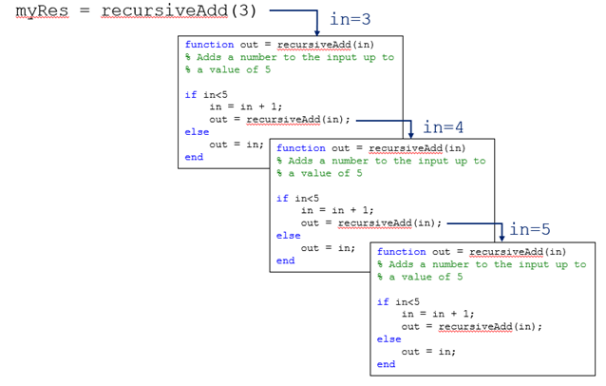

**Once the logical statement is not satistifed**, each invocation of the function will output the same entity.

% Call the recursive function

x = recursiveAdd(3)

x = 5

### Example: Revisiting the fibonacci sequence

Earlier in this course, we created code to calculate either the first n entries of the Fibonacci sequence or all elements less than some integer. For example, consider the latter, in which we can use a while loop to calculate all elements of the Fibonacci sequence less than 50.

% Max value of entries in Fibonacci sequence

n = 50;

% Define first two entries

x(1) = 0;

x(2) = 1;

% Iterate as long as the last element is less than 100.

while x(end) < n

% If the last element is less that 100, add the next element of the

% Fibonacci sequence to the vector

x(end+1)=x(end)+x(end-1);

end

x(end)=[]; % Remove last element

disp(x)

0 1 1 2 3 5 8 13 21 34

The same process can be accomplished using **recursion**. Consider the following function.

function x = recursiveFib(x,maxVal)

% Function using recursion to create a Fibonacci sequence vector

% If the last element is less that maxVal, add the next element of the

% Fibonacci sequence to the vector

if x(end-1) + x(end) < maxVal

% Calculate next entry

x(end+1) = x(end)+x(end-1);

% Use recursion to repeat the process

x = recursiveFib(x,maxVal);

end

end

% Calculate Fibonacci sequence vector containing elements less than 50

x = recursiveFib(0:1,50)

x = 1×10

0 1 1 2 3 5 8 13 21 34

**Recursion can be useful:**

* **Not all languages support loops** (e.g. Haskell)
* Loops may, in some cases, require more complex code/indexing that leads to a *higher probability of errors.*

Recursion can have **limitations**:

* First, recursive solutions may involve extensive overhead because they use function calls.
* Each time you make a call you use up some of your memory allocation. If the recursion is deep – that is, if there is a large number of recursive calls – then you may run out of memory.

### Example: calculate the factorial of a number

Consider calculating the factorial of a number:

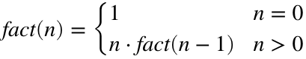

We can solve this problem using either recursion or loops in MATLAB. Consider the following recursive function.

function y = fact(n)

% Recursive function for determining the factorial

% Specify the number we are interested in solving the factorial for

y = n;

% Specify the "lower limit" in the factorial calculation

if n == 0

y = 1;

else

% We multiply by all the integers before the input,

% one at a time...

y = y*fact(n-1);

end

end

The factorial of a number may be calculated by calling this **recursive function**. However, "out-of-memory" errors will arise for **large input numbers**.

n = 50000;

% Call recursive function

x = fact(n);

This issue is avoided by using a simple for loop.

fact_n = 1;

for m = 1:n

fact_n = fact_n*m;

end

**Takeaway**: recursion is another tool that, in the right context, will yield simple, easy-to-troubleshoot code.

# TOPIC 13: Plotting in MATLAB

ENGR105, 10/15/20

**An introductory note about data**

As scientists and engineers, you will work a lot with data: acquiring it, processing it, visualizing it. An advantage of MATLAB is that many data visualization capabilities are built into MATLAB. We will start by importing sensor data.

% Load the data we just collected

rawData = load('sensorData5.mat')

rawData = *struct with fields:*

Position: [42×6 timetable]

The imported data is an *object*, a data structure. The table that we want can be specified by selecting the Position field.

% Timetable containing our collected sensor data

rawData = rawData.Position

rawData = *42×6 timetable*

**Timestamp** **latitude** **longitude** **altitude** **speed** **course** **hacc**

**________________________** **________** **_________** **________** **_____** **______** **______**

**15-Oct-2020 09:03:04.624** 39.952 -75.191 13.347 0.462 187.39 35.374

**15-Oct-2020 09:03:05.624** 39.952 -75.191 13.07 0.29 203.6 26.742

**15-Oct-2020 09:03:06.624** 39.952 -75.191 13.07 0.29 203.6 26.742

**15-Oct-2020 09:03:07.624** 39.952 -75.191 13.045 0.245 203.49 21.802

**15-Oct-2020 09:03:08.624** 39.952 -75.191 13.053 0.277 209.58 25.921

**15-Oct-2020 09:03:09.624** 39.952 -75.191 13.035 0.275 211.23 43.667

**15-Oct-2020 09:03:10.625** 39.952 -75.191 13.038 0.275 208.77 61.217

**15-Oct-2020 09:03:11.625** 39.952 -75.191 13.033 0.261 212.36 26.538

**15-Oct-2020 09:03:12.625** 39.952 -75.191 13.039 0.257 212.19 27.775

**15-Oct-2020 09:03:13.625** 39.952 -75.191 13.041 0.248 212.04 29.138

**15-Oct-2020 09:03:14.624** 39.952 -75.191 13.042 0.242 211.56 30.59

**15-Oct-2020 09:03:15.760** 39.952 -75.191 13.041 0.237 209.36 32.166

**15-Oct-2020 09:03:31.167** 39.952 -75.19 13.242 0 0 65

**15-Oct-2020 09:03:37.127** 39.952 -75.19 13.441 0 0 65

**15-Oct-2020 09:03:50.359** 39.952 -75.19 13.441 0 0 73.948

**15-Oct-2020 09:03:50.364** 39.952 -75.19 13.441 0 0 73.948

**Note**: a field is essentially a parameter for the object. This parameter can contain some setting or it can contain useful data.

When working with data, it is **extemely important** to understand what ***class*** (or data type) you are working with.

* myData is timetable class
* myData.Timestamp is datetime class
* myData.speed is double class
* 'hello world' is char class

**Important**: when working with data, part of **STEP 1** (**P**lanning, **p**rep, and **p**seudocode) is always getting your data into the correct format. For now, we will simply convert the above data table into a matrix containing all numbers (of class double).

**Note on coordinates systems**: one can convert latitude and longitude differences to distance using knowledge of coordinate systems. For the purposes here, we will use a "rule of thumb" from the [USGS](https://www.usgs.gov/faqs/how-much-distance-does-a-degree-minute-and-second-cover-your-maps?qt-news_science_products=0#qt-news_science_products): At 38 degrees North latitude:

* One degree of **latitude** equals approximately 364,000 feet (69 miles), one minute equals 6,068 feet (1.15 miles), and one-second equals 101 feet.
* One-degree of **longitude** equals 288,200 feet (54.6 miles), one minute equals 4,800 feet (0.91 mile), and one second equals 80 feet.

% Step 1: convert the Timestamp information into "seconds past start time"

% Convert date time vector into numbers representing the corresponding minutes

t = minute(rawData.Timestamp) + second(rawData.Timestamp)/60;

t = (t - t(1))*60; % t is now a vector in which entries are in seconds

% Step 2: Convert positional information to relative positions

% Convert both to relative positions

lat_1 = (rawData.latitude - rawData.latitude(1));

long_1 = (rawData.longitude - rawData.longitude(1));

% Both are in units of "degrees" -> convert to units of meters

lat_2 = lat_1*364000*0.3048;

long_2 = long_1*288200*0.3048;

% Convert altitude to relative z position, in meters

alt = rawData.altitude - rawData.altitude(1);

% Step 2: Create data matrix

myData = [t,long_2,lat_2,alt,rawData.speed];

disp(myData)

0 0 0 0 0.4620

1.0000 -0.8784 -1.1095 -0.2770 0.2900

2.0000 -0.8784 -1.1095 -0.2770 0.2900

3.0000 -0.8784 -2.2189 -0.3020 0.2450

4.0000 -0.8784 -3.3284 -0.2940 0.2770

5.0000 -0.8784 -3.3284 -0.3120 0.2750

6.0010 -0.8784 -3.3284 -0.3090 0.2750

7.0010 -1.7569 -4.4379 -0.3140 0.2610

8.0010 -1.7569 -4.4379 -0.3080 0.2570

9.0010 -1.7569 -4.4379 -0.3060 0.2480

10.0000 -1.7569 -4.4379 -0.3050 0.2420

11.1360 -1.7569 -4.4379 -0.3060 0.2370

26.5430 41.2864 -36.6126 -0.1050 0

32.5030 44.8001 -38.8315 0.0940 0

45.7350 64.1257 -53.2547 0.0940 0

45.7400 64.1257 -53.2547 0.0940 0

51.9090 39.5295 -44.3789 9.7340 0

55.3610 35.1373 -44.3789 10.1320 0

55.7870 45.6785 -52.1452 9.8350 0

58.1060 47.4354 -57.6925 9.7520 0

58.5210 47.4354 -58.8020 9.6310 0

64.7160 54.4629 -66.5683 9.2280 0

70.0000 32.5020 -52.1452 2.8660 0.2960

71.0000 32.5020 -52.1452 2.8660 0.2960

72.0000 30.7452 -55.4736 -1.4850 0.3580

73.0000 27.2314 -54.3641 -1.5480 0.3580

74.0000 27.2314 -56.5831 -1.5190 0.4710

74.9990 26.3530 -59.9115 -1.5550 0.6290

75.9990 26.3530 -62.1304 -1.5930 0.6060

76.9990 25.4746 -63.2399 -1.6090 0.6060

77.9990 23.7177 -65.4588 -1.6680 0.1980

78.9990 23.7177 -65.4588 -1.6410 0.1990

79.9990 25.4746 -65.4588 -1.6610 0.1510

80.9990 22.8393 -67.6778 -1.7470 0.3580

81.9990 23.7177 -71.0062 -1.7350 0.3990

82.9990 24.5961 -71.0062 -1.7520 0.3720

83.9990 24.5961 -72.1157 -1.7830 0.1140

84.9990 22.8393 -72.1157 -1.8370 0.2040

85.9990 21.9608 -73.2252 -1.8570 0.2630

86.9990 21.0824 -73.2252 -1.8410 0.2690

87.9990 20.2040 -73.2252 -1.8140 0.1450

88.9990 20.2040 -74.3346 -1.7820 0.2290

**Note**: always include in your script (or function) explicit information about what each row or column of a matrix corresponds to. I do this by commenting out portions of code

% myData(:,1): time, seconds

% myData(:,2): longitude (x value), meters relative to start.

% Positive x: move east; negative x: move west

% myData(:,3): latitude (y value), meters relative to start

% Positive y: move north; negative y: move south

% myData(:,4): altitude (z value), meters relative to start

% myData(:,5): speed, meters/second

## Plotting in 2D

**Helpful resources:**

* **List of plotting functions in MATLAB**

<https://www.mathworks.com/help/matlab/creating_plots/types-of-matlab-plots.html>

* **Axis settings**

<https://www.mathworks.com/help/matlab/ref/axis.html>

* The help documentation for all of these functions.

### plot() - the "workhorse" plotting function

* plot() requires **input vectors of equal length**

% Independent variable

t = 0:0.1:10;

% Function (dependent variable) is sin(t)

f = sin(t);

% Plot the function: adjust the "line specification" to change the output

plot(t,f,'k-')

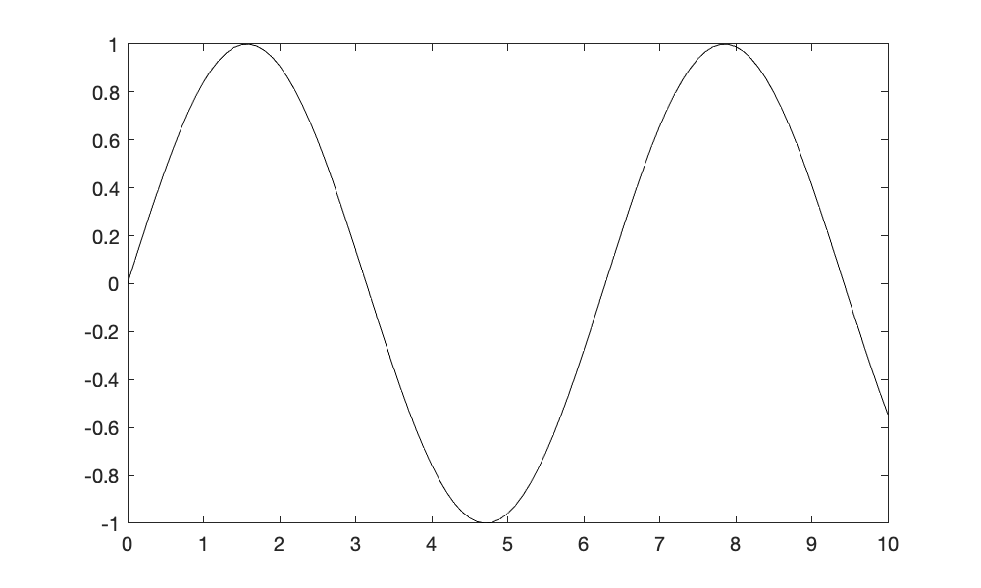

% time

t1 = myData(:,1);

% z position

y1 = myData(:,4);

% Plot the function: adjust the "line specification" to change the output

plot(t1,y1,'ko-');

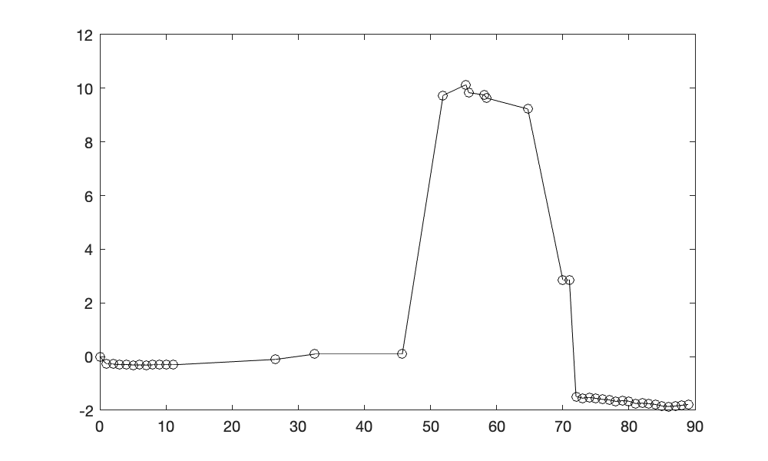

**Plotting straight lines**. Straight lines can be plotted by specifying as little as two points - the beginning and end of the line

plot([0 20],[-5 5],'r--')

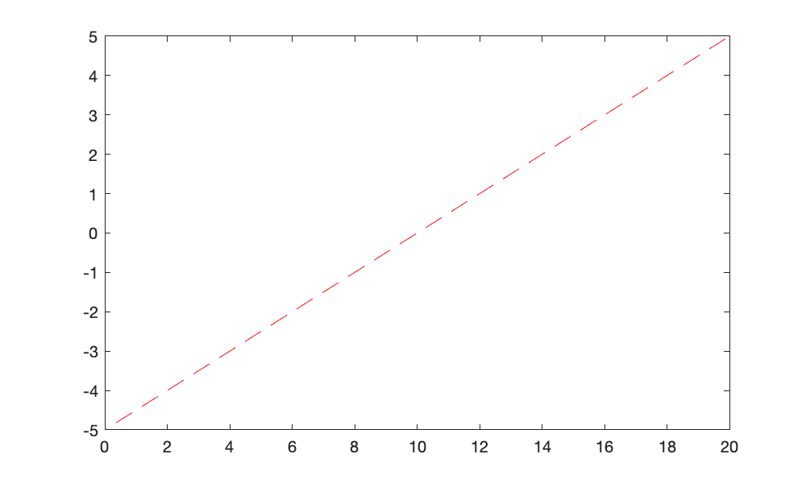

**Plotting one vector**. Most 2D plot commands can be called with a single vector, which is often useful for debugging.

plot(myData(:,1),'ko','MarkerFaceColor','k')

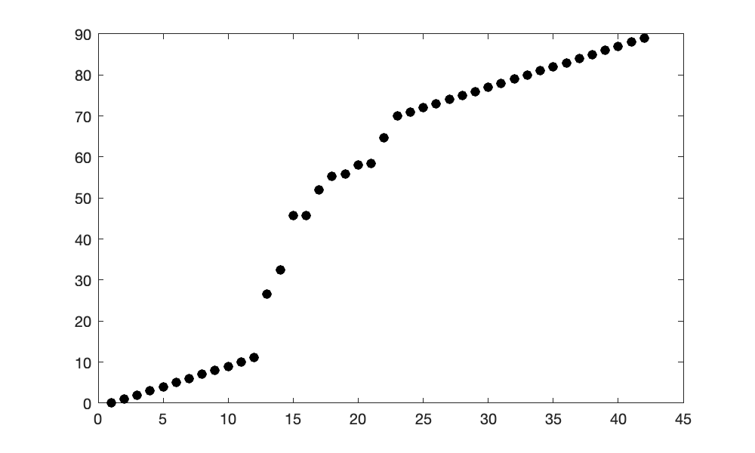

In this case, the x values indicate the **index number**.

### Overlaying plots

**Using one plot function call**. Multiple plots may be **overlaid** by **specifying multiple vectors** for most built-in plotting functions.

x = -2*pi:pi/20:2*pi;

y1 = sin(x);

y2 = cos(x);

plot(x,y1,'ro-',x,y2,'k-','LineWidth',4,'MarkerSize',10)

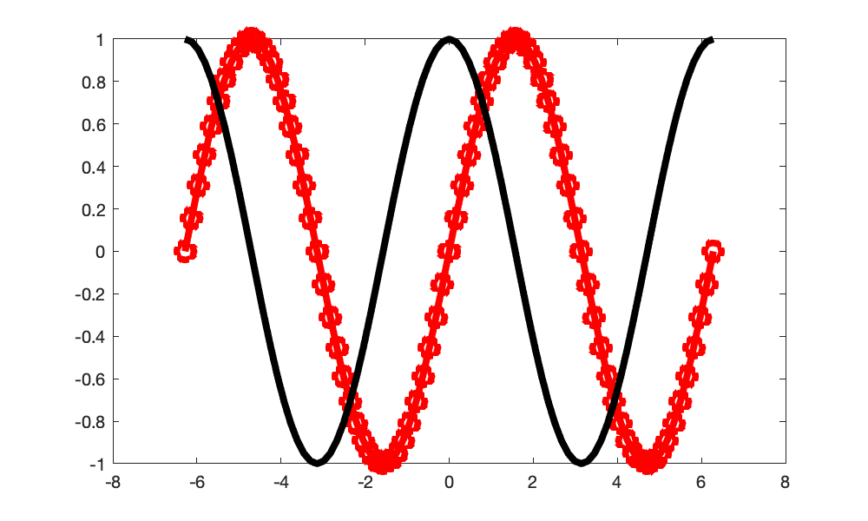

Here, the "x" input must be specified for each plot instance. In the above, MATLAB automatically chooses the plotting colors unless otherwise specified. Plot colors may be specified for each vector.

**Note**: line specifications such as LineWidth invoked within the plot function will be applied to **all** data series when using this method.

**Using hold on/off**. Multiple plots may also be overlaid by using the hold on and hold off commands

x = -2*pi:pi/20:2*pi;

y1 = sin(x);

y2 = cos(x);

plot(x,y1,'r-','LineWidth', 5)

hold on

plot(x,y2,'b-','LineWidth', 5)

hold off

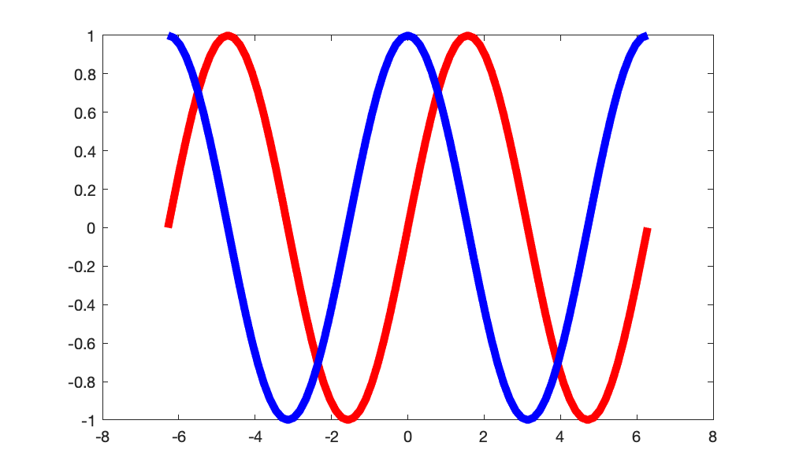

hold on is invoked after the first plot command and indicates that more data will be attributed to the existing axes; hold off "closes out" hold on.

% x position vs. time

plot(myData(:,1), myData(:,2),'ro-');

hold on

% y position vs. time

plot(myData(:,1), myData(:,3),'bo-');

hold on

% z position vs. time

plot(myData(:,1),myData(:,4),'ko-','LineWidth',2)

hold off

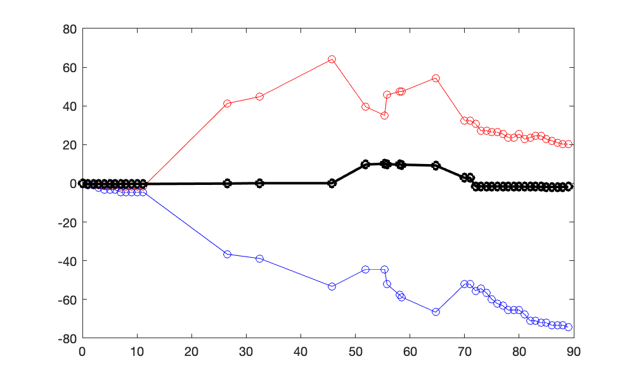

**IMPORTANT NOTE**: if you are **not** using a LiveScript file, any additional plots will completely overwrite the axes if you do not use hold on/off. hold on is only needed once, though I often call it after every plot for clarity.

### Specifying plot attributes inline

The canonical plot call is:

plot(x,y,‘LineSpecifiers', ...

‘PropertyName',PropertyValue)

**Line specifiers**

* Line style: solid, dash, dot, dash-dot
* Line color: red, green, blue, cyan, etc.
* Marker: plus, circle, asterisk, etc.

**Property names**

* LineWidth
* MarkerSize
* MarkerEdgeColor
* MarkerFaceColor

% Independent variable

t = 0:.1:10;

% Function (dependent variable) is sin(t)

f = sin(t);

% Plot the function: adjust the "line specification" to change the output

plot(t,f,'ko','MarkerFaceColor','y','LineWidth',2)

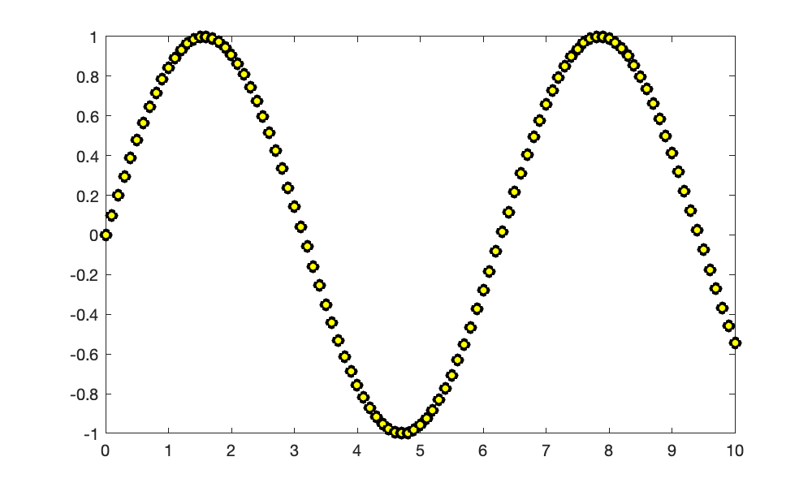

**Note**: the default plot attributes are blue lines, though this can be changed by adjusting the above inputs. Please see the **help** documentation for plot and adjust the above plot.

Can you produce the above with:

* Red circles
* Red circles with lines between markers
* Black circles with connected lines
* Green dots
* Magenta circles with dashed lines between markers
* Black plot line set to a 10 pt width
* Circles with a green face color, red edge color, and 2 pt edge width

### Colors

MATLAB includes many predefined colors:

* r = Red
* g = Green
* b = Blue
* c = Cyan
* m = Magenta
* y = Yellow
* k = Black
* w = White

Colors may also be specified using the Color (or other appropriate) property and specifying the **3-digit RGB color set.**

* RGB colors typically range from 0 to 255 in most computer systems (languages), however, **MATLAB takes in color values rescaled from 0 to 1.**

**Example**. Consider Penn blue (RGB color code 1, 37, 10) and red (RGB color code 149, 0, 26)

% x vector

x = -2*pi:pi/20:2*pi;

% Two different y functions

y1 = sin(x);

y2 = cos(x);

plot(x,y1,'Color',[1,37,110]./255,'LineWidth',3);

hold on

plot(x,y2,'Color',[200,0,26]./255,'LineWidth',3);

hold off

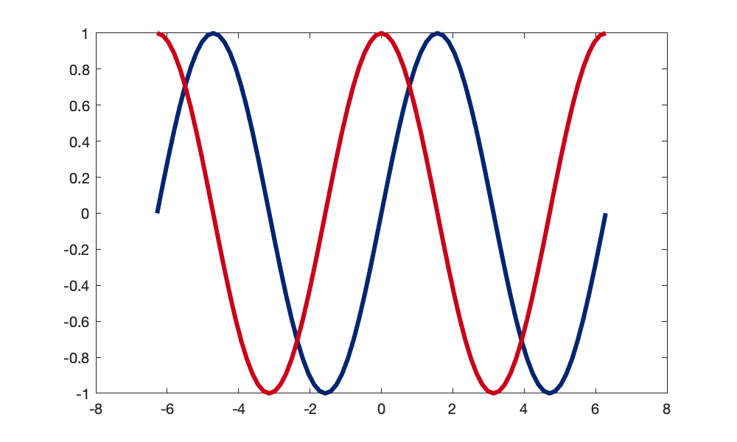

### Basic axis formatting

**Consider our example data** -- we want to view our path, only considering motion in the x/y.

% x position vs. y position

plot(myData(:,2), myData(:,3),'ro-')

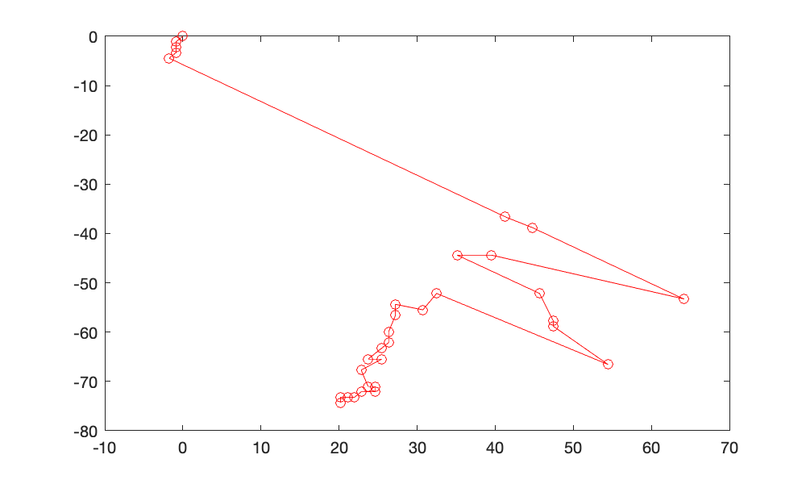

* A specific **domain and range** may be specified using xlim or ylim

xlim([-100,100]) % set x limit

ylim([-100,100]) % set y limit

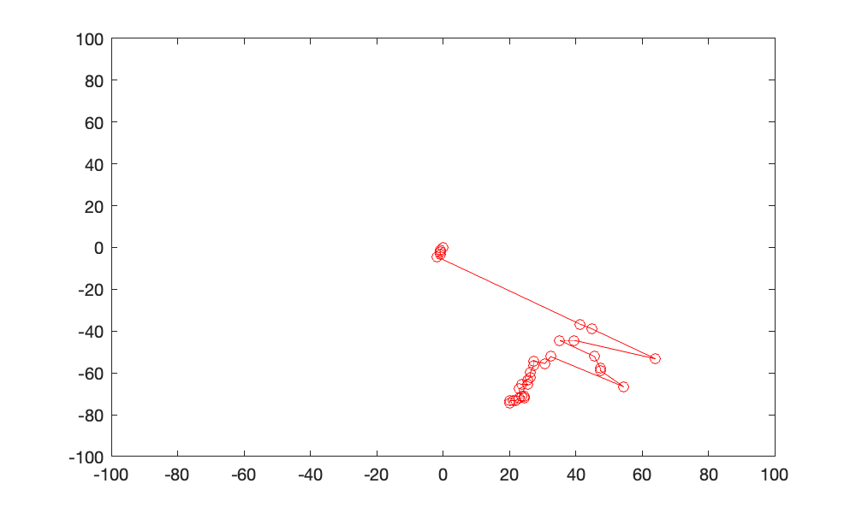

* The axis command offers many predefined axis scaling/sizing operations

Useful documentation: <https://www.mathworks.com/help/matlab/ref/axis.html>

axis auto % Automatically choose all axis limits

axis tight % Fit the axes box tightly around the data by setting the axis limits equal to the range of the data.

axis equal % Use the same length for the data units along each axis

axis square % Use axis lines with equal lengths

axis off % Turn off axes

axis ij % Reverse y axis direction

axis square %change shape of axis

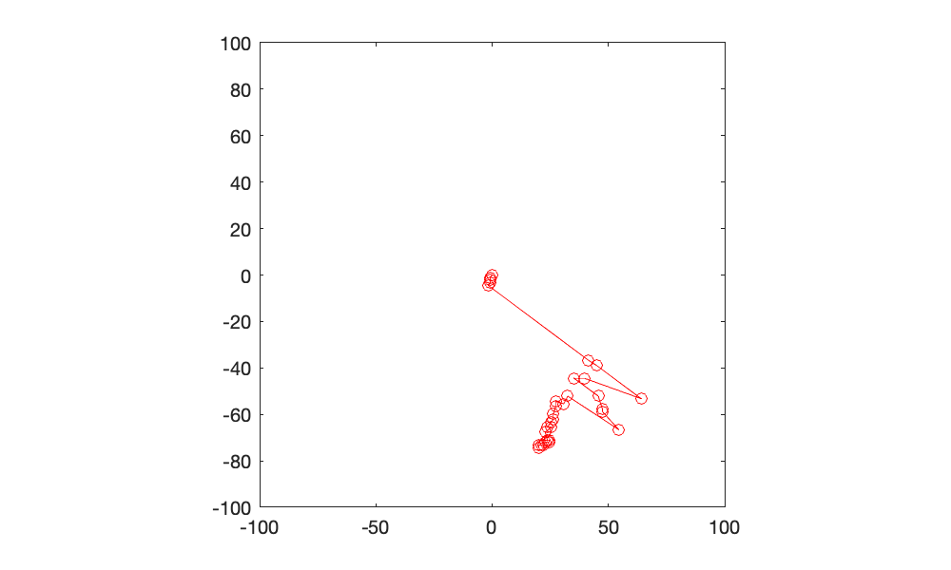

**Note**: specifying a parameter like this operates on the previous plot. Information about the previous plot is stored as the **current axis** and **current figure**.

* **Legends** may be added and the position of the legend specified

legend('Our ENGR105', 'Location', 'NorthWest');

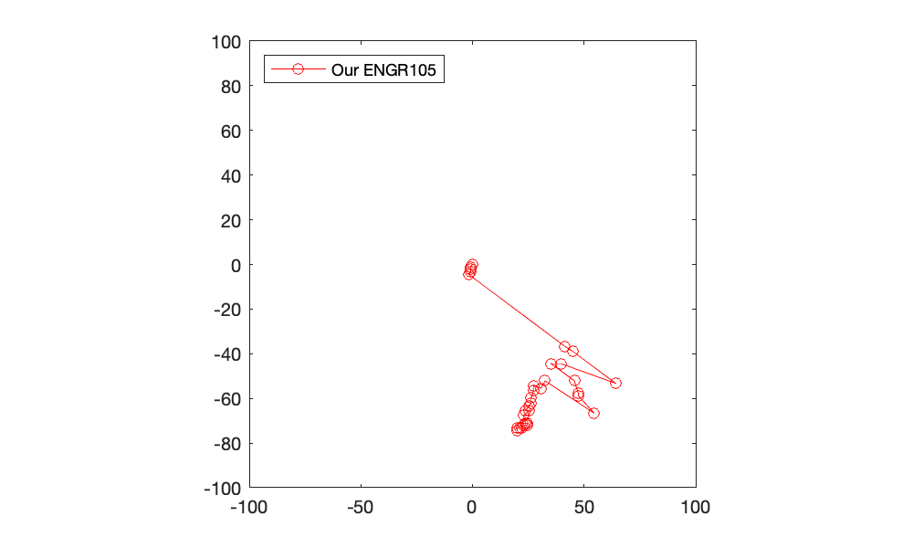

* **Axis labels and titles** may be placed on the graph

xlabel('x position relative to start (m)')

ylabel('y position relative to start (m)')

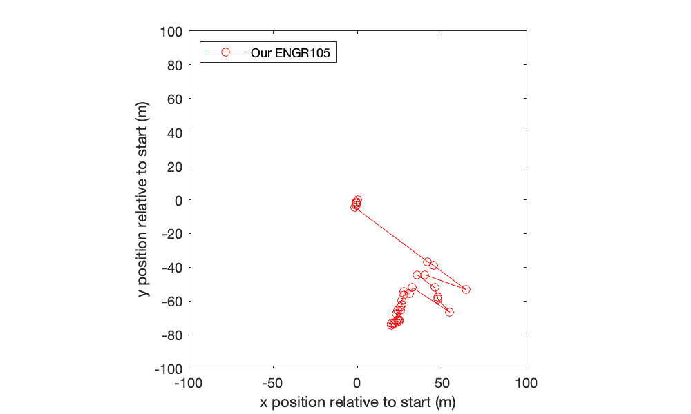

* We can add a **title**

title('x/y movement of our ENGR105 path')

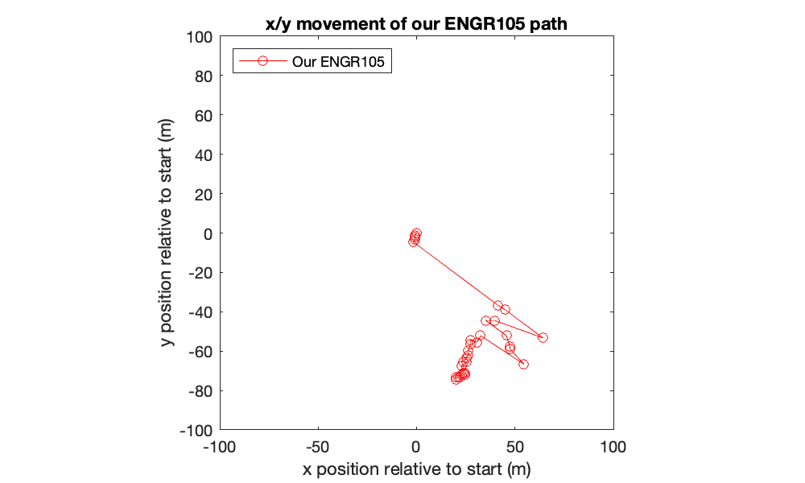

* **Text may be placed on a plot** using the text command

text(myData(1,2), myData(1,3), 'Start')

text(myData(end,2), myData(end,3), 'End')

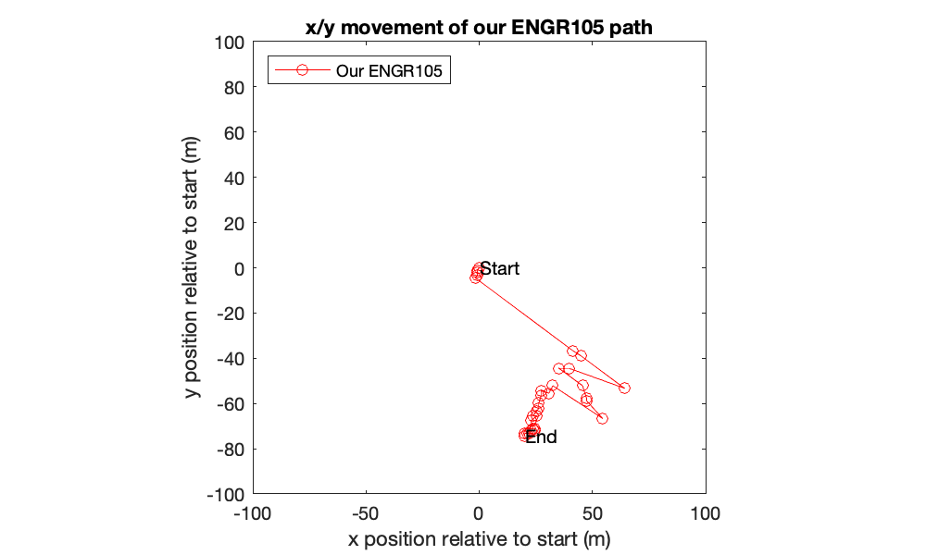

### Important note regarding LiveScript files

We are using LiveScript files because these are a really convenient way to combine text and code, ultimately because we want these lecture notes to be an accessible resource for you.

However, when plotting in a .mlx file, all figures are embedded in the document (which is what we want). When you are working with a script file (.m) or at the command line, figures will "pop up" when called. **The following code will create a plot in a new figure window.**

% Display figure in its own window

set(gcf,'Visible','on');

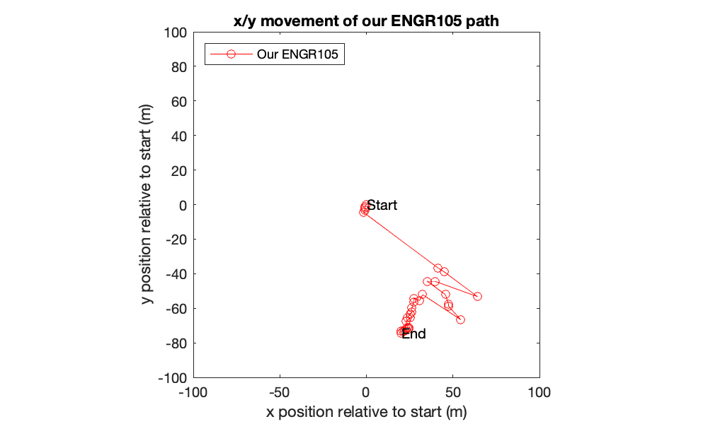

### Plots as objects

* Functions can be stored as **function handles**.
* Plots and graphics are inherently stored as **graphic handles**.

While these are not technically the same thing, they are both ways to store (at least temporarily) and access something as/from an (*explicitly* or *implicitly* defined) variable.

**First go**: Characteristics of the plot may be modified by referring to the **current axes or figure -- the one that is active.**

* gca: get current axes
* gcf: get current figure

The following is an example of a "typical" figure produced in the command line or a script file.

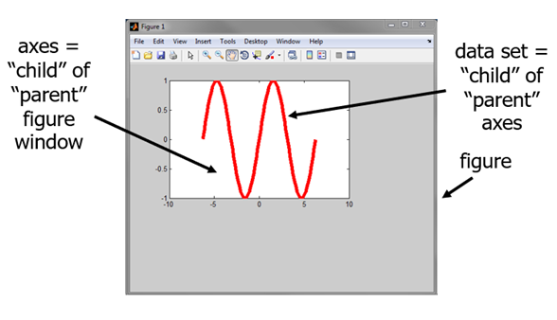

* A second plot command executed (without specifying hold on) will overwrite the axes from a first plot.

**Important: When working at the command line or in a .m file, new figures** can be created using the figure function, which will establish a new parent figure window. In a LiveScript document, **all figures are set to "not visible" by default and you see the axes**.

figure

When invoking the axes() command, MATLAB creates a "blank" set of axes. If invoked outside a LiveScript document, a new figure window will also be created to contain it.

axes

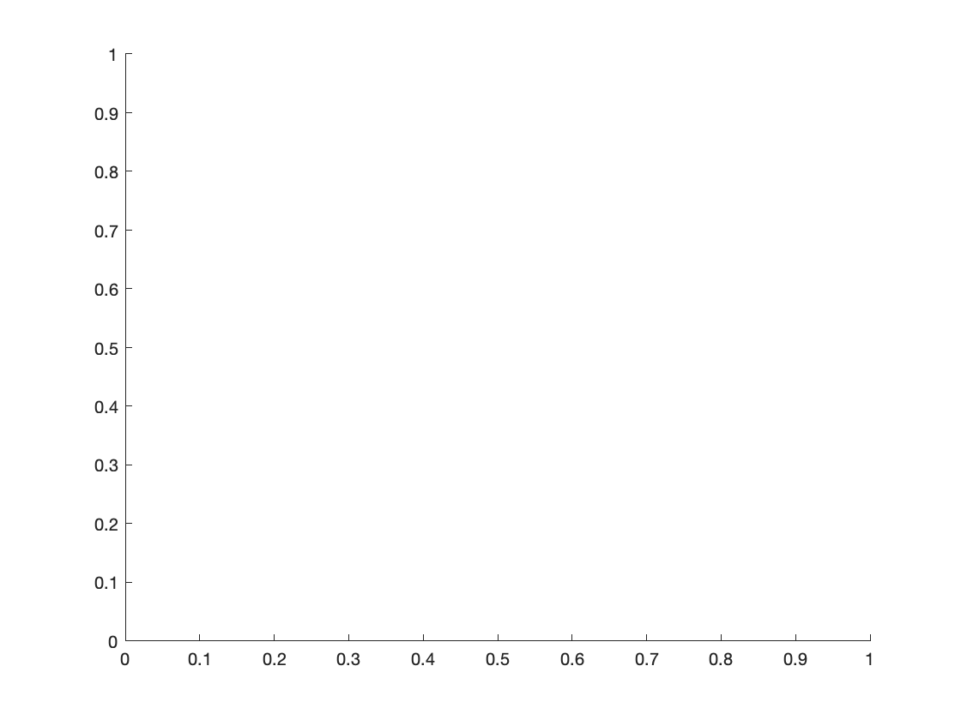

### Getting axes or figure properties

Current figure or axis parameters may be viewed by using the get function. **This is often a helpful way to understand what potential parameters may be modified.**

% Create new plot of f(t) = exp(t)

t = 0:0.1:10;

f = exp(t);

plot(t,f,'k-')

get(gca)

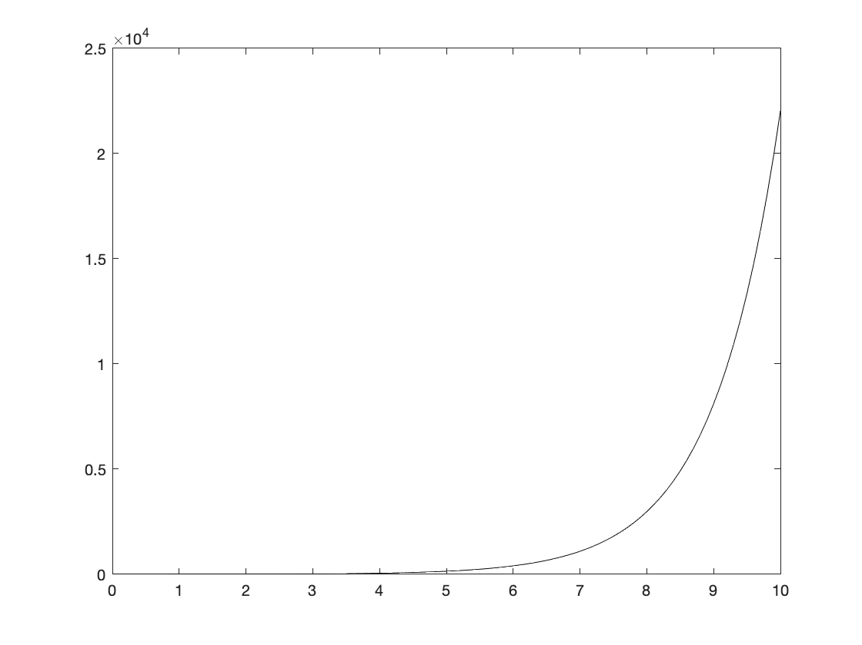

ALim: [0 1]

ALimMode: 'auto'

AlphaScale: 'linear'

Alphamap: [1×64 double]

AmbientLightColor: [1 1 1]

BeingDeleted: off

Box: on

BoxStyle: 'back'

BusyAction: 'queue'

ButtonDownFcn: ''

CLim: [0 1]

CLimMode: 'auto'

CameraPosition: [5 12500 17.3205]

CameraPositionMode: 'auto'

CameraTarget: [5 12500 0]

CameraTargetMode: 'auto'

CameraUpVector: [0 1 0]

CameraUpVectorMode: 'auto'

CameraViewAngle: 6.6086

CameraViewAngleMode: 'auto'

Children: [1×1 Line]

Clipping: on

ClippingStyle: '3dbox'

Color: [1 1 1]

ColorOrder: [7×3 double]

ColorOrderIndex: 2

ColorScale: 'linear'

Colormap: [256×3 double]

ContextMenu: [0×0 GraphicsPlaceholder]

CreateFcn: ''

CurrentPoint: [2×3 double]

DataAspectRatio: [5 12500 1]

DataAspectRatioMode: 'auto'

DeleteFcn: ''

FontAngle: 'normal'

FontName: 'Helvetica'

FontSize: 10

FontSizeMode: 'auto'

FontSmoothing: on

FontUnits: 'points'

FontWeight: 'normal'

GridAlpha: 0.1500

GridAlphaMode: 'auto'

GridColor: [0.1500 0.1500 0.1500]

GridColorMode: 'auto'

GridLineStyle: '-'

HandleVisibility: 'on'

HitTest: on

InnerPosition: [0.1300 0.1100 0.7750 0.8150]

Interactions: [1×1 matlab.graphics.interaction.interface.DefaultAxesInteractionSet]

Interruptible: on

LabelFontSizeMultiplier: 1.1000

Layer: 'bottom'

Layout: [0×0 matlab.ui.layout.LayoutOptions]

Legend: [0×0 GraphicsPlaceholder]

LineStyleOrder: '-'

LineStyleOrderIndex: 1

LineWidth: 0.5000

MinorGridAlpha: 0.2500

MinorGridAlphaMode: 'auto'

MinorGridColor: [0.1000 0.1000 0.1000]

MinorGridColorMode: 'auto'

MinorGridLineStyle: ':'

NextPlot: 'replace'

NextSeriesIndex: 2

OuterPosition: [0 0 1 1]

Parent: [1×1 Figure]

PickableParts: 'visible'

PlotBoxAspectRatio: [1 0.7892 0.7892]

PlotBoxAspectRatioMode: 'auto'

Position: [0.1300 0.1100 0.7750 0.8150]

PositionConstraint: 'outerposition'

Projection: 'orthographic'

Selected: off

SelectionHighlight: on

SortMethod: 'childorder'

Subtitle: [1×1 Text]

SubtitleFontWeight: 'normal'

Tag: ''

TickDir: 'in'

TickDirMode: 'auto'

TickLabelInterpreter: 'tex'

TickLength: [0.0100 0.0250]

TightInset: [0.0321 0.0393 0.0103 0.0369]

Title: [1×1 Text]

TitleFontSizeMultiplier: 1.1000

TitleFontWeight: 'bold'

TitleHorizontalAlignment: 'center'

Toolbar: [1×1 AxesToolbar]

Type: 'axes'

Units: 'normalized'

UserData: []

View: [0 90]

Visible: on

XAxis: [1×1 NumericRuler]

XAxisLocation: 'bottom'

XColor: [0.1500 0.1500 0.1500]

XColorMode: 'auto'

XDir: 'normal'

XGrid: off

XLabel: [1×1 Text]

XLim: [0 10]

XLimMode: 'auto'

XMinorGrid: off

XMinorTick: off

XScale: 'linear'

XTick: [0 1 2 3 4 5 6 7 8 9 10]

XTickLabel: {11×1 cell}

XTickLabelMode: 'auto'

XTickLabelRotation: 0

XTickMode: 'auto'

YAxis: [1×1 NumericRuler]

YAxisLocation: 'left'

YColor: [0.1500 0.1500 0.1500]

YColorMode: 'auto'

YDir: 'normal'

YGrid: off

YLabel: [1×1 Text]

YLim: [0 25000]

YLimMode: 'auto'

YMinorGrid: off

YMinorTick: off

YScale: 'linear'

YTick: [0 5000 10000 15000 20000 25000]

YTickLabel: {6×1 cell}

YTickLabelMode: 'auto'

YTickLabelRotation: 0

YTickMode: 'auto'

ZAxis: [1×1 NumericRuler]

ZColor: [0.1500 0.1500 0.1500]

ZColorMode: 'auto'

ZDir: 'normal'

ZGrid: off

ZLabel: [1×1 Text]

ZLim: [-1 1]

ZLimMode: 'auto'

ZMinorGrid: off

ZMinorTick: off

ZScale: 'linear'

ZTick: [-1 0 1]

ZTickLabel: ''

ZTickLabelMode: 'auto'

ZTickLabelRotation: 0

ZTickMode: 'auto'

### Setting axes and figure properties

* gca or gcf may be combined with the set command to modify a plot characteristic.
* The general form for the set command is

set(<ref to handle>,<property name>,<property value>)

% Change some parameters

set(gca,'YScale','log')

set(gca,'XMinorTic','on')

set(gca,'TickDir','out')

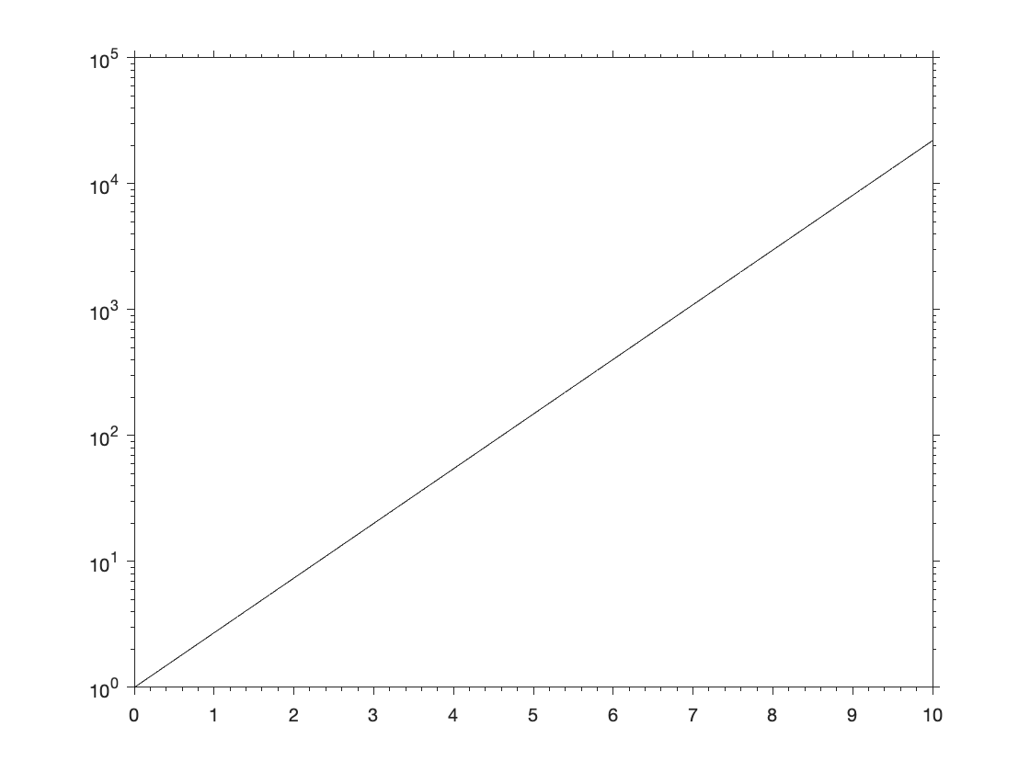

x = 0:pi/20:2*pi;

y = sin(x);

plot(x,y,'LineWidth',3)

% Increase the font size of the figure

set(gca,'FontSize',20)

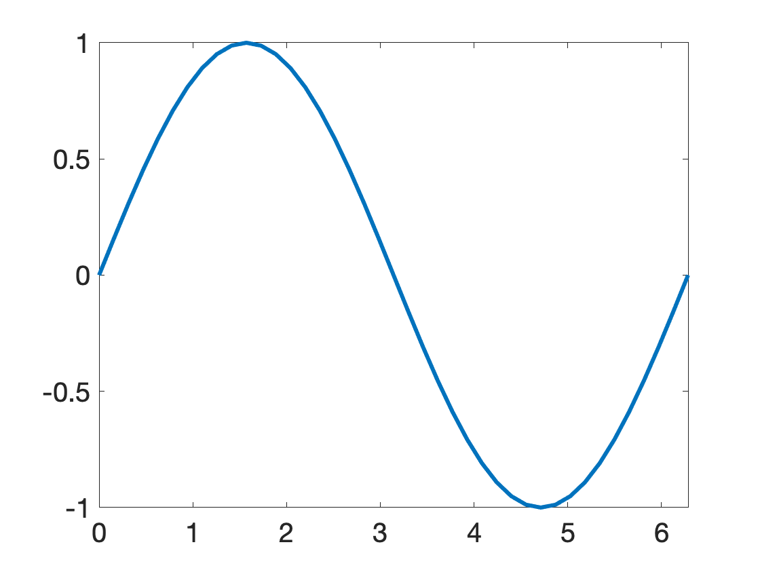

**Note**: the plot that was produced most recently or is active is stored as gca or gcf. In the above case, set operates on that set of axes.

### Graphics handles

In the same way that we created function handles to store functions in a variable, you can **create graphics handles** to store graphics in a variable.

% Example handles

myHandle1 = plot(x,y);

myFig = figure;

h = axes;

foo = axes;

% Example graphics handle use

x = 0:pi/100:2*pi;

y = sin(x);

myFigure = figure;

plot(x,y)

% Set the background of the figure

% to white

set(myFigure,'Color','w')

% Take the default plot position and

% reduce the width by 1/2

pos = get(myFigure,'Position');

pos(3) = 0.5*pos(3);

set(myFigure,'Position',pos);

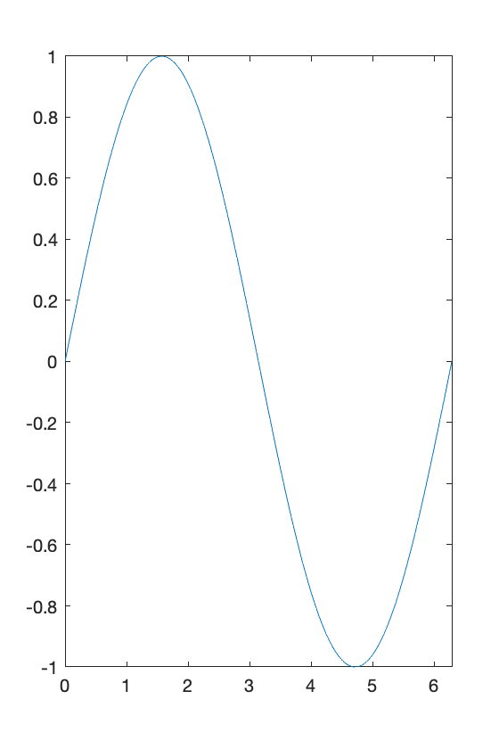

**Question 1:** my legend / plot / graphics object isn't working. What do I do?

* **Step 1**: Double check code for errors
* **Step 2**: Close all graphics objects and figures (close all)
* **Step 3**: consult documentation and Google (mathworks Q/A)

% This is the "usual" way we have added legends

t = 0:0.1:5;

f1 = 2*t;

f2 = t.^2;

plot(t,f1,'r-')

legend('f1')

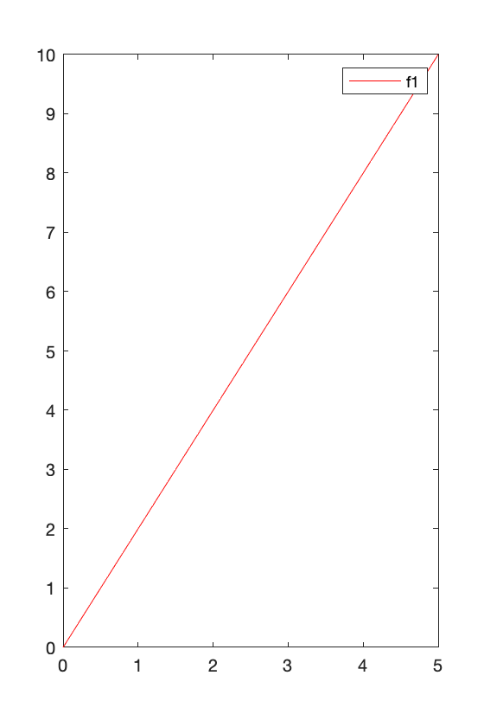

% Create graphics handles

h1 = plot(t,f1,'r-');

hold on

h2 = plot(t,f2,'k-');

hold off

% Create a legend by inputting. NOTE: this will change handle properties in

% h1 and h2!

h3 = legend([h1 h2],{'f1','f2'});

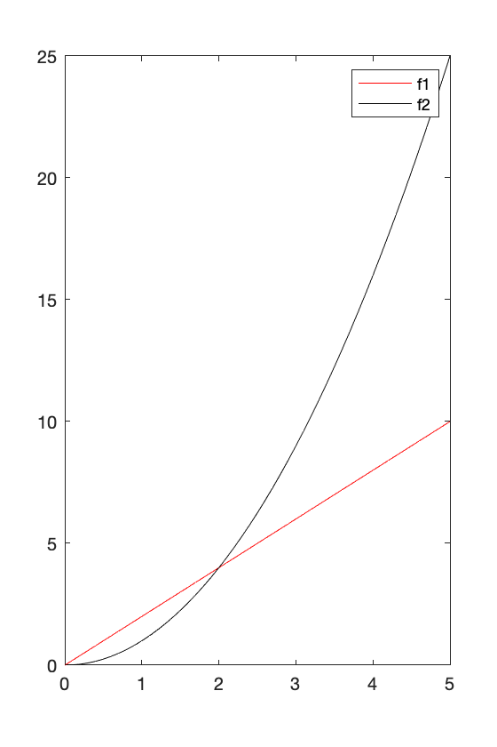

% Modify the the handle associated with each plot

plot(t,f1,'r-', 'DisplayName', 'f1');

hold on

plot(t,f2,'k-','DisplayName','f2');

hold off

legend



**Takeaway:** all of these are doing the same thing. If one doesn't work, try one of the alternatives.

**Question 2**: what happens when you specifiy a line spec for a plot?

x = 0:pi/20:2*pi;

y = sin(x);

h1 = plot(x,y);

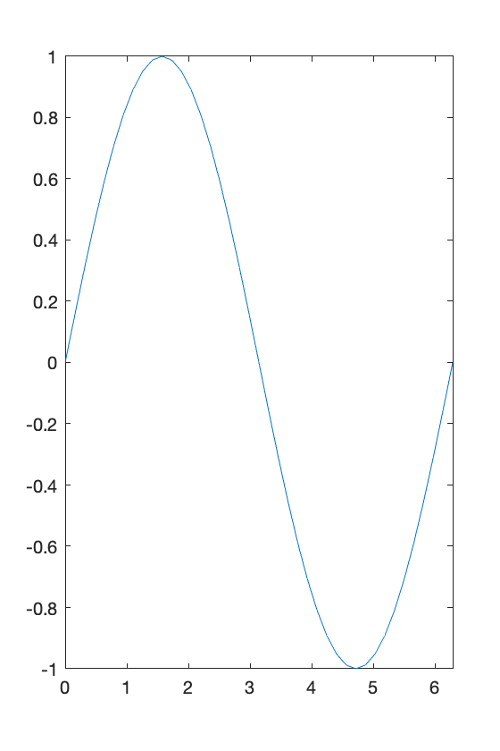

get(h1, 'LineWidth')

ans = 0.5000

h2 = plot(x,y,'LineWidth',3);

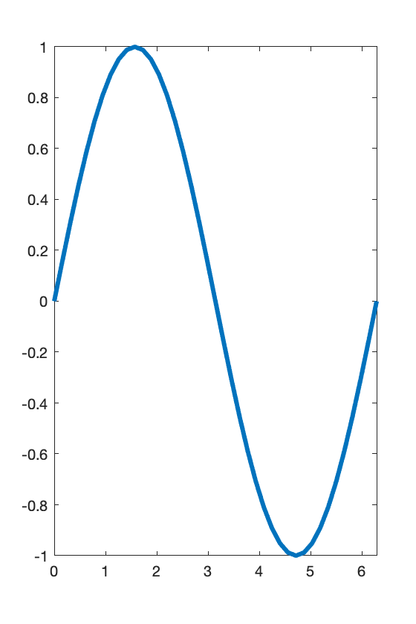

get(h2, 'LineWidth')

ans = 3

**Specifiying a line specification or plotting option in the plot function is convenient for changing formatting perferences. It is equilavent to setting a field (parameter) for a graphics handle to a different value.**

### Linear vs log axes

* Using set to **change axes properties**

% Create new plot of f(t) = exp(t)

t = 0:0.1:5;

f = exp(t);

plot(t,f,'k-')

% Set y scale to logarithmic

set(gca,'YScale','log')

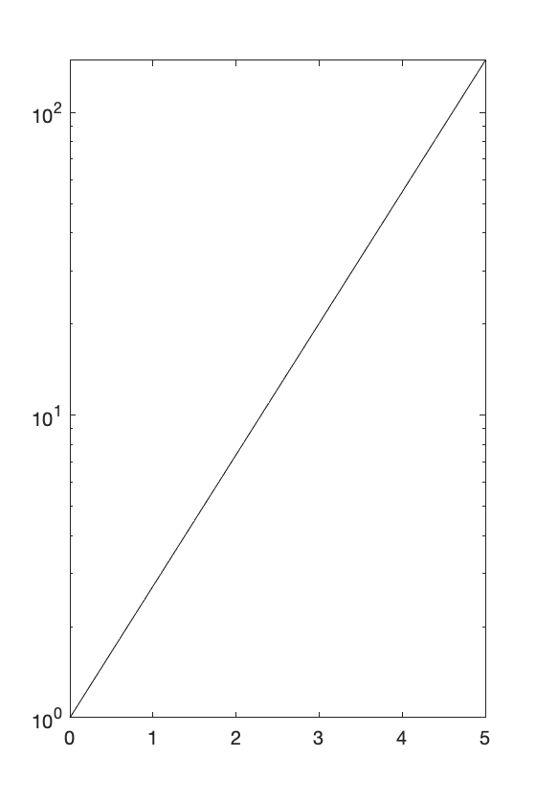

* **Logarithmic y axis**: semilogy

% x and y values

x = 0:1:25;

y = exp(x);

% Plot: y axis will have logarithmic scale

p = semilogy(x,y);

% Change the line width

set(p,'LineWidth',2)

set(p,'LineWidth',2)

set(gca,'FontSize',12)

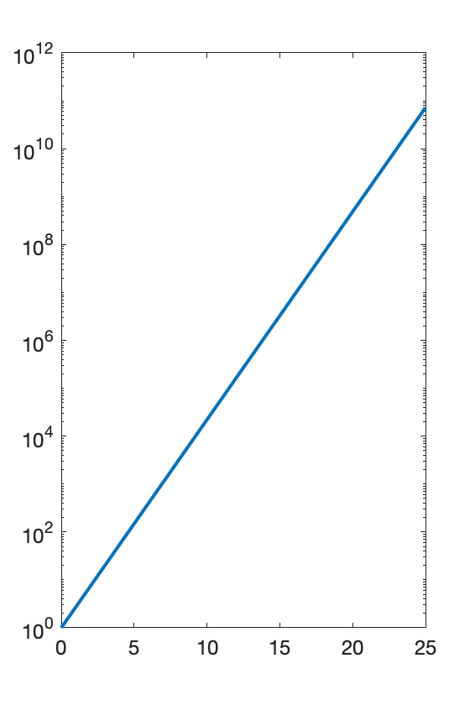

**Note**: line parameters can be changed using set, as above, **OR** by specifying line specification into plotting function.

* **Logarithmic x axis**: semilogx

% Plot: y axis will have logarithmic scale

p = semilogx(x,y);

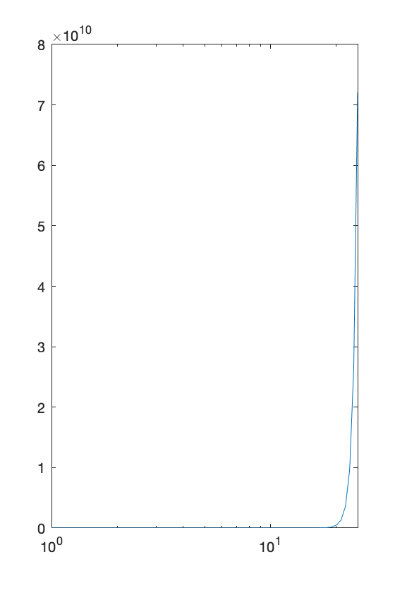

* **Log-log plot**: loglog

x = logspace(0,5,25);

y = x.^5;

p = loglog(x,y);

set(p,'LineWidth',2)

set(gca,'FontSize',20)

set(gca,'XTick',logspace(0,5,6))

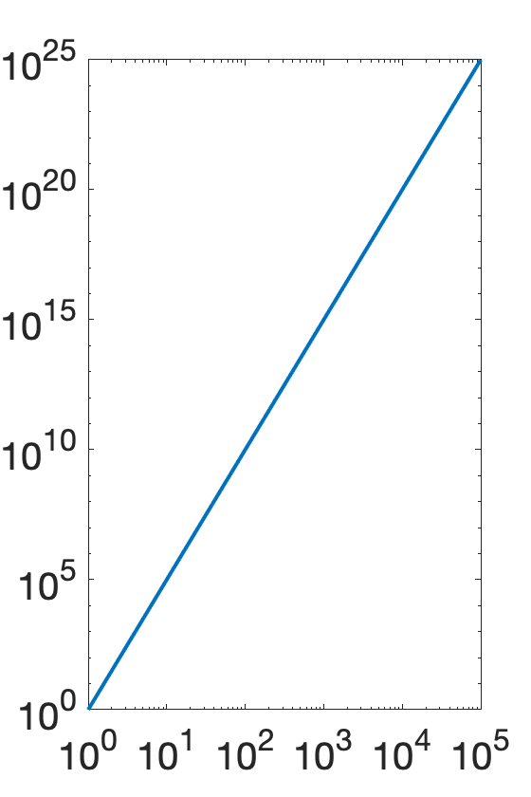

### Error bars

* **Y error bars**: use errorbar plotting function

% Data values

x = [2,5,10,15];

y = [3,7,15,40];

% Y error bars: positive and negative are same

ye = [1,5,10,10];

% Graphics handle representing error bar plot function

h = errorbar(x,y,ye,'k-');

set(h,'LineWidth',1)

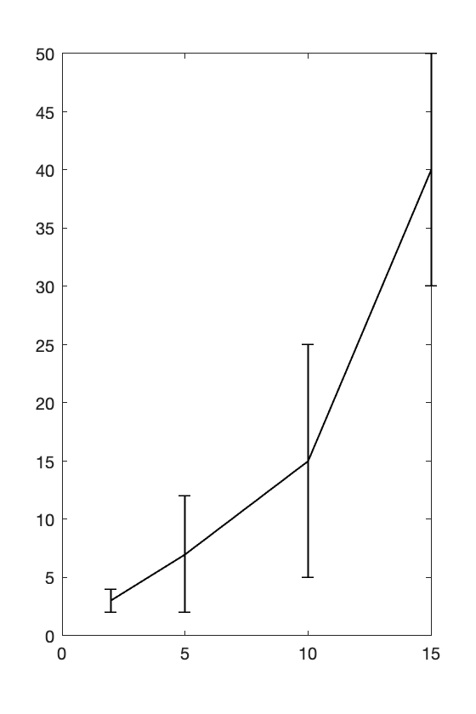

**Example**. How can we change error bar line properties and not the "data" line?

% Graphics handle representing error bar plot function

h = errorbar(x,y,ye,'k.','Marker','none');

hold on

plot(x,y,'k-','LineWidth',2)

hold off

% Change the parameters *ONLY* of the error bars

set(h,'LineWidth',1)

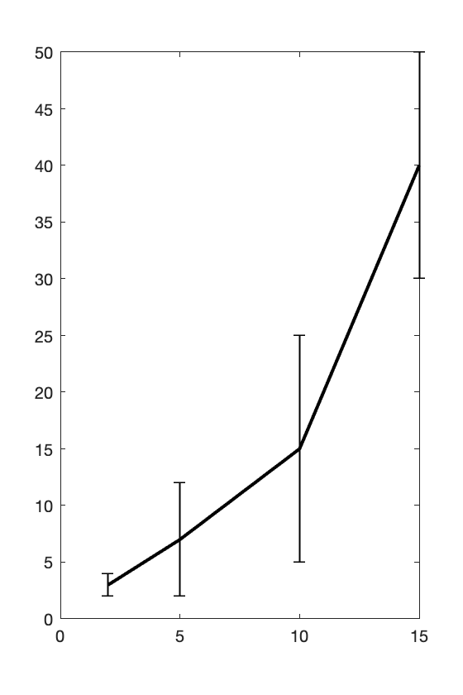

* **Y and X error bars**

% Data values

x = [2,5,10,15];

y = [3,7,15,40];

% Positive and negative x error bars

xePos = [1,3,2,3];

xeNeg = [1,3,4,1];

% Positive and negative y error bars

yePos = [1,8,2,20];

yeNeg = [2,6,4,10];

% Create x and y error bar plot

h = errorbar(x,y,yeNeg,yePos,xeNeg,xePos,'k-');

set(h,'LineWidth',1)

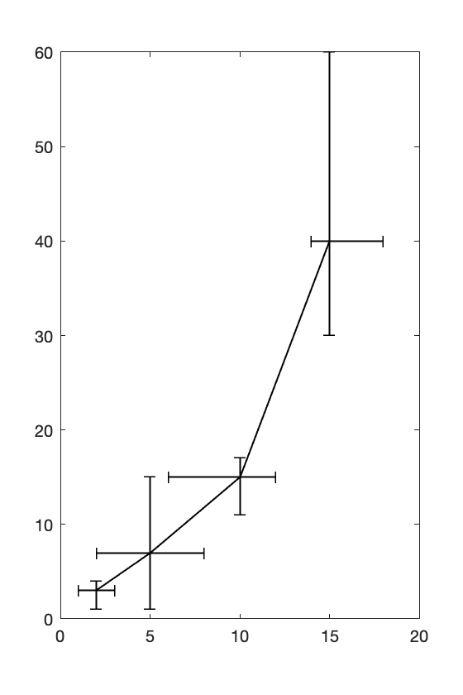

### Additional 2D plotting functions

* **Scatter plots.** Like plot, scatter()require vectors of equal length. the default plot attributes are circular blue data markers.

x = 0:pi/20:2*pi;

y = sin(x);

scatter(x,y)

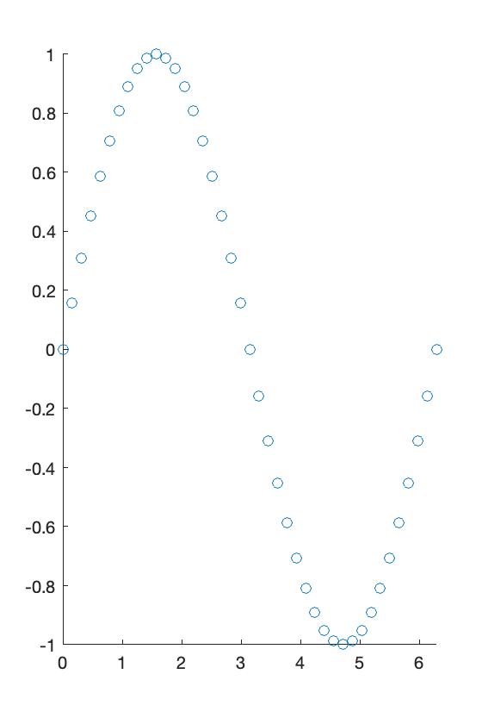

* **Polarplot**

theta = 0:0.01:2*pi;

rho = sin(2*theta).*cos(2*theta);

% Plot theta vs. rho

plot(theta,rho,'ko')

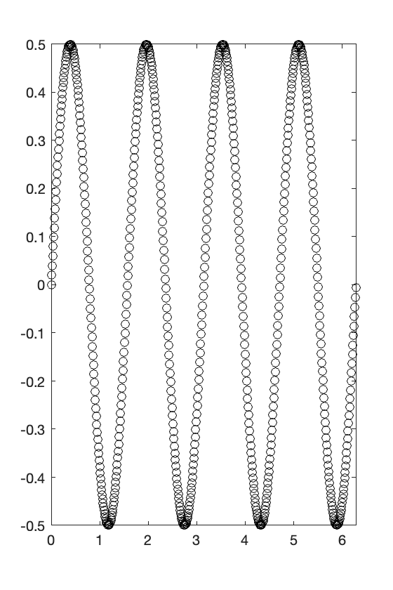

% Plot in polar space

polarplot(theta,rho)

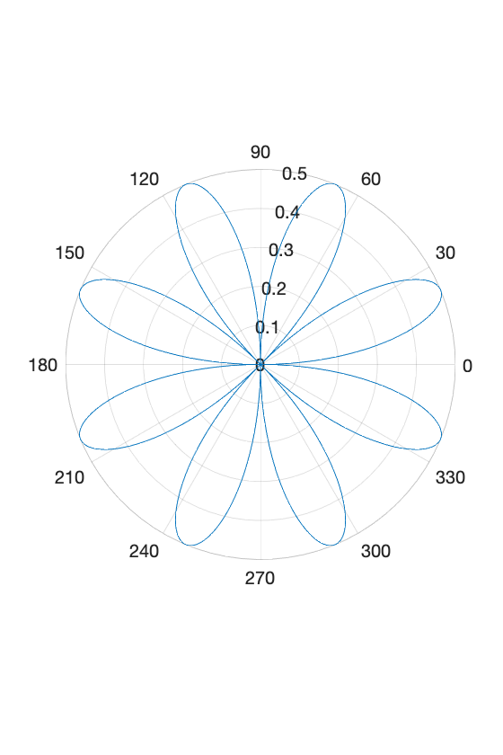

**Note**: input is in units of radians.

* **histogram.** Display counts in different bins

data = randi(5,[1,1000]);

h = histogram(data);

% Change bin sizes

set(h,'BinEdges',[0,1.5,4.5,5.5])

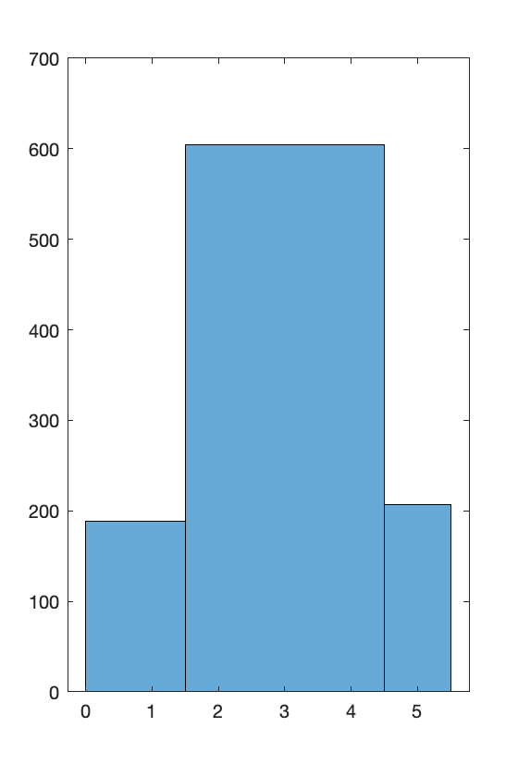

Back to our data. Create a histogram of speeds I traveled

histogram(myData(:,5));

axis square

xlabel('Speed (m/s)')

ylabel('Counts')

title('Distribution of movement speed')

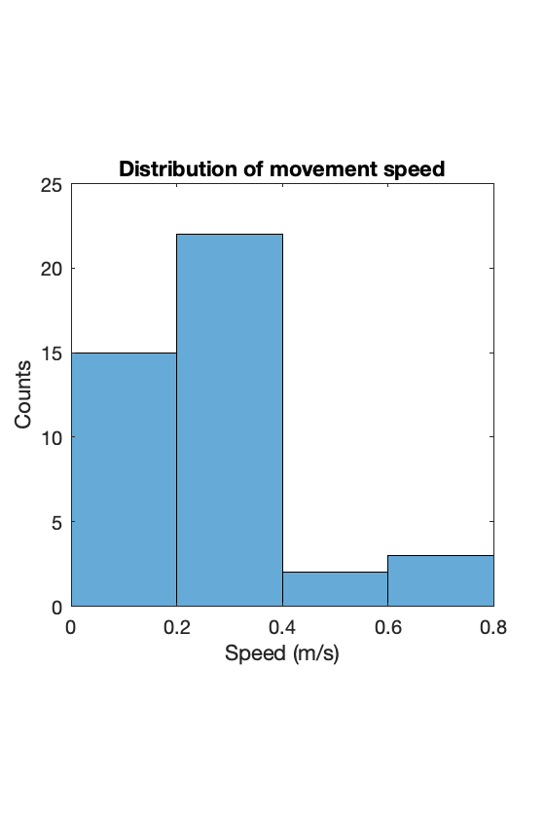

* **bar** plot

t = myData(1:10:end,1);

z = myData(1:10:end,4);

h = bar(t,z);

ylim([-10,10])

set(h,'FaceColor','none')

axis square

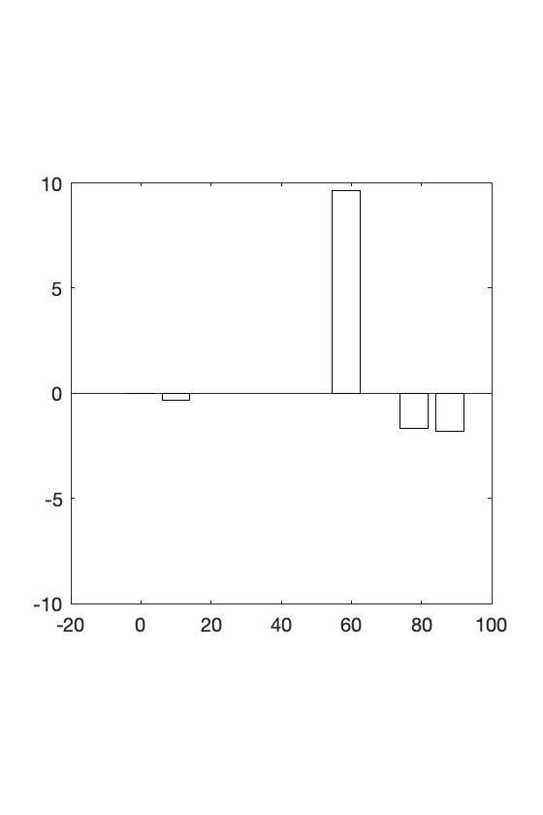

**Grouped bar plots**

x = 1:4;

y1 = randi(3,[1,4]);

y2 = randi(5,[1,4]);

% Note: dimensions of "Y" input

h = bar(x,[y1;y2]');

ylim([0,7])

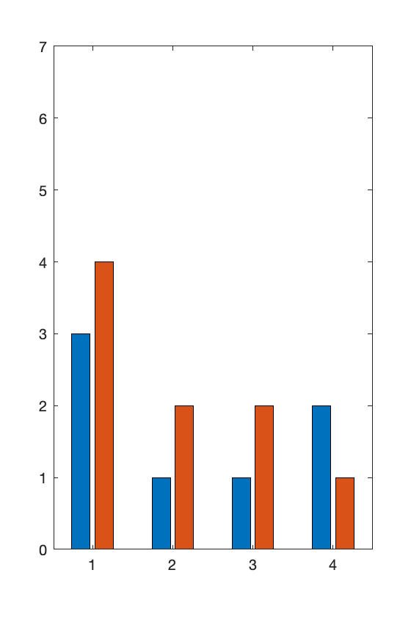

**Stacked bar plots**

h = bar(x,[y1;y2]','stacked');

ylim([0,7])

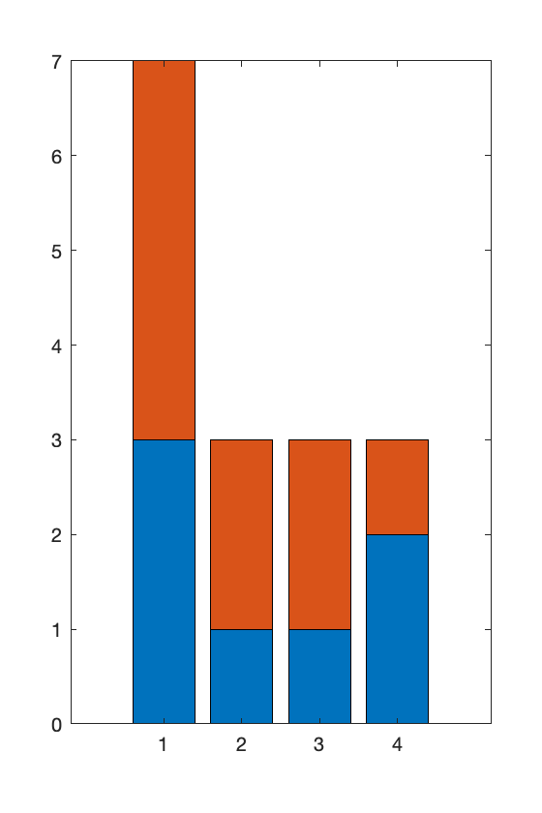

### Closing graphics objects -- SURPRISINGLY USEFUL

In an automated script, you may need to close figure windows. Figures may be closed using the close command

close: closes the last figure

close(n): closes figure number n

close all: closes all figures

Sometimes when my figures are not responding correctly, I can fix the issue by closing all figure instances. The issue may be related to an open figure in the background. Figures, axes, and plots may also be assigned to handles and the handle specified to **close** the object.

f = figure;

plot(rand(1,20))

close(f)

### Multiple axes in a single figure window

Multiple axes may be assigned to a single figure using the subplot command. This command has the following syntax:

subplot(<number of rows>,<number of columns>,<current figure index>)

% X values

x = 0:pi/20:2*pi;

% Separate Y functions

y1 = sin(x-0);

y2 = sin(x-.5);

y3 = sin(x-1);

y4 = sin(x-1.5);

y5 = sin(x-2);

y6 = sin(x-2.5);

subplot(2,3,1)

plot(x,y1)

axis tight

subplot(2,3,2)

plot(x,y2)

axis tight

subplot(2,3,3)

plot(x,y3)

axis tight

subplot(2,3,4)

plot(x,y4)

axis tight

subplot(2,3,5)

plot(x,y5)

axis tight

subplot(2,3,6)

plot(x,y6)

axis tight

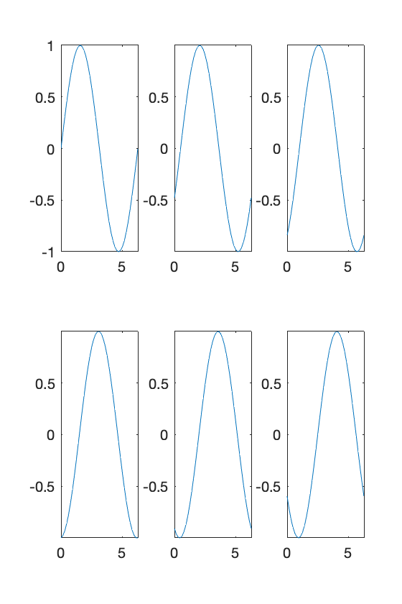

**Question**. How can this code be made **clearer**? Use a for loop -- we know how many iterations to perform

% X values

x = 0:pi/20:2*pi;

% For each loop iteration, fill in one of the subplots

for k = 0:5

y = sin(x-0.5*k);

subplot(2,3,k+1)

plot(x,y)

axis tight

end



## Plotting in 3D

All of the same concepts apply to producing 3D plots. In this case, the workhorse plot function is plot3.

### plot3

plot3 takes in 3 inputs corresponding to x, y, and z positions

t = 0:pi/100:2*pi;

x = sin(t);

y = cos(t);

z = t;

plot3(x,y,z,'LineWidth',4)

xlabel('x')

ylabel('y')

zlabel('z')

grid on

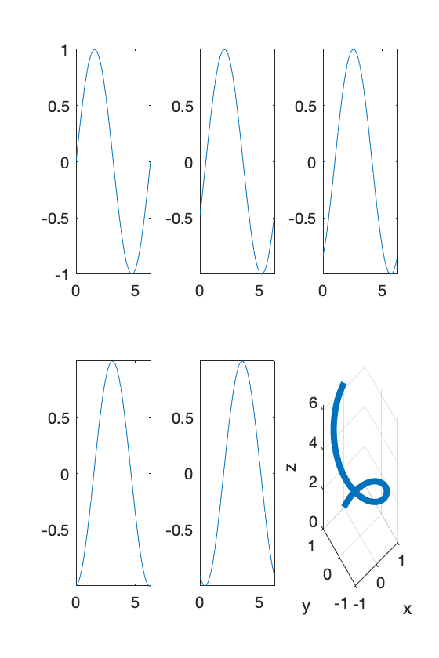

**Note**: you can manually change the view point by clicking and dragging on the plot.

**Important note**: it is strongly recommended to specify a view point using view. This will help you precisely pick an angle to view.

view(<azimuth angle>,<elevation angle>)

% Change the viewpoint

view(45,45)

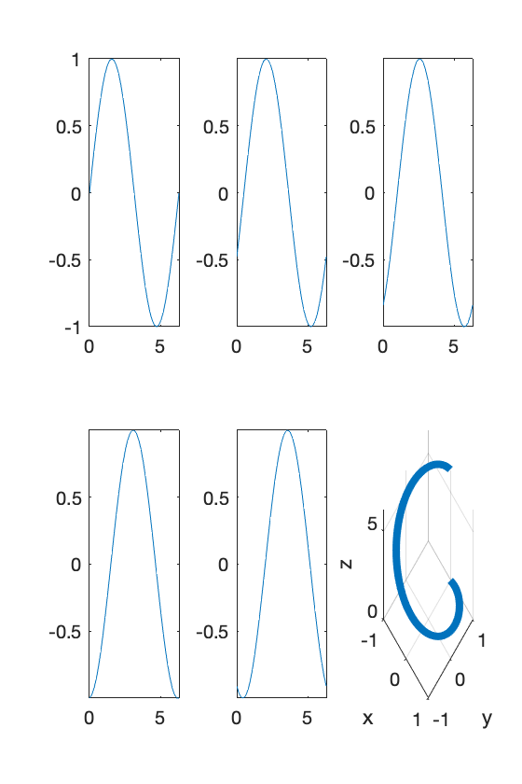

plot3(myData(:,2),myData(:,3),myData(:,4),'LineWidth',2)

xlabel('x')

ylabel('y')

zlabel('z')

xlim([-100,100])

ylim([-100,100])

zlim([-10,10])

grid on

title('Our ENGR105 adventure in 3D')

text(myData(1,2),myData(1,3),myData(1,4),'Start')

text(myData(end,2),myData(end,3),myData(end,4),'End')

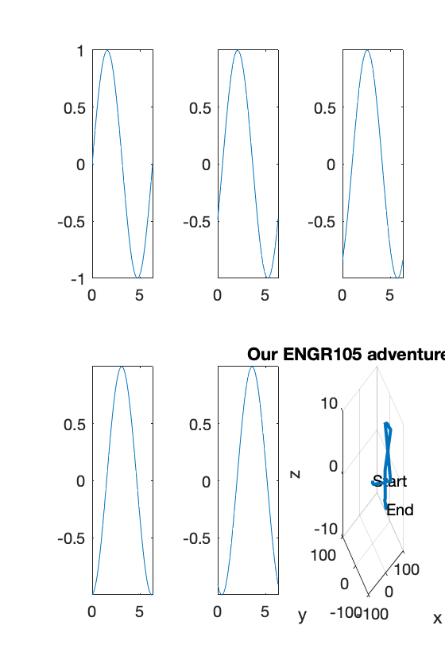

### 

### Practice Problem: adventure summary

Produce one figure that summarizes the walk. That is, it should contain:

1. Travel in 3D space
2. x vs. y travel
3. altitude as a function of time
4. distribution of walking speeds

% Subplot 1: Travel in 3D

subplot(2,2,1)

plot3(myData(:,2), myData(:,3), myData(:,4), 'LineWidth', 2)

xlabel('x')

ylabel('y')

zlabel('z')

xlim([-100,100])

ylim([-100,100])

zlim([-10,10])

grid on

title('3D trajectory of movement')

text(myData(1,2), myData(1,3),myData(1,4),'Start')

text(myData(end,2), myData(end,3),myData(end,4),'End')

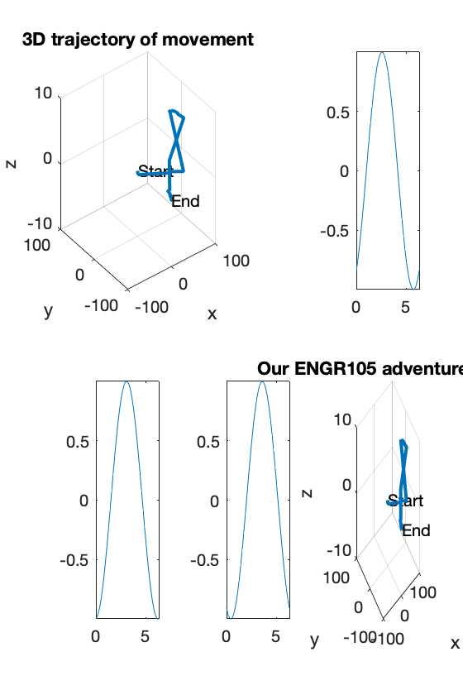

% Subplot 2: altitude as a function of time

subplot(2,2,2)

plot(myData(:,1), myData(:,4), 'ko-')

zlim([-10,10])

title('Height traversed')

xlabel('time (s)')

ylabel('height (m)')

axis square

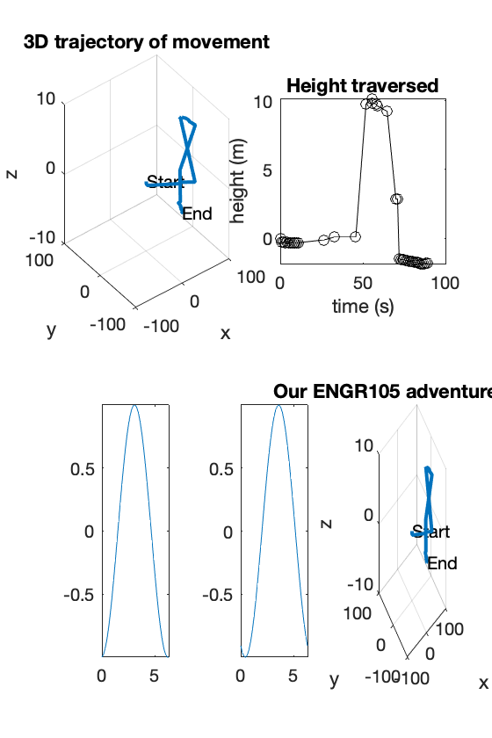

% Subplot 3: x vs y position

subplot(2,2,3)

plot(myData(:,2), myData(:,3), 'ro-')

xlabel('x position')

ylabel('y position')

xlim([-100,100])

ylim([-100,100])

axis square

title('Lateral movement')

text(myData(1,2), myData(1,3), 'Start')

text(myData(end,2), myData(end,3), 'End')

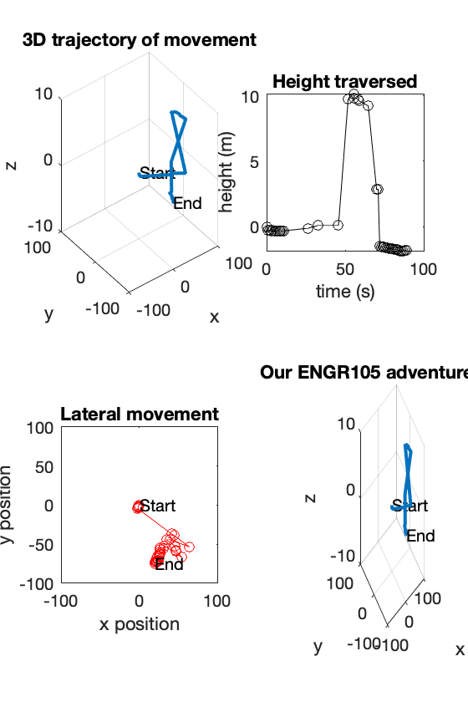

% Subplot 4: histogram of speeds

subplot(2,2,4)

histogram(myData(:,5));

axis square

xlabel('Speed (m/s)')

ylabel('Counts')

title('Distribution of movement speed')

% Add a title to the entire figure

sgtitle('ENGR105 adventure summary')

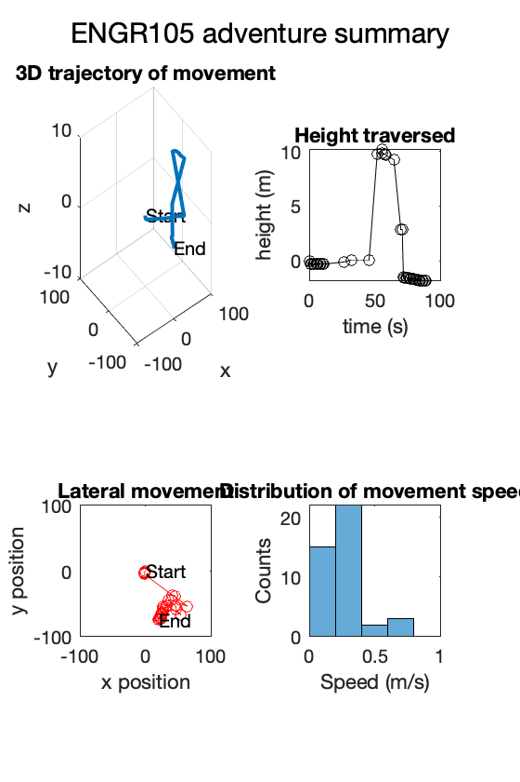

# TOPIC 14: Data types in MATLAB

ENGR105, 10/20/20

### Practice problem: Legendre polynomials and recursion

Legendre’s differential equation, depicted below, is seen in many engineering topics including mechanics, fluid dynamics, thermodynamics, and electromagnetism.

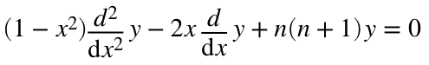

A differential equation of this form is convenient, because solutions can be given as **Legendre polynomials**. The general recurrence formula for the Legendre polynomial may be mathematically represented as the following.

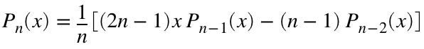

The first two Legendre polynomials are defined as 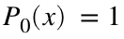 and 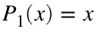.

**a)** **Create a recursive function** named legendreP that takes **two inputs**: 1) a vector containing positions at which to evaluate the legendre polynomial, and 2) n, a scalar (positive) integer specifying the degree of the Legendre polynomial, as defined in the above equation, to be determined. Your function should have **one output**: pn, a vector containing the specified Legendre polynomial. This function should be clear and stored in the space provided at the end of this LiveScript document.

**b)** *Using your function*, produce one plot that contains 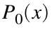, 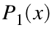, 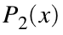, 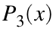, 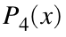 plotted over the domain 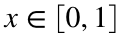. As always, ensure that your plot is professional and clear.

% specify a range of x

x = 0:0.01:1;

%plot the lengendre polynomial

plot(x,legendreP(x,0),'k-', 'LineWidth', 2)

hold on

plot(x,legendreP(x,1),'r-', 'LineWidth', 1)

hold on

plot(x,legendreP(x,2),'k--', 'LineWidth', 2)

hold on

plot(x,legendreP(x,3),'r--', 'LineWidth', 1)

hold on

plot(x,legendreP(x,4),'b:', 'LineWidth', 2)

hold off

axis square

ylim([-1,1.5])

set(gca,'Color', [0.95, 0.95, 0.95])

xlim([0,1.3])

legend('P_0','P_1','P_2','P_3','P_4')

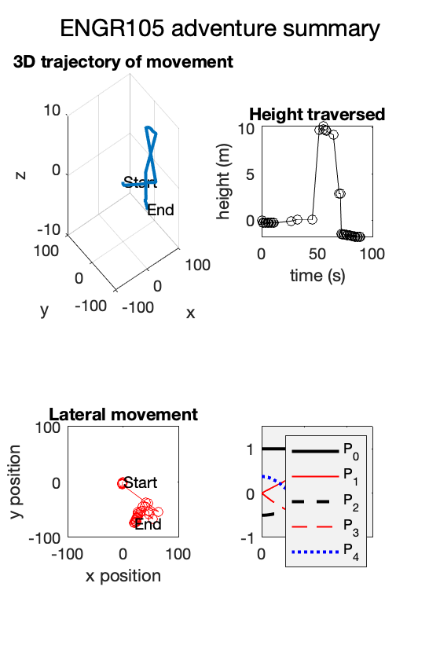

### Recall: different data types

In producing the above plot (and throughout this class), we have used many different *types* of variables. Last week, we saw that we could use class to give information about what **kind of information** is stored in a given variable.

class(x)

ans = 'double'

class('LineWidth')

ans = 'char'

class(legendreP(x,2))

ans = 'double'

Last week:

* myData is timetable class
* myData.Timestamp is datetime class
* myData.speed is double class
* 'hello world' is char class

We can also use whos to give information, including the data type (or class) of a given variable.

whos x

Name Size Bytes Class Attributes

x 1x101 808 double

a = 2;

whos a

Name Size Bytes Class Attributes

a 1x1 8 double

In the above, variable a is class *double* requiring a memory of 8 *bytes*.

## Data types (classes) in MATLAB

**Useful MATLAB documentation:**

* <https://www.mathworks.com/help/matlab/matlab_prog/fundamental-matlab-classes.html>

### Bits, bytes, and memory

Remember that computation occurs at the **transistor scale**. Each of the memory locations in a computer is assoicated with multiple transistors and stores a finite sequence of **bi**nary dig**its** (**bits**).

* Typical storage sizes are **8**, **16**, **32** or **64 bits**
* A group of **8 bits** is referred to as a **byte**

**Note**: in the above example, a is associated with (8x8) **64 bits**.

### Binary vs. base 10

Each bit may be off (**0**) or on (**1**). A eight-component line of binary storage can represent a number in base 10.

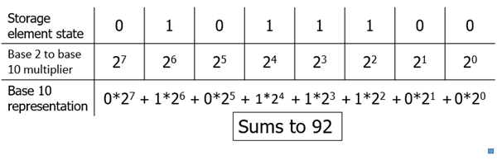

In the line of binary storage, the **position matters** just as in a base 10 number (e.g 9332). In the case of base 2 (binary), each individual digit is either 1 or 0, instead of 0-9 in base 10.

**Note**: the base 10 number is the sum of the binary base (2) raised to the corresponding 0 or 1.

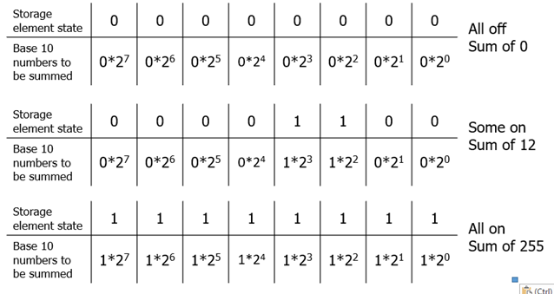

**That is, only on (1) bits are multiplied by the base 2 multiplier**. The sum of the on (1) bits in base 10 is how our programs interact with memory.

### Bit size and numbers

Bits enable a computer to represent a "number" using a **digital** infrastructure. **In the section just above, an 8-bit line of storage can be used to store an 8-bit integer.**

* That is, the integer can take any value between 0 and 2^8 - 1 (255).

In a computer, the bit system limits the **range of values** that can be stored and distinguished. Modern computers operate with **64 bits** while some older architectures and microcontrollers utilize 32 bits.

**Takeaway**: a **larger bit size** yields a larger range of base 10 numbers:

* 8 bit unsigned integers: 0 - 255
* 16 bit unsigned integers: 0 – 65535
* 32 bit unsigned integers: 0 – approx. 4 billion (or 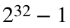)
* 64 bit unsigned integers: 0 – approx. 20 quintillion (or 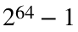)

In MATLAB, integers may be **signed** or **unsigned**

* **unsigned: only positive**
* **signed: positive or negative, though the range of potential options is reduced by two.**

% unsigned integers

uint8()

uint16()

uint32()

uint64()

% signed integers

int8()

int16()

int32()

int64()

**Motivation:** this will be very important when we talk about audio and image processing.

% Convert "numbers" to an integer

a = uint8(4)

a = uint8

4

b = uint16(20)

b = uint16

20

c = int32(200)

c = int32

200

whos a b c

Name Size Bytes Class Attributes

a 1x1 1 uint8

b 1x1 2 uint16

c 1x1 4 int32

**Note**: a stored number is clipped (overflow) if numbers larger or smaller than the bit size are stored

d = uint8(4000)

d = uint8

255

% Note the range for "signed" integers

f = int8(200)

f = int8

127

**Thus**: smaller bit size corresponds to a smaller range of potential integer values

**Unrelated side question: where have we seen integers to be important? Indexing!**

data = [1.5,3,4,2.2];

output = zeros(1,length(data));

% Goal: element-by-element, we want to square each element of data

for k = 1:length(data)

output(k) = data(k)^2;

disp(output)

end

2.2500 0 0 0

2.2500 9.0000 0 0

2.2500 9.0000 16.0000 0

2.2500 9.0000 16.0000 4.8400

### MATLAB defaults to double precision

We often are not interested only in integers but in decimal values. To represent these, MATLAB defaults to the most accurate storage bit length available in the program – **64 bits (aka "double precision")**. This accuracy **costs storage space** – you can only store so many numbers given your RAM.

* Assignment of bits to representation of a number in 64 bits in accordance with standard [IEEE 754](https://en.wikipedia.org/wiki/IEEE_754)

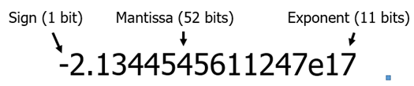

You can query the largest and smallest double precision numbers in MATLAB by invoking realmax and realmin.

realmax

ans = 1.7977e+308

realmin

ans = 2.2251e-308

**Note**: in the above, "e17" is equivalent to 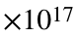

**Note 2:** double precision can be overridden to economize memory use and (sometimes) computation time

### Characters arrays and strings

**Character arrays**. We have worked a lot with **character arrays**, which can be read as text/symbols

plot(x,legendreP(x,0),'k--','LineWidth',2)

Just like with number, function handles, and graphic handles, character arrays can be assigned to variables.

a = 'k--';

b = 'LineWidth';

c = 'This is a character array';

disp(c)

This is a character array

**Character arrays are distinguished by single quotes** (').

**Strings**. String arrays are created using double quotes (").

s1 = "This is a string";

disp(s1)

This is a string

**Similarity**: both can be used to store text information

**Difference**:

* Each character (including spaces and punctuation) in a character arrays corresponds to an index position in a "vector" or array.
* An entire string corresponds to one index position

% Index the above character array

c(1)

ans = 'T'

c(5:10)

ans = ' is a '

c(1:2:end)

ans = 'Ti sacaatrary'

% Use vector operations to determine the number of characters (including

% spaces) in a piece of text.

length(c)

ans = 25

% Use indexing on string. NOTE: only ONE element of s1

s1(1)

ans = "This is a string"

**Thus**: character arrays enable you to retrieve and manipulate each character in a piece of text, while strings treat the entire "block" of text as one unit.

### Cell arrays

Cell arrays are arrays with indices that can hold a variety of data types or sizes - **all in the same variable**.

**Example**:

C = {'it is Tuesday', [1 5 9], [2 3 1; 5 9 7], ...

uint8([1 4]), [.5; .1; .9], {'hello',[1 5]}}

C = *1×6 cell array*

{'it is Tuesday'} {1×3 double} {2×3 double} {1×2 uint8} {3×1 double} {1×2 cell}

In this case, we even place a cell in a cell.

**Indexing cell arrays**. Cells are indexed much like arrays, except "()" **references a cell container** and "{}" references the **contents of the cells**

C = {'it is Tuesday', [1 5 9], [2 3 1; 5 9 7], ...

uint8([1 4]), [.5; .1; .9], {'hello',[1 5]}}

C = *1×6 cell array*

{'it is Tuesday'} {1×3 double} {2×3 double} {1×2 uint8} {3×1 double} {1×2 cell}

% Reference the cell container

C(1)

ans = *1×1 cell array*

{'it is Tuesday'}

class(C(1))

ans = 'cell'

% Reference the contents of a particular cell

C{1}

ans = 'it is Tuesday'

class(C{1})

ans = 'char'

**That is:**

* Individual cells can be extracted as full cell units using ()
* Cell contents can be extracted using {}

**Important**: to write to a cell, you must write to the "contents" of a particular cell

**Creating cell arrays**. Cell arrays in productive code are often built within loops and are useful for storing numeric/character arrays of mixed sizes and/or mixed data types

for jj = 1:3

myCell{jj} = rand(randi(5),randi(5));

end

**Note**: vector and array operations work on cells too:

length(myCell)

ans = 3

size(myCell)

ans = 1×2

1 3

myCell{1}

ans = 4×2

0.8072 0.4328

0.4914 0.2072

0.8769 0.3132

0.5737 0.7182

**Growing cell arrays**. end + 1 indexing can also be used to grow a cell arrays

tic % initialize timer

myCell = cell(0); % create empty cell

% Keep filling cell array with random matrices

% until .25 secs have passed

while toc < .01

myCell{end+1} = rand(randi(5),randi(5));

end

size(myCell)

ans = 1×2

1 1894

**Note**: use cell(0) to declare an empty cell array before the loop.

**Shrinking cell arrays**. Cells can be deleted by setting a particular element to [].

for jj = 1:100

myCell(jj) = [];

end

size(myCell)

ans = 1×2

1 1794

myCell{1}

ans = 5×4

0.4347 0.3987 0.8685 0.4439

0.0850 0.2961 0.6257 0.0953

0.6032 0.2887 0.5583 0.3038

0.7470 0.8574 0.2847 0.3740

0.3474 0.0337 0.6995 0.8692

Note: this is different from deleting the contents of individual cells.

for jj = 1:100

myCell{jj} = [];

end

size(myCell)

ans = 1×2

1 1794

myCell{1}

ans =

[]

### Back to the practice problem: making more efficient

%Specify a range of x

x = 0:0.01:1;

%Cell array to store line specifications

Str = {'k-', 'r-', 'k--', 'r--', 'b:'};

for k = 0:4

%Plot legrendre polynomial

plot(x,legendreP(x,k),Str{k+1},'LineWidth',mod(k+1,2)+1)

hold on

end

hold off

% Graphical parameters

axis square

ylim([-1,1.5])

set(gca,'Color', [0.95, 0.95, 0.95])

xlim([0,1])

legend('P_0','P_1','P_2','P_3','P_4','Location','eastoutside')

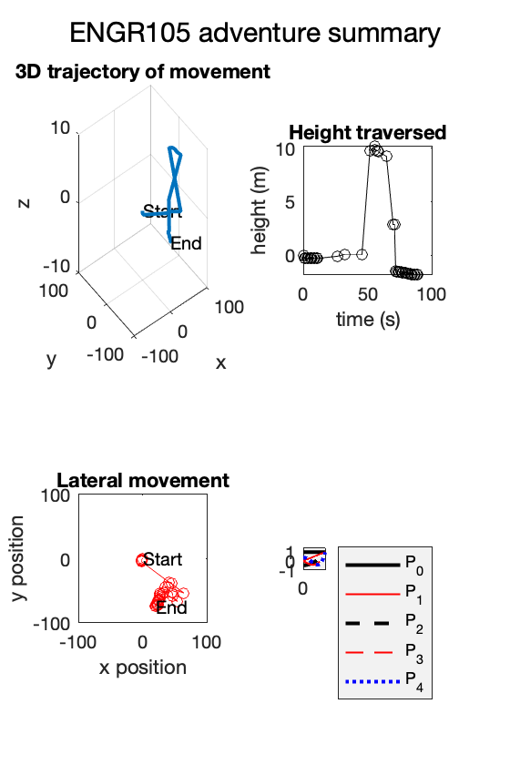

**Functions stored at the end of the document.**

**Practice problem: Legendre polynomial**

# TOPIC 15: Working with text

ENGR105, 10/22/20

### Practice problem: reactor cooling

Consider a reactor (e.g. a bioreactor, chemical reactor, nuclear reactor, etc.) that, due to some internal perturbation**, experiences a temporary increase in temperature right before t = 0**. The reactor itself is designed such that it is encased by a “barrier material” that serves to protect the wall of the reactor from a potentially caustic cooling fluid. This constantly flowing low temperature cooling fluid serves as a heat sink that should (hopefully!) keep the reactor at a sufficiently low temperature for the reaction to proceed safely and efficiently

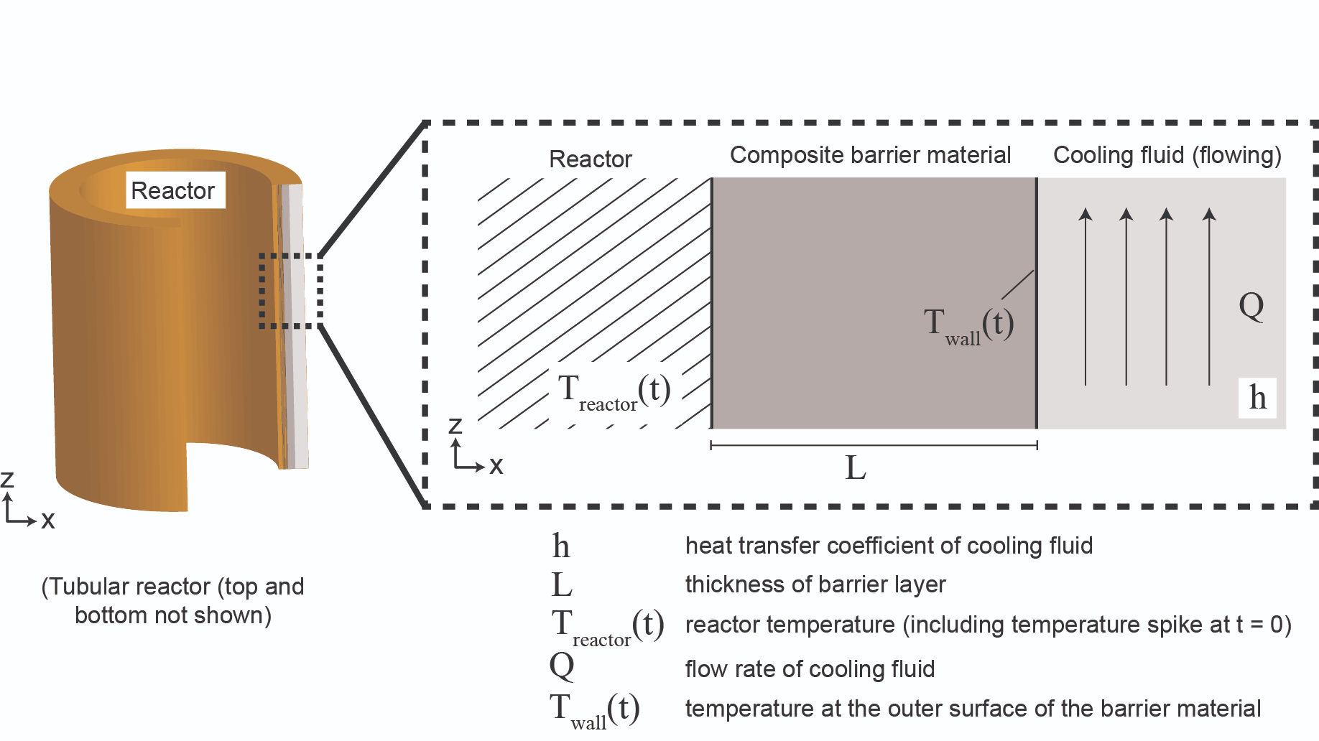

Assume you have already applied your knowledge of heat transport to quantitatively describe this system. **You have produced the following equation** that describes T_wall, the temperature of the outer surface of the barrier layer as a function of time, where the **time-dependency** (*i.e.* the shape of the curve) **is influenced by the heat transfer coefficient of the cooling fluid,** as well as many other system parameters.

% Equation describing the wall temperature as a function of t and h

T_wall = 50*(1./(t+1) + 5*(t+1).^(-4*h)) + 300;

**Issue**: T_wall (defined above) increases in temperature to above 400 degrees following the perturbation in the reactor. If T_wall remains greater than 400C for more than some important length of time (*e.g.* 30 minutes), there is a significant risk of barrier layer degradation or some other adverse outcome.

**Your task as an engineer**: produce a MATLAB script that enables you to visualize how **the time required for T_wall to drop below 400C** (in the system described above) **depends on the cooling fluid heat transfer coefficient, h**.

% Step 1: Plot the raw data -> can do so by plotting T_wall vs time

%create a vector for time

t = 0:0.01:50;

Twall = @(h) 50*(1./(t+1) + 5*(t+1).^(-4*h)) + 300;

plot(t,Twall(1), 'k-')

axis square

xlabel('time (minutes)')

ylabel('Temperature (degrees C)')

ylim([350,600])

%Step 2: specify ranges of h

%"relevant" -> determined from our system

h = logspace(-2, 1, 200);

%preallocate the vector

t400 = zeros(1,length(h))

t400 = 1×200

0 0 0 0 0 0 0 0 0 0 0 0 0 0 0 0 0 0 0 0 0 0 0 0 0 0 0 0 0 0

%Step 3: For each h value, solve for the cooling time

for k = 1:length(h)

%Step 4: Store cooling time in a vector so that we can produce a plot

t400(k) = newtonSolve(@(x) quiz3(x,h(k)),0,10^-4);

end

% Step 5: Produce a plot to visualize how t400 depends on the heat transfer

% coefficient

plot(h,t400,'k-')

%set graphical parameters

xlabel('Heat transfer coefficient')

ylabel('Time required to drop below 400 degrees')

axis square

set(gca, 'YScale', 'log')

set(gca, 'XScale', 'log')

set(gca, 'XMinorTick', 'on')

set(gca, 'TickLength', [0.02, 0.05])

grid on

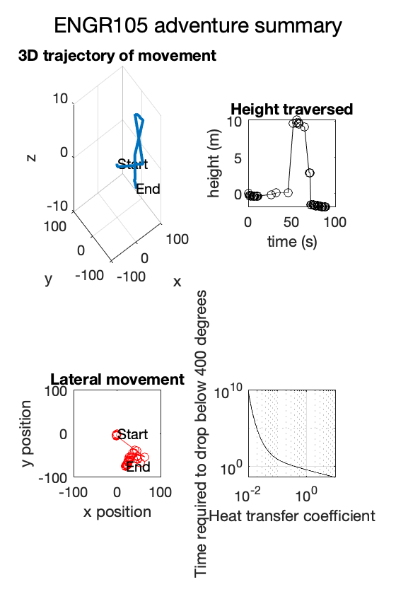

**Question**: define t400 as the time required for T_wall to drop to 400C for a given value of h. **How can we solve for t400?**

There are (at least) two different potential philosophical approaches to solve this problem:

**1) "Brute force" arrival at the solution**

* Calculate a large array of time points, determine the temperature at these points, then determine the first temperature that is less than 400C.
* Or, similarly, calculate the temperature at time zero after every small increment until the temperature drops below 400C.

*Example:*

% Time vector

t1 = 0:0.001:50000;

% Temperature vector

T = @(h) 50*(1./(t1+1) + 5*(t1+1).^(-4*h)) + 300;

% Preallocate vector to store cooling time

t_400v2 = zeros(size(h));

% Loop for each value value of h

for k = 1:length(h)

% Calculate temperature profile

T_h = T(h(k));

% Use logical indexing to determine all time points corresponding to

% T_h being less than 400

t2 = t1(T_h < 400);

% Store the first such time point

t_400v2(k) = t2(1);

end

**2) Use a numerical solver**

* Newton-Raphson: root-finding algorithm. Use iterative calculations until we converge at the root of an equation.

*Example:* We have used this method a lot so far, and have already created a function to carry out this approach.

function xn = newtonSolve(F,xn,tol)

% The purpose of this function is to apply the Newton-Raphson method to

% solve any arbitrary function, specified in an input F.

% Inputs:

% F: function and derivative

% x: initial guess

% tol: specified tolerance

% Step 1: specify initial guess

% Input xn -> initial guess

xprev = inf; % Variable to store previous xn value -> ensure it is

% not xn to enter while loop

% Step 2: iterate until xn -> xn+1

while abs(xn - xprev) > tol

% Apply input function to algorithm. NOTE: first output is function

% evaluated at xn, the second output is the derivative of the

% function evaluated at xn

f = F(xn);

% Instead of calculating the "next" x value, store the previous xn

% value

xprev = xn;

% Step 3b: update xn to next value for the iteration

xn = xn - f(1)/f(2);

end

end

**For applications like this (well-behaved, arbitrary function): Newton-Raphson will generally work better than a brute force approach**

*This can be seen in two ways:*

**A)** Computational considerations -- how many "calculations" need to be performed for each approach. We can depict this visually by plotting the data point following each iteration

% Heat transfer coefficient to consider

h1 = 0.07;

% Temperature

T_wall = @(h) 50*(1./(t+1) + 5*(t+1).^(-4*h)) + 300;

% FIRST Subplot: Brute Force approach

subplot(1,2,1)

% Temperature profile corresponding to tested heat transfer coefficient

TempH1 = T_wall(h1);

% Simulate "brute force" approach

t_BF = t(TempH1 > 400);

TempH2 = TempH1(TempH1 > 400);

% Plot temperature profile

plot(t,TempH1,'k-')

hold on

% Plot brute force calculations

plot(t_BF(1:100:end),TempH2(1:100:end),'ko')

hold off

axis square

title('Brute Force')

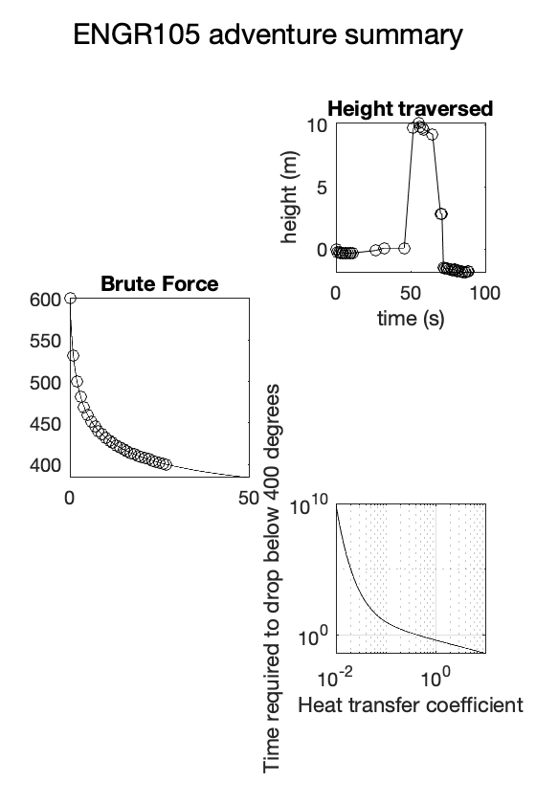

% SECOND Subplot: Newton-Raphson

subplot(1,2,2)

% Simulate Newton-Raphson:

% Determine t values for each iteration

t_NRiterations = newtonSolveReturnXvalues(@(x) quiz3(x,h1),0,10^-4);

% Determine corresponding temperature value

T_NR = 50*(1./(t_NRiterations+1) + 5*(t_NRiterations+1).^(-4*h1)) + 300;

% Plot temperature profile

plot(t,TempH1,'k-')

hold on

% Plot each NR iteration

plot(t_NRiterations,T_NR,'ro')

hold off

axis square

title('Newton-Raphson')

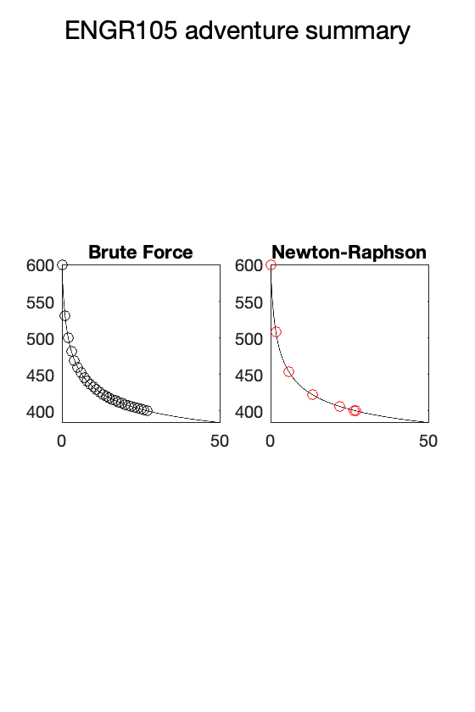

**Takeaway**: Newton-Raphson "finds" the solution in **fewer iterations** at a **higher precision** (stricter tolerance).

**B)** Memory considerations -- Newton-Raphson requires substantially fewer resources. In the above example, note that vectors (t1 and T) each require >400MB of memory!

**Other common themes and issues in Quiz 3**

1) Uncertainty about for loop notation and indexing / not preallocating

close all % Close above plots

% Goal: perform some operation on each entry of the vector h.

% Declare vector of heat transfer coefficients

h = 1:0.1:10;

% Use a FOR loop, do some operation on each element of h and store the

% output in the corrsponding entry in some other vector

t_out = [];

for k = h

t_out(end+1) = k^2;

end

This could be rewritten using **array preallocation**:

% Use a FOR loop, do some operation on each element of h and store the

% output in the corrsponding entry in some other vector

t_out = zeros(1,length(h));

for k = 1:length(h)

t_out(k) = h(k)^2;

end

2) Newton Raphson / root-finding

Recall: N-R is a root-finding algorithm. As such, it can only be used to solve for when some function evaluates to zero. This is not a problem though, as f(t) = a can be rewritten as g(t) = f(t) - a, which can be used with the Newton-Raphson method.

### Reminder: characters and strings

MATLAB can process text as character arrays and strings.

**Character arrays are distinguished by single quotes** (').

a = 'k--';

b = 'LineWidth';

c = 'This is a character array';

disp(c)

This is a character array

**Strings are created using double quotes** (").

s1 = "This is a string";

disp(s1)

This is a string

**Similarity**: both can be used to store text information

**Difference**:

* Each character (including spaces and punctuation) in a character arrays corresponds to an index position in a "vector" or array.
* An entire string corresponds to one index position

% Index the above character array

c(1)

ans = 'T'

c(5:10)

ans = ' is a '

c(1:2:end)

ans = 'Ti sacaatrary'

% Use vector operations to determine the number of characters (including

% spaces) in a piece of text.

length(c)

ans = 25

% Use indexing on string. NOTE: only ONE element of s1

s1(1)

ans = "This is a string"

**Thus**: character arrays enable you to retrieve and manipulate each character in a piece of text, while strings treat the entire "block" of text as one unit.

### Reminder: cell arrays

Cell arrays are arrays with indices that can hold a variety of data types or sizes - **all in the same variable**. Use {} to refer to cell contents and () to refer to the container.

% Create cell array

C = {'it is Thursday', [1 5 9], [2 3 1; 5 9 7], ...

uint8([1 4]), [.5; .1; .9], {'hello',[1 5]}}

C = *1×6 cell array*

{'it is Thursday'} {1×3 double} {2×3 double} {1×2 uint8} {3×1 double} {1×2 cell}

% Reference the cell container

C(1)

ans = *1×1 cell array*

{'it is Thursday'}

% Reference the contents of a particular cell

Str = C{1}

Str = 'it is Thursday'

% The contents could then be processed

Str(1:9 )

ans = 'it is Thu'

## Working with text

The ability to work with and manipulate text is important in many different applications: both those that *explicitly* deal with text data (e.g. studying genomic data) and those that involve numerical data but have some *text identifier* (e.g. batch processing of data files, images, etc.).

### Loading text

* importdata() reads in each line of text as a cell array index.

txt1 = importdata("TextData.txt");

disp(txt1)

{'Hey Macklemore? can we go thrift shopping?' }

{'What, what, what, what' }

{'What, what, what, what' }

{'What, what, what, what' }

{'What, what, what, what' }

{'What, what, what, what' }

{'What, what, what, what' }

{'What, what, what, what' }

{'What, what, what, what' }

{'I'm gonna pop some tags' }

{'Only got twenty dollars in my pocket' }

{'I, I, I'm hunting, looking for a come-up' }

{'This is frickin awesome' }

{'Nah walk up to the club like, what up, I got a big shirt!' }

{'I'm just pumped, just bought some stuff from the thrift shop' }

{'Ice on the fringe, it's so damn frosty' }

{'The people like, Damn! That's a cold ass honkey.' }

{'Rollin' in, hella deep, headin' to the mezzanine' }

{'Dressed in all pink, 'cept my gator shoes, those are green' }

{'Draped in a leopard mink, girls standin' next to me' }

{'Probably shoulda washed this, smells like R. Kelly's sheets' }

{'(Piss)' }

{'But shoot, it was ninety-nine cents! (Bag it) Coppin' it, washin' it' }

{''Bout to go and get some compliments' }

{'Passin' up on those moccasins someone else's been walkin' in them' }

{'Bummy and grungy, f it man, I am stuntin' and flossin' and' }

{'And savin' my money and I'm hella happy that's a bargain, b' }

{'I'ma take your grandpa's style, I'ma take your grandpa's style' }

{'No for real ask your grandpa can I have his hand-me-downs?' }

{'(Thank you) Velour jumpsuit and some house slippers' }

{'Dookie brown leather jacket that I found diggin'' }

{'They had a broken keyboard, I bought a broken keyboard' }

{'I bought a skeet blanket, and then I bought a kneeboard' }

{'Hello, hello, my ace man, my Miller' }

{'John Wayne ain't got nothing on my fringe game, hell no' }

{'I could take some Pro Wings, make them cool, sell those' }

{'The sneaker heads would be like Aw, he got the Velcros' }

{'I'm gonna pop some tags' }

{'Only got twenty dollars in my pocket' }

{'I, I, I'm hunting, looking for a come-up' }

{'This is frickin awesome' }

{'I'm gonna pop some tags' }

{'Only got twenty dollars in my pocket' }

{'I, I, I'm hunting, looking for a come-up' }

{'This is frickin awesome' }

{'What you know about rockin' a wolf on your noggin?' }

{'What you knowin' about wearin' a fur fox skin?' }

{'I'm digging, I'm digging, I'm searching right through that luggage' }

{'One man's trash, that's another man's come up' }

{'Thank your granddad for donating that plaid button-up shirt' }

{''Cause right now I'm up in her skirt' }

{'I'm at the Goodwill, you can find me in the (Uptons)' }

{'I'm that, I'm that sucker searchin' in that section (Uptons)' }

{'Your grammy, your aunty, your momma, your mammy' }

{'I'll take those flannel zebra jammies, second-hand, I rock that muhmuhmuhmuh'}

{'The built-in onesie with the socks on that muhmuhmuhmuh' }

{'I hit the party and they stop in that muhmuhmuhmuh' }

{'They be like, Oh, that Gucci. That's hella tight' }

{'I'm like, Yo that's fifty dollars for a T-shirt' }

{'Limited edition, let's do some simple addition' }

{'Fifty dollars for a T-shirt, that's just some ignorant fool (Shoot)' }

{'I call that getting swindled and pimped (Shoot)' }

{'I call that getting tricked by a business' }

{'That shirt's hella dope' }

{'And having the same one as six other people in this club is a hella don't' }

{'Peep game, come take a look through my telescope' }

{'Trying to get girls from a brand? Then you hella won't' }

{'Then you hella won't' }

{'I'm gonna pop some tags' }

{'Only got twenty dollars in my pocket' }

{'I, I, I'm hunting, looking for a come-up' }

{'This is frickin awesome' }

{'I wear your granddad's clothes' }

{'I look incredible' }

{'I'm in this big ass coat' }

{'From that thrift shop down the road' }

{'I wear your granddad's clothes' }

{'I look incredible' }

{'I'm in this big ass coat' }

{'From that thrift shop down the road' }

{'I'm gonna pop some tags' }

{'Only got twenty dollars in my pocket' }

{'I, I, I'm hunting, looking for a come-up' }

{'This is frickin awesome' }

{'Is that your grandma's coat?' }

* Text files may be read into a workspace using fileread(), which brings in the text as one long character string.

txt2 = fileread("TextData.txt")

txt2 =

'Hey Macklemore? can we go thrift shopping?

What, what, what, what

What, what, what, what

What, what, what, what

What, what, what, what

What, what, what, what

What, what, what, what

What, what, what, what

What, what, what, what

I'm gonna pop some tags

Only got twenty dollars in my pocket

I, I, I'm hunting, looking for a come-up

This is frickin awesome

Nah walk up to the club like, what up, I got a big shirt!

I'm just pumped, just bought some stuff from the thrift shop

Ice on the fringe, it's so damn frosty

The people like, Damn! That's a cold ass honkey.

Rollin' in, hella deep, headin' to the mezzanine

Dressed in all pink, 'cept my gator shoes, those are green

Draped in a leopard mink, girls standin' next to me

Probably shoulda washed this, smells like R. Kelly's sheets

(Piss)

But shoot, it was ninety-nine cents! (Bag it) Coppin' it, washin' it

'Bout to go and get some compliments

Passin' up on those moccasins someone else's been walkin' in them

Bummy and grungy, f it man, I am stuntin' and flossin' and

And savin' my money and I'm hella happy that's a bargain, b

I'ma take your grandpa's style, I'ma take your grandpa's style

No for real ask your grandpa can I have his hand-me-downs?

(Thank you) Velour jumpsuit and some house slippers

Dookie brown leather jacket that I found diggin'

They had a broken keyboard, I bought a broken keyboard

I bought a skeet blanket, and then I bought a kneeboard

Hello, hello, my ace man, my Miller

John Wayne ain't got nothing on my fringe game, hell no

I could take some Pro Wings, make them cool, sell those

The sneaker heads would be like Aw, he got the Velcros

I'm gonna pop some tags

Only got twenty dollars in my pocket

I, I, I'm hunting, looking for a come-up

This is frickin awesome

I'm gonna pop some tags

Only got twenty dollars in my pocket

I, I, I'm hunting, looking for a come-up

This is frickin awesome

What you know about rockin' a wolf on your noggin?

What you knowin' about wearin' a fur fox skin?

I'm digging, I'm digging, I'm searching right through that luggage

One man's trash, that's another man's come up

Thank your granddad for donating that plaid button-up shirt

'Cause right now I'm up in her skirt

I'm at the Goodwill, you can find me in the (Uptons)

I'm that, I'm that sucker searchin' in that section (Uptons)

Your grammy, your aunty, your momma, your mammy

I'll take those flannel zebra jammies, second-hand, I rock that muhmuhmuhmuh

The built-in onesie with the socks on that muhmuhmuhmuh

I hit the party and they stop in that muhmuhmuhmuh

They be like, Oh, that Gucci. That's hella tight

I'm like, Yo that's fifty dollars for a T-shirt

Limited edition, let's do some simple addition

Fifty dollars for a T-shirt, that's just some ignorant fool (Shoot)

I call that getting swindled and pimped (Shoot)

I call that getting tricked by a business

That shirt's hella dope

And having the same one as six other people in this club is a hella don't

Peep game, come take a look through my telescope

Trying to get girls from a brand? Then you hella won't

Then you hella won't

I'm gonna pop some tags

Only got twenty dollars in my pocket

I, I, I'm hunting, looking for a come-up

This is frickin awesome

I wear your granddad's clothes

I look incredible

I'm in this big ass coat

From that thrift shop down the road

I wear your granddad's clothes

I look incredible

I'm in this big ass coat

From that thrift shop down the road

I'm gonna pop some tags

Only got twenty dollars in my pocket

I, I, I'm hunting, looking for a come-up

This is frickin awesome

Is that your grandma's coat?'

disp(txt2)

Hey Macklemore? can we go thrift shopping?

What, what, what, what

What, what, what, what

What, what, what, what

What, what, what, what

What, what, what, what

What, what, what, what

What, what, what, what

What, what, what, what

I'm gonna pop some tags

Only got twenty dollars in my pocket

I, I, I'm hunting, looking for a come-up

This is frickin awesome

Nah walk up to the club like, what up, I got a big shirt!

I'm just pumped, just bought some stuff from the thrift shop

Ice on the fringe, it's so damn frosty

The people like, Damn! That's a cold ass honkey.

Rollin' in, hella deep, headin' to the mezzanine

Dressed in all pink, 'cept my gator shoes, those are green

Draped in a leopard mink, girls standin' next to me

Probably shoulda washed this, smells like R. Kelly's sheets

(Piss)

But shoot, it was ninety-nine cents! (Bag it) Coppin' it, washin' it

'Bout to go and get some compliments

Passin' up on those moccasins someone else's been walkin' in them

Bummy and grungy, f it man, I am stuntin' and flossin' and

And savin' my money and I'm hella happy that's a bargain, b

I'ma take your grandpa's style, I'ma take your grandpa's style

No for real ask your grandpa can I have his hand-me-downs?

(Thank you) Velour jumpsuit and some house slippers

Dookie brown leather jacket that I found diggin'

They had a broken keyboard, I bought a broken keyboard

I bought a skeet blanket, and then I bought a kneeboard

Hello, hello, my ace man, my Miller

John Wayne ain't got nothing on my fringe game, hell no

I could take some Pro Wings, make them cool, sell those

The sneaker heads would be like Aw, he got the Velcros

I'm gonna pop some tags

Only got twenty dollars in my pocket

I, I, I'm hunting, looking for a come-up

This is frickin awesome

I'm gonna pop some tags

Only got twenty dollars in my pocket

I, I, I'm hunting, looking for a come-up

This is frickin awesome

What you know about rockin' a wolf on your noggin?

What you knowin' about wearin' a fur fox skin?

I'm digging, I'm digging, I'm searching right through that luggage

One man's trash, that's another man's come up

Thank your granddad for donating that plaid button-up shirt

'Cause right now I'm up in her skirt

I'm at the Goodwill, you can find me in the (Uptons)

I'm that, I'm that sucker searchin' in that section (Uptons)

Your grammy, your aunty, your momma, your mammy

I'll take those flannel zebra jammies, second-hand, I rock that muhmuhmuhmuh

The built-in onesie with the socks on that muhmuhmuhmuh

I hit the party and they stop in that muhmuhmuhmuh

They be like, Oh, that Gucci. That's hella tight

I'm like, Yo that's fifty dollars for a T-shirt

Limited edition, let's do some simple addition

Fifty dollars for a T-shirt, that's just some ignorant fool (Shoot)

I call that getting swindled and pimped (Shoot)

I call that getting tricked by a business

That shirt's hella dope

And having the same one as six other people in this club is a hella don't

Peep game, come take a look through my telescope

Trying to get girls from a brand? Then you hella won't

Then you hella won't

I'm gonna pop some tags

Only got twenty dollars in my pocket

I, I, I'm hunting, looking for a come-up

This is frickin awesome

I wear your granddad's clothes

I look incredible

I'm in this big ass coat

From that thrift shop down the road

I wear your granddad's clothes

I look incredible

I'm in this big ass coat

From that thrift shop down the road

I'm gonna pop some tags

Only got twenty dollars in my pocket

I, I, I'm hunting, looking for a come-up

This is frickin awesome

Is that your grandma's coat?

Note the differences: importdata creates a **cell** array, fileread creates a **character** array.

size(txt1)

ans = 1×2

85 1

size(txt2)

ans = 1×2

1 3630

### Character arrays

* **Storing consistent width character arrays**. Character arrays can be stored in a array-like format provided each **row is of the same length**.

M = ['hello' 'hi' ;'phone' 'it';'funny' 'oh']

M = *3×7 char array*

'hellohi'

'phoneit'

'funnyoh'

Concatenation errors will occur if all columns are not of equal length.

% F = ['mat' 'labs' ;'fun' 'times';'a' 'b']

* **Character arrays of variable width can be stored in cells.**

V = {'mat', 'labs' ;'fun' , 'times';'a', 'b'}

V = *3×2 cell array*

{'mat'} {'labs' }

{'fun'} {'times'}

{'a' } {'b' }

Individual lists of characters within the cell can then be accessed.

% Reference the text in the above cell array

c = V{2,1}

c = 'fun'

% Note the indexing is the same as before. Above, we have a cell array in

% the format of a vector.

d = txt1{10}

d = 'I'm gonna pop some tags'

**Note**: In practice, **character arrays are typically utilized to store vectors of characters** and these vectors are stored in cells

* Character vectors and arrays can be **indexed similarly as numeric arrays** and operated upon by many common array functions

% Using vector indexing to retrieve sub arrays of characters from the "d"

t1 = d(1)

t1 = 'I'

t2 = d(7)

t2 = 'n'

t3 = d(1:2:end-2)

t3 = 'Imgnappsm a'

t4 = fliplr(d)

t4 = 'sgat emos pop annog m'I'

* Like numeric arrays, character array indices may be concatenated, replaced, and expanded

% Concatenate character arrays

d = [d,', yo']

d = 'I'm gonna pop some tags, yo'

% Expand array

d(end+1:end+5) = '. Woo'

d = 'I'm gonna pop some tags, yo. Woo'

% Delete entries

d([11:16,18:end-2]) = []

d = 'I'm gonna moo'

* Character arrays can use logical indexing

% Remove all spaces

d(d ~= ' ')

ans = 'I'mgonnamoo'

* Character arrays stored in cells may be indexed by **reference to cell** and **then array indices.**

% Create new character array

t1 = txt1{29}

t1 = 'No for real ask your grandpa can I have his hand-me-downs?'

% Create subarray

t2 = txt1{29}(1:11)

t2 = 'No for real'

% Return character array containing all "r"s

t3 = txt1{29}(txt1{29} == 'r')

t3 = 'rrrr'

### String arrays

String arrays can be formulated just like character arrays, except columns need not be of the same length - **each string** is viewed as a single index of data.

S = ["position", "velocity";...

"acceleration","g-force"]

S = *2×2 string array*

"position" "velocity"

"acceleration" "g-force"

% Return the string in index position 1 (single index notation)

S(1)

ans = "position"

**Note**: Because each string in a string array is viewed as a single index, any index can be replaced by a string without explicit reference to the indices of the characters

S(1,2) = "velocity in x"

S = *2×2 string array*

"position" "velocity in x"

"acceleration" "g-force"

S

S = *2×2 string array*

"position" "velocity in x"

"acceleration" "g-force"

**Note**: Because each string is viewed as a **single index**, a string array index **must be converted to a character array** in order to access specific characters.This can be done with the char function.

% Convert one entry into a character sub array

c = char(S(2,1))

c = 'acceleration'

c = c(1:3)

c = 'acc'

### Character and string functions

There are many high level functions to operate on character arrays and strings

* isletter(): returns logical array indicating whether a particular character is a **letter** or not (**true**: that character is a letter).

c1 = txt1{39}

c1 = 'Only got twenty dollars in my pocket'

% Returns logical array indicating whether a particular character is a

% letter or not (true: that character is a letter)

v = isletter(c1)

v = *1×36 logical array*

1 1 1 1 0 1 1 1 0 1 1 1 1 1 1 0 1 1 1 1 1 1 1 0 1 1 0 1 1 0 1 1 1 1 1 1

% Convert all to upper case

sU = upper(c1)

sU = 'ONLY GOT TWENTY DOLLARS IN MY POCKET'

% Convert all to lower case

sL = lower(c1)

sL = 'only got twenty dollars in my pocket'

% Create a character array of spaces

sB = blanks(7)

sB = ' '

* **Finding** a piece of text inside a character array

c1

c1 = 'Only got twenty dollars in my pocket'

% Create index at which word "dollars" appears

ind = strfind(c1, 'dollars')

ind = 17

**Note**: strfind is case-sensitive

% Create index at which word "Dollars" appears

ind = strfind(c1,'Dollars')

ind =

[]

* **Comparing** text

**Character arrays**. strcmp()can be used to successfully evaluate if one character array is the same as another

if ~strcmp('twenty',c1)

disp('yes')

end

yes

**Strings**. Because strings (denoted by double quotation marks) are viewed as singular entities, they can be compared via decision even if they have differing lengths

if "owl" ~= "owls"

disp('yes')

end

yes

### Converting numbers to characters

num2str() can be used to convert numbers to characters for concatenation with other characters.

* One situation where this can be useful: converting a loop index or counter into text.

% Assume: 10 image files are present in a folder and I want to easily

% open all of them. First: declare base file name

basefile = 'imageFile';

% Second: use a for loop to create text (that could be used to open each)

for k = 1:10

disp([basefile,num2str(k),'.tif'])

end

imageFile1.tif

imageFile2.tif

imageFile3.tif

imageFile4.tif

imageFile5.tif

imageFile6.tif

imageFile7.tif

imageFile8.tif

imageFile9.tif

imageFile10.tif

### Practice Problem: analyzing song lyrics

Consider the data in txt1, imported above. How many words are in the 46-th line? What is the average word length?

%Step 1: Create variable with 46th of code from txt1

%Step 2: Can use spaces to determine where the words are -> have an

%isletter function and an isspace function

%This would determine where spaces are

%Step 3: for space, assign "previous" letters to a cell storing words

%add space to front and end of character array

Q1: how many words are there?

Q2: What is the average word length?

# TOPIC 16: Working with text, pt 2

ENGR105, 10/27/20

### Reminder: working with text

The ability to work with and manipulate text is important in many different applications: both those that *explicitly* deal with text data (e.g. studying genomic data) and those that involve numerical data but have some *text identifier* (e.g. batch processing of data files, images, etc.).

**Loading text.**. importdata() reads in each line of text as a cell array index.

txt1 = importdata('TextData.txt');

size(txt1)

ans = 1×2

85 1

fileread() reads a text file as one long character array.

%read as one long character array

txt2 = fileread('TextData.txt');

size(txt2)

ans = 1×2

1 3630

**Note**: unless explicitly specified (HW 8), you should use which ever works better for a given situation.

**Character arrays can be read from cells in a cell array**.

% Read the 39th line as a character array

c = txt1{39}

c = 'Only got twenty dollars in my pocket'

Character vectors and arrays can be **indexed similarly as numeric arrays** and operated upon by many common array functions

% Using vector indexing to retrieve sub arrays of characters from the "c"

t1 = c(1:5)

t1 = 'Only '

% Concatenate array

t2 = [t1,' , ',t1]

t2 = 'Only , Only '

Character arrays can use **logical indexing**.

% Create a text array without spaces

t2 = t2(t2 ~= ' ')

t2 = 'Only,Only'

**Character and string functions**. There are many high level functions to operate on character arrays and strings

* isletter(): returns logical array indicating whether a particular character is a **letter** or not (**true**: that character is a letter).

c = txt1(39)

c = *1×1 cell array*

{'Only got twenty dollars in my pocket'}

% Logical array indicating positions that are letters

v1 = isletter(c)

v1 = *logical*

0

* isspace(): returns logical array indicating whether a particular character is a **space** or not (**true**: that character is a space).

% Logical array indicating positions that are spaces

v2 = isspace(c)

v2 = *logical*

0

* Functions to change the **case** of a character sting

% Convert all to upper case

sU = upper(c)

sU = *1×1 cell array*

{'ONLY GOT TWENTY DOLLARS IN MY POCKET'}

% Convert all to lower case

sL = lower(c)

sL = *1×1 cell array*

{'only got twenty dollars in my pocket'}

* **Finding** a piece of text inside a character array

% Create index at which word "dollars" appears

ind = strfind(c,'twenty')

ind = *1×1 cell array*

{[10]}

ind = strfind(c,'t')

ind = *1×1 cell array*

{1×4 double}

Many more functions may be found here:

<https://www.mathworks.com/help/matlab/characters-and-strings.html>

### Practice Problem: analyzing song lyrics

Consider the data in txt1, imported above. How many words are in the 46-th line? What is the average word length?

% Step 1: Read the 46th line

c1 = txt1{46}

c1 = 'What you know about rockin' a wolf on your noggin?'

%Step 2: Remove punctiation

c1 = c1(isletter(c1)|isspace(c1))

c1 = 'What you know about rockin a wolf on your noggin'

%Step 3: Isolate each word

% Step 3a: add a space to front and back of text

c1 = [' ', c1, ' ']

c1 = ' What you know about rockin a wolf on your noggin '

% Step 3b: Determine where spaces are

spaces = strfind(c1, ' ')

spaces = 1×11

1 6 10 15 21 28 30 35 38 43 50

% Step 3c: Store each word in cell array. note: if we have n spaces, then

% we will have n - 1 words.

myCell = cell(1,length(spaces)-1); % Preallocate cell array

% loop through all spaces to store words

for k = 1:length(myCell)

myCell{k} = c1(spaces(k)+1:spaces(k+1)-1);

end

disp(myCell)

{'What'} {'you'} {'know'} {'about'} {'rockin'} {'a'} {'wolf'} {'on'} {'your'} {'noggin'}

Q1: how many words are there?

numWords = numel(myCell)

numWords = 10

Q2: What is the average word length?

numLetters = 0;

%Loop through all words, add number of letters

for k = 1:numWords

numLetters = numLetters + length(myCell{k})

end

numLetters = 4

numLetters = 7

numLetters = 11

numLetters = 16

numLetters = 22

numLetters = 23

numLetters = 27

numLetters = 29

numLetters = 33

numLetters = 39

avgLength = numLetters/numWords

avgLength = 3.9000

Q3: in the above case, we analyzed one *line* of text. How could we modify this to analyze *all* of the lines of text in the file?

### Practice Problem: the central dogma of molecular biology

The **central dogma of molecular biology** is an explanation of the genetic flow of information in a biological system, often stated as "DNA makes RNA, and RNA makes protein." *Depicted visually (from* [wikipedia](https://en.wikipedia.org/wiki/Protein_production)*):*

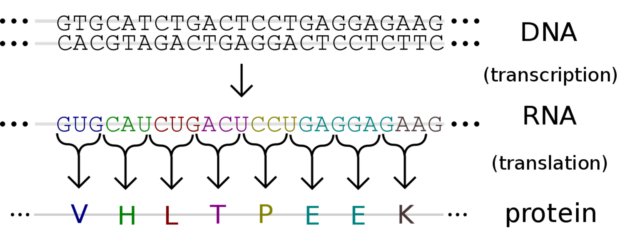

*Key terms for this problem:*

* **DNA**: the "genetic blueprint" for life. Strands of DNA are biopolymers consisting of a sequence of monomers, known as nucleotides. Each nucleotide consists of one base (cytosine [**C**], guanine [**G**], adenine [**A**] or thymine [**T**]), a sugar (deoxyribose), and a phosphate group. **Information is stored in the sequence of bases**, and DNA sequences are represented as a sequence of A, T, C, and G. Example: TCTTGTTTTATTG
* **mRNA**: the "instructions copied from DNA" dictating how to construct a protein. Like DNA, strands of RNA are biopolymers consisting of a sequence of nucleotide monomers. In this case, each nucleotide consists of one base (cytosine [**C**], guanine [**G**], adenine [**A**] or uracil [**U**]), a sugar (ribose), and a phosphate group. An mRNA strand is **produced from its DNA template**, with all bases matching except with uracils replacing thymines. Information is stored in the sequence of bases, and mRNA sequences are represented as a sequence of A, U, C, and G. Example corresponding to the above: UCUUGUUUUAUUG
* **Protein**: the "functional units" produced from an mRNA template. Encoded from mRNA, proteins are biopolymers that consist of a sequence of amino acid monomers. There are 20 naturally occuring amino acids.
* **Codon**: sequence of three bases that specify which amino acid will be added next to *a protein that is being constructed*.

% List of codons. Note the use of importdata()

codon_list = importdata('codonList.txt');

disp(codon_list)

{'TTT,Phenylalanine,F'}

{'TTC,Phenylalanine,F'}

{'TTA,Leucine,L' }

{'TTG,Leucine,L' }

{'TCT,Serine,S' }

{'TCC,Serine,S' }

{'TCA,Serine,S' }

{'TCG,Serine,S' }

{'TAT,Tyrosine,Y' }

{'TAC,Tyrosine,Y' }

{'TAA,Stop,X' }

{'TAG,Stop,X' }

{'TGT,Cysteine,C' }

{'TGC,Cysteine,C' }

{'TGA,Stop,X' }

{'TGG,Tryptophan,W' }

{'CTT,Leucine,L' }

{'CTC,Leucine,L' }

{'CTA,Leucine,L' }

{'CTG,Leucine,L' }

{'CCT,Proline,P' }

{'CCC,Proline,P' }

{'CCA,Proline,P' }

{'CCG,Proline,P' }

{'CAT,Histidine,H' }

{'CAC,Histidine,H' }

{'CAA,Glutamine,Q' }

{'CAG,Glutamine,Q' }

{'CGT,Arginine,R' }

{'CGC,Arginine,R' }

{'CGA,Arginine,R' }

{'CGG,Arginine,R' }

{'ATT,Isoleucine,I' }

{'ATC,Isoleucine,I' }

{'ATA,Isoleucine,I' }

{'ATG,Methionine,M' }

{'ACT,Threonine,T' }

{'ACC,Threonine,T' }

{'ACA,Threonine,T' }

{'ACG,Threonine,T' }

{'AAT,Asparagine,N' }

{'AAC,Asparagine,N' }

{'AAA,Lysine,K' }

{'AAG,Lysine,K' }

{'AGT,Serine,S' }

{'AGC,Serine,S' }

{'AGA,Arginine,R' }

{'AGG,Arginine,R' }

{'GTT,Valine,V' }

{'GTC,Valine,V' }

{'GTA,Valine,V' }

{'GTG,Valine,V' }

{'GCT,Alanine,A' }

{'GCC,Alanine,A' }

{'GCA,Alanine,A' }

{'GCG,Alanine,A' }

{'GAT,Aspartate,D' }

{'GAC,Aspartate,D' }

{'GAA,Glutamate,E' }

{'GAG,Glutamate,E' }

{'GGT,Glycine,G' }

{'GGC,Glycine,G' }

{'GGA,Glycine,G' }

{'GGG,Glycine,G' }

**Important notes:**

* Genes occur in sets of three bases. One codon (three bases) specifies an amino acid.
* Methionine (DNA base sequence ATG) is nearly always the "Start" codon, indicating the start of a sequence for a gene.
* There are three common "Stop" codons that indicate where a gene sequence stops: DNA base sequences TAA, TAG, TGA.
* We are representing these biomolecules as text. Remember that these correspond to *different chemical structures*.

*Short summary:*

* DNA specifies mRNA, which encodes the protein to be made.
* DNA/mRNA can be represented as text - either ATCG or AUCG
* Protein can be represented as text - a string of one of twenty letters.

In this problem, we will analyze this flow of biological information describing the **"spike"** protein on the membrane of **severe acute respiratory syndrome coronavirus 2 (SARS-CoV-2)**.SARS-CoV-2 is an enveloped, *positive-sense*, single-stranded RNA virus that causes coronavirus disease 2019 (COVID-19). Virus particles include the RNA genetic material and structural proteins needed for invasion of host cells. Once inside the cell the infecting RNA is used to encode structural proteins that make up virus particles, nonstructural proteins that direct virus assembly, transcription, replication and host control and accessory proteins whose function has not been determined.

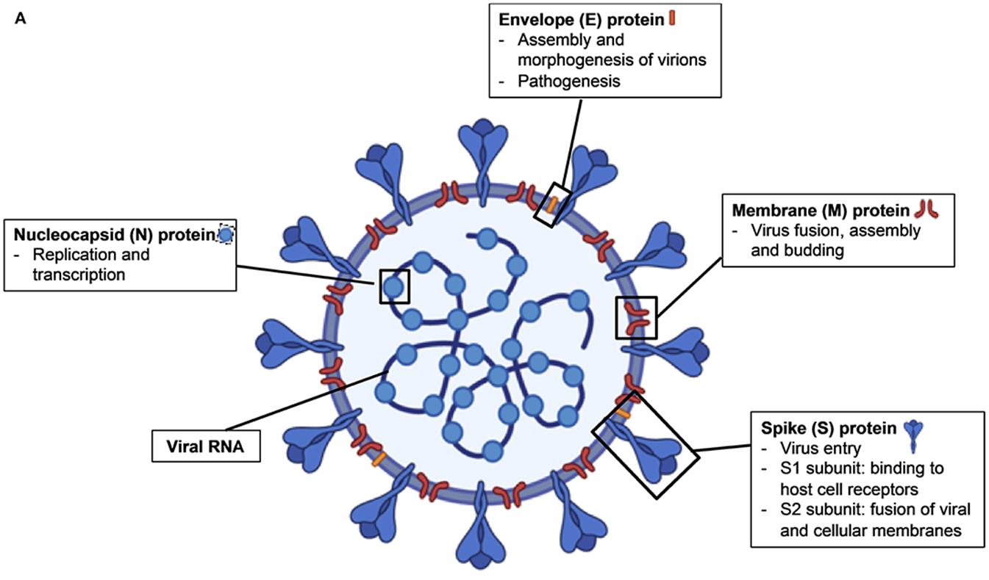

***Source DOI:*** [***10.3389/fimmu.2020.00879***](https://www.frontiersin.org/articles/10.3389/fimmu.2020.00879/full)

The structural proteins of SARS-CoV-2 include the envelope protein, **spike or surface glycoprotein**, membrane protein and the nucleocapsid protein. **The spike glycoprotein is found on the outside of the virus particle and gives coronavirus viruses their crown-like appearance. This glycoprotein mediates attachment of the virus particle and entry into the host cell.** This protein is an *important target* for vaccine development, antibody therapies and diagnostic antigen-based tests.

***Key resources and references:***

* Review of SARS-CoV-2 and COVID-19: <https://www.nature.com/articles/s41579-020-00459-7>
* Genomic information (Wuhan-Hu-1): <https://www.ncbi.nlm.nih.gov/nuccore/NC_045512>

**Problem statement**

Given a DNA primer (a short sequence of DNA representing the first few bases of a given gene) for the spike glycoprotein and the genome of SARS-CoV-2, answer the following questions:

**Question 1:** how many bases are in the SARS-CoV-2 genome?

**Question 2:** how many of *each* base appear in the genome?

**Question 3:** given a primer, what is the DNA sequence for the spike glycoprotein? How many bases long is it?

**Question 4:** what is the mRNA transcript of the spike protein?

**Question 5:** What is the amino acid sequence of the spike protein?

**Question 6:** How many of each amino acid are in the spike protein?

**First thing to do: organize information that is provided**

*SARS-CoV-2 genome:*

% Import genomic information as one long character array.

% NOTE: difference from importdata()

sarsCov2_genome = fileread('sarsCov2_genome.txt'); % Read text file

sarsCov2_genome = sarsCov2_genome(isletter(sarsCov2_genome)); % remove spaces and commas

sarsCov2_genome = upper(sarsCov2_genome); % Convert to upper case

disp(sarsCov2_genome)



*Spike protein primer:*

% DNA sequence that you know starts the gene

spike_FWprimer = 'ATGTTTGTTTTTCTTGTTTTATTG';

*Codon information - reorganize into a three column cell array for easier accessibility:*

% NOTE: one cell in codon_list (imported above) is a line of information

% containing 1) the nucleotides, the name, and abbreviation for

% each amino acid. We want each of these three items in a separate column

codon_list = importdata('codonList.txt');

disp(codon_list);

{'TTT,Phenylalanine,F'}

{'TTC,Phenylalanine,F'}

{'TTA,Leucine,L' }

{'TTG,Leucine,L' }

{'TCT,Serine,S' }

{'TCC,Serine,S' }

{'TCA,Serine,S' }

{'TCG,Serine,S' }

{'TAT,Tyrosine,Y' }

{'TAC,Tyrosine,Y' }

{'TAA,Stop,X' }

{'TAG,Stop,X' }

{'TGT,Cysteine,C' }

{'TGC,Cysteine,C' }

{'TGA,Stop,X' }

{'TGG,Tryptophan,W' }

{'CTT,Leucine,L' }

{'CTC,Leucine,L' }

{'CTA,Leucine,L' }

{'CTG,Leucine,L' }

{'CCT,Proline,P' }

{'CCC,Proline,P' }

{'CCA,Proline,P' }

{'CCG,Proline,P' }

{'CAT,Histidine,H' }

{'CAC,Histidine,H' }

{'CAA,Glutamine,Q' }

{'CAG,Glutamine,Q' }

{'CGT,Arginine,R' }

{'CGC,Arginine,R' }

{'CGA,Arginine,R' }

{'CGG,Arginine,R' }

{'ATT,Isoleucine,I' }

{'ATC,Isoleucine,I' }

{'ATA,Isoleucine,I' }

{'ATG,Methionine,M' }

{'ACT,Threonine,T' }

{'ACC,Threonine,T' }

{'ACA,Threonine,T' }

{'ACG,Threonine,T' }

{'AAT,Asparagine,N' }

{'AAC,Asparagine,N' }

{'AAA,Lysine,K' }

{'AAG,Lysine,K' }

{'AGT,Serine,S' }

{'AGC,Serine,S' }

{'AGA,Arginine,R' }

{'AGG,Arginine,R' }

{'GTT,Valine,V' }

{'GTC,Valine,V' }

{'GTA,Valine,V' }

{'GTG,Valine,V' }

{'GCT,Alanine,A' }

{'GCC,Alanine,A' }

{'GCA,Alanine,A' }

{'GCG,Alanine,A' }

{'GAT,Aspartate,D' }

{'GAC,Aspartate,D' }

{'GAA,Glutamate,E' }

{'GAG,Glutamate,E' }

{'GGT,Glycine,G' }

{'GGC,Glycine,G' }

{'GGA,Glycine,G' }

{'GGG,Glycine,G' }

codons = cell(length(codon_list),3);

%process each line and seperate the elements

tempCodon = codon_list{k}

tempCodon = 'TAC,Tyrosine,Y'

commaInd = strfind(tempCodon, ',')

commaInd = 1×2

4 13

for k = 1:length(codon_list)

%First cell codon ATCG

codons{k,1} = tempCodon(1:commaInd(1)-1);

%second cell: name of amino acid

codons{k,2} = tempCodon(1:commaInd(2)-1);

%third cell: First cell codon ATCG

codons{k,1} = tempCodon(commaInd(2)+1:end);

end

**Note**: the codons listed are given in terms of *DNA bases*.

**Question 1:** how many bases are in the SARS-CoV-2 genome?

% Number of bases equals number of elements in the character vector

numBases = length(sarsCov2_genome)

numBases = 29903

**Question 2:** how many of *each* base appear in the genome?

**Note**: for this problem we consider only one strand.

% Step 1: Determine how many of each base are in the genome

base_A = length(sarsCov2_genome(sarsCov2_genome == 'A'))

base_A = 8954

base_T = length(sarsCov2_genome(sarsCov2_genome == 'T'))

base_T = 9594

base_C = length(sarsCov2_genome(sarsCov2_genome == 'C'))

base_C = 5492

base_G = length(sarsCov2_genome(sarsCov2_genome == 'G'))

base_G = 5863

% Step 2: Plotting

% Create cell array containing each x label

xval = {'A', 'T', 'C', 'G'}

xval = *1×4 cell array*

{'A'} {'T'} {'C'} {'G'}

%Convert cell array to categorical and then reorder to be in the same order

xval2 = categorical(xval);

xval2 = reordercats(xval2, xval)';

% Make bar graph

bar(xval2, [base_A, base_T, base_C, base_G]);

title('Bases in the Sars-Cov2 genome')

axis square

ylabel('Number');

xlabel('Base');

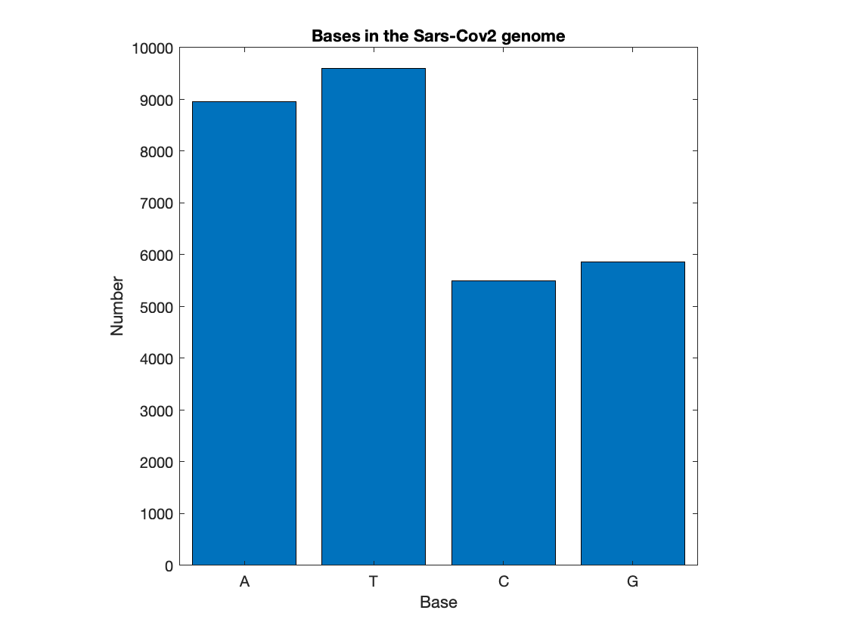

**Question 3:** given a primer, what is the DNA sequence for the spike glycoprotein? How many bases long is it?

# TOPIC 17: Text and structure arrays

ENGR105, 10/29/20

### Practice Problem: the central dogma of molecular biology

The **central dogma of molecular biology** is an explanation of the genetic flow of information in a biological system, often stated as "DNA makes RNA, and RNA makes protein." *Depicted visually (from* [wikipedia](https://en.wikipedia.org/wiki/Protein_production)*):*



*Key terms for this problem:*

* **DNA**: the "genetic blueprint" for life. Strands of DNA are biopolymers consisting of a sequence of monomers, known as nucleotides. Each nucleotide consists of one base (cytosine [**C**], guanine [**G**], adenine [**A**] or thymine [**T**]), a sugar (deoxyribose), and a phosphate group. **Information is stored in the sequence of bases**, and DNA sequences are represented as a sequence of A, T, C, and G. Example: TCTTGTTTTATTG
* **mRNA**: the "instructions copied from DNA" dictating how to construct a protein. Like DNA, strands of RNA are biopolymers consisting of a sequence of nucleotide monomers. In this case, each nucleotide consists of one base (cytosine [**C**], guanine [**G**], adenine [**A**] or uracil [**U**]), a sugar (ribose), and a phosphate group. An mRNA strand is **produced from its DNA template**, with all bases matching except with uracils replacing thymines. Information is stored in the sequence of bases, and mRNA sequences are represented as a sequence of A, U, C, and G. Example corresponding to the above: UCUUGUUUUAUUG
* **Protein**: the "functional units" produced from an mRNA template. Encoded from mRNA, proteins are biopolymers that consist of a sequence of amino acid monomers. There are 20 naturally occuring amino acids.
* **Codon**: sequence of three bases that specify which amino acid will be added next to *a protein that is being constructed*.

% List of codons. Note the use of importdata()

codon_list = importdata('codonList.txt');

disp(codon_list)

{'TTT,Phenylalanine,F'}

{'TTC,Phenylalanine,F'}

{'TTA,Leucine,L' }

{'TTG,Leucine,L' }

{'TCT,Serine,S' }

{'TCC,Serine,S' }

{'TCA,Serine,S' }

{'TCG,Serine,S' }

{'TAT,Tyrosine,Y' }

{'TAC,Tyrosine,Y' }

{'TAA,Stop,X' }

{'TAG,Stop,X' }

{'TGT,Cysteine,C' }

{'TGC,Cysteine,C' }

{'TGA,Stop,X' }

{'TGG,Tryptophan,W' }

{'CTT,Leucine,L' }

{'CTC,Leucine,L' }

{'CTA,Leucine,L' }

{'CTG,Leucine,L' }

{'CCT,Proline,P' }

{'CCC,Proline,P' }

{'CCA,Proline,P' }

{'CCG,Proline,P' }

{'CAT,Histidine,H' }

{'CAC,Histidine,H' }

{'CAA,Glutamine,Q' }

{'CAG,Glutamine,Q' }

{'CGT,Arginine,R' }

{'CGC,Arginine,R' }

{'CGA,Arginine,R' }

{'CGG,Arginine,R' }

{'ATT,Isoleucine,I' }

{'ATC,Isoleucine,I' }

{'ATA,Isoleucine,I' }

{'ATG,Methionine,M' }

{'ACT,Threonine,T' }

{'ACC,Threonine,T' }

{'ACA,Threonine,T' }

{'ACG,Threonine,T' }

{'AAT,Asparagine,N' }

{'AAC,Asparagine,N' }

{'AAA,Lysine,K' }

{'AAG,Lysine,K' }

{'AGT,Serine,S' }

{'AGC,Serine,S' }

{'AGA,Arginine,R' }

{'AGG,Arginine,R' }

{'GTT,Valine,V' }

{'GTC,Valine,V' }

{'GTA,Valine,V' }

{'GTG,Valine,V' }

{'GCT,Alanine,A' }

{'GCC,Alanine,A' }

{'GCA,Alanine,A' }

{'GCG,Alanine,A' }

{'GAT,Aspartate,D' }

{'GAC,Aspartate,D' }

{'GAA,Glutamate,E' }

{'GAG,Glutamate,E' }

{'GGT,Glycine,G' }

{'GGC,Glycine,G' }

{'GGA,Glycine,G' }

{'GGG,Glycine,G' }

**Important notes:**

* Genes occur in sets of three bases. One codon (three bases) specifies an amino acid.
* Methionine (DNA base sequence ATG) is nearly always the "Start" codon, indicating the start of a sequence for a gene.
* There are three common "Stop" codons that indicate where a gene sequence stops: DNA base sequences TAA, TAG, TGA.
* We are representing these biomolecules as text. Remember that these correspond to *different chemical structures*.

*Short summary:*

* DNA specifies mRNA, which encodes the protein to be made.
* DNA/mRNA can be represented as text - either ATCG or AUCG
* Protein can be represented as text - a string of one of twenty letters.

In this problem, we will analyze this flow of biological information describing the **"spike"** protein on the membrane of **severe acute respiratory syndrome coronavirus 2 (SARS-CoV-2)**.SARS-CoV-2 is an enveloped, *positive-sense*, single-stranded RNA virus that causes coronavirus disease 2019 (COVID-19). Virus particles include the RNA genetic material and structural proteins needed for invasion of host cells. Once inside the cell the infecting RNA is used to encode structural proteins that make up virus particles, nonstructural proteins that direct virus assembly, transcription, replication and host control and accessory proteins whose function has not been determined.



***Source DOI:*** [***10.3389/fimmu.2020.00879***](https://www.frontiersin.org/articles/10.3389/fimmu.2020.00879/full)

The structural proteins of SARS-CoV-2 include the envelope protein, **spike or surface glycoprotein**, membrane protein and the nucleocapsid protein. **The spike glycoprotein is found on the outside of the virus particle and gives coronavirus viruses their crown-like appearance. This glycoprotein mediates attachment of the virus particle and entry into the host cell.** This protein is an *important target* for vaccine development, antibody therapies and diagnostic antigen-based tests.

***Key resources and references:***

* Review of SARS-CoV-2 and COVID-19: <https://www.nature.com/articles/s41579-020-00459-7>
* Genomic information (Wuhan-Hu-1): <https://www.ncbi.nlm.nih.gov/nuccore/NC_045512>
* General information about coronaviruses: <https://www.ncbi.nlm.nih.gov/pmc/articles/PMC4369385/>

**Problem statement**

Given a DNA primer (a short sequence of DNA representing the first few bases of a given gene) for the spike glycoprotein and the genome of SARS-CoV-2, answer the following questions:

**Question 1:** how many bases are in the SARS-CoV-2 genome?

**Question 2:** how many of *each* base appear in the genome?

**Question 3:** given a primer, what is the DNA sequence for the spike glycoprotein? How many bases long is it?

**Question 4:** what is the mRNA transcript of the spike protein?

**Question 5:** What is the amino acid sequence of the spike protein?

**Question 6:** How many of each amino acid are in the spike protein?

**First thing to do: organize information that is provided**

*SARS-CoV-2 genome:*

% Import genomic information as one long character array.

% NOTE: difference from importdata()

sarsCov2_genome = fileread('sarsCov2_genome.txt'); % Read text file

sarsCov2_genome = sarsCov2_genome(isletter(sarsCov2_genome)); % remove spaces and commas

sarsCov2_genome = upper(sarsCov2_genome); % Convert to upper case

disp(sarsCov2_genome)



*Spike protein primer:*

% DNA sequence that you know starts the gene

spike_FWprimer = 'ATGTTTGTTTTTCTTGTTTTATTG';

*Codon information - reorganize into a three column cell array for easier accessibility:*

% NOTE: one cell in codon_list (imported above) is a line of information

% containing 1) the nucleotides, the name, and abbreviation for

% each amino acid. We want each of these three items in a separate column

% Preallocate cell array

codons = cell(length(codon_list),3);

% Loop through each entry in the list of codons

for k = 1:length(codon_list)

% Read character arrays from the k-th row

codon_row = codon_list{k};

% Determine indices where commas occur

ind = strfind(codon_row,',');

% First column: bases

codons{k,1} = codon_row(1:ind(1)-1);

% Second column: corresponding codon name

codons{k,2} = codon_row(ind(1)+1:ind(2)-1);

% Third column: Amino acid

codons{k,3} = codon_row(ind(2)+1:end);

end

**Note**: the codons listed are given in terms of *DNA bases*.

**Question 1:** how many bases are in the SARS-CoV-2 genome?

% Number of bases equals number of elements in the character vector

numBases = length(sarsCov2_genome)

numBases = 29903

**Question 2:** how many of *each* base appear in the genome?

**Note**: for this problem we consider only one strand.

% Step 1: Determine how many of each base are in the genome

base_A = length(strfind(sarsCov2_genome, 'A'))

base_A = 8954

base_T = length(strfind(sarsCov2_genome, 'T'))

base_T = 9594

base_C = length(strfind(sarsCov2_genome, 'C'))

base_C = 5492

base_G = length(strfind(sarsCov2_genome, 'G'))

base_G = 5863

% Step 2: Plotting

% Create cell array containing each x label

xval = {'A','T','C','G'};

% Convert cell array to categorical and then reorder to be in the same

% order

xval2 = categorical(xval);

xval2 = reordercats(xval2,xval)';

% Make bar graph

bar(xval2,[base_A,base_T,base_C,base_G]);

title('Bases in the Sars-Cov-2 genome')

axis square

ylabel('Number');

xlabel('Base');

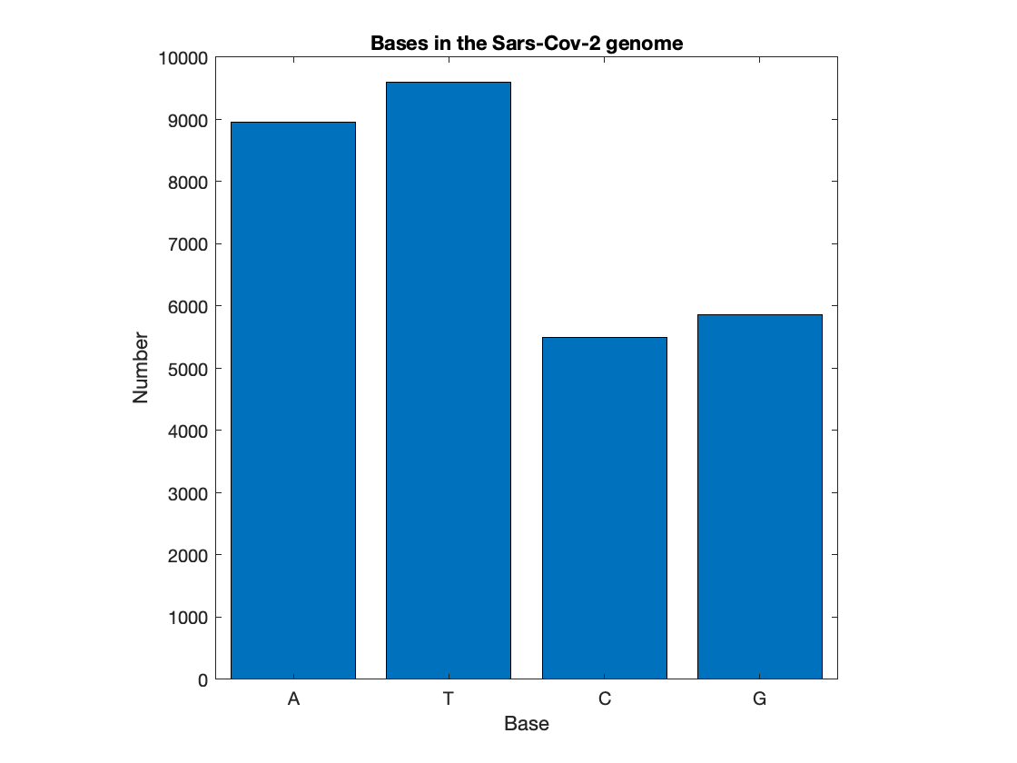

**Question 3:** given a primer, what is the DNA sequence for the spike glycoprotein? How many bases long is it?

% Step 1: Find the index in the genome where the gene starts

DNA_start = strfind(sarsCov2_genome, spike_FWprimer)

DNA_start = 21563

% Define the DNA sequence starting at taht position

spike_DNA = sarsCov2_genome(DNA_start:end)

spike_DNA = ''

% Step 2: determine length of gene

% Goal: find each instance of a "possible" stop codon. In this case, the

% first one that occurs after a "multiple of three bases" will be it.

possibleStops = [];

stopCodons = ['TAA'; 'TAG'; 'TGA']

stopCodons = *3×3 char array*

'TAA'

'TAG'

'TGA'

%Loop through sequence to find potential stop codons

for k = 1:3

% stop codon to be considered

tempStop = stopCodons(k,:);

%find and add potential stop locations

possibleStops = [possibleStops, strfind(spike_DNA, tempStop)];

end

%find the first stop position that is consisitent

possibleStops = sort(possibleStops, 'ascend')

possibleStops = 1×427

29 36 48 87 117 228 237 240 258 261 285 294 299 302 329 360 363 372 384 393 408 411 465 483 492 504 537 552 567 582

%find positions in modulus of 3

lastCodon = possibleStops(mod(possibleStops,3) == 1);

lastBase = lastCodon(1) + 2;

% DNA sequence of spike protein

spike_DNA = spike_DNA(1:lastBase)

spike_DNA = ''

disp(spike_DNA)



**Question 4:** what is the mRNA transcript of the spike protein?

% First, initialize the RNA sequence from the DNA sequence

spike_RNA = spike_DNA;

% The difference between DNA and RNA is that RNA contains uracil bases int

% he place of thymine

spike_RNA(spike_DNA == 'T') = 'U';

length(spike_RNA)

ans = 3822

disp(spike_RNA)



**Question 5:** What is the amino acid sequence of the spike protein? That is, what is the product of protein *translation*.

% Step 1: Preallocate character array to contain protein sequence. Note:

% stop codon is not included in the aminoa cid sequence

spike_protein = blanks(length(spike_DNA)/3-1);

% Step 2: compare each three bases to list of codons to determine

% appropriate amino acod.

% String array: each line corresponds to a codon. To be used for

% identifying codon

codon_bases = string(codons(:,1));

% Note: we do not consider the Stop Codon

for k = 1:length(spike_protein)-3

% Based on based pairs in codon, identify the index of the codon we are

% interested in

codon_index = codon_bases == string(spike_DNA((1:3)+(k-1)*3));

% Retrive amino acid corresponding to codon and store in protein

% sequence

spike_Protein(k) = codons{codon_index,3};

end

length(spike_Protein)

ans = 1270

disp(spike_Protein)



**Question 6:** How many of each amino acid are in the spike protein?

% To solve this: create a cell array containing "unique" amino acids and a

% corresponding vector that specifies if that amino acid has been so far

% Create cell array to store unique amino acids

AA_list = {spike_Protein(1)};

%Create a vector to store the corresponding counts

AA_count = 1;

% Loop through each amino acid of protien

for k = 2:length(spike_Protein)

% Create a logical variable

% True: amino acid has been observed before in protein sequence

%False: no match -> new amino acid

match = false;

% For each identified "unique" amino acid

for m = 1:length(AA_list)

% If the amino acids match, increment the number of times it

% appears

if strcmp(AA_list{m}, spike_Protein(k))

AA_count(m) = AA_count(m)+1;

match = true;

end

end

% If the current word did not match, then we have found a new amino

% acid!

if ~match

AA_list{end+1} = spike_Protein(k);

AA_count(end+1) = 1;

end

end

% Step 2: Plot the distribution

% Convert cell array to categorical

xval_Q6 = categorical(AA_list);

% Make bar graph

h1 = bar(xval_Q6, AA_count);

title('Amino acids in the spike protein')

axis square

ylabel('Number');

xlabel('Amino Acid')

set(h1, 'horizontal', 'on')

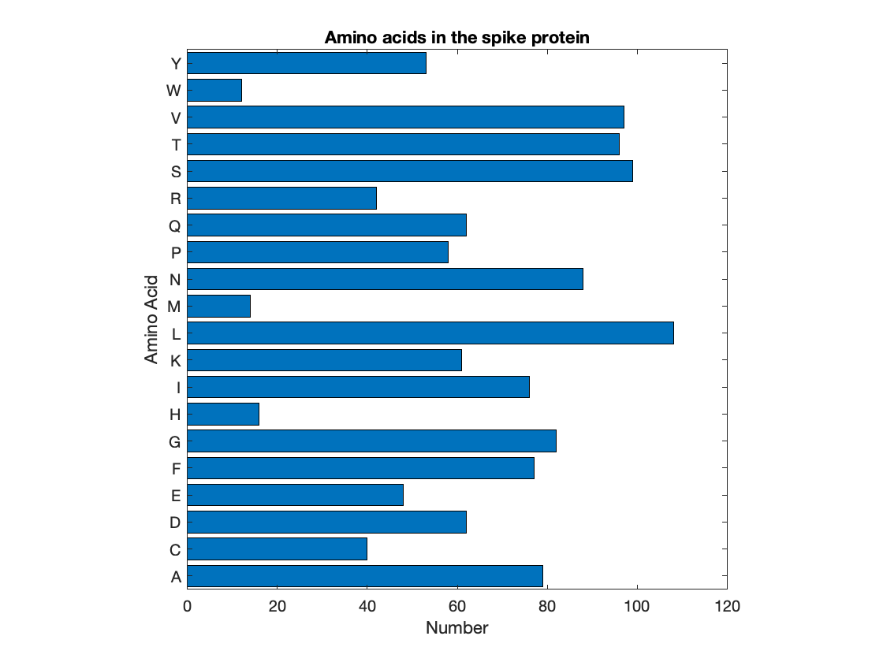

### Writing text data to a file

* Simple: Write a **cell array** to a **delimitted file** using writecell. Any delimiter may be used but comma-delimitted is the default.

% Write codons to a text file

writecell(codons,'myCodonFile.txt');

* More involved: use built-in MATLAB **file manipulation commands**: fopen, fprintf, fclose

% Create and open a new file with specified name

fileID = fopen('S_ProteinSequence.txt','w');

% Write character array to file

fprintf(fileID,spike_Protein);

% Close file so that it can be read elsewhere

fclose(fileID);

## Structure arrays

Structure arrays are useful for storing data in a **tree-like structure** and are common when importing data into MATLAB. A *structure array* is a data type that groups related data using data containers called *fields*. Each field can contain any type of data.

**You have worked with structure arrays (and analogous entities) already**:

* In **lecture 14**, we recorded my position as we walked through the halls of Towne building and, afterwards, imported that data into MATLAB. The imported data was a structure array with one field, Position:

### 

* We have done a lot of formatting of plots and graphics. While these are graphics objects, there are parallels because each is a **base object** with **parameters** or **fields** associated with it.

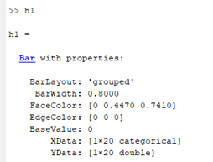

**Tree analogy**: the base object (known as the *structure*) is the trunk, the *fields/parameters* are the branches. Values in a field are associated with the "higher order" structure.

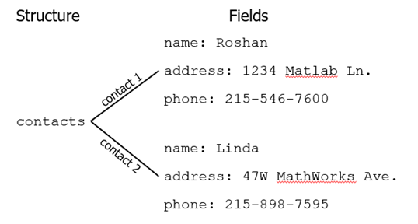

### Creating a structure array

Fields in a structure array can be created or accessed using dot notation (.).

% Create two fields for a structure array, a:

% a.b = 2;

% a.c.b = 'hello';

% a

The above structure array can be represented visually below. The fields b and c "belong" to structure array a.

**Note**: a.c is a structure array itself!

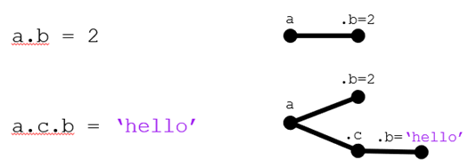

% Access field values

% a.b

% a.c

% a.c.b

**Any data type can be added to a structure array**. In the following, we add a numerical vector, a cell array, and a character array.

% a.c.c = [1,5,9];

% a.c.d = {'day',3};

Visually:

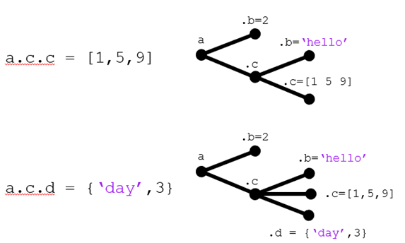

Furthermore, structure arrays can have a dimension greater than 1x1:

% a(2).c.c = 'fun';

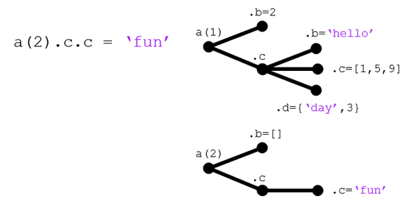

**Takeaway**: structure arrays are a useful way to organize data. A structure array and all fields within may be passed to a function or command by simply referring to the structure.

### Relation to graphics objects

So far, we have used get() to visualize the parameters for a graphics object (e.g. plot) and set() to change the parameters. You can also use **dot notation to view or modify a parameter value**.

close all

x = 0:pi/24:2*pi;

y = sin(x);

h = plot(x,y,'k-');

axis square

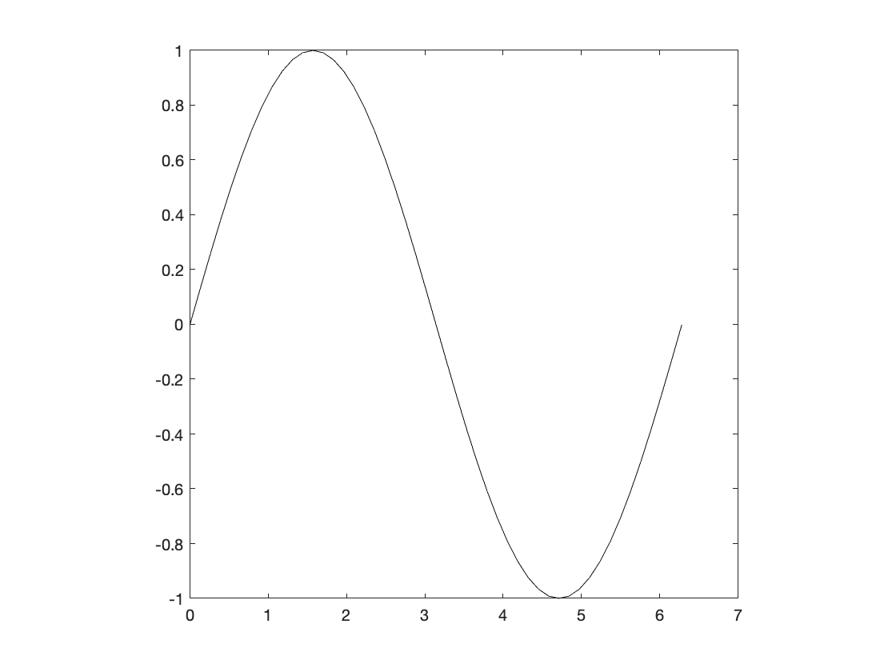

get(h)

AlignVertexCenters: off

Annotation: [1×1 matlab.graphics.eventdata.Annotation]

BeingDeleted: off

BusyAction: 'queue'

ButtonDownFcn: ''

Children: [0×0 GraphicsPlaceholder]

Clipping: on

Color: [0 0 0]

ColorMode: 'manual'

ContextMenu: [0×0 GraphicsPlaceholder]

CreateFcn: ''

DataTipTemplate: [1×1 matlab.graphics.datatip.DataTipTemplate]

DeleteFcn: ''

DisplayName: ''

HandleVisibility: 'on'

HitTest: on

Interruptible: on

LineJoin: 'round'

LineStyle: '-'

LineStyleMode: 'manual'

LineWidth: 0.5000

Marker: 'none'

MarkerEdgeColor: 'auto'

MarkerFaceColor: 'none'

MarkerIndices: [1×49 uint64]

MarkerMode: 'manual'

MarkerSize: 6

Parent: [1×1 Axes]

PickableParts: 'visible'

Selected: off

SelectionHighlight: on

SeriesIndex: 1

Tag: ''

Type: 'line'

UserData: []

Visible: on

XData: [1×49 double]

XDataMode: 'manual'

XDataSource: ''

YData: [1×49 double]

YDataSource: ''

ZData: [1×0 double]

ZDataSource: ''

* Modification using set()/get()

% Change line color

set(h,'Color','r')

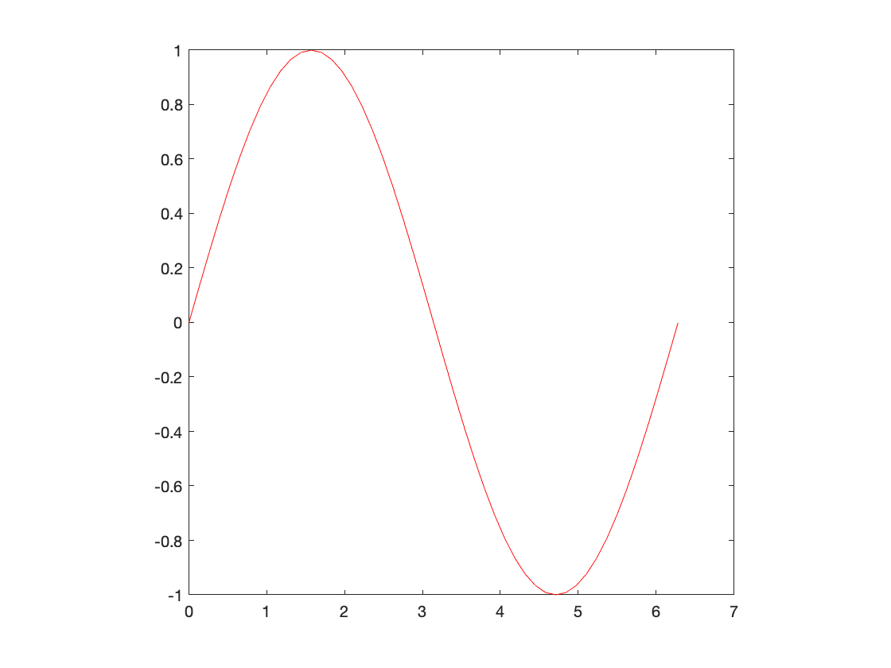

* Using dot notation on the structure/fields:

% Change line width

h.LineWidth = 3;

% Change line style

h.LineStyle = ':';

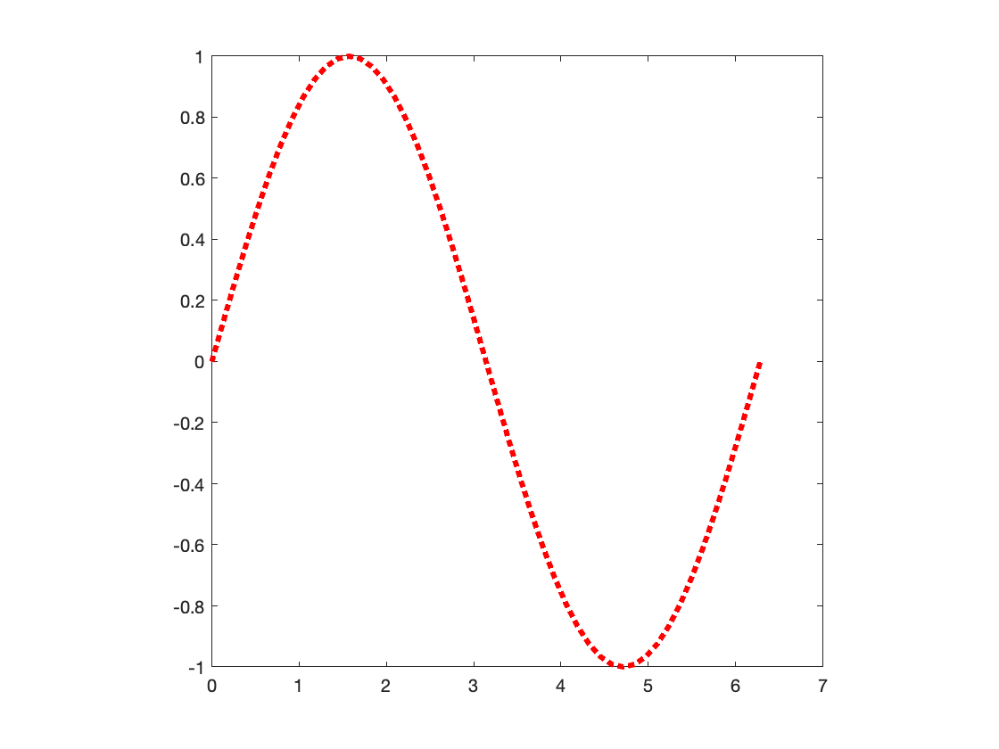

**Note**: even if you prefer dot notation, get() is still useful to identify potential parameters to change.

### Example: visualizing "particle" movement

There are many cases in science and engineering where you may track the position of *some entity* over time. You could record the motion of fluorescent molecules, the run and tumble trajectories of bacteria, group dynamics of animal swarms, or human migration. In this problem: **given some recorded data, produce a visualization of the "particle" movement**.

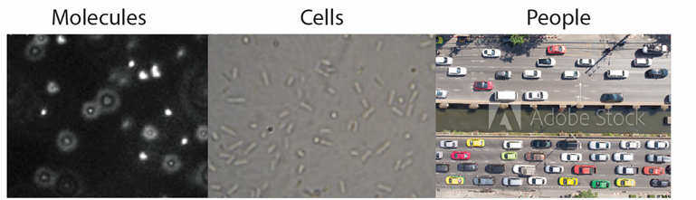

***Tips and notes:***

* importdata(), used above, can be used to incorporate mixed data (*e.g.* text and numbers).
* pause will halt MATLAB command execution for the specified time, in seconds.
* rectangle can be used to produce a square, rectangle, oval, or circle on the current axes.

% Import data as a structure array

myData = importdata('L18_TrackingData.txt')

myData = *struct with fields:*

data: [20×3 double]

textdata: {21×4 cell}

% Numerical data

myData.data

ans = 20×3

3.0000 3.0000 1.0000

3.0000 4.0000 1.5000

4.0000 4.0000 2.0000

4.0000 5.0000 2.5000

5.0000 5.0000 3.0000

6.0000 5.0000 2.5000

7.0000 5.0000 2.0000

8.0000 6.0000 1.5000

8.0000 7.0000 1.0000

7.0000 7.0000 0.5000

% Text data

myData.textdata

ans = *21×4 cell array*

{'Marker'} {'X' } {'Y' } {'Radius'}

{'A' } {0×0 char} {0×0 char} {0×0 char}

{'A' } {0×0 char} {0×0 char} {0×0 char}

{'A' } {0×0 char} {0×0 char} {0×0 char}

{'A' } {0×0 char} {0×0 char} {0×0 char}

{'A' } {0×0 char} {0×0 char} {0×0 char}

{'A' } {0×0 char} {0×0 char} {0×0 char}

{'A' } {0×0 char} {0×0 char} {0×0 char}

{'A' } {0×0 char} {0×0 char} {0×0 char}

{'A' } {0×0 char} {0×0 char} {0×0 char}

{'A' } {0×0 char} {0×0 char} {0×0 char}

{'B' } {0×0 char} {0×0 char} {0×0 char}

{'B' } {0×0 char} {0×0 char} {0×0 char}

{'B' } {0×0 char} {0×0 char} {0×0 char}

{'B' } {0×0 char} {0×0 char} {0×0 char}

{'B' } {0×0 char} {0×0 char} {0×0 char}

{'B' } {0×0 char} {0×0 char} {0×0 char}

{'B' } {0×0 char} {0×0 char} {0×0 char}

{'B' } {0×0 char} {0×0 char} {0×0 char}

{'B' } {0×0 char} {0×0 char} {0×0 char}

{'B' } {0×0 char} {0×0 char} {0×0 char}

**Step 1: start simple**. Write pseudocode and figure out how to plot "circles" for a given position

close all % Close previous plots

% Create visualization: note

h1 = rectangle('Position',[0,0,1,1],'Curvature',[1,1]);

h2 = rectangle('Position',[3,3,1,1],'Curvature',[1,1]);

% Specify plotting parameters

axis square

xlim([0,10])

ylim([0,10])

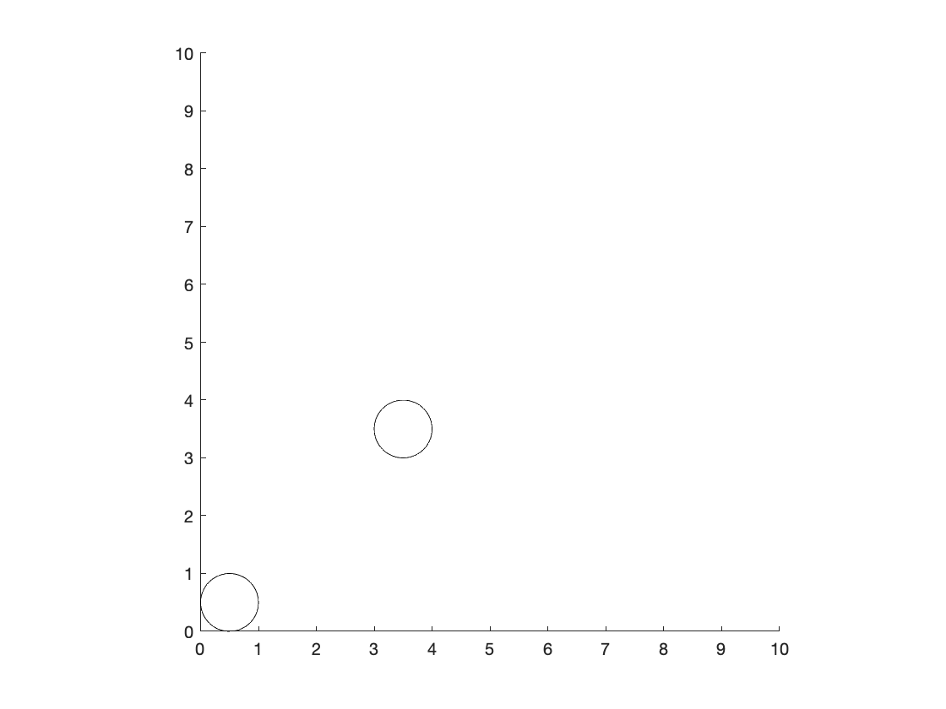

**Step 2: Convert data into a convenient format**. In this case, a structure array is good.

% Step 1: Create cell array of just particle identifiers

particle_ID = myData.textdata(2:end,1);

% Step 2: Create subarrays unique to each particle

A_data = myData.data(strcmp(particle_ID,'A'),:);

B_data = myData.data(strcmp(particle_ID,'B'),:);

% Step 3: Populate structure array with data for both particles

particle(1).ID = 'A';

particle(1).pos = A_data(:,1:2);

particle(1).dia = A_data(:,3);

particle(2).ID = 'B';

particle(2).pos = B_data(:,1:2);

particle(2).dia = B_data(:,3);

particle

particle = *1×2 struct array with fields:*

ID

pos

dia

**Step 3: Refine plotting code for one time point**

close all % Close previous plots

% Goal: loop through all time points, i.e. all rows int he positional

% arrays

% Create axes and specify graphical parameters

g = axes;

axis square

xlim([0,10])

ylim([0,10])

% Create visualization: note the values of each position

h(1) = rectangle('Position',[particle(1).pos(1,:),particle(1).dia(1)*[1,1]],'Curvature',[1,1]);

h(2) = rectangle('Position',[particle(2).pos(1,:),particle(2).dia(1)*[1,1]],'Curvature',[1,1]);

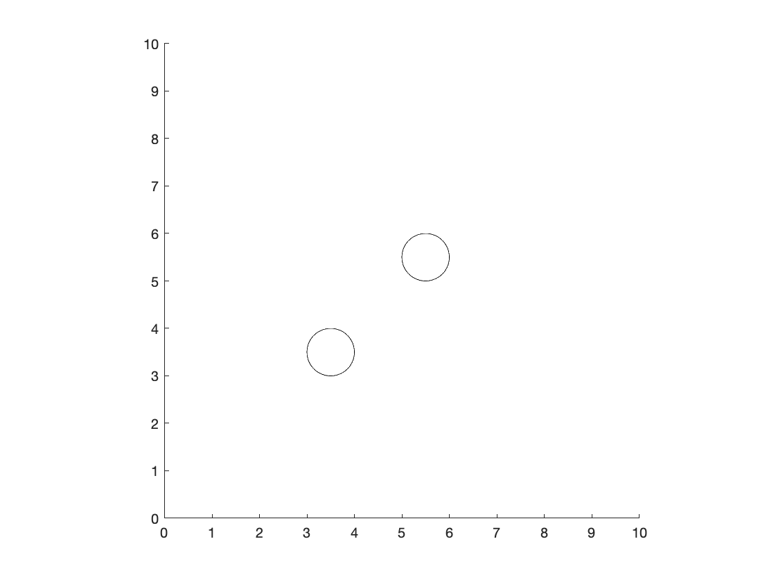

**Step 4: Refine plotting code for all time point**

close all % Close previous plots

% Goal: loop through all time points, i.e. all rows in the positional

% arrays.

% Time points

timePts = size(particle(1).pos,1);

% Create axes and specify graphical paramters

axis square

xlim([0,10])

ylim([0,10])

%Create Initial position of particles

h(1) = rectangle('Position',[particle(1).pos(1,:),particle(1).dia(1)*[1,1]],'Curvature',[1,1]);

h(2) = rectangle('Position',[particle(2).pos(1,:),particle(2).dia(1)*[1,1]],'Curvature',[1,1]);

% Specify colors

h(1).FaceColor = 'r';

h(2).FaceColor = 'g';

% Loop through all time points

for k = 2:timePts

% Pause for 1 second

pause(1)

% Update position and radius for each particle

for m = 1:2

h(m).Position = [particle(m).pos(k,:),particle(m).dia(k)*[1,1]];

end

end

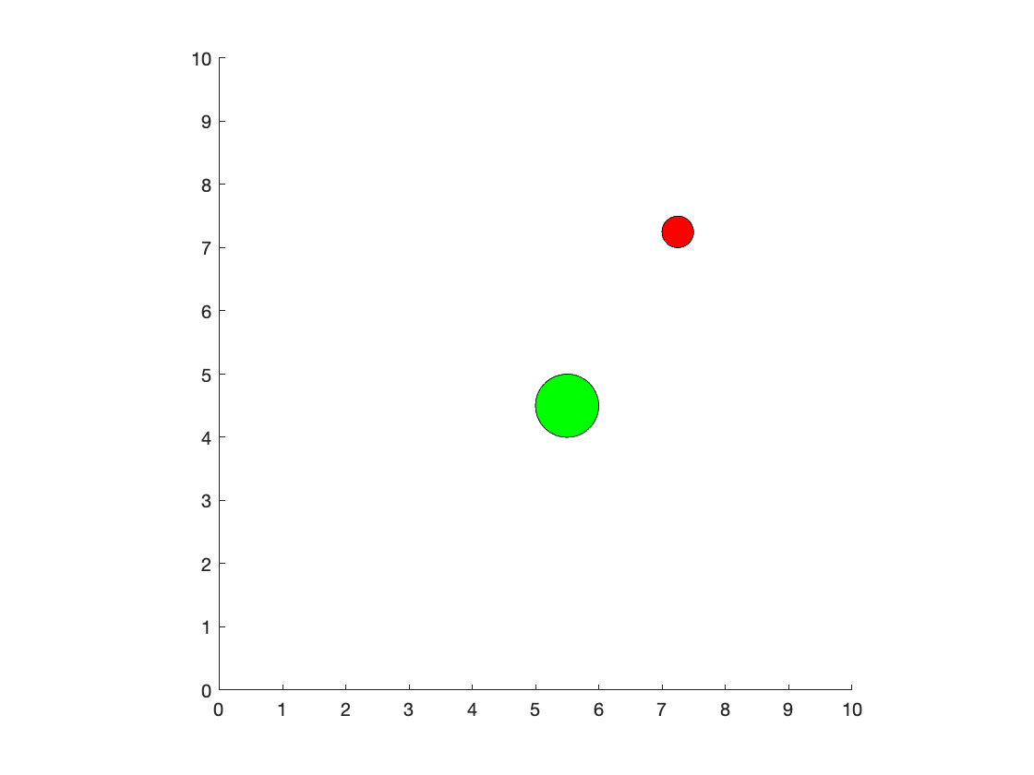

disp('Done')

Done

# TOPIC 18: Intro to audio and image processing

ENGR105, 11/3/20

## Numeric data, audio, and images

In the example at the end of class on Thursday, we loaded and processed a file that contained both text and numerical information. In your courses, research, job, you will likely need to load and analyze other numerical data as well.

***Remember***: to open a file by specifying only its name, the file must be located in the current directory

### Importing data and reading files

These are some of the most commonly used functions to load files and data into MATLAB.

**Note**: "comma-delimitted" file means a text file in which each entry in a give row is separated by commas. You may be able to load files with **other delimitters** by changing an input to the following functions (please see the corresponding help documentation).

**Numerical data**

* importdata - read numerical/text data files as a **structure array**
* readcell - read a comma delimitted file (numerical, text, or both) into a **cell array**
* csvread - read **numerical only** csv files into an **array** (I use this a lot because it is "easy")

% Read CSV file: Additional inputs specify "offset" to row/column to start

% reading from

data1 = csvread('L18_TrackingData.txt',1,1)

data1 = 20×3

3.0000 3.0000 1.0000

3.0000 4.0000 1.5000

4.0000 4.0000 2.0000

4.0000 5.0000 2.5000

5.0000 5.0000 3.0000

6.0000 5.0000 2.5000

7.0000 5.0000 2.0000

8.0000 6.0000 1.5000

8.0000 7.0000 1.0000

7.0000 7.0000 0.5000

**Note**: the offsets are necessary to ensure that MATLAB *only* reads the numerical data. The function will **error** if it tries to read text data.

**Audio files**

* audioread - read audio files to a double array and **output sampling frequency**

**Image files**

* imread - read an image to an integer array

**Video files**

* VideoReader - creates a VideoReader object used to read a given video file
* readFrame - reads a frame of the VideoReader object

### Exporting data and writing files

**Numerical data**

* csvwrite - write numerical only csv files
* writecell - write a cell to a csv file

**Audio files**

* audiowrite - write an array to an audio file based on the sampling frequency

**Image files**

* imwrite - write an integer array to an image file

**Video files**

* VideoWriter - creates a VideoWriter object used to write a given video file
* writeVideo - writes a frame of the VideoWriter object

### What is a "signal?"

In engineering, a signal is simply a function that conveys information about a phenomenon. This could be a voltage that changes over *time*, a measured intensity that changes over *position*, the *spatiotemporal* concentration profile in a system, etc.

*This lecture will introduce two common signals in signal processing:*

1) An **audio** signal (represented by a "voltage" or acoustic pressure over time)

2) An **image** (represented by gray values at different pixel locations)

### 

## Introduction to audio processing

An audio file may be read using the audioread() function. There are two outputs when using this function: the **audio signal** and the **sampling frequency**.

% Read audio file

[y_signal,Fs] = audioread('clip0.mp4');

% Sampling frequency (Hz)

disp(Fs)

44100

***Audio signal***: this is simply an Nx2 array of type **double**. In MATLAB, each entry in the audio signal must fall in the interval [-1,1].

% Size of audio signal

size(y_signal)

ans = 1×2

439232 2

% Plot audio signal

plot(y_signal);

axis square

xlabel('index')

ylabel('signal')

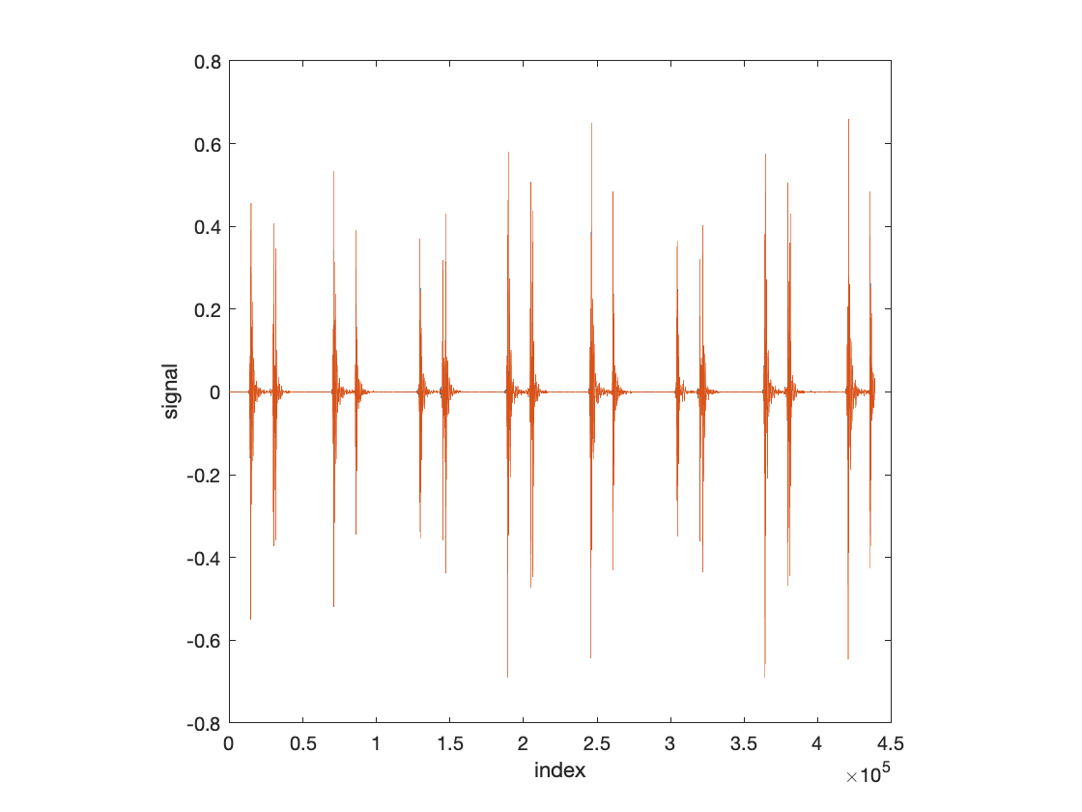

**You can think of the y values as analagous to a voltage.** Where you see "beats" corresponds to changes in this voltage. When such a voltage signal is applied to a speaker, e.g. in your headphones, it will cause some electricomechanical component to move (as defined by the time-varying voltages) and therby create vibrations (local air pressure fluctuations, compressions, expansions) in the surround air. We perceive these expansions and contractions as **sound**.

**Note**: this is the first audio signal you will deal with on HW9.

**You can play a given audio signal** in MATLAB using sound(). To play it, you need to input both the audio signal and the sampling frequency.

% Listen to sound

sound(y_signal,Fs)

***Sampling frequency***: this refers to the number of points in a **signal that is continuous in time** that are discretized.

In "real life," many signals may *seem* continuous -- when you hear someone speak, it seems like a continuous sound. That is, it seems like the sound *just* be represented as a function of time, 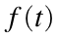.

However, recall that computation is inherently discrete.

* Computation occurs at discrete physical locations
* Memory is stored at discrete physical locations
* The numbers that we use in MATLAB (class double) are 64-bit numbers that have some minimum and maximum possible values, and only *so many* possible decimal points. That is, the numbers and vectors are **discrete**.(see topic 14 / lecture 15).

To process signals, we have to "approximate" continuous signals as a sequence of discrete points to **perform any useful operations** (to store them, to analyze them, to play them, etc.).

* Consider a continuous signal, , represented by the green line. This signal could have an explicity formula, such as:



* The function only depends upon t and is defined for every possible t value -- we could in theory evaluate the function at arbitrary precision.

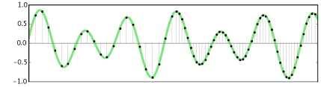

*Source: Audacity*

* To convert this signal into a discrete signal, we **sample** points along the function. That is, we select discrete points and evaluate the function at those points to approximate the function. **The number of such points that we evaluate per one second of the second is called the sampling frequency**.

*The left side: lower sampling frequency -- less accurate representation of the signal*

*The right side: higher sampling frequency -- more accurate representaiton of the signal*

*There is a tradeoff: A* ***small*** *sampling interval results in a* ***better quality*** *sound file but* ***increases the size*** *of the audio file*

**Note**: most computers have an audio sampling frequency of 44.1 kHz, as above. That, there are 44,100 discrete points that represent the signal per second.

**The sampling frequency contains information**:

* The **number** of audio samples per second.
* Since the audio signal is an array where each entry corresponds to a sample, the **duration** of an audio signal (in units of seconds) can be easily determined.

% Calculate a time vector using the sampling frequency

time = 1/Fs*(1:size(y_signal,1)); % seconds

% Plot audio signal

plot(time,y_signal)

axis square

xlabel('time (s)')

ylabel('audio signal')

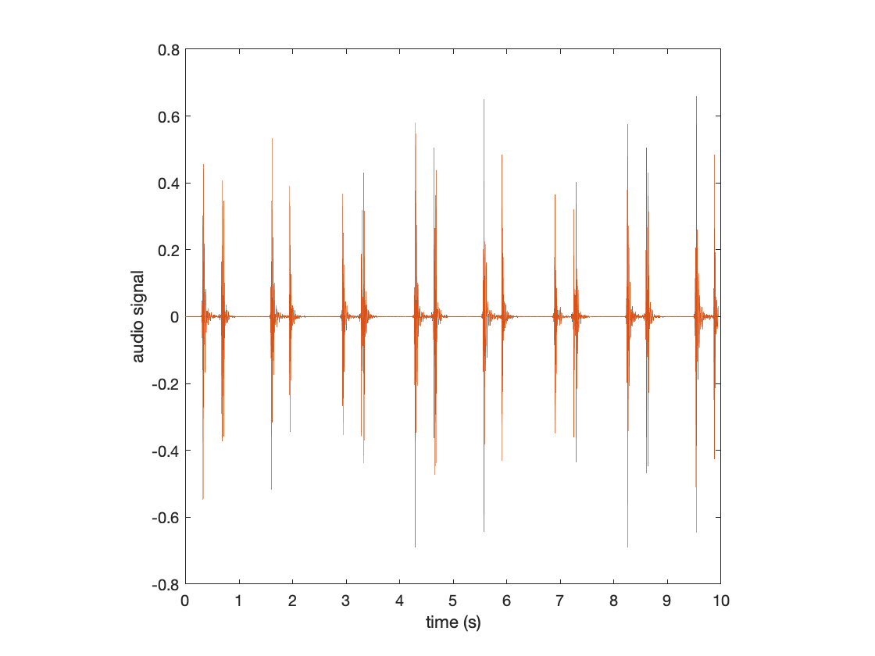

### Stereo vs. mono sound

The size of the imported audio data often contains two "channels," or columns. This corresponds to **stereo** audio: the first column is output to the "left" speaker and the second column is output to the "right" speaker.

% Depict size of the data array

size(y_signal)

ans = 1×2

439232 2

*If only one column is input*, it will be played as **mono** audio: both speakers will play the same thing.

% Listen to the first channel in mono

sound(y_signal(:,1),Fs)

*If only two columns are input, but one is all zeros,* you will only hear output from one of the speakers

% Listen to only the first channel in stereo: you should only hear it in

% one side of your headphones/speakers

sound([y_signal(:,1),zeros(size(y_signal(:,1)))],Fs)

% Listen to only the first channel in stereo: you should only hear it in

% the other side of your headphones/speakers

sound([zeros(size(y_signal(:,1))),y_signal(:,1)],Fs)

### Filtering a 1-D signal

A goal of signal processing is to obtain some information from a signal. The "raw data" of signal is often very noisy and difficult to obtain quantitative information from. For example, consider the following to be output from instrumentation that you have interfaced with MATLAB:

% Simulate noisy output from instrumentation

t = linspace(0,2*pi,100);

x = sin(t) + 0.3*rand(size(t));

% Plot noisy signal

plot(t,x,'k-')

axis square

xlabel('time (s)')

ylabel('voltage signal')

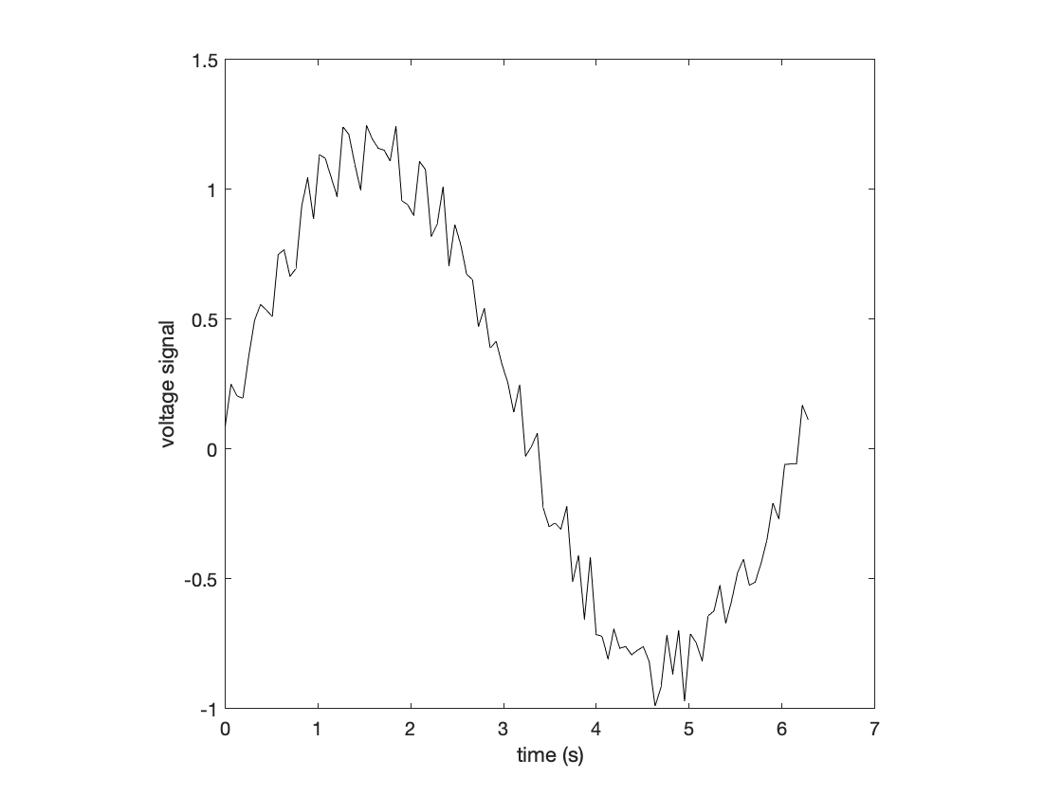

You are really just interested in the *low frequency* signal, that is the *general sinusoidal* shape.

* You wish to disregard the noise that is occuring because that could just be due to the instrumentation and not the signal that you care about.
* To get rid of the high frequency noise, you could apply a **low pass filter**.
* One type of low pass filter is a **rolling mean filter**.

**Note: what is a "filter?"** A filter is just some mathematical operation or computational algorithm that you **apply to an input signal** to produce a new output.

**A rolling mean filter**: averages the recent points and takes that average as the new data point in the filtered output.



* 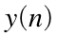: the filtered output at point 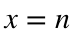
* 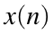: the raw, unfilterd signal at 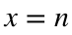.

% Example: rolling filter applied to the data point n = 36 with a window

% size of 4. In this plot, the four data points will be averaged together,

% and the "filtered output" at the THIS data point will be this average.

% Plot noisy signal

plot(t,x,'k-')

hold on

plot(t(32:35),x(32:35),'ro')

hold off

axis square

xlabel('time (s)')

ylabel('voltage signal')

xlim([1,3])

ylim([0.7,1.3])

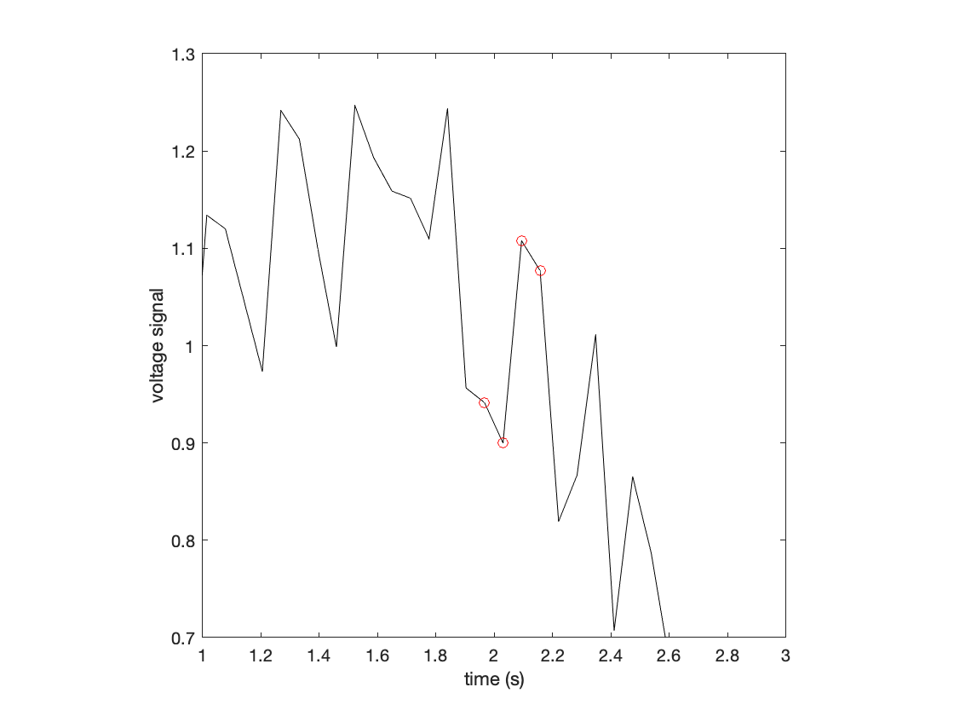

**1-D rolling mean filters can be created** using the filter() function in MATLAB.



The filter takes inputs based on the desired **transfer function**. This is outside of the scope of this class and is related to the process of ***convolution***. For now, just note the parallels with the desired equation giving the output.

% Define the window

windowSize = 4;

% The numerator of the transfer function

% Note: 1/windowSize is the coefficient. Based on a window size of 4, we

% want to analyze x(n) ... x(n - 4 + 1). That is, we want to analyze the

% four "most recent" x values. This information is contained within the

% ones vector

b = ones(1,windowSize);

% The denominator of the transfer function

a = windowSize;

Applying the filter:

close all % Close previous plots

% Create the filtered output

y = filter(b,a,x);

% Plot noisy signal and filtered signal on same plot

g1 = axes;

plot(t,x,'k-')

hold on

plot(t,y,'r-','LineWidth',2)

hold off

axis square

xlabel('time (s)')

ylabel('voltage signal')

legend('Raw data','Filtered signal','Location','northeast')

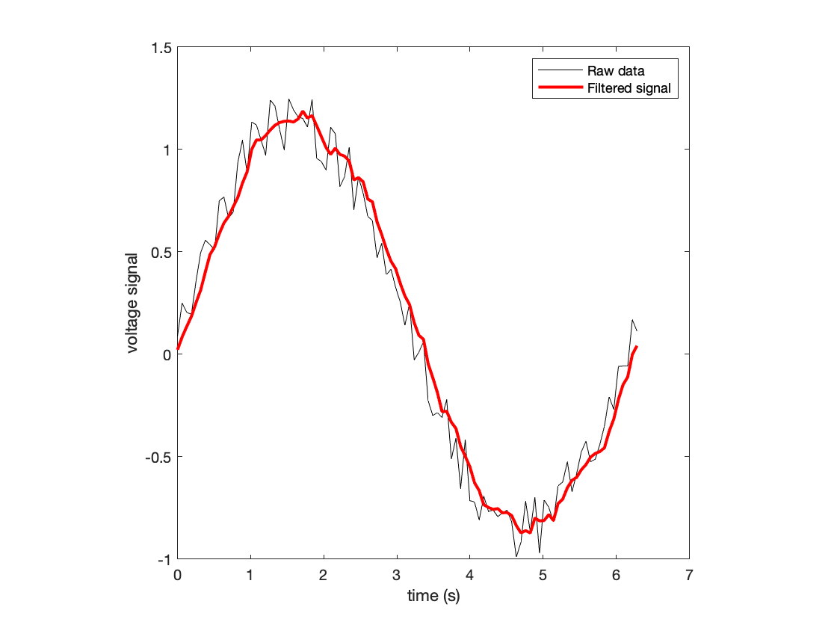

**What about filtering the heart beat signal?** We could apply the same rolling mean filter in this case.

close all % close previous figures

% Create a rolling mean filter

windowSize = 1000;

b = ones(1,windowSize);

a = windowSize;

y_filtered = filter(b,a,y_signal);

% Plot audio signal

plot(time,y_signal,'k-')

hold on

plot(time,y_filtered,'r-','LineWidth',2)

hold off

axis square

xlabel('time (s)')

ylabel('audio signal')

xlim([0,1])

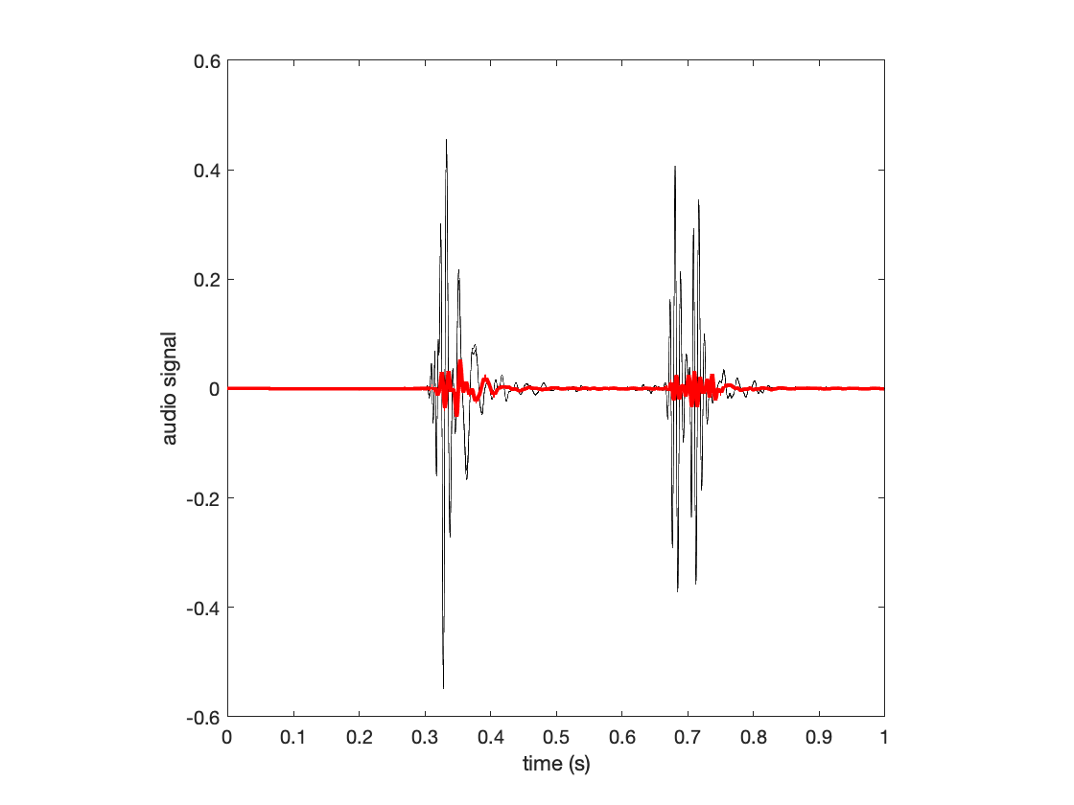

**Note**: you can incorporate additional mathematical functions to produce different outputs from the filter.

**It is up to you, as the engineer, to decide how to apply mathematical and computational tools to best solve a problem. In this case, that means to convert it into something that provides useful information**

### Creating audio signals

The sound function, used above, enables you to play an audio signal on your computer's speakers. Since you can think of an audio signal as a *voltage that dictates how some electromechanical component of your speakers will move*, we can create a **steady oscillation at a defined frequency** to produce a given **pitch**.

% Create a time interval that is dependent upon the sampling frequency

Fs = 44100;

t = linspace(1/Fs,1,Fs);

% Produce a note corresponding to "middle C"

y_sound = sin(2*pi*262*t);

sound(y_sound,Fs)

**Note**: the above vector, y_sound, oscillates at a frequency of 262 times per second. This frequency corresponds to a "middle C". The above vector is sampled 44,100 times per second. Note the difference between these two frequencies.

**Note**: changing the "musical frequency" will alter the pitch of the sound.

## Introduction to image processing

An image **may be read into MATLAB** using the imread function.

% Read the first image

image1 = imread('L19_image1.jpg');

An image may be displayed using imshow:

imshow(image1)

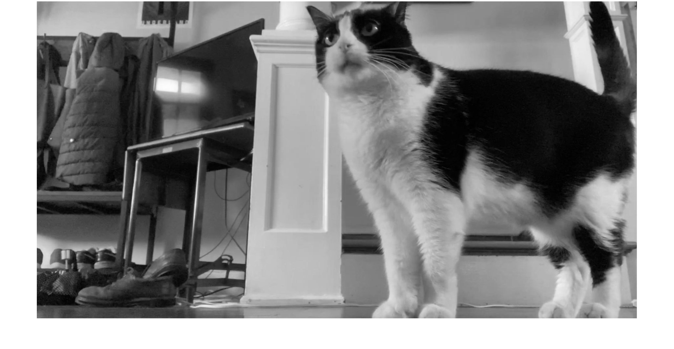

Images are another kind of signal -- in this case, these signals represent **spatial** information.

* **An image is essentially a matrix of integer values**. The dimensions of this matrix correspond to the number of pixels in your image. The dimensions correspond to *rows and columns of pixels*.

% Dimensions of an image

size(image1)

ans = 1×2

972 1829

% Total number of pixels

numel(image1)

ans = 1777788

In this case, the picture is 1.7 MPx (mega-pixels).

**In each matrix position, there is an integer number**. This is the **gray value** of that pixel.

* In this case, I have gray (not color) image and so each pixel represents the shade of gray of that pixel.
* This integer can take any values within the allowable range of the ***bit depth*** of the image. In this case, the above image is an 8-bit image, and so a value of 0 corresponds to **black** and a value of 255 corresponds to **white**.

% Bit depth of image

class(image1)

ans = 'uint8'

### Color images

We have seen representations of color previously in terms of an R-G-B color vector, where the value of each components dictates how red/green/blue the desired color should be. For example, using the rectangle function we discussed last time:

close all % close all figures

% Define color

myColor = [0.8,0.2,0.2];

axes

rectangle('Position',[0,0,2,2],'FaceColor',myColor)

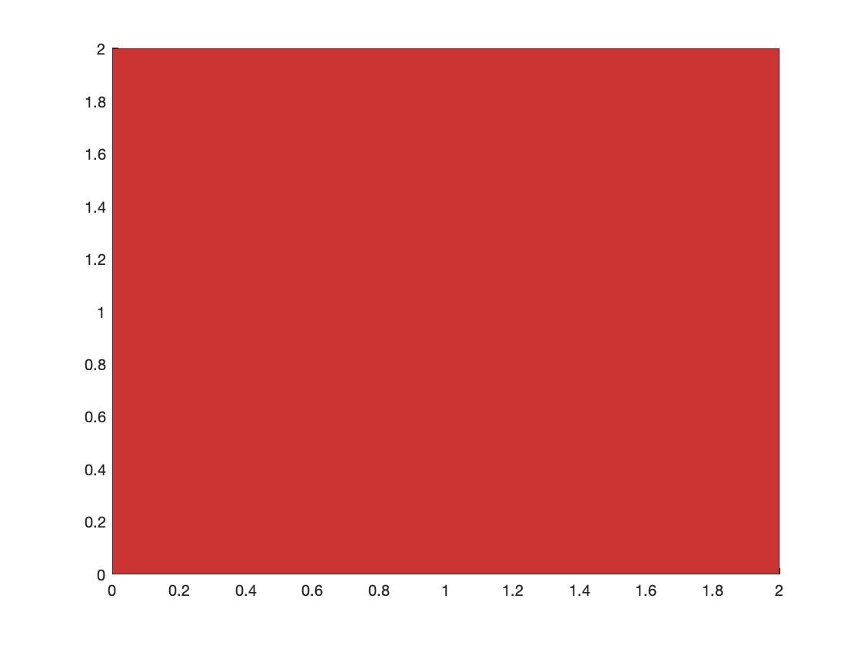

**Color images are represented in the same way**. In this case, each pixel location has a 3 component vector describing what the color of that pixel should be. To represent the color of the entire image, a color image is represented ***with three channels.***

% Load a similar color image

image1_color = imread('L19_image1color.jpg');

% Depict dimensions of color image

size(image1_color)

ans = 1×3

1080 1920 3

% Show color image

imshow(image1_color)

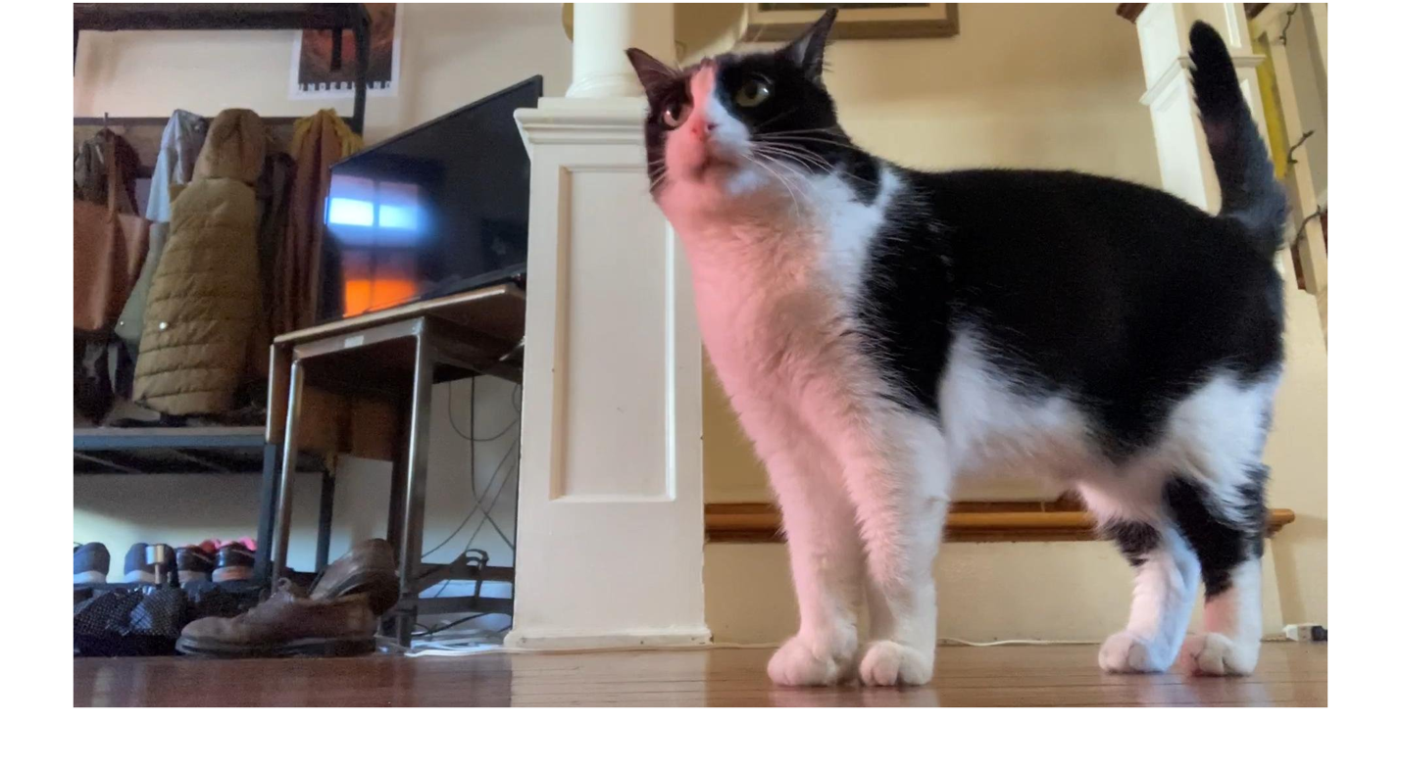

### Loading multiple signal files

**Structure arrays** are often a convenient way to store multiple signals or images.

% Number of images

numIm = 3;

% Character array that is common to all image files

baseName = 'L19_image';

% Define imData as a structure array

imData = struct;

for k = 1:numIm

imData(k).pic = imread([baseName,num2str(k),'.jpg']);

end

% Show desired image

imshow(imData(3).pic)

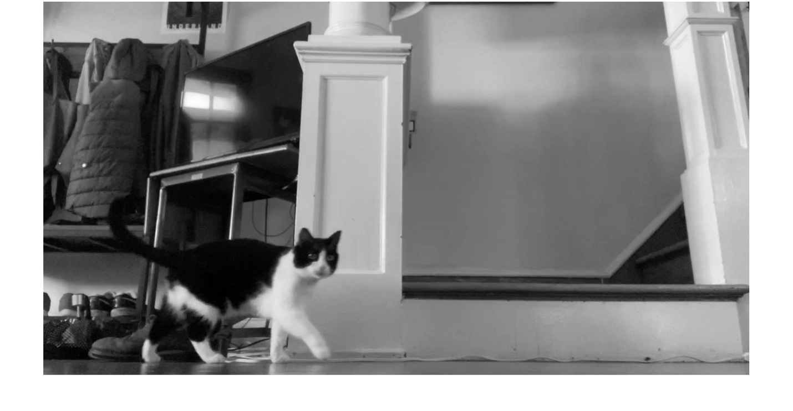

### Example: removing the cat from the image

Say we are only interested in a picture of the background and that the cat (as cats do) is just being nosy and getting in the way. To produce a picture of the background from our three images, **we can remember that images are *just* matrices with numbers**. As such, you can perform **basic mathematical and array operations** on them.

% Goal: create a 3-D matrix, where each image is on one *page* of this

% matrix

% Preallocate matrix

imDataMatrix = zeros([size(imData(3).pic),3]);

% Populate each page of the matrix

for k = 1:3

imDataMatrix(:,:,k) = imData(k).pic;

end

% Ensure imDataMatrix is the correct data type

imDataMatrix = uint8(imDataMatrix);

% Dimensions of this image "matrix"

size(imDataMatrix)

ans = 1×3

972 1829 3

In a given pixel location for the three images, that pixel is the "background" in two of them, and the cat in one of them. There are no two pictures where the cat is in the same pixel location. Thus, since we have ***three data points for each pixel***, we can select the median pixel, as this will likely represent ***just the background.*** *Thus, to create a picture without the cat*, we can simply **find the median gray value in each pixel location**.

**Note**: remember that when performing mathematical functions on an array, you can specify the dimension to operate over.

* Dim 1: operate over rows
* Dim 2: operate over columns
* Dim 3: operate over pages

% Find "median" image

image_median = median(imDataMatrix,3);

imshow(image_median)

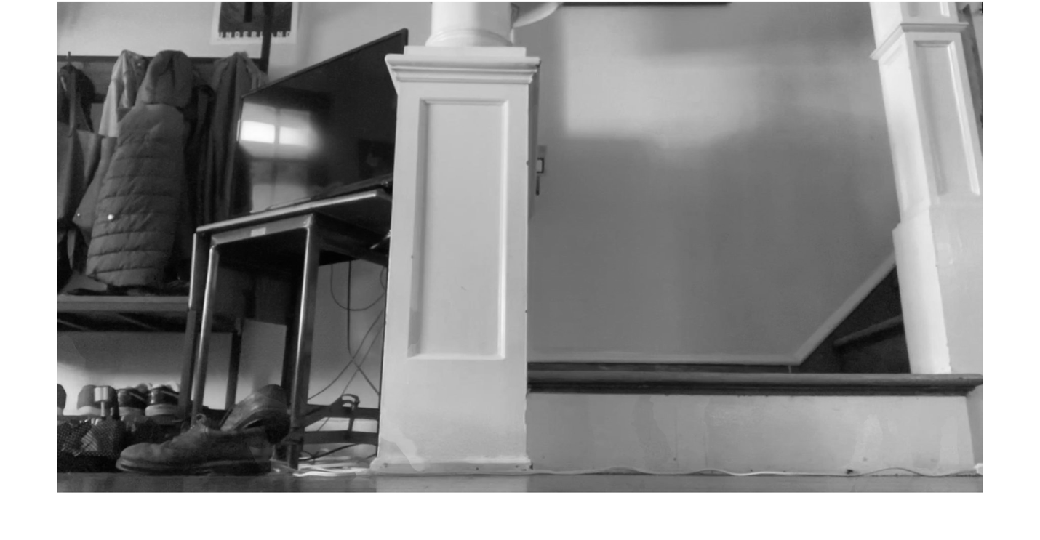

**Takeaway**: images are just matrices of integers. From these three images, we can construct an image of just the background pixels using just the median() operation, even though **none** of the individual images were without that cat,

# TOPIC 19: Revisiting images and graphics

ENGR105, 11/5/20

### 

### Reminder: audio processing

* ***Audio signal***: this is simply an Nx2 array of type **double**. In MATLAB, each entry in the audio signal must fall in the interval [-1,1]. We can import audio using audioread and playback using sound.
* ***Sampling frequency****:*The number of points per second used to discretize a continous signal.



*Source: Audacity*

* ***Remember***: audio data is just an array of decimal values. This can be manipulated using all of our previous array operations.

### Reminder: image processing

An image **may be read into MATLAB** using the imread function.

% Read the first image

image1 = imread('L19_image1color.jpg');

An image may be displayed using imshow:

imshow(image1)



**Images are just "integer matrices,"**  in which the each index corresponds to a unique **pixel**, and the value of the corresponding element is the **gray value** of that pixel. The bit depth of an image corresponds to the range of possible integer values each element can take.

% Bit depth of image

class(image1)

ans = 'uint8'

Images can be **cropped** using **array indexing**.

% Create a cropped image: note the array indices

imX = image1(1:500,800:1200,:);

imshow(imX)

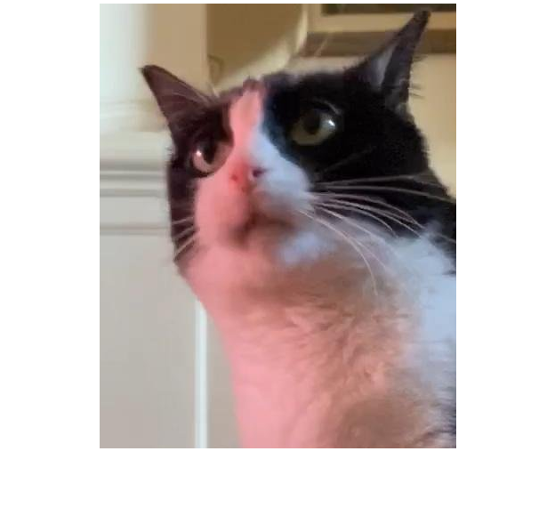

**Grayscale images** have one value associated with each **X-Y index position**, whereas color images have three values (R-G-B). As a result, color images have **three dimensions**.

% Dimensions of image1

size(imX)

ans = 1×3

500 401 3

Since the "third dimension" corresponds to the **color**, each "channel" (*red, green, or blue*) can be displayed by setting the other channels to zero.

% Display red channel

imX_red = imX;

imX_red(:,:,2:3) = 0;

imshow(imX_red)

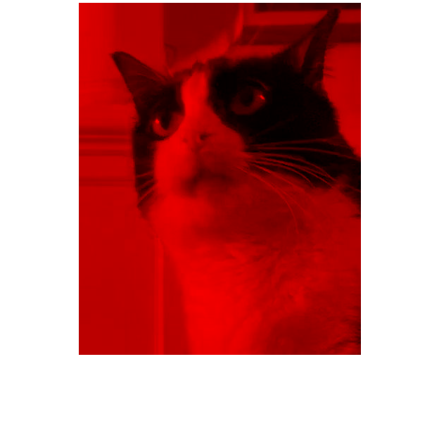

% Display blue channel

imX_blue = imX;

imX_blue(:,:,1:2) = 0;

imshow(imX_blue)

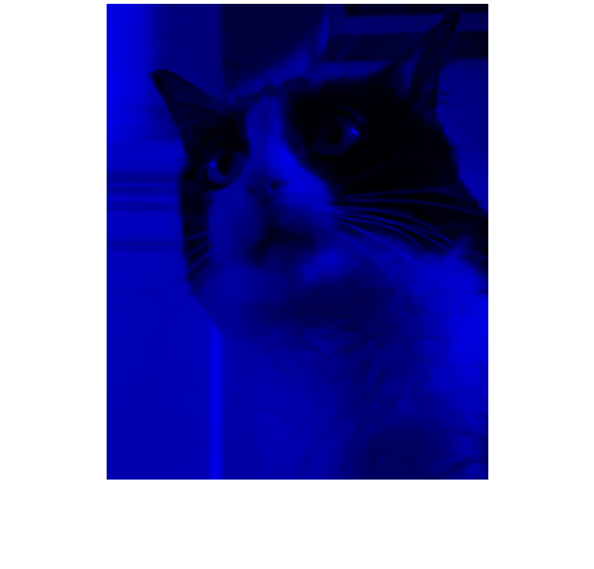

Displaying one color channel as a grayscale image

% Create grayscale image from green channel

imX_gray = imX(:, :, 2);

imshow(imX_gray)

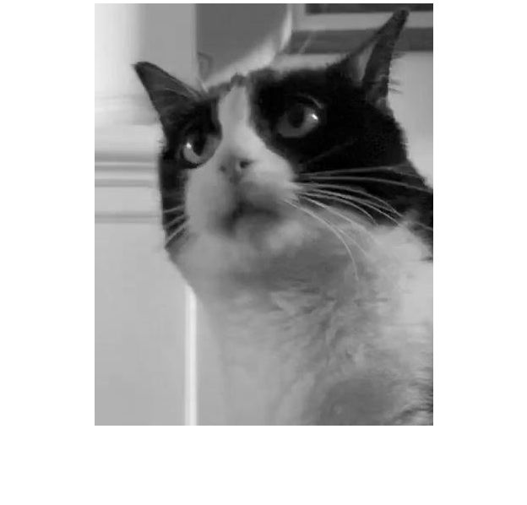

By changing the pixel value of image elements, you can change the image that will be displayed.

% Change the "brightness" of a given pixel

imshow(imX_gray + 100)

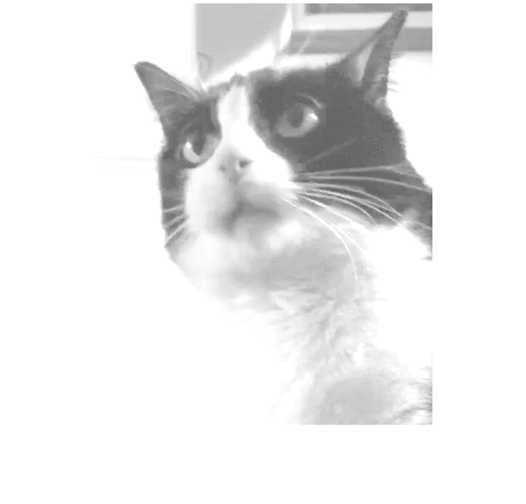

You can use **logical indexing** on a given image to obtain or modify specific pixel values.

% Preallocate array to store information about image to be produced

imX2 = uint8(zeros(size(imX_gray)));

% Loop through some values to convert the image into "buckets"

% of only a few gray values

gvThresh = [0,50,120,200,255];

for k = 1:length(gvThresh)-1

% All pixel between corresponding gray value limits are set to the

% lower limit

imX2(imX_gray > gvThresh(k) & imX_gray <= gvThresh(k+1)) = gvThresh(k);

end

% Display image

imshow(imX2)

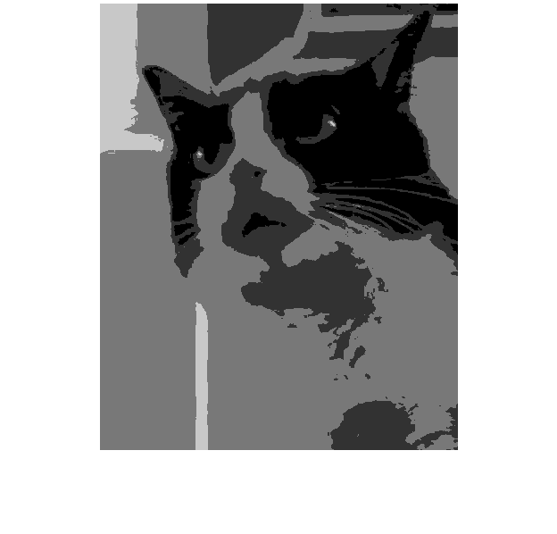

**Note**: the above example uses a for loop -- don't forget about vectorization

### Basic image filtering

Last time, we used filter to apply a **rolling mean filter** to a temporal, 1-D signal:



* : the filtered output at point 
* : the raw, unfilterd signal at .

The result was us being able to remove high frequency noise to effectively smoothe the signal.

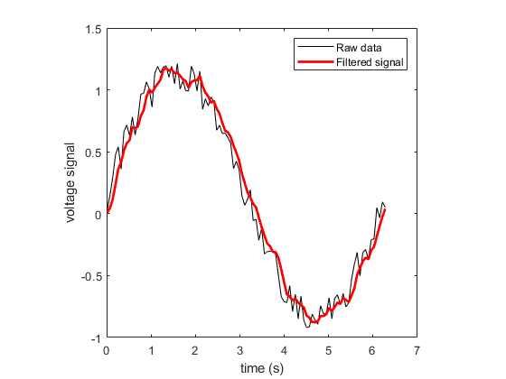

One can apply a similar concept to images: we can use filter2 to create a "*2-D mean filter*" to remove "high frequency" details. As a result, the filter image will appear "**blurry**." A few notes:

* This filtering is the result of **2D convolution** of the **image** with a **kernel**.
* This **2-D kernel is equivalent to the 1-D "window"** in the example above. For *every pixel location*, it will take the average of all nearby pixel values.
* Note that the kernal is **typically** **normalized by the sum of all elements.**

% Create the kernel

B = ones(10);

B = B/sum(B,'all');

% Filter image using filter2

imX_filt = filter2(B, imX_gray)

imX_filt = 500×401

83.1000 96.8400 110.5800 124.3200 138.0000 137.7000 137.4600 137.1600 136.9200 136.6200 136.2600 135.9600 135.7200 135.4800 135.2400 134.9400 134.5800 134.2800 133.9200 133.6200 133.2600 132.9000 132.4200 131.9400 131.4000 130.8600 130.3800 129.9000 129.4200 128.9400

96.9500 112.9800 129.0100 145.0400 161.0000 160.6500 160.3700 160.0200 159.7400 159.3900 158.9700 158.6200 158.3400 158.0600 157.7800 157.4300 157.0100 156.6600 156.2400 155.8900 155.4700 155.0500 154.4900 153.9300 153.3000 152.6700 152.1100 151.5500 150.9900 150.4300

110.8000 129.1200 147.4400 165.7600 184.0000 183.6000 183.2800 182.8800 182.5600 182.1600 181.6800 181.2800 180.9600 180.6400 180.3200 179.9200 179.4400 179.0400 178.5600 178.1600 177.6800 177.2000 176.5600 175.9200 175.2000 174.4800 173.8400 173.2000 172.5600 171.9200

124.6500 145.2600 165.8700 186.4800 207.0000 206.5500 206.1900 205.7400 205.3800 204.9300 204.3900 203.9400 203.5500 203.1600 202.7900 202.3300 201.7900 201.3200 200.7600 200.2800 199.7400 199.1900 198.4900 197.7700 196.9500 196.1300 195.4100 194.7100 194.0200 193.3500

138.5000 161.4000 184.3000 207.2000 230.0000 229.5000 229.1000 228.6000 228.2000 227.7000 227.1000 226.6000 226.1400 225.6800 225.2600 224.7400 224.1400 223.6000 222.9600 222.4000 221.8000 221.1800 220.4200 219.6200 218.7000 217.7800 216.9800 216.2200 215.4800 214.7800

138.5000 161.4000 184.3000 207.2000 230.0000 229.5000 229.1000 228.6000 228.2000 227.7000 227.1000 226.6000 226.1100 225.6200 225.1900 224.6600 224.0600 223.5000 222.8400 222.2500 221.6500 221.0200 220.2800 219.4800 218.5500 217.6200 216.8200 216.0800 215.3700 214.7200

138.5000 161.4000 184.3000 207.2000 230.0000 229.5000 229.1000 228.6000 228.2000 227.7000 227.1000 226.6000 226.0800 225.5600 225.1200 224.5800 223.9800 223.4000 222.7200 222.1000 221.5000 220.8600 220.1400 219.3400 218.4000 217.4600 216.6600 215.9400 215.2600 214.6600

138.5000 161.4000 184.3000 207.2000 230.0000 229.5000 229.1000 228.6000 228.2000 227.7000 227.1000 226.6000 226.0500 225.5000 225.0500 224.5000 223.9000 223.3000 222.6000 221.9500 221.3500 220.7000 220.0000 219.2000 218.2500 217.3000 216.5000 215.8000 215.1500 214.6000

138.5000 161.4000 184.3000 207.2000 230.0000 229.5000 229.1000 228.6000 228.2000 227.7000 227.1000 226.6000 226.0200 225.4400 224.9800 224.4200 223.8200 223.2000 222.4800 221.8000 221.2000 220.5400 219.8600 219.0600 218.1000 217.1400 216.3400 215.6600 215.0400 214.5400

138.5000 161.4000 184.3000 207.2000 230.0000 229.5000 229.1000 228.6000 228.2000 227.7000 227.1000 226.6000 225.9900 225.3800 224.9100 224.3400 223.7400 223.1000 222.3600 221.6500 221.0500 220.3800 219.7200 218.9200 217.9500 216.9800 216.1800 215.5200 214.9300 214.4800

% Convert filtered image to 8-bit

% NOTE: images must be 8-bit integer values

imX_filt = uint8(imX_filt);

% Create a subplot showing both images

% First image: unfiltered

subplot(1,2,1)

imshow(imX_gray)

title('Unfiltered')

% Second image: mean filtered

subplot(1,2,2)

imshow(imX_filt)

title('Mean filtered')

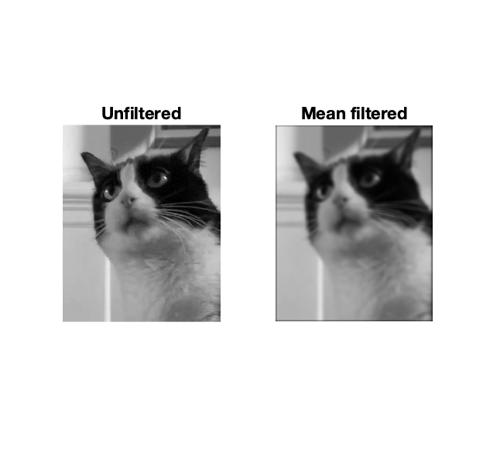

**Note**: the above is a simple kernel for mean filtering an image. Other kernels exist for edge detection, image sharpening, and applying a Gaussian blur.

### Binary (logical) images

Converting an image to a **logical array** is known as creating a **binary image** (or black/white image or logical image).

% Close all previous images

close all

% Create a binary image from imX2

imX_bw = imX_filt<50;

% Depict properties of the black/white image

whos imX_bw

Name Size Bytes Class Attributes

imX_bw 500x401 200500 logical

% Display image

imshow(imX_bw)



**Binary images** are useful for extracting and analyzing "objects" in an image. The following are two useful functions

* bwlabel -- labels (isolates) the different connected components of a binary image.
* imfill -- perform flood fill operation, convert dark (0) pixels to white (1). The most common setting I use is to fill 'holes' -- i.e. fill in dark (0) pixels that are internally present within a white (1) object.
* regionprops -- gives quantiative information about a binary "object" in an image.

**Example**. Let's apply all of these functions to the above black/white image

% 1) Label all (1) objects in binary image

[L, num] = bwlabel(imX_bw);

% The number of unique binary objects

num

num = 12

% Inspect different binary objects

imshow(L == 5)



% 2) Fill in dark (0) pixels INSIDE object

% Store specific binary image as a variable

im = L == 5;

im2 = imfill(im,'holes')

im2 = *500×401 logical array*

0 0 0 0 0 0 0 0 0 0 0 0 0 0 0 0 0 0 0 0 0 0 0 0 0 0 0 0 0 0 0 0 0 0 0 0 0 0 0 0 0 0 0 0 0 0 0 0 0 0 0 0 0 0 0 0 0 0 0 0 0 0 0 0 0 0 0 0 0 0 0 0 0 0 0 0 0 0 0 0 0 0 0 0 0 0 0 0 0 0 0 0 0 0 0 0 0 0 0 0 0 0 0 0 0 0 0 0 0 0 0 0 0 0 0 0 0 0 0 0 0 0 0 0 0 0 0 0 0 0 0 0 0 0 0 0 0 0 0 0 0 0 0 0 0 0 0 0 0 0 0 0 0 0 0 0 0 0 0 0 0 0 0 0 0 0 0 0 0 0 0 0 0 0 0 0 0 0 0 0 0 0 0 0 0 0 0 0 0 0 0 0 0 0 0 0 0 0 0 0 0 0 0 0 0 0 0 0 0 0 0 0 0 0 0 0 0 0 0 0 0 0 0 0 0 0 0 0 0 0 0 0 0 0 0 0 0 0 0 0 0 0 0 0 0 0 0 0 0 0 0 0 0 0 0 0 0 0 0 0 0 0 0 0 0 0 0 0 0 0 0 0 0 0 0 0 0 0 0 0 0 0 0 0 0 0 0 0 0 0 0 0 0 0 0 0 0 0 0 0 0 0 0 0 0 0 0 0 0 0 0 0 0 0 0 0 0 0 0 0 0 0 0 0 0 0 0 0 0 0 0 0 0 0 0 0 0 0 0 0 0 0 0 0 0 0 0 0 0 0 0 0 0 0 0 0 0 0 0 0 0 0 0 0 0 0 0 0 0 0 0 0 0 0 0 0 0 0 0 0 0 0 0 0 0 0 0 0 0 0 0 0 0 0 0 0 0 0 0 0 0

0 0 0 0 0 0 0 0 0 0 0 0 0 0 0 0 0 0 0 0 0 0 0 0 0 0 0 0 0 0 0 0 0 0 0 0 0 0 0 0 0 0 0 0 0 0 0 0 0 0 0 0 0 0 0 0 0 0 0 0 0 0 0 0 0 0 0 0 0 0 0 0 0 0 0 0 0 0 0 0 0 0 0 0 0 0 0 0 0 0 0 0 0 0 0 0 0 0 0 0 0 0 0 0 0 0 0 0 0 0 0 0 0 0 0 0 0 0 0 0 0 0 0 0 0 0 0 0 0 0 0 0 0 0 0 0 0 0 0 0 0 0 0 0 0 0 0 0 0 0 0 0 0 0 0 0 0 0 0 0 0 0 0 0 0 0 0 0 0 0 0 0 0 0 0 0 0 0 0 0 0 0 0 0 0 0 0 0 0 0 0 0 0 0 0 0 0 0 0 0 0 0 0 0 0 0 0 0 0 0 0 0 0 0 0 0 0 0 0 0 0 0 0 0 0 0 0 0 0 0 0 0 0 0 0 0 0 0 0 0 0 0 0 0 0 0 0 0 0 0 0 0 0 0 0 0 0 0 0 0 0 0 0 0 0 0 0 0 0 0 0 0 0 0 0 0 0 0 0 0 0 0 0 0 0 0 0 0 0 0 0 0 0 0 0 0 0 0 0 0 0 0 0 0 0 0 0 0 0 0 0 0 0 0 0 0 0 0 0 0 0 0 0 0 0 0 0 0 0 0 0 0 0 0 0 0 0 0 0 0 0 0 0 0 0 0 0 0 0 0 0 0 0 0 0 0 0 0 0 0 0 0 0 0 0 0 0 0 0 0 0 0 0 0 0 0 0 0 0 0 0 0 0 0 0 0 0 0 0 0 0 0 0 0 0 0 0 0 0 0 0

0 0 0 0 0 0 0 0 0 0 0 0 0 0 0 0 0 0 0 0 0 0 0 0 0 0 0 0 0 0 0 0 0 0 0 0 0 0 0 0 0 0 0 0 0 0 0 0 0 0 0 0 0 0 0 0 0 0 0 0 0 0 0 0 0 0 0 0 0 0 0 0 0 0 0 0 0 0 0 0 0 0 0 0 0 0 0 0 0 0 0 0 0 0 0 0 0 0 0 0 0 0 0 0 0 0 0 0 0 0 0 0 0 0 0 0 0 0 0 0 0 0 0 0 0 0 0 0 0 0 0 0 0 0 0 0 0 0 0 0 0 0 0 0 0 0 0 0 0 0 0 0 0 0 0 0 0 0 0 0 0 0 0 0 0 0 0 0 0 0 0 0 0 0 0 0 0 0 0 0 0 0 0 0 0 0 0 0 0 0 0 0 0 0 0 0 0 0 0 0 0 0 0 0 0 0 0 0 0 0 0 0 0 0 0 0 0 0 0 0 0 0 0 0 0 0 0 0 0 0 0 0 0 0 0 0 0 0 0 0 0 0 0 0 0 0 0 0 0 0 0 0 0 0 0 0 0 0 0 0 0 0 0 0 0 0 0 0 0 0 0 0 0 0 0 0 0 0 0 0 0 0 0 0 0 0 0 0 0 0 0 0 0 0 0 0 0 0 0 0 0 0 0 0 0 0 0 0 0 0 0 0 0 0 0 0 0 0 0 0 0 0 0 0 0 0 0 0 0 0 0 0 0 0 0 0 0 0 0 0 0 0 0 0 0 0 0 0 0 0 0 0 0 0 0 0 0 0 0 0 0 0 0 0 0 0 0 0 0 0 0 0 0 0 0 0 0 0 0 0 0 0 0 0 0 0 0 0 0 0 0 0 0 0 0 0 0 0 0 0 0

0 0 0 0 0 0 0 0 0 0 0 0 0 0 0 0 0 0 0 0 0 0 0 0 0 0 0 0 0 0 0 0 0 0 0 0 0 0 0 0 0 0 0 0 0 0 0 0 0 0 0 0 0 0 0 0 0 0 0 0 0 0 0 0 0 0 0 0 0 0 0 0 0 0 0 0 0 0 0 0 0 0 0 0 0 0 0 0 0 0 0 0 0 0 0 0 0 0 0 0 0 0 0 0 0 0 0 0 0 0 0 0 0 0 0 0 0 0 0 0 0 0 0 0 0 0 0 0 0 0 0 0 0 0 0 0 0 0 0 0 0 0 0 0 0 0 0 0 0 0 0 0 0 0 0 0 0 0 0 0 0 0 0 0 0 0 0 0 0 0 0 0 0 0 0 0 0 0 0 0 0 0 0 0 0 0 0 0 0 0 0 0 0 0 0 0 0 0 0 0 0 0 0 0 0 0 0 0 0 0 0 0 0 0 0 0 0 0 0 0 0 0 0 0 0 0 0 0 0 0 0 0 0 0 0 0 0 0 0 0 0 0 0 0 0 0 0 0 0 0 0 0 0 0 0 0 0 0 0 0 0 0 0 0 0 0 0 0 0 0 0 0 0 0 0 0 0 0 0 0 0 0 0 0 0 0 0 0 0 0 0 0 0 0 0 0 0 0 0 0 0 0 0 0 0 0 0 0 0 0 0 0 0 0 0 0 0 0 0 0 0 0 0 0 0 0 0 0 0 0 0 0 0 0 0 0 0 0 0 0 0 0 0 0 0 0 0 0 0 0 0 0 0 0 0 0 0 0 0 0 0 0 0 0 0 0 0 0 0 0 0 0 0 0 0 0 0 0 0 0 0 0 0 0 0 0 0 0 0 0 0 0 0 0 0 0 0 0 0 0 0

0 0 0 0 0 0 0 0 0 0 0 0 0 0 0 0 0 0 0 0 0 0 0 0 0 0 0 0 0 0 0 0 0 0 0 0 0 0 0 0 0 0 0 0 0 0 0 0 0 0 0 0 0 0 0 0 0 0 0 0 0 0 0 0 0 0 0 0 0 0 0 0 0 0 0 0 0 0 0 0 0 0 0 0 0 0 0 0 0 0 0 0 0 0 0 0 0 0 0 0 0 0 0 0 0 0 0 0 0 0 0 0 0 0 0 0 0 0 0 0 0 0 0 0 0 0 0 0 0 0 0 0 0 0 0 0 0 0 0 0 0 0 0 0 0 0 0 0 0 0 0 0 0 0 0 0 0 0 0 0 0 0 0 0 0 0 0 0 0 0 0 0 0 0 0 0 0 0 0 0 0 0 0 0 0 0 0 0 0 0 0 0 0 0 0 0 0 0 0 0 0 0 0 0 0 0 0 0 0 0 0 0 0 0 0 0 0 0 0 0 0 0 0 0 0 0 0 0 0 0 0 0 0 0 0 0 0 0 0 0 0 0 0 0 0 0 0 0 0 0 0 0 0 0 0 0 0 0 0 0 0 0 0 0 0 0 0 0 0 0 0 0 0 0 0 0 0 0 0 0 0 0 0 0 0 0 0 0 0 0 0 0 0 0 0 0 0 0 0 0 0 0 0 0 0 0 0 0 0 0 0 0 0 0 0 0 0 0 0 0 0 0 0 0 0 0 0 0 0 0 0 0 0 0 0 0 0 0 0 0 0 0 0 0 0 0 0 0 0 0 0 0 0 0 0 0 0 0 0 0 0 0 0 0 0 0 0 0 0 0 0 0 0 0 0 0 0 0 0 0 0 0 0 0 0 0 0 0 0 0 0 0 0 0 0 0 0 0 0 0 0

0 0 0 0 0 0 0 0 0 0 0 0 0 0 0 0 0 0 0 0 0 0 0 0 0 0 0 0 0 0 0 0 0 0 0 0 0 0 0 0 0 0 0 0 0 0 0 0 0 0 0 0 0 0 0 0 0 0 0 0 0 0 0 0 0 0 0 0 0 0 0 0 0 0 0 0 0 0 0 0 0 0 0 0 0 0 0 0 0 0 0 0 0 0 0 0 0 0 0 0 0 0 0 0 0 0 0 0 0 0 0 0 0 0 0 0 0 0 0 0 0 0 0 0 0 0 0 0 0 0 0 0 0 0 0 0 0 0 0 0 0 0 0 0 0 0 0 0 0 0 0 0 0 0 0 0 0 0 0 0 0 0 0 0 0 0 0 0 0 0 0 0 0 0 0 0 0 0 0 0 0 0 0 0 0 0 0 0 0 0 0 0 0 0 0 0 0 0 0 0 0 0 0 0 0 0 0 0 0 0 0 0 0 0 0 0 0 0 0 0 0 0 0 0 0 0 0 0 0 0 0 0 0 0 0 0 0 0 0 0 0 0 0 0 0 0 0 0 0 0 0 0 0 0 0 0 0 0 0 0 0 0 0 0 0 0 0 0 0 0 0 0 0 0 0 0 0 0 0 0 0 0 0 0 0 0 0 0 0 0 0 0 0 0 0 0 0 0 0 0 0 0 0 0 0 0 0 0 0 0 0 0 0 0 0 0 0 0 0 0 0 0 0 0 0 0 0 0 0 0 0 0 0 0 0 0 0 0 0 0 0 0 0 0 0 0 0 0 0 0 0 0 0 0 0 0 0 0 0 0 0 0 0 0 0 0 0 0 0 0 0 0 0 0 0 0 0 0 0 0 0 0 0 0 0 0 0 0 0 0 0 0 0 0 0 0 0 0 0 0 0

0 0 0 0 0 0 0 0 0 0 0 0 0 0 0 0 0 0 0 0 0 0 0 0 0 0 0 0 0 0 0 0 0 0 0 0 0 0 0 0 0 0 0 0 0 0 0 0 0 0 0 0 0 0 0 0 0 0 0 0 0 0 0 0 0 0 0 0 0 0 0 0 0 0 0 0 0 0 0 0 0 0 0 0 0 0 0 0 0 0 0 0 0 0 0 0 0 0 0 0 0 0 0 0 0 0 0 0 0 0 0 0 0 0 0 0 0 0 0 0 0 0 0 0 0 0 0 0 0 0 0 0 0 0 0 0 0 0 0 0 0 0 0 0 0 0 0 0 0 0 0 0 0 0 0 0 0 0 0 0 0 0 0 0 0 0 0 0 0 0 0 0 0 0 0 0 0 0 0 0 0 0 0 0 0 0 0 0 0 0 0 0 0 0 0 0 0 0 0 0 0 0 0 0 0 0 0 0 0 0 0 0 0 0 0 0 0 0 0 0 0 0 0 0 0 0 0 0 0 0 0 0 0 0 0 0 0 0 0 0 0 0 0 0 0 0 0 0 0 0 0 0 0 0 0 0 0 0 0 0 0 0 0 0 0 0 0 0 0 0 0 0 0 0 0 0 0 0 0 0 0 0 0 0 0 0 0 0 0 0 0 0 0 0 0 0 0 0 0 0 0 0 0 0 0 0 0 0 0 0 0 0 0 0 0 0 0 0 0 0 0 0 0 0 0 0 0 0 0 0 0 0 0 0 0 0 0 0 0 0 0 0 0 0 0 0 0 0 0 0 0 0 0 0 0 0 0 0 0 0 0 0 0 0 0 0 0 0 0 0 0 0 0 0 0 0 0 0 0 0 0 0 0 0 0 0 0 0 0 0 0 0 0 0 0 0 0 0 0 0 0

0 0 0 0 0 0 0 0 0 0 0 0 0 0 0 0 0 0 0 0 0 0 0 0 0 0 0 0 0 0 0 0 0 0 0 0 0 0 0 0 0 0 0 0 0 0 0 0 0 0 0 0 0 0 0 0 0 0 0 0 0 0 0 0 0 0 0 0 0 0 0 0 0 0 0 0 0 0 0 0 0 0 0 0 0 0 0 0 0 0 0 0 0 0 0 0 0 0 0 0 0 0 0 0 0 0 0 0 0 0 0 0 0 0 0 0 0 0 0 0 0 0 0 0 0 0 0 0 0 0 0 0 0 0 0 0 0 0 0 0 0 0 0 0 0 0 0 0 0 0 0 0 0 0 0 0 0 0 0 0 0 0 0 0 0 0 0 0 0 0 0 0 0 0 0 0 0 0 0 0 0 0 0 0 0 0 0 0 0 0 0 0 0 0 0 0 0 0 0 0 0 0 0 0 0 0 0 0 0 0 0 0 0 0 0 0 0 0 0 0 0 0 0 0 0 0 0 0 0 0 0 0 0 0 0 0 0 0 0 0 0 0 0 0 0 0 0 0 0 0 0 0 0 0 0 0 0 0 0 0 0 0 0 0 0 0 0 0 0 0 0 0 0 0 0 0 0 0 0 0 0 0 0 0 0 0 0 0 0 0 0 0 0 0 0 0 0 0 0 0 0 0 0 0 0 0 0 0 0 0 0 0 0 0 0 0 0 0 0 0 0 0 0 0 0 0 0 0 0 0 0 0 0 0 0 0 0 0 0 0 0 0 0 0 0 0 0 0 0 0 0 0 0 0 0 0 0 0 0 0 0 0 0 0 0 0 0 0 0 0 0 0 0 0 0 0 0 0 0 0 0 0 0 0 0 0 0 0 0 0 0 0 0 0 0 0 0 0 0 0 0

0 0 0 0 0 0 0 0 0 0 0 0 0 0 0 0 0 0 0 0 0 0 0 0 0 0 0 0 0 0 0 0 0 0 0 0 0 0 0 0 0 0 0 0 0 0 0 0 0 0 0 0 0 0 0 0 0 0 0 0 0 0 0 0 0 0 0 0 0 0 0 0 0 0 0 0 0 0 0 0 0 0 0 0 0 0 0 0 0 0 0 0 0 0 0 0 0 0 0 0 0 0 0 0 0 0 0 0 0 0 0 0 0 0 0 0 0 0 0 0 0 0 0 0 0 0 0 0 0 0 0 0 0 0 0 0 0 0 0 0 0 0 0 0 0 0 0 0 0 0 0 0 0 0 0 0 0 0 0 0 0 0 0 0 0 0 0 0 0 0 0 0 0 0 0 0 0 0 0 0 0 0 0 0 0 0 0 0 0 0 0 0 0 0 0 0 0 0 0 0 0 0 0 0 0 0 0 0 0 0 0 0 0 0 0 0 0 0 0 0 0 0 0 0 0 0 0 0 0 0 0 0 0 0 0 0 0 0 0 0 0 0 0 0 0 0 0 0 0 0 0 0 0 0 0 0 0 0 0 0 0 0 0 0 0 0 0 0 0 0 0 0 0 0 0 0 0 0 0 0 0 0 0 0 0 0 0 0 0 0 0 0 0 0 0 0 0 0 0 0 0 0 0 0 0 0 0 0 0 0 0 0 0 0 0 0 0 0 0 0 0 0 0 0 0 0 0 0 0 0 0 0 0 0 0 0 0 0 0 0 0 0 0 0 0 0 0 0 0 0 0 0 0 0 0 0 0 0 0 0 0 0 0 0 0 0 0 0 0 0 0 0 0 0 0 0 0 0 0 0 0 0 0 0 0 0 0 0 0 0 0 0 0 0 0 0 0 0 0 0 0

0 0 0 0 0 0 0 0 0 0 0 0 0 0 0 0 0 0 0 0 0 0 0 0 0 0 0 0 0 0 0 0 0 0 0 0 0 0 0 0 0 0 0 0 0 0 0 0 0 0 0 0 0 0 0 0 0 0 0 0 0 0 0 0 0 0 0 0 0 0 0 0 0 0 0 0 0 0 0 0 0 0 0 0 0 0 0 0 0 0 0 0 0 0 0 0 0 0 0 0 0 0 0 0 0 0 0 0 0 0 0 0 0 0 0 0 0 0 0 0 0 0 0 0 0 0 0 0 0 0 0 0 0 0 0 0 0 0 0 0 0 0 0 0 0 0 0 0 0 0 0 0 0 0 0 0 0 0 0 0 0 0 0 0 0 0 0 0 0 0 0 0 0 0 0 0 0 0 0 0 0 0 0 0 0 0 0 0 0 0 0 0 0 0 0 0 0 0 0 0 0 0 0 0 0 0 0 0 0 0 0 0 0 0 0 0 0 0 0 0 0 0 0 0 0 0 0 0 0 0 0 0 0 0 0 0 0 0 0 0 0 0 0 0 0 0 0 0 0 0 0 0 0 0 0 0 0 0 0 0 0 0 0 0 0 0 0 0 0 0 0 0 0 0 0 0 0 0 0 0 0 0 0 0 0 0 0 0 0 0 0 0 0 0 0 0 0 0 0 0 0 0 0 0 0 0 0 0 0 0 0 0 0 0 0 0 0 0 0 0 0 0 0 0 0 0 0 0 0 0 0 0 0 0 0 0 0 0 0 0 0 0 0 0 0 0 0 0 0 0 0 0 0 0 0 0 0 0 0 0 0 0 1 1 1 0 0 0 0 0 0 0 0 0 0 0 0 0 0 0 0 0 0 0 0 0 0 0 0 0 0 0 0 0 0 0 0 0 0 0 0

0 0 0 0 0 0 0 0 0 0 0 0 0 0 0 0 0 0 0 0 0 0 0 0 0 0 0 0 0 0 0 0 0 0 0 0 0 0 0 0 0 0 0 0 0 0 0 0 0 0 0 0 0 0 0 0 0 0 0 0 0 0 0 0 0 0 0 0 0 0 0 0 0 0 0 0 0 0 0 0 0 0 0 0 0 0 0 0 0 0 0 0 0 0 0 0 0 0 0 0 0 0 0 0 0 0 0 0 0 0 0 0 0 0 0 0 0 0 0 0 0 0 0 0 0 0 0 0 0 0 0 0 0 0 0 0 0 0 0 0 0 0 0 0 0 0 0 0 0 0 0 0 0 0 0 0 0 0 0 0 0 0 0 0 0 0 0 0 0 0 0 0 0 0 0 0 0 0 0 0 0 0 0 0 0 0 0 0 0 0 0 0 0 0 0 0 0 0 0 0 0 0 0 0 0 0 0 0 0 0 0 0 0 0 0 0 0 0 0 0 0 0 0 0 0 0 0 0 0 0 0 0 0 0 0 0 0 0 0 0 0 0 0 0 0 0 0 0 0 0 0 0 0 0 0 0 0 0 0 0 0 0 0 0 0 0 0 0 0 0 0 0 0 0 0 0 0 0 0 0 0 0 0 0 0 0 0 0 0 0 0 0 0 0 0 0 0 0 0 0 0 0 0 0 0 0 0 0 0 0 0 0 0 0 0 0 0 0 0 0 0 0 0 0 0 0 0 0 0 0 0 0 0 0 0 0 0 0 0 0 0 0 0 0 0 0 0 0 0 0 0 0 0 0 0 0 0 0 0 0 1 1 1 1 1 1 1 0 0 0 0 0 0 0 0 0 0 0 0 0 0 0 0 0 0 0 0 0 0 0 0 0 0 0 0 0 0 0 0 0 0

0 0 0 0 0 0 0 0 0 0 0 0 0 0 0 0 0 0 0 0 0 0 0 0 0 0 0 0 0 0 0 0 0 0 0 0 0 0 0 0 0 0 0 0 0 0 0 0 0 0 0 0 0 0 0 0 0 0 0 0 0 0 0 0 0 0 0 0 0 0 0 0 0 0 0 0 0 0 0 0 0 0 0 0 0 0 0 0 0 0 0 0 0 0 0 0 0 0 0 0 0 0 0 0 0 0 0 0 0 0 0 0 0 0 0 0 0 0 0 0 0 0 0 0 0 0 0 0 0 0 0 0 0 0 0 0 0 0 0 0 0 0 0 0 0 0 0 0 0 0 0 0 0 0 0 0 0 0 0 0 0 0 0 0 0 0 0 0 0 0 0 0 0 0 0 0 0 0 0 0 0 0 0 0 0 0 0 0 0 0 0 0 0 0 0 0 0 0 0 0 0 0 0 0 0 0 0 0 0 0 0 0 0 0 0 0 0 0 0 0 0 0 0 0 0 0 0 0 0 0 0 0 0 0 0 0 0 0 0 0 0 0 0 0 0 0 0 0 0 0 0 0 0 0 0 0 0 0 0 0 0 0 0 0 0 0 0 0 0 0 0 0 0 0 0 0 0 0 0 0 0 0 0 0 0 0 0 0 0 0 0 0 0 0 0 0 0 0 0 0 0 0 0 0 0 0 0 0 0 0 0 0 0 0 0 0 0 0 0 0 0 0 0 0 0 0 0 0 0 0 0 0 0 0 0 0 0 0 0 0 0 0 0 0 0 0 0 0 0 0 0 0 0 0 0 0 0 0 0 1 1 1 1 1 1 1 1 0 0 0 0 0 0 0 0 0 0 0 0 0 0 0 0 0 0 0 0 0 0 0 0 0 0 0 0 0 0 0 0 0 0

0 0 0 0 0 0 0 0 0 0 0 0 0 0 0 0 0 0 0 0 0 0 0 0 0 0 0 0 0 0 0 0 0 0 0 0 0 0 0 0 0 0 0 0 0 0 0 0 0 0 0 0 0 0 0 0 0 0 0 0 0 0 0 0 0 0 0 0 0 0 0 0 0 0 0 0 0 0 0 0 0 0 0 0 0 0 0 0 0 0 0 0 0 0 0 0 0 0 0 0 0 0 0 0 0 0 0 0 0 0 0 0 0 0 0 0 0 0 0 0 0 0 0 0 0 0 0 0 0 0 0 0 0 0 0 0 0 0 0 0 0 0 0 0 0 0 0 0 0 0 0 0 0 0 0 0 0 0 0 0 0 0 0 0 0 0 0 0 0 0 0 0 0 0 0 0 0 0 0 0 0 0 0 0 0 0 0 0 0 0 0 0 0 0 0 0 0 0 0 0 0 0 0 0 0 0 0 0 0 0 0 0 0 0 0 0 0 0 0 0 0 0 0 0 0 0 0 0 0 0 0 0 0 0 0 0 0 0 0 0 0 0 0 0 0 0 0 0 0 0 0 0 0 0 0 0 0 0 0 0 0 0 0 0 0 0 0 0 0 0 0 0 0 0 0 0 0 0 0 0 0 0 0 0 0 0 0 0 0 0 0 0 0 0 0 0 0 0 0 0 0 0 0 0 0 0 0 0 0 0 0 0 0 0 0 0 0 0 0 0 0 0 0 0 0 0 0 0 0 0 0 0 0 0 0 0 0 0 0 0 0 0 0 0 0 0 0 0 0 0 0 0 0 0 0 0 0 0 0 1 1 1 1 1 1 1 1 0 0 0 0 0 0 0 0 0 0 0 0 0 0 0 0 0 0 0 0 0 0 0 0 0 0 0 0 0 0 0 0 0 0

0 0 0 0 0 0 0 0 0 0 0 0 0 0 0 0 0 0 0 0 0 0 0 0 0 0 0 0 0 0 0 0 0 0 0 0 0 0 0 0 0 0 0 0 0 0 0 0 0 0 0 0 0 0 0 0 0 0 0 0 0 0 0 0 0 0 0 0 0 0 0 0 0 0 0 0 0 0 0 0 0 0 0 0 0 0 0 0 0 0 0 0 0 0 0 0 0 0 0 0 0 0 0 0 0 0 0 0 0 0 0 0 0 0 0 0 0 0 0 0 0 0 0 0 0 0 0 0 0 0 0 0 0 0 0 0 0 0 0 0 0 0 0 0 0 0 0 0 0 0 0 0 0 0 0 0 0 0 0 0 0 0 0 0 0 0 0 0 0 0 0 0 0 0 0 0 0 0 0 0 0 0 0 0 0 0 0 0 0 0 0 0 0 0 0 0 0 0 0 0 0 0 0 0 0 0 0 0 0 0 0 0 0 0 0 0 0 0 0 0 0 0 0 0 0 0 0 0 0 0 0 0 0 0 0 0 0 0 0 0 0 0 0 0 0 0 0 0 0 0 0 0 0 0 0 0 0 0 0 0 0 0 0 0 0 0 0 0 0 0 0 0 0 0 0 0 0 0 0 0 0 0 0 0 0 0 0 0 0 0 0 0 0 0 0 0 0 0 0 0 0 0 0 0 0 0 0 0 0 0 0 0 0 0 0 0 0 0 0 0 0 0 0 0 0 0 0 0 0 0 0 0 0 0 0 0 0 0 0 0 0 0 0 0 0 0 0 0 0 0 0 0 0 0 0 0 0 0 1 1 1 1 1 1 1 1 1 0 0 0 0 0 0 0 0 0 0 0 0 0 0 0 0 0 0 0 0 0 0 0 0 0 0 0 0 0 0 0 0 0 0

0 0 0 0 0 0 0 0 0 0 0 0 0 0 0 0 0 0 0 0 0 0 0 0 0 0 0 0 0 0 0 0 0 0 0 0 0 0 0 0 0 0 0 0 0 0 0 0 0 0 0 0 0 0 0 0 0 0 0 0 0 0 0 0 0 0 0 0 0 0 0 0 0 0 0 0 0 0 0 0 0 0 0 0 0 0 0 0 0 0 0 0 0 0 0 0 0 0 0 0 0 0 0 0 0 0 0 0 0 0 0 0 0 0 0 0 0 0 0 0 0 0 0 0 0 0 0 0 0 0 0 0 0 0 0 0 0 0 0 0 0 0 0 0 0 0 0 0 0 0 0 0 0 0 0 0 0 0 0 0 0 0 0 0 0 0 0 0 0 0 0 0 0 0 0 0 0 0 0 0 0 0 0 0 0 0 0 0 0 0 0 0 0 0 0 0 0 0 0 0 0 0 0 0 0 0 0 0 0 0 0 0 0 0 0 0 0 0 0 0 0 0 0 0 0 0 0 0 0 0 0 0 0 0 0 0 0 0 0 0 0 0 0 0 0 0 0 0 0 0 0 0 0 0 0 0 0 0 0 0 0 0 0 0 0 0 0 0 0 0 0 0 0 0 0 0 0 0 0 0 0 0 0 0 0 0 0 0 0 0 0 0 0 0 0 0 0 0 0 0 0 0 0 0 0 0 0 0 0 0 0 0 0 0 0 0 0 0 0 0 0 0 0 0 0 0 0 0 0 0 0 0 0 0 0 0 0 0 0 0 0 0 0 0 0 0 0 0 0 0 0 0 0 0 0 0 0 1 1 1 1 1 1 1 1 1 1 0 0 0 0 0 0 0 0 0 0 0 0 0 0 0 0 0 0 0 0 0 0 0 0 0 0 0 0 0 0 0 0 0 0

0 0 0 0 0 0 0 0 0 0 0 0 0 0 0 0 0 0 0 0 0 0 0 0 0 0 0 0 0 0 0 0 0 0 0 0 0 0 0 0 0 0 0 0 0 0 0 0 0 0 0 0 0 0 0 0 0 0 0 0 0 0 0 0 0 0 0 0 0 0 0 0 0 0 0 0 0 0 0 0 0 0 0 0 0 0 0 0 0 0 0 0 0 0 0 0 0 0 0 0 0 0 0 0 0 0 0 0 0 0 0 0 0 0 0 0 0 0 0 0 0 0 0 0 0 0 0 0 0 0 0 0 0 0 0 0 0 0 0 0 0 0 0 0 0 0 0 0 0 0 0 0 0 0 0 0 0 0 0 0 0 0 0 0 0 0 0 0 0 0 0 0 0 0 0 0 0 0 0 0 0 0 0 0 0 0 0 0 0 0 0 0 0 0 0 0 0 0 0 0 0 0 0 0 0 0 0 0 0 0 0 0 0 0 0 0 0 0 0 0 0 0 0 0 0 0 0 0 0 0 0 0 0 0 0 0 0 0 0 0 0 0 0 0 0 0 0 0 0 0 0 0 0 0 0 0 0 0 0 0 0 0 0 0 0 0 0 0 0 0 0 0 0 0 0 0 0 0 0 0 0 0 0 0 0 0 0 0 0 0 0 0 0 0 0 0 0 0 0 0 0 0 0 0 0 0 0 0 0 0 0 0 0 0 0 0 0 0 0 0 0 0 0 0 0 0 0 0 0 0 0 0 0 0 0 0 0 0 0 0 0 0 0 0 0 0 0 0 0 0 0 0 0 0 0 0 0 1 1 1 1 1 1 1 1 1 1 0 0 0 0 0 0 0 0 0 0 0 0 0 0 0 0 0 0 0 0 0 0 0 0 0 0 0 0 0 0 0 0 0 0

0 0 0 0 0 0 0 0 0 0 0 0 0 0 0 0 0 0 0 0 0 0 0 0 0 0 0 0 0 0 0 0 0 0 0 0 0 0 0 0 0 0 0 0 0 0 0 0 0 0 0 0 0 0 0 0 0 0 0 0 0 0 0 0 0 0 0 0 0 0 0 0 0 0 0 0 0 0 0 0 0 0 0 0 0 0 0 0 0 0 0 0 0 0 0 0 0 0 0 0 0 0 0 0 0 0 0 0 0 0 0 0 0 0 0 0 0 0 0 0 0 0 0 0 0 0 0 0 0 0 0 0 0 0 0 0 0 0 0 0 0 0 0 0 0 0 0 0 0 0 0 0 0 0 0 0 0 0 0 0 0 0 0 0 0 0 0 0 0 0 0 0 0 0 0 0 0 0 0 0 0 0 0 0 0 0 0 0 0 0 0 0 0 0 0 0 0 0 0 0 0 0 0 0 0 0 0 0 0 0 0 0 0 0 0 0 0 0 0 0 0 0 0 0 0 0 0 0 0 0 0 0 0 0 0 0 0 0 0 0 0 0 0 0 0 0 0 0 0 0 0 0 0 0 0 0 0 0 0 0 0 0 0 0 0 0 0 0 0 0 0 0 0 0 0 0 0 0 0 0 0 0 0 0 0 0 0 0 0 0 0 0 0 0 0 0 0 0 0 0 0 0 0 0 0 0 0 0 0 0 0 0 0 0 0 0 0 0 0 0 0 0 0 0 0 0 0 0 0 0 0 0 0 0 0 0 0 0 0 0 0 0 0 0 0 0 0 0 0 0 0 0 0 0 0 0 1 1 1 1 1 1 1 1 1 1 0 0 0 0 0 0 0 0 0 0 0 0 0 0 0 0 0 0 0 0 0 0 0 0 0 0 0 0 0 0 0 0 0 0 0

0 0 0 0 0 0 0 0 0 0 0 0 0 0 0 0 0 0 0 0 0 0 0 0 0 0 0 0 0 0 0 0 0 0 0 0 0 0 0 0 0 0 0 0 0 0 0 0 0 0 0 0 0 0 0 0 0 0 0 0 0 0 0 0 0 0 0 0 0 0 0 0 0 0 0 0 0 0 0 0 0 0 0 0 0 0 0 0 0 0 0 0 0 0 0 0 0 0 0 0 0 0 0 0 0 0 0 0 0 0 0 0 0 0 0 0 0 0 0 0 0 0 0 0 0 0 0 0 0 0 0 0 0 0 0 0 0 0 0 0 0 0 0 0 0 0 0 0 0 0 0 0 0 0 0 0 0 0 0 0 0 0 0 0 0 0 0 0 0 0 0 0 0 0 0 0 0 0 0 0 0 0 0 0 0 0 0 0 0 0 0 0 0 0 0 0 0 0 0 0 0 0 0 0 0 0 0 0 0 0 0 0 0 0 0 0 0 0 0 0 0 0 0 0 0 0 0 0 0 0 0 0 0 0 0 0 0 0 0 0 0 0 0 0 0 0 0 0 0 0 0 0 0 0 0 0 0 0 0 0 0 0 0 0 0 0 0 0 0 0 0 0 0 0 0 0 0 0 0 0 0 0 0 0 0 0 0 0 0 0 0 0 0 0 0 0 0 0 0 0 0 0 0 0 0 0 0 0 0 0 0 0 0 0 0 0 0 0 0 0 0 0 0 0 0 0 0 0 0 0 0 0 0 0 0 0 0 0 0 0 0 0 0 0 0 0 0 0 0 0 0 0 0 0 0 0 1 1 1 1 1 1 1 1 1 1 0 0 0 0 0 0 0 0 0 0 0 0 0 0 0 0 0 0 0 0 0 0 0 0 0 0 0 0 0 0 0 0 0 0 0

0 0 0 0 0 0 0 0 0 0 0 0 0 0 0 0 0 0 0 0 0 0 0 0 0 0 0 0 0 0 0 0 0 0 0 0 0 0 0 0 0 0 0 0 0 0 0 0 0 0 0 0 0 0 0 0 0 0 0 0 0 0 0 0 0 0 0 0 0 0 0 0 0 0 0 0 0 0 0 0 0 0 0 0 0 0 0 0 0 0 0 0 0 0 0 0 0 0 0 0 0 0 0 0 0 0 0 0 0 0 0 0 0 0 0 0 0 0 0 0 0 0 0 0 0 0 0 0 0 0 0 0 0 0 0 0 0 0 0 0 0 0 0 0 0 0 0 0 0 0 0 0 0 0 0 0 0 0 0 0 0 0 0 0 0 0 0 0 0 0 0 0 0 0 0 0 0 0 0 0 0 0 0 0 0 0 0 0 0 0 0 0 0 0 0 0 0 0 0 0 0 0 0 0 0 0 0 0 0 0 0 0 0 0 0 0 0 0 0 0 0 0 0 0 0 0 0 0 0 0 0 0 0 0 0 0 0 0 0 0 0 0 0 0 0 0 0 0 0 0 0 0 0 0 0 0 0 0 0 0 0 0 0 0 0 0 0 0 0 0 0 0 0 0 0 0 0 0 0 0 0 0 0 0 0 0 0 0 0 0 0 0 0 0 0 0 0 0 0 0 0 0 0 0 0 0 0 0 0 0 0 0 0 0 0 0 0 0 0 0 0 0 0 0 0 0 0 0 0 0 0 0 0 0 0 0 0 0 0 0 0 0 0 0 0 0 0 0 0 0 0 0 0 0 0 1 1 1 1 1 1 1 1 1 1 1 0 0 0 0 0 0 0 0 0 0 0 0 0 0 0 0 0 0 0 0 0 0 0 0 0 0 0 0 0 0 0 0 0 0 0

0 0 0 0 0 0 0 0 0 0 0 0 0 0 0 0 0 0 0 0 0 0 0 0 0 0 0 0 0 0 0 0 0 0 0 0 0 0 0 0 0 0 0 0 0 0 0 0 0 0 0 0 0 0 0 0 0 0 0 0 0 0 0 0 0 0 0 0 0 0 0 0 0 0 0 0 0 0 0 0 0 0 0 0 0 0 0 0 0 0 0 0 0 0 0 0 0 0 0 0 0 0 0 0 0 0 0 0 0 0 0 0 0 0 0 0 0 0 0 0 0 0 0 0 0 0 0 0 0 0 0 0 0 0 0 0 0 0 0 0 0 0 0 0 0 0 0 0 0 0 0 0 0 0 0 0 0 0 0 0 0 0 0 0 0 0 0 0 0 0 0 0 0 0 0 0 0 0 0 0 0 0 0 0 0 0 0 0 0 0 0 0 0 0 0 0 0 0 0 0 0 0 0 0 0 0 0 0 0 0 0 0 0 0 0 0 0 0 0 0 0 0 0 0 0 0 0 0 0 0 0 0 0 0 0 0 0 0 0 0 0 0 0 0 0 0 0 0 0 0 0 0 0 0 0 0 0 0 0 0 0 0 0 0 0 0 0 0 0 0 0 0 0 0 0 0 0 0 0 0 0 0 0 0 0 0 0 0 0 0 0 0 0 0 0 0 0 0 0 0 0 0 0 0 0 0 0 0 0 0 0 0 0 0 0 0 0 0 0 0 0 0 0 0 0 0 0 0 0 0 0 0 0 0 0 0 0 0 0 0 0 0 0 0 0 0 0 0 0 0 0 0 0 0 1 1 1 1 1 1 1 1 1 1 1 1 0 0 0 0 0 0 0 0 0 0 0 0 0 0 0 0 0 0 0 0 0 0 0 0 0 0 0 0 0 0 0 0 0 0 0

0 0 0 0 0 0 0 0 0 0 0 0 0 0 0 0 0 0 0 0 0 0 0 0 0 0 0 0 0 0 0 0 0 0 0 0 0 0 0 0 0 0 0 0 0 0 0 0 0 0 0 0 0 0 0 0 0 0 0 0 0 0 0 0 0 0 0 0 0 0 0 0 0 0 0 0 0 0 0 0 0 0 0 0 0 0 0 0 0 0 0 0 0 0 0 0 0 0 0 0 0 0 0 0 0 0 0 0 0 0 0 0 0 0 0 0 0 0 0 0 0 0 0 0 0 0 0 0 0 0 0 0 0 0 0 0 0 0 0 0 0 0 0 0 0 0 0 0 0 0 0 0 0 0 0 0 0 0 0 0 0 0 0 0 0 0 0 0 0 0 0 0 0 0 0 0 0 0 0 0 0 0 0 0 0 0 0 0 0 0 0 0 0 0 0 0 0 0 0 0 0 0 0 0 0 0 0 0 0 0 0 0 0 0 0 0 0 0 0 0 0 0 0 0 0 0 0 0 0 0 0 0 0 0 0 0 0 0 0 0 0 0 0 0 0 0 0 0 0 0 0 0 0 0 0 0 0 0 0 0 0 0 0 0 0 0 0 0 0 0 0 0 0 0 0 0 0 0 0 0 0 0 0 0 0 0 0 0 0 0 0 0 0 0 0 0 0 0 0 0 0 0 0 0 0 0 0 0 0 0 0 0 0 0 0 0 0 0 0 0 0 0 0 0 0 0 0 0 0 0 0 0 0 0 0 0 0 0 0 0 0 0 0 0 0 0 0 0 0 0 0 0 0 1 1 1 1 1 1 1 1 1 1 1 1 0 0 0 0 0 0 0 0 0 0 0 0 0 0 0 0 0 0 0 0 0 0 0 0 0 0 0 0 0 0 0 0 0 0 0 0

0 0 0 0 0 0 0 0 0 0 0 0 0 0 0 0 0 0 0 0 0 0 0 0 0 0 0 0 0 0 0 0 0 0 0 0 0 0 0 0 0 0 0 0 0 0 0 0 0 0 0 0 0 0 0 0 0 0 0 0 0 0 0 0 0 0 0 0 0 0 0 0 0 0 0 0 0 0 0 0 0 0 0 0 0 0 0 0 0 0 0 0 0 0 0 0 0 0 0 0 0 0 0 0 0 0 0 0 0 0 0 0 0 0 0 0 0 0 0 0 0 0 0 0 0 0 0 0 0 0 0 0 0 0 0 0 0 0 0 0 0 0 0 0 0 0 0 0 0 0 0 0 0 0 0 0 0 0 0 0 0 0 0 0 0 0 0 0 0 0 0 0 0 0 0 0 0 0 0 0 0 0 0 0 0 0 0 0 0 0 0 0 0 0 0 0 0 0 0 0 0 0 0 0 0 0 0 0 0 0 0 0 0 0 0 0 0 0 0 0 0 0 0 0 0 0 0 0 0 0 0 0 0 0 0 0 0 0 0 0 0 0 0 0 0 0 0 0 0 0 0 0 0 0 0 0 0 0 0 0 0 0 0 0 0 0 0 0 0 0 0 0 0 0 0 0 0 0 0 0 0 0 0 0 0 0 0 0 0 0 0 0 0 0 0 0 0 0 0 0 0 0 0 0 0 0 0 0 0 0 0 0 0 0 0 0 0 0 0 0 0 0 0 0 0 0 0 0 0 0 0 0 0 0 0 0 0 0 0 0 0 0 0 0 0 0 0 0 0 0 0 0 1 1 1 1 1 1 1 1 1 1 1 1 1 0 0 0 0 0 0 0 0 0 0 0 0 0 0 0 0 0 0 0 0 0 0 0 0 0 0 0 0 0 0 0 0 0 0 0 0

0 0 0 0 0 0 0 0 0 0 0 0 0 0 0 0 0 0 0 0 0 0 0 0 0 0 0 0 0 0 0 0 0 0 0 0 0 0 0 0 0 0 0 0 0 0 0 0 0 0 0 0 0 0 0 0 0 0 0 0 0 0 0 0 0 0 0 0 0 0 0 0 0 0 0 0 0 0 0 0 0 0 0 0 0 0 0 0 0 0 0 0 0 0 0 0 0 0 0 0 0 0 0 0 0 0 0 0 0 0 0 0 0 0 0 0 0 0 0 0 0 0 0 0 0 0 0 0 0 0 0 0 0 0 0 0 0 0 0 0 0 0 0 0 0 0 0 0 0 0 0 0 0 0 0 0 0 0 0 0 0 0 0 0 0 0 0 0 0 0 0 0 0 0 0 0 0 0 0 0 0 0 0 0 0 0 0 0 0 0 0 0 0 0 0 0 0 0 0 0 0 0 0 0 0 0 0 0 0 0 0 0 0 0 0 0 0 0 0 0 0 0 0 0 0 0 0 0 0 0 0 0 0 0 0 0 0 0 0 0 0 0 0 0 0 0 0 0 0 0 0 0 0 0 0 0 0 0 0 0 0 0 0 0 0 0 0 0 0 0 0 0 0 0 0 0 0 0 0 0 0 0 0 0 0 0 0 0 0 0 0 0 0 0 0 0 0 0 0 0 0 0 0 0 0 0 0 0 0 0 0 0 0 0 0 0 0 0 0 0 0 0 0 0 0 0 0 0 0 0 0 0 0 0 0 0 0 0 0 0 0 0 0 0 0 0 0 0 0 0 0 1 1 1 1 1 1 1 1 1 1 1 1 1 1 0 0 0 0 0 0 0 0 0 0 0 0 0 0 0 0 0 0 0 0 0 0 0 0 0 0 0 0 0 0 0 0 0 0 0 0

0 0 0 0 0 0 0 0 0 0 0 0 0 0 0 0 0 0 0 0 0 0 0 0 0 0 0 0 0 0 0 0 0 0 0 0 0 0 0 0 0 0 0 0 0 0 0 0 0 0 0 0 0 0 0 0 0 0 0 0 0 0 0 0 0 0 0 0 0 0 0 0 0 0 0 0 0 0 0 0 0 0 0 0 0 0 0 0 0 0 0 0 0 0 0 0 0 0 0 0 0 0 0 0 0 0 0 0 0 0 0 0 0 0 0 0 0 0 0 0 0 0 0 0 0 0 0 0 0 0 0 0 0 0 0 0 0 0 0 0 0 0 0 0 0 0 0 0 0 0 0 0 0 0 0 0 0 0 0 0 0 0 0 0 0 0 0 0 0 0 0 0 0 0 0 0 0 0 0 0 0 0 0 0 0 0 0 0 0 0 0 0 0 0 0 0 0 0 0 0 0 0 0 0 0 0 0 0 0 0 0 0 0 0 0 0 0 0 0 0 0 0 0 0 0 0 0 0 0 0 0 0 0 0 0 0 0 0 0 0 0 0 0 0 0 0 0 0 0 0 0 0 0 0 0 0 0 0 0 0 0 0 0 0 0 0 0 0 0 0 0 0 0 0 0 0 0 0 0 0 0 0 0 0 0 0 0 0 0 0 0 0 0 0 0 0 0 0 0 0 0 0 0 0 0 0 0 0 0 0 0 0 0 0 0 0 0 0 0 0 0 0 0 0 0 0 0 0 0 0 0 0 0 0 0 0 0 0 0 0 0 0 0 0 0 0 0 0 0 0 0 1 1 1 1 1 1 1 1 1 1 1 1 1 1 0 0 0 0 0 0 0 0 0 0 0 0 0 0 0 0 0 0 0 0 0 0 0 0 0 0 0 0 0 0 0 0 0 0 0 0

0 0 0 0 0 0 0 0 0 0 0 0 0 0 0 0 0 0 0 0 0 0 0 0 0 0 0 0 0 0 0 0 0 0 0 0 0 0 0 0 0 0 0 0 0 0 0 0 0 0 0 0 0 0 0 0 0 0 0 0 0 0 0 0 0 0 0 0 0 0 0 0 0 0 0 0 0 0 0 0 0 0 0 0 0 0 0 0 0 0 0 0 0 0 0 0 0 0 0 0 0 0 0 0 0 0 0 0 0 0 0 0 0 0 0 0 0 0 0 0 0 0 0 0 0 0 0 0 0 0 0 0 0 0 0 0 0 0 0 0 0 0 0 0 0 0 0 0 0 0 0 0 0 0 0 0 0 0 0 0 0 0 0 0 0 0 0 0 0 0 0 0 0 0 0 0 0 0 0 0 0 0 0 0 0 0 0 0 0 0 0 0 0 0 0 0 0 0 0 0 0 0 0 0 0 0 0 0 0 0 0 0 0 0 0 0 0 0 0 0 0 0 0 0 0 0 0 0 0 0 0 0 0 0 0 0 0 0 0 0 0 0 0 0 0 0 0 0 0 0 0 0 0 0 0 0 0 0 0 0 0 0 0 0 0 0 0 0 0 0 0 0 0 0 0 0 0 0 0 0 0 0 0 0 0 0 0 0 0 0 0 0 0 0 0 0 0 0 0 0 0 0 0 0 0 0 0 0 0 0 0 0 0 0 0 0 0 0 0 0 0 0 0 0 0 0 0 0 0 0 0 0 0 0 0 0 0 0 0 0 0 0 0 0 0 0 0 0 0 1 1 1 1 1 1 1 1 1 1 1 1 1 1 1 0 0 0 0 0 0 0 0 0 0 0 0 0 0 0 0 0 0 0 0 0 0 0 0 0 0 0 0 0 0 0 0 0 0 0 0 0

0 0 0 0 0 0 0 0 0 0 0 0 0 0 0 0 0 0 0 0 0 0 0 0 0 0 0 0 0 0 0 0 0 0 0 0 0 0 0 0 0 0 0 0 0 0 0 0 0 0 0 0 0 0 0 0 0 0 0 0 0 0 0 0 0 0 0 0 0 0 0 0 0 0 0 0 0 0 0 0 0 0 0 0 0 0 0 0 0 0 0 0 0 0 0 0 0 0 0 0 0 0 0 0 0 0 0 0 0 0 0 0 0 0 0 0 0 0 0 0 0 0 0 0 0 0 0 0 0 0 0 0 0 0 0 0 0 0 0 0 0 0 0 0 0 0 0 0 0 0 0 0 0 0 0 0 0 0 0 0 0 0 0 0 0 0 0 0 0 0 0 0 0 0 0 0 0 0 0 0 0 0 0 0 0 0 0 0 0 0 0 0 0 0 0 0 0 0 0 0 0 0 0 0 0 0 0 0 0 0 0 0 0 0 0 0 0 0 0 0 0 0 0 0 0 0 0 0 0 0 0 0 0 0 0 0 0 0 0 0 0 0 0 0 0 0 0 0 0 0 0 0 0 0 0 0 0 0 0 0 0 0 0 0 0 0 0 0 0 0 0 0 0 0 0 0 0 0 0 0 0 0 0 0 0 0 0 0 0 0 0 0 0 0 0 0 0 0 0 0 0 0 0 0 0 0 0 0 0 0 0 0 0 0 0 0 0 0 0 0 0 0 0 0 0 0 0 0 0 0 0 0 0 0 0 0 0 0 0 0 0 0 0 0 0 0 0 0 1 1 1 1 1 1 1 1 1 1 1 1 1 1 1 1 0 0 0 0 0 0 0 0 0 0 0 0 0 0 0 0 0 0 0 0 0 0 0 0 0 0 0 0 0 0 0 0 0 0 0 0 0

0 0 0 0 0 0 0 0 0 0 0 0 0 0 0 0 0 0 0 0 0 0 0 0 0 0 0 0 0 0 0 0 0 0 0 0 0 0 0 0 0 0 0 0 0 0 0 0 0 0 0 0 0 0 0 0 0 0 0 0 0 0 0 0 0 0 0 0 0 0 0 0 0 0 0 0 0 0 0 0 0 0 0 0 0 0 0 0 0 0 0 0 0 0 0 0 0 0 0 0 0 0 0 0 0 0 0 0 0 0 0 0 0 0 0 0 0 0 0 0 0 0 0 0 0 0 0 0 0 0 0 0 0 0 0 0 0 0 0 0 0 0 0 0 0 0 0 0 0 0 0 0 0 0 0 0 0 0 0 0 0 0 0 0 0 0 0 0 0 0 0 0 0 0 0 0 0 0 0 0 0 0 0 0 0 0 0 0 0 0 0 0 0 0 0 0 0 0 0 0 0 0 0 0 0 0 0 0 0 0 0 0 0 0 0 0 0 0 0 0 0 0 0 0 0 0 0 0 0 0 0 0 0 0 0 0 0 0 0 0 0 0 0 0 0 0 0 0 0 0 0 0 0 0 0 0 0 0 0 0 0 0 0 0 0 0 0 0 0 0 0 0 0 0 0 0 0 0 0 0 0 0 0 0 0 0 0 0 0 0 0 0 0 0 0 0 0 0 0 0 0 0 0 0 0 0 0 0 0 0 0 0 0 0 0 0 0 0 0 0 0 0 0 0 0 0 0 0 0 0 0 0 0 0 0 0 0 0 0 0 0 0 0 0 0 0 0 1 1 1 1 1 1 1 1 1 1 1 1 1 1 1 1 1 0 0 0 0 0 0 0 0 0 0 0 0 0 0 0 0 0 0 0 0 0 0 0 0 0 0 0 0 0 0 0 0 0 0 0 0 0

0 0 0 0 0 0 0 0 0 0 0 0 0 0 0 0 0 0 0 0 0 0 0 0 0 0 0 0 0 0 0 0 0 0 0 0 0 0 0 0 0 0 0 0 0 0 0 0 0 0 0 0 0 0 0 0 0 0 0 0 0 0 0 0 0 0 0 0 0 0 0 0 0 0 0 0 0 0 0 0 0 0 0 0 0 0 0 0 0 0 0 0 0 0 0 0 0 0 0 0 0 0 0 0 0 0 0 0 0 0 0 0 0 0 0 0 0 0 0 0 0 0 0 0 0 0 0 0 0 0 0 0 0 0 0 0 0 0 0 0 0 0 0 0 0 0 0 0 0 0 0 0 0 0 0 0 0 0 0 0 0 0 0 0 0 0 0 0 0 0 0 0 0 0 0 0 0 0 0 0 0 0 0 0 0 0 0 0 0 0 0 0 0 0 0 0 0 0 0 0 0 0 0 0 0 0 0 0 0 0 0 0 0 0 0 0 0 0 0 0 0 0 0 0 0 0 0 0 0 0 0 0 0 0 0 0 0 0 0 0 0 0 0 0 0 0 0 0 0 0 0 0 0 0 0 0 0 0 0 0 0 0 0 0 0 0 0 0 0 0 0 0 0 0 0 0 0 0 0 0 0 0 0 0 0 0 0 0 0 0 0 0 0 0 0 0 0 0 0 0 0 0 0 0 0 0 0 0 0 0 0 0 0 0 0 0 0 0 0 0 0 0 0 0 0 0 0 0 0 0 0 0 0 0 0 0 0 0 0 0 0 0 0 0 0 0 1 1 1 1 1 1 1 1 1 1 1 1 1 1 1 1 1 0 0 0 0 0 0 0 0 0 0 0 0 0 0 0 0 0 0 0 0 0 0 0 0 0 0 0 0 0 0 0 0 0 0 0 0 0 0

0 0 0 0 0 0 0 0 0 0 0 0 0 0 0 0 0 0 0 0 0 0 0 0 0 0 0 0 0 0 0 0 0 0 0 0 0 0 0 0 0 0 0 0 0 0 0 0 0 0 0 0 0 0 0 0 0 0 0 0 0 0 0 0 0 0 0 0 0 0 0 0 0 0 0 0 0 0 0 0 0 0 0 0 0 0 0 0 0 0 0 0 0 0 0 0 0 0 0 0 0 0 0 0 0 0 0 0 0 0 0 0 0 0 0 0 0 0 0 0 0 0 0 0 0 0 0 0 0 0 0 0 0 0 0 0 0 0 0 0 0 0 0 0 0 0 0 0 0 0 0 0 0 0 0 0 0 0 0 0 0 0 0 0 0 0 0 0 0 0 0 0 0 0 0 0 0 0 0 0 0 0 0 0 0 0 0 0 0 0 0 0 0 0 0 0 0 0 0 0 0 0 0 0 0 0 0 0 0 0 0 0 0 0 0 0 0 0 0 0 0 0 0 0 0 0 0 0 0 0 0 0 0 0 0 0 0 0 0 0 0 0 0 0 0 0 0 0 0 0 0 0 0 0 0 0 0 0 0 0 0 0 0 0 0 0 0 0 0 0 0 0 0 0 0 0 0 0 0 0 0 0 0 0 0 0 0 0 0 0 0 0 0 0 0 0 0 0 0 0 0 0 0 0 0 0 0 0 0 0 0 0 0 0 0 0 0 0 0 0 0 0 0 0 0 0 0 0 0 0 0 0 0 0 0 0 0 0 0 0 0 0 0 0 1 1 1 1 1 1 1 1 1 1 1 1 1 1 1 1 1 1 1 0 0 0 0 0 0 0 0 0 0 0 0 0 0 0 0 0 0 0 0 0 0 0 0 0 0 0 0 0 0 0 0 0 0 0 0 0 0

0 0 0 0 0 0 0 0 0 0 0 0 0 0 0 0 0 0 0 0 0 0 0 0 0 0 0 0 0 0 0 0 0 0 0 0 0 0 0 0 0 0 0 0 0 0 0 0 0 0 0 0 0 0 0 0 0 0 0 0 0 0 0 0 0 0 0 0 0 0 0 0 0 0 0 0 0 0 0 0 0 0 0 0 0 0 0 0 0 0 0 0 0 0 0 0 0 0 0 0 0 0 0 0 0 0 0 0 0 0 0 0 0 0 0 0 0 0 0 0 0 0 0 0 0 0 0 0 0 0 0 0 0 0 0 0 0 0 0 0 0 0 0 0 0 0 0 0 0 0 0 0 0 0 0 0 0 0 0 0 0 0 0 0 0 0 0 0 0 0 0 0 0 0 0 0 0 0 0 0 0 0 0 0 0 0 0 0 0 0 0 0 0 0 0 0 0 0 0 0 0 0 0 0 0 0 0 0 0 0 0 0 0 0 0 0 0 0 0 0 0 0 0 0 0 0 0 0 0 0 0 0 0 0 0 0 0 0 0 0 0 0 0 0 0 0 0 0 0 0 0 0 0 0 0 0 0 0 0 0 0 0 0 0 0 0 0 0 0 0 0 0 0 0 0 0 0 0 0 0 0 0 0 0 0 0 0 0 0 0 0 0 0 0 0 0 0 0 0 0 0 0 0 0 0 0 0 0 0 0 0 0 0 0 0 0 0 0 0 0 0 0 0 0 0 0 0 0 0 0 0 0 0 0 0 0 0 0 0 0 0 0 0 1 1 1 1 1 1 1 1 1 1 1 1 1 1 1 1 1 1 1 1 0 0 0 0 0 0 0 0 0 0 0 0 0 0 0 0 0 0 0 0 0 0 0 0 0 0 0 0 0 0 0 0 0 0 0 0 0 0

0 0 0 0 0 0 0 0 0 0 0 0 0 0 0 0 0 0 0 0 0 0 0 0 0 0 0 0 0 0 0 0 0 0 0 0 0 0 0 0 0 0 0 0 0 0 0 0 0 0 0 0 0 0 0 0 0 0 0 0 0 0 0 0 0 0 0 0 0 0 0 0 0 0 0 0 0 0 0 0 0 0 0 0 0 0 0 0 0 0 0 0 0 0 0 0 0 0 0 0 0 0 0 0 0 0 0 0 0 0 0 0 0 0 0 0 0 0 0 0 0 0 0 0 0 0 0 0 0 0 0 0 0 0 0 0 0 0 0 0 0 0 0 0 0 0 0 0 0 0 0 0 0 0 0 0 0 0 0 0 0 0 0 0 0 0 0 0 0 0 0 0 0 0 0 0 0 0 0 0 0 0 0 0 0 0 0 0 0 0 0 0 0 0 0 0 0 0 0 0 0 0 0 0 0 0 0 0 0 0 0 0 0 0 0 0 0 0 0 0 0 0 0 0 0 0 0 0 0 0 0 0 0 0 0 0 0 0 0 0 0 0 0 0 0 0 0 0 0 0 0 0 0 0 0 0 0 0 0 0 0 0 0 0 0 0 0 0 0 0 0 0 0 0 0 0 0 0 0 0 0 0 0 0 0 0 0 0 0 0 0 0 0 0 0 0 0 0 0 0 0 0 0 0 0 0 0 0 0 0 0 0 0 0 0 0 0 0 0 0 0 0 0 0 0 0 0 0 0 0 0 0 0 0 0 0 0 0 0 0 0 1 1 1 1 1 1 1 1 1 1 1 1 1 1 1 1 1 1 1 1 1 0 0 0 0 0 0 0 0 0 0 0 0 0 0 0 0 0 0 0 0 0 0 0 0 0 0 0 0 0 0 0 0 0 0 0 0 0 0 0

0 0 0 0 0 0 0 0 0 0 0 0 0 0 0 0 0 0 0 0 0 0 0 0 0 0 0 0 0 0 0 0 0 0 0 0 0 0 0 0 0 0 0 0 0 0 0 0 0 0 0 0 0 0 0 0 0 0 0 0 0 0 0 0 0 0 0 0 0 0 0 0 0 0 0 0 0 0 0 0 0 0 0 0 0 0 0 0 0 0 0 0 0 0 0 0 0 0 0 0 0 0 0 0 0 0 0 0 0 0 0 0 0 0 0 0 0 0 0 0 0 0 0 0 0 0 0 0 0 0 0 0 0 0 0 0 0 0 0 0 0 0 0 0 0 0 0 0 0 0 0 0 0 0 0 0 0 0 0 0 0 0 0 0 0 0 0 0 0 0 0 0 0 0 0 0 0 0 0 0 0 0 0 0 0 0 0 0 0 0 0 0 0 0 0 0 0 0 0 0 0 0 0 0 0 0 0 0 0 0 0 0 0 0 0 0 0 0 0 0 0 0 0 0 0 0 0 0 0 0 0 0 0 0 0 0 0 0 0 0 0 0 0 0 0 0 0 0 0 0 0 0 0 0 0 0 0 0 0 0 0 0 0 0 0 0 0 0 0 0 0 0 0 0 0 0 0 0 0 0 0 0 0 0 0 0 0 0 0 0 0 0 0 0 0 0 0 0 0 0 0 0 0 0 0 0 0 0 0 0 0 0 0 0 0 0 0 0 0 0 0 0 0 0 0 0 0 0 0 0 0 0 0 0 0 0 0 0 0 0 1 1 1 1 1 1 1 1 1 1 1 1 1 1 1 1 1 1 1 1 1 1 0 0 0 0 0 0 0 0 0 0 0 0 0 0 0 0 0 0 0 0 0 0 0 0 0 0 0 0 0 0 0 0 0 0 0 0 0 0 0

0 0 0 0 0 0 0 0 0 0 0 0 0 0 0 0 0 0 0 0 0 0 0 0 0 0 0 0 0 0 0 0 0 0 0 0 0 0 0 0 0 0 0 0 0 0 0 0 0 0 0 0 0 0 0 0 0 0 0 0 0 0 0 0 0 0 0 0 0 0 0 0 0 0 0 0 0 0 0 0 0 0 0 0 0 0 0 0 0 0 0 0 0 0 0 0 0 0 0 0 0 0 0 0 0 0 0 0 0 0 0 0 0 0 0 0 0 0 0 0 0 0 0 0 0 0 0 0 0 0 0 0 0 0 0 0 0 0 0 0 0 0 0 0 0 0 0 0 0 0 0 0 0 0 0 0 0 0 0 0 0 0 0 0 0 0 0 0 0 0 0 0 0 0 0 0 0 0 0 0 0 0 0 0 0 0 0 0 0 0 0 0 0 0 0 0 0 0 0 0 0 0 0 0 0 0 0 0 0 0 0 0 0 0 0 0 0 0 0 0 0 0 0 0 0 0 0 0 0 0 0 0 0 0 0 0 0 0 0 0 0 0 0 0 0 0 0 0 0 0 0 0 0 0 0 0 0 0 0 0 0 0 0 0 0 0 0 0 0 0 0 0 0 0 0 0 0 0 0 0 0 0 0 0 0 0 0 0 0 0 0 0 0 0 0 0 0 0 0 0 0 0 0 0 0 0 0 0 0 0 0 0 0 0 0 0 0 0 0 0 0 0 0 0 0 0 0 0 0 0 0 0 0 0 0 0 0 0 1 1 1 1 1 1 1 1 1 1 1 1 1 1 1 1 1 1 1 1 1 1 1 1 0 0 0 0 0 0 0 0 0 0 0 0 0 0 0 0 0 0 0 0 0 0 0 0 0 0 0 0 0 0 0 0 0 0 0 0 0 0 0

0 0 0 0 0 0 0 0 0 0 0 0 0 0 0 0 0 0 0 0 0 0 0 0 0 0 0 0 0 0 0 0 0 0 0 0 0 0 0 0 0 0 0 0 0 0 0 0 0 0 0 0 0 0 0 0 0 0 0 0 0 0 0 0 0 0 0 0 0 0 0 0 0 0 0 0 0 0 0 0 0 0 0 0 0 0 0 0 0 0 0 0 0 0 0 0 0 0 0 0 0 0 0 0 0 0 0 0 0 0 0 0 0 0 0 0 0 0 0 0 0 0 0 0 0 0 0 0 0 0 0 0 0 0 0 0 0 0 0 0 0 0 0 0 0 0 0 0 0 0 0 0 0 0 0 0 0 0 0 0 0 0 0 0 0 0 0 0 0 0 0 0 0 0 0 0 0 0 0 0 0 0 0 0 0 0 0 0 0 0 0 0 0 0 0 0 0 0 0 0 0 0 0 0 0 0 0 0 0 0 0 0 0 0 0 0 0 0 0 0 0 0 0 0 0 0 0 0 0 0 0 0 0 0 0 0 0 0 0 0 0 0 0 0 0 0 0 0 0 0 0 0 0 0 0 0 0 0 0 0 0 0 0 0 0 0 0 0 0 0 0 0 0 0 0 0 0 0 0 0 0 0 0 0 0 0 0 0 0 0 0 0 0 0 0 0 0 0 0 0 0 0 0 0 0 0 0 0 0 0 0 0 0 0 0 0 0 0 0 0 0 0 0 0 0 0 0 0 0 0 0 0 0 0 0 0 1 1 1 1 1 1 1 1 1 1 1 1 1 1 1 1 1 1 1 1 1 1 1 1 1 0 0 0 0 0 0 0 0 0 0 0 0 0 0 0 0 0 0 0 0 0 0 0 0 0 0 0 0 0 0 0 0 0 0 0 0 0 0 0 0

0 0 0 0 0 0 0 0 0 0 0 0 0 0 0 0 0 0 0 0 0 0 0 0 0 0 0 0 0 0 0 0 0 0 0 0 0 0 0 0 0 0 0 0 0 0 0 0 0 0 0 0 0 0 0 0 0 0 0 0 0 0 0 0 0 0 0 0 0 0 0 0 0 0 0 0 0 0 0 0 0 0 0 0 0 0 0 0 0 0 0 0 0 0 0 0 0 0 0 0 0 0 0 0 0 0 0 0 0 0 0 0 0 0 0 0 0 0 0 0 0 0 0 0 0 0 0 0 0 0 0 0 0 0 0 0 0 0 0 0 0 0 0 0 0 0 0 0 0 0 0 0 0 0 0 0 0 0 0 0 0 0 0 0 0 0 0 0 0 0 0 0 0 0 0 0 0 0 0 0 0 0 0 0 0 0 0 0 0 0 0 0 0 0 0 0 0 0 0 0 0 0 0 0 0 0 0 0 0 0 0 0 0 0 0 0 0 0 0 0 0 0 0 0 0 0 0 0 0 0 0 0 0 0 0 0 0 0 0 0 0 0 0 0 0 0 0 0 0 0 0 0 0 0 0 0 0 0 0 0 0 0 0 0 0 0 0 0 0 0 0 0 0 0 0 0 0 0 0 0 0 0 0 0 0 0 0 0 0 0 0 0 0 0 0 0 0 0 0 0 0 0 0 0 0 0 0 0 0 0 0 0 0 0 0 0 0 0 0 0 0 0 0 0 0 0 0 0 0 0 0 0 0 0 0 1 1 1 1 1 1 1 1 1 1 1 1 1 1 1 1 1 1 1 1 1 1 1 1 1 1 0 0 0 0 0 0 0 0 0 0 0 0 0 0 0 0 0 0 0 0 0 0 0 0 0 0 0 0 0 0 0 0 0 0 0 0 0 0 0 0

0 0 0 0 0 0 0 0 0 0 0 0 0 0 0 0 0 0 0 0 0 0 0 0 0 0 0 0 0 0 0 0 0 0 0 0 0 0 0 0 0 0 0 0 0 0 0 0 0 0 0 0 0 0 0 0 0 0 0 0 0 0 0 0 0 0 0 0 0 0 0 0 0 0 0 0 0 0 0 0 0 0 0 0 0 0 0 0 0 0 0 0 0 0 0 0 0 0 0 0 0 0 0 0 0 0 0 0 0 0 0 0 0 0 0 0 0 0 0 0 0 0 0 0 0 0 0 0 0 0 0 0 0 0 0 0 0 0 0 0 0 0 0 0 0 0 0 0 0 0 0 0 0 0 0 0 0 0 0 0 0 0 0 0 0 0 0 0 0 0 0 0 0 0 0 0 0 0 0 0 0 0 0 0 0 0 0 0 0 0 0 0 0 0 0 0 0 0 0 0 0 0 0 0 0 0 0 0 0 0 0 0 0 0 0 0 0 0 0 0 0 0 0 0 0 0 0 0 0 0 0 0 0 0 0 0 0 0 0 0 0 0 0 0 0 0 0 0 0 0 0 0 0 0 0 0 0 0 0 0 0 0 0 0 0 0 0 0 0 0 0 0 0 0 0 0 0 0 0 0 0 0 0 0 0 0 0 0 0 0 0 0 0 0 0 0 0 0 0 0 0 0 0 0 0 0 0 0 0 0 0 0 0 0 0 0 0 0 0 0 0 0 0 0 0 0 0 0 0 0 0 0 0 0 1 1 1 1 1 1 1 1 1 1 1 1 1 1 1 1 1 1 1 1 1 1 1 1 1 1 1 0 0 0 0 0 0 0 0 0 0 0 0 0 0 0 0 0 0 0 0 0 0 0 0 0 0 0 0 0 0 0 0 0 0 0 0 0 0 0 0

0 0 0 0 0 0 0 0 0 0 0 0 0 0 0 0 0 0 0 0 0 0 0 0 0 0 0 0 0 0 0 0 0 0 0 0 0 0 0 0 0 0 0 0 0 0 0 0 0 0 0 0 0 0 0 0 0 0 0 0 0 0 0 0 0 0 0 0 0 0 0 0 0 0 0 0 0 0 0 0 0 0 0 0 0 0 0 0 0 0 0 0 0 0 0 0 0 0 0 0 0 0 0 0 0 0 0 0 0 0 0 0 0 0 0 0 0 0 0 0 0 0 0 0 0 0 0 0 0 0 0 0 0 0 0 0 0 0 0 0 0 0 0 0 0 0 0 0 0 0 0 0 0 0 0 0 0 0 0 0 0 0 0 0 0 0 0 0 0 0 0 0 0 0 0 0 0 0 0 0 0 0 0 0 0 0 0 0 0 0 0 0 0 0 0 0 0 0 0 0 0 0 0 0 0 0 0 0 0 0 0 0 0 0 0 0 0 0 0 0 0 0 0 0 0 0 0 0 0 0 0 0 0 0 0 0 0 0 0 0 0 0 0 0 0 0 0 0 0 0 0 0 0 0 0 0 0 0 0 0 0 0 0 0 0 0 0 0 0 0 0 0 0 0 0 0 0 0 0 0 0 0 0 0 0 0 0 0 0 0 0 0 0 0 0 0 0 0 0 0 0 0 0 0 0 0 0 0 0 0 0 0 0 0 0 0 0 0 0 0 0 0 0 0 0 0 0 0 0 0 0 0 0 1 1 1 1 1 1 1 1 1 1 1 1 1 1 1 1 1 1 1 1 1 1 1 1 1 1 1 0 0 0 0 0 0 0 0 0 0 0 0 0 0 0 0 0 0 0 0 0 0 0 0 0 0 0 0 0 0 0 0 0 0 0 0 0 0 0 0 0

imshow(im2)



% Use regionprops to obtain information from the isolated object

pic_info = regionprops(im2, 'all')

pic_info = *struct with fields:*

Area: 23651

Centroid: [294.7183 151.5875]

BoundingBox: [188.5000 9.5000 213 281]

SubarrayIdx: {[1×281 double] [1×213 double]}

MajorAxisLength: 234.9789

MinorAxisLength: 166.7343

Eccentricity: 0.7046

Orientation: -46.0300

ConvexHull: [110×2 double]

ConvexImage: [281×213 logical]

ConvexArea: 36063

Circularity: 0.3221

Image: [281×213 logical]

FilledImage: [281×213 logical]

FilledArea: 23651

EulerNumber: 1

Extrema: [8×2 double]

EquivDiameter: 173.5321

Solidity: 0.6558

Extent: 0.3952

PixelIdxList: [23651×1 double]

PixelList: [23651×2 double]

Perimeter: 960.5990

PerimeterOld: 1.0112e+03

MaxFeretDiameter: 288.6243

MaxFeretAngle: -136.6847

MaxFeretCoordinates: [2×2 double]

MinFeretDiameter: 194.3400

MinFeretAngle: 170.7601

MinFeretCoordinates: [2×2 double]

**Note**: pic_info is a **structure array**, where each field can be accessed using dot notation, as before.

% Area in pixels of binary object

a = pic_info.Area

a = 23651

% How "circular" the object is

b = pic_info.Circularity

b = 0.3221

## Revisiting plotting and graphics

A few **useful functions** for creating and adding graphics:

% First, create a blank set of axes to add to

close all

axes;

xlim([0,10]);

ylim([0,10]);

axis square

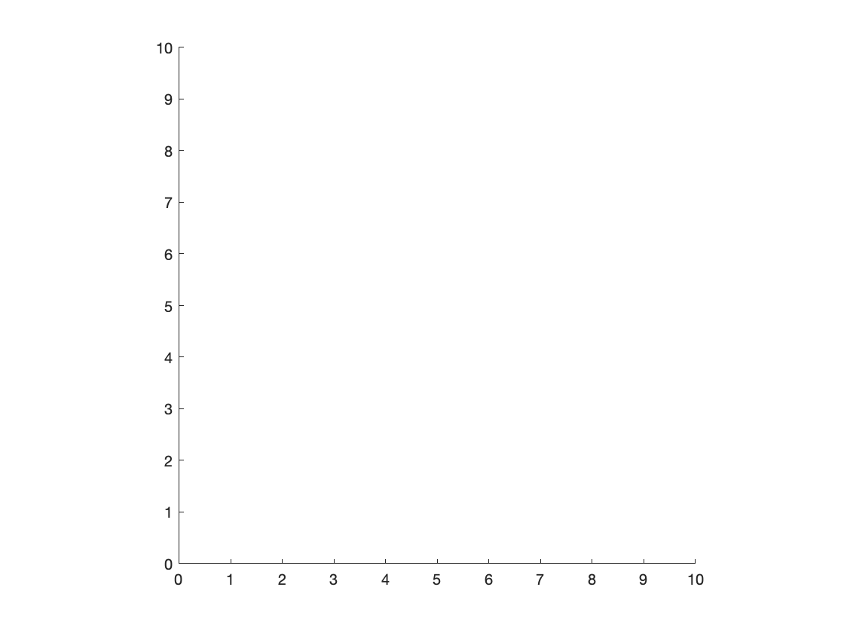

* rectangle -- adds a rectangle, rounded-rectangle, or ellipse

% Add two rectangles

h1 = rectangle('Position',[2,1,2,2]);

h2 = rectangle('Position',[0,0,1,1],'Curvature',[1,1]);

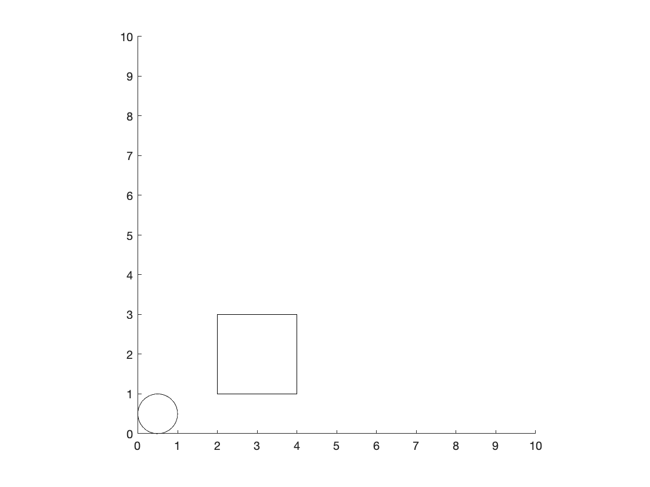

As before, graphics object parameters can be changed and accessed by referencing the **graphics object handle**.

h1.FaceColor = 'r';

h1.Position = [5,5,1,1];

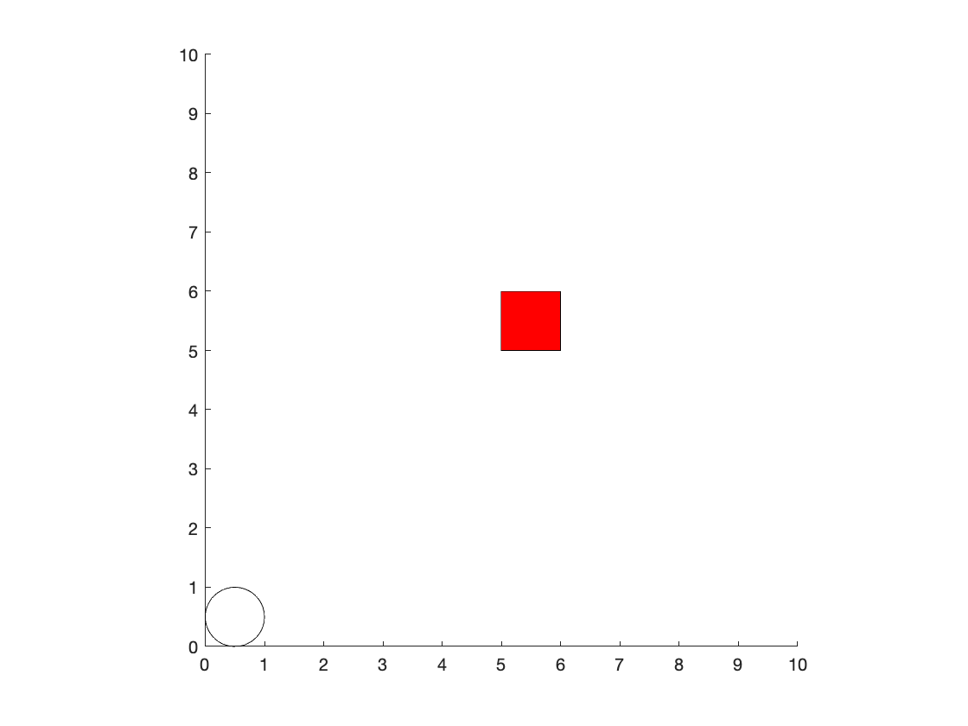

* text -- adds text to a plot at the defined position

text(2,2,'ENGR105')

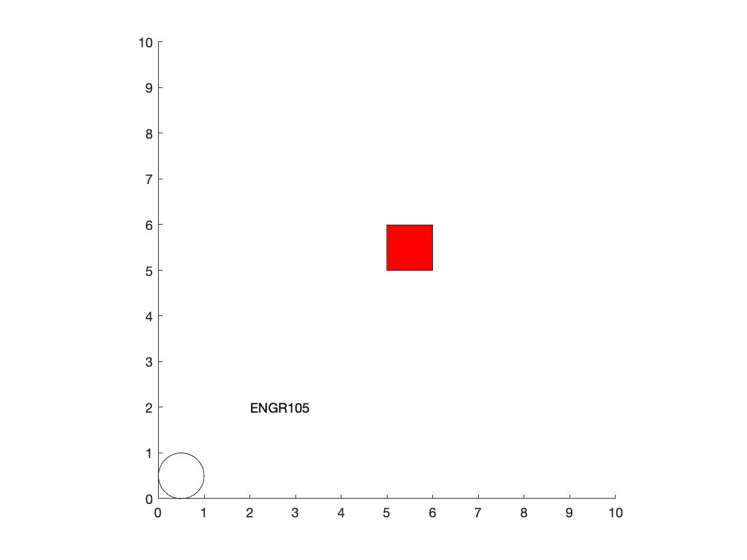

### Animating objects

In lecture 18, we **imported positional data** for creating a visualization of particle motion.

figure

axis square

xlim([0,10])

ylim([0,10])

h3 = rectangle('Position',[1,1,1,1]);

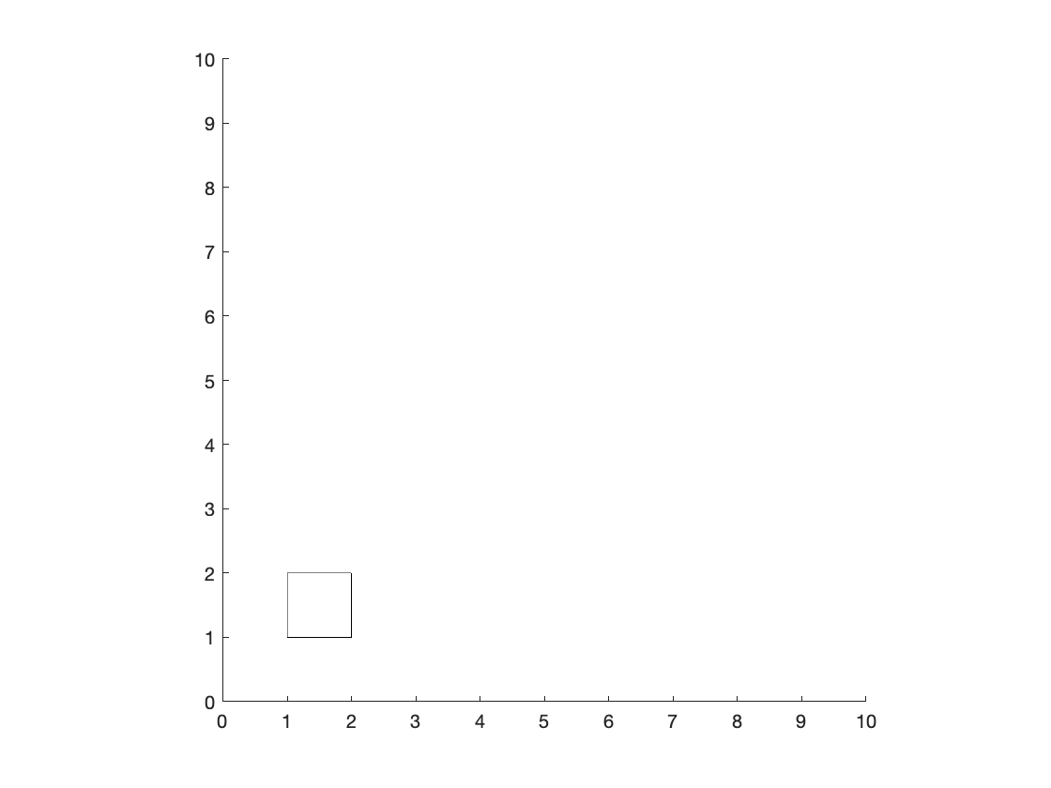

One could also specify positions based on a **mathematical expression.**

% Create time and positional vectors

t = 1:10;

x = cos(t/10*2*pi)+1;

y = sin(t/10*2*pi)+1;

% For each time point specified above, move the rectangle to a new spot

for k = t

% Pause MATLAB for 0.5 seconds

pause(0.5)

% Update to new position

h3.Position = [x(k),y(k),1,1];

end

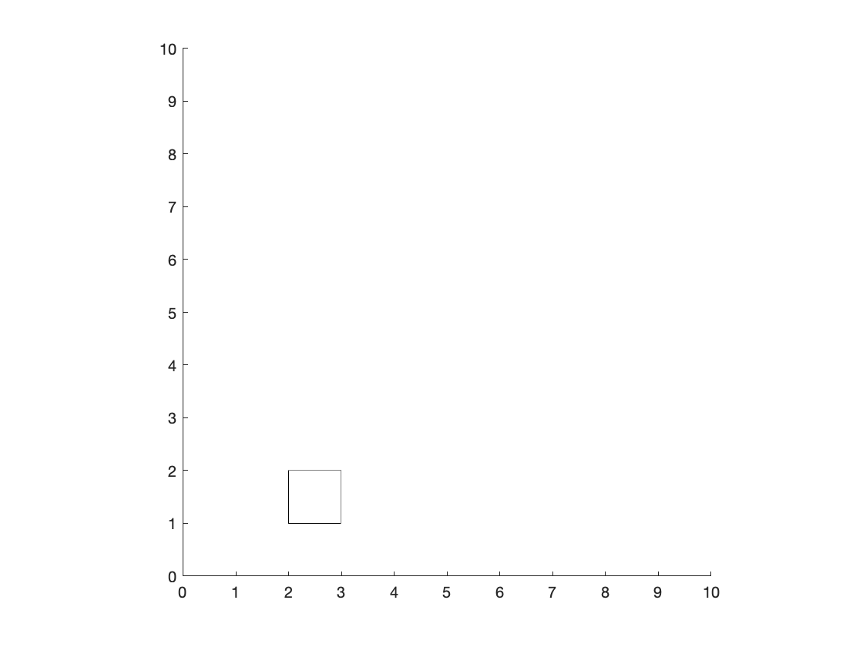

**Note**: pause(t) pauses for t seconds

**Example.** Plot (in 3D) 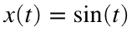 , 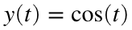 , 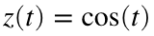 for 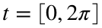

% New plot

figure;

% Step 1: create vectors for time and corresponding positions

t = 0:.1:2*pi;

x = sin(t);

y = cos(t);

z = t;

% Step 2: Plot nothing and establish axis bounds.

p = plot3(NaN,NaN,NaN,'go-');

xlim([-1,1])

ylim([-1,1])

zlim([0,2*pi])

% Step 3: the plot over time

for jj = 1:length(x)

p.XData = x(1:jj);

p.YData = y(1:jj);

p.ZData = z(1:jj);

pause(.1) % Pause for 100 ms

end

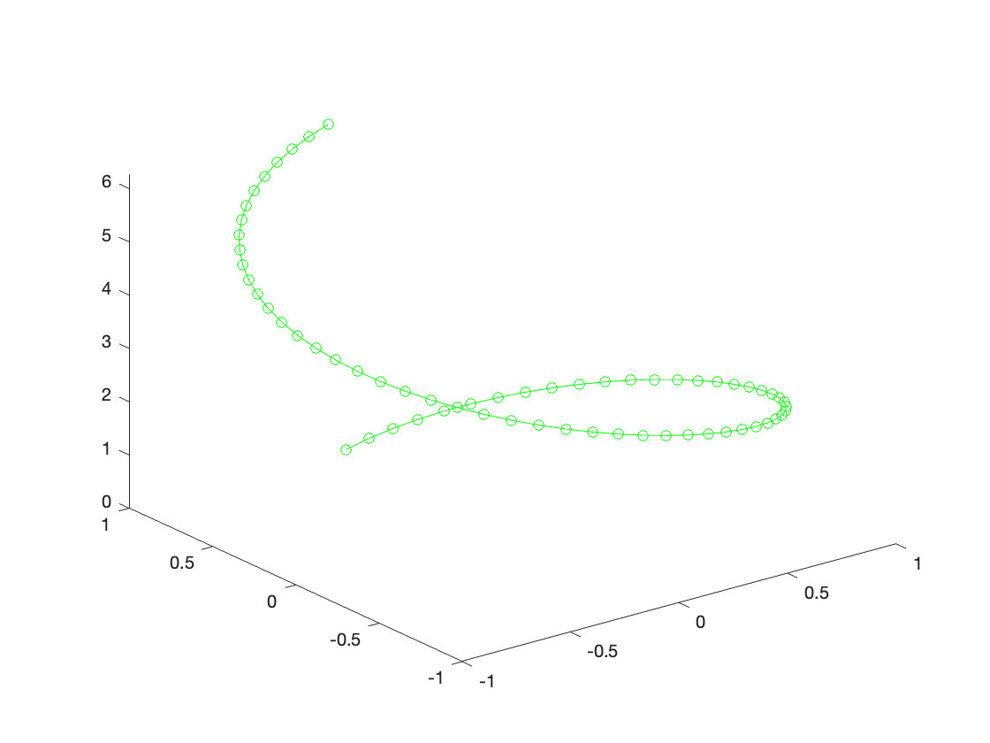

### Keyboard callbacks

Keyboard interactions with a script or interface often make for a more useful and interactive experience. Such interfaces may include movement of on-screen objects by keyboard direction, selection points or regions on a pair of axes, or selecting options or menu items. Interaction between the keyboard and your user interface/program are achieved using keyboard callbacks.

*Additional resources:*

* [MathWorks documentation](https://www.mathworks.com/help/matlab/creating_plots/callbacks-programmed-response-to-user-action.html)
* [Callback definitions](https://www.mathworks.com/help/matlab/creating_plots/callback-definition.html)

The general format for adding a **keyboard callback** to a figure is as follows. The 'KeyPressFcn' field is just a parameter associated with a figure graphics handle.

% Figure to be associated with callback

h1 = figure;

% Specify the function that will be executed upon a key press event

h1.KeyPressFcn = @FctnToCall

*The corresponding callback function stored at the end of the document:*

% Callback function.

function FctnToCall(hObj,eventdata)

if strcmp(eventdata.Key,’w’)

disp('Pressed a w!')

end

end

**Notes:**

* **Keyboard callbacks are often associated with a figure.**
* hObj refers to the calling object but is unnecessary in most cases, *i*.*e*. hObj could be listed as ~ in most situations.
* eventdata contains several fields, one of which is the keyboard key pressed

**Useful**: to view the character codes or names associated with a keystroke, type the following into the command line:

run(fullfile(docroot,'techdoc','ref','examples','ex_KeyPressFcn'));

**Example 1.** Printing to command line by pressing the 'w' key.

close all % Close all previous figures

% Figure to be associated with callback

h1 = figure;

set(h1,'Visible','on')

% Specify the function that will be executed upon a key press event

**Note**: since the call back is associated with a figure, when using a LiveScript file, the visibility of the figure needs to be set to 'on'

**Example 2.** Moving a ball

In the following, example, we can use the arrow keys to move a ball across the screen, while 'q' closes the figure window. The following callback function is located at the end of the LiveScript document.

function DoWhenKeyIsPressed(~,eventdata,hBall)

% Utilizes keypresses to move the x/y coordinates of the

% ball or closes the figure.

% Movement increment

inc = 0.3;

% Move up

if strcmp(eventdata.Key,'uparrow')

hBall.Position(2) = hBall.Position(2)+inc;

% Move down

elseif strcmp(eventdata.Key,'downarrow')

hBall.Position(2) = hBall.Position(2)-inc;

% Move left

elseif strcmp(eventdata.Key,'leftarrow')

hBall.Position(1) = hBall.Position(1)-inc;

% Move right

elseif strcmp(eventdata.Key,'rightarrow')

hBall.Position(1) = hBall.Position(1)+inc;

% Close figure

elseif strcmp(eventdata.Key,'q')

close()

% Display invalid keystroke

else

disp('Key not mapped')

end

end

% Initialize the figure and assign the keyboard callback

% function.

hFig = figure('Position',[200,200,1000,500]);

% Specify plot formatting

text(10,0,{'up arrow = move up','down arrow = move down', ...

'left arrow = move left','right arrow = move right','q = quit'})

axis square

xlim([-10,10])

ylim([-10,10])

% Create a "ball" and place it at [0,0] initially

hBall = rectangle('Position',[0,0,1,1],'Curvature',[1,1]);

% Assign a keyboard call back

hFig.KeyPressFcn = {@DoWhenKeyIsPressed,hBall};

% Set figure to visible -> have it pop out so we can input the keyboard

% call backs

set(hFig,'Visible','on')

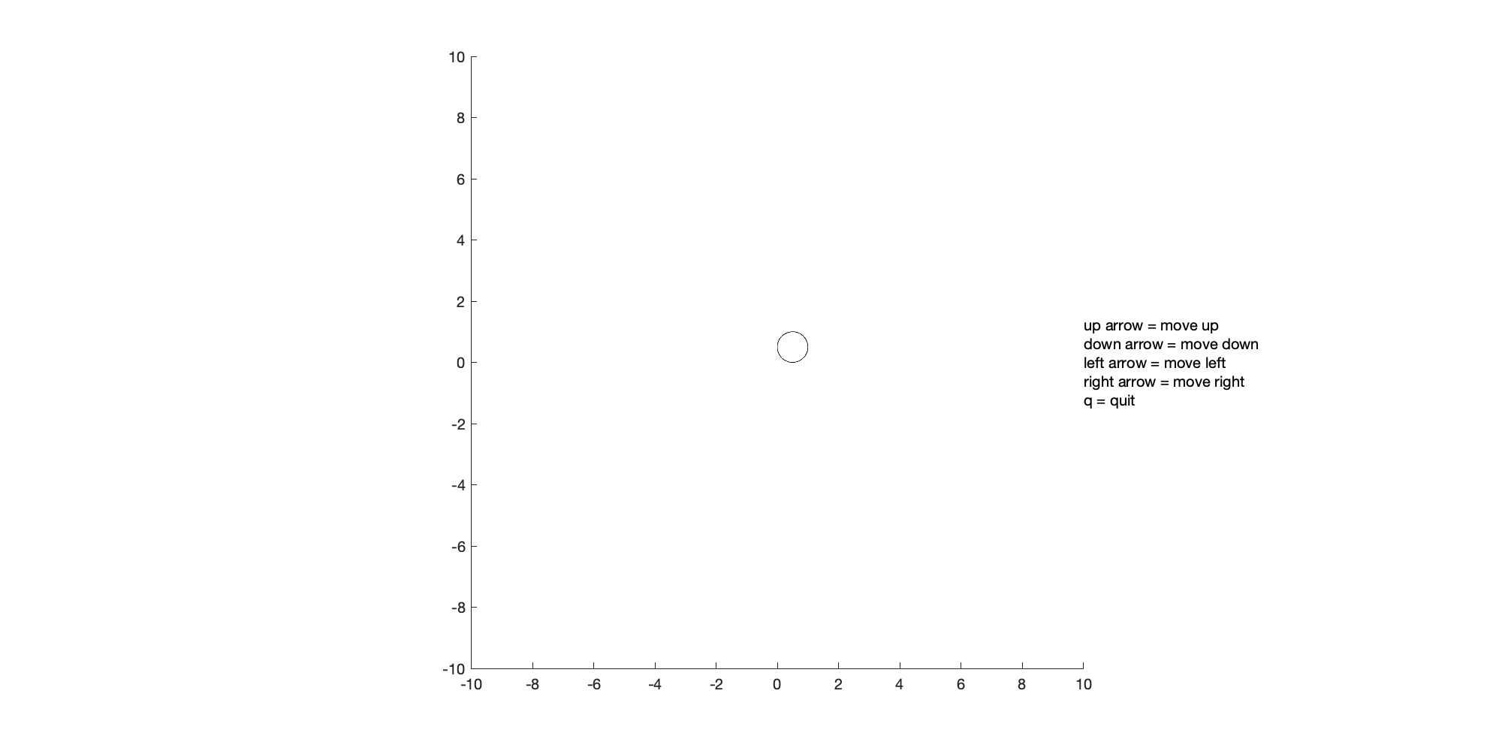

# TOPIC 20: Simulations and Callbacks (cont'd)

ENGR105, 11/10/20

### Revisiting simulations

We have already created and ran simulations in this class for a few different applications. Namely, we have simulated:

* The *number of turns* to obtain certain face values on a set of dice.
* The *number of turns* to obtain a number coin heads/tails in a row.
* The *outcome* from many interactions between **two individuals**, where an individual can act in cooperative, hostile, or more sophisticated manner.

As in these cases, **simulations** enable us to **study how a system evolves over time** and to **provide insight into possible outcomes**. Simulations are often simplified representations of something complex, and it is up to the scientist and engineer to determine appropriate rules, initial conditions, and boundary conditions.

### Practice problem: simulating an infectious disease

Many simulations have been performed over the last year to describe viral transmission within a population. One recent simulation by the Washington Post modeled the transmission of SARS-CoV-2 amongst a population of *moving, interacting particles*:

<https://www.washingtonpost.com/graphics/2020/world/corona-simulator/>

Even in this *highly-simplified system*, the beneficial effects of **quarantining and social distancing** -- introducing "barriers" to social interactions resulted in fewer "super-spreader" events and the *flattening of the curve* of infections over time.

**Create a program that models the spread of an infectious disease between moving, interacting particles**. Your simulation should have the following rules:

1. It should consider **two particles**: one *"healthy"* particle and one *"infected"* particle.
2. Each particle can be represented *visually* as a **circle with a diameter of 1.**
3. Each particle should move in **steps**, where in a given step each particle may change x position by a value randomly distributed on the interval [-0.5,0.5].
4. Each particle **may only move in the +/- x direction**. That is, the particle motion is 1-D.
5. The particle motion is confined to the domain [0,7]: that is, any "part" of each particle may not move to an x value less than 0 or an x value greater than 7.
6. **The infected particle remains infected for the entire simulation**. The healthy particle remains healthy until the particles have "interacted," *i.e.* when the distance between particles is less than one particle diameter.

**Question**. By simulating ***many*** "sets" of particles, what are the **effects of social distancing**?

**PRO, Step 1: P**lan, **P**repare, and **P**seudocode

Helpful tasks and thoughts:

* What do we want to create? A simulation of moving particles, where we record when the particles come within one particle diameter of each other. This is when the "infection" occurs.
* What is our ultimate goal? Run many simulations with and without "social distancing." How can we implement social distancing? One idea would be to have **one particle remain stationary** while the other can move.
* How can we break this up into manageable chunks?

**Remember**: when faced with a large task like this, ***start small and gradually build up your solution***. Frequently check your output along the way. In this case, we will stop at defined checkpoints.

**PRO, Step 2:** w**R**ite **R**ough (increments of code) and **R**efine

***Checkpoint goal 1***: Produce a visualization of both particles.

clear

%1) Vector representing the positions of the particles

pos = [1,4];

% particle one would be infected

%particle 2 is healthy

%3)produce visualization of the particles

g1 = axes;

axis image

xlim([0,7])

ylim([-2,2])

set(g1, 'ytick', [])

set(g1, 'Box', 'on')

xlabel('Position')

% Plot both particles initial positions

p1 = rectangle('Position',[pos(1),-0.5,1,1],'Curvature',[1,1],'FaceColor','r');

p2 = rectangle('Position',[pos(2),-0.5,1,1],'Curvature',[1,1],'FaceColor','w','LineWidth',2);

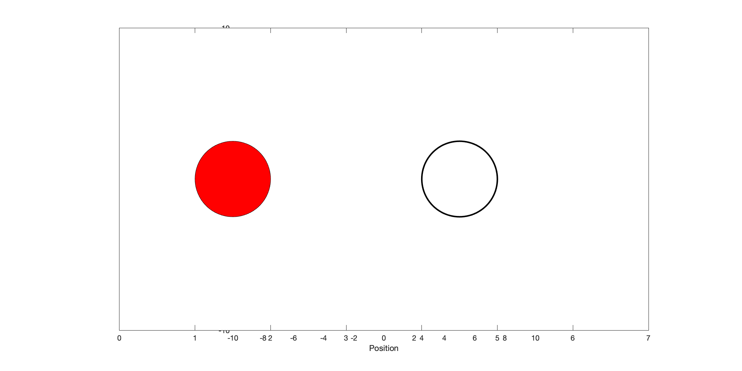

***Checkpoint goal 2***: Produce a visualization of particles moving.

close all

%1) Vector representing the positions of the particles

pos = [1,4];

% particle one would be infected

%particle 2 is healthy

%3)produce visualization of the particles

g1 = axes;

axis image

xlim([0,7])

ylim([-2,2])

set(g1, 'ytick', [])

set(g1, 'Box', 'on')

xlabel('Position')

% Plot both particles initial positions

p1 = rectangle('Position',[pos(1),-0.5,1,1],'Curvature',[1,1],'FaceColor','r');

p2 = rectangle('Position',[pos(2),-0.5,1,1],'Curvature',[1,1],'FaceColor','w','LineWidth',2);

% Step throught he simulation. In each step, update the particles positions

for k = 1:50

% A) Create vector determining particle step

d_k = (rand(1,2)-0.5);

% B) Update particle position

pos = pos + d_k;

% C) Ensure particle doesn't move out of bounds

pos = max(min(pos,6),0);

% D) Update visualization

p1.Position(1) = pos(1);

p2.Position(1) = pos(2);

% E) Pause Matlab

pause(0.2)

end

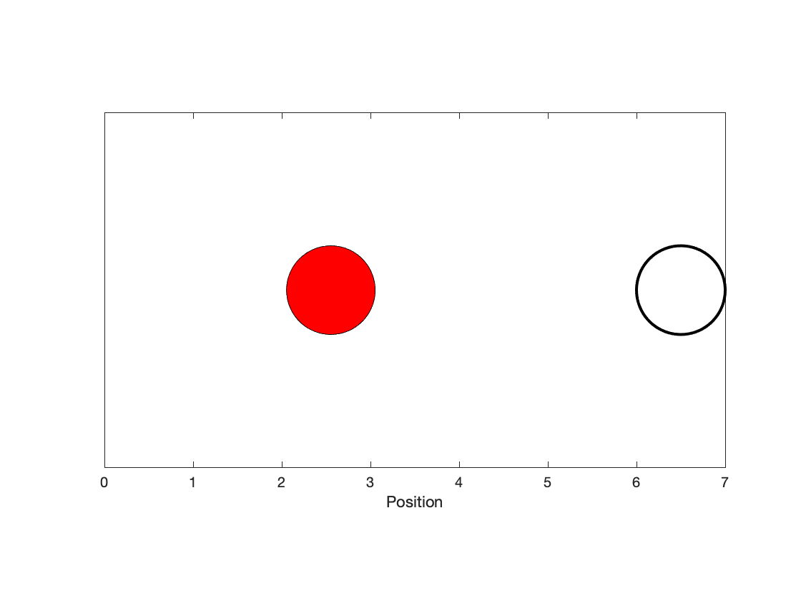

***Checkpoint goal 3***: Incorporate interactions. Change healthy particle color when infection occurs

close all

%1) Vector representing the positions of the particles

pos = [1,4];

% particle one would be infected

%particle 2 is healthy

%3)produce visualization of the particles

g1 = axes;

axis image

xlim([0,7])

ylim([-2,2])

set(g1, 'ytick', [])

set(g1, 'Box', 'on')

xlabel('Position')

% Plot both particles initial positions

p1 = rectangle('Position',[pos(1),-0.5,1,1],'Curvature',[1,1],'FaceColor','r');

p2 = rectangle('Position',[pos(2),-0.5,1,1],'Curvature',[1,1],'FaceColor','w','LineWidth',2);

% Step throught he simulation. In each step, update the particles positions

for k = 1:50

% A) Create vector determining particle step

d_k = (rand(1,2)-0.5);

% B) Update particle position

pos = pos + d_k;

% C) Ensure particle doesn't move out of bounds

pos = max(min(pos,6),0);

% Check if the particles interact

if abs(pos(1) - pos(2)) < 1

p2.FaceColor = 'r';

end

% D) Update visualization

p1.Position(1) = pos(1);

p2.Position(1) = pos(2);

% E) Pause Matlab

pause(0.2)

end

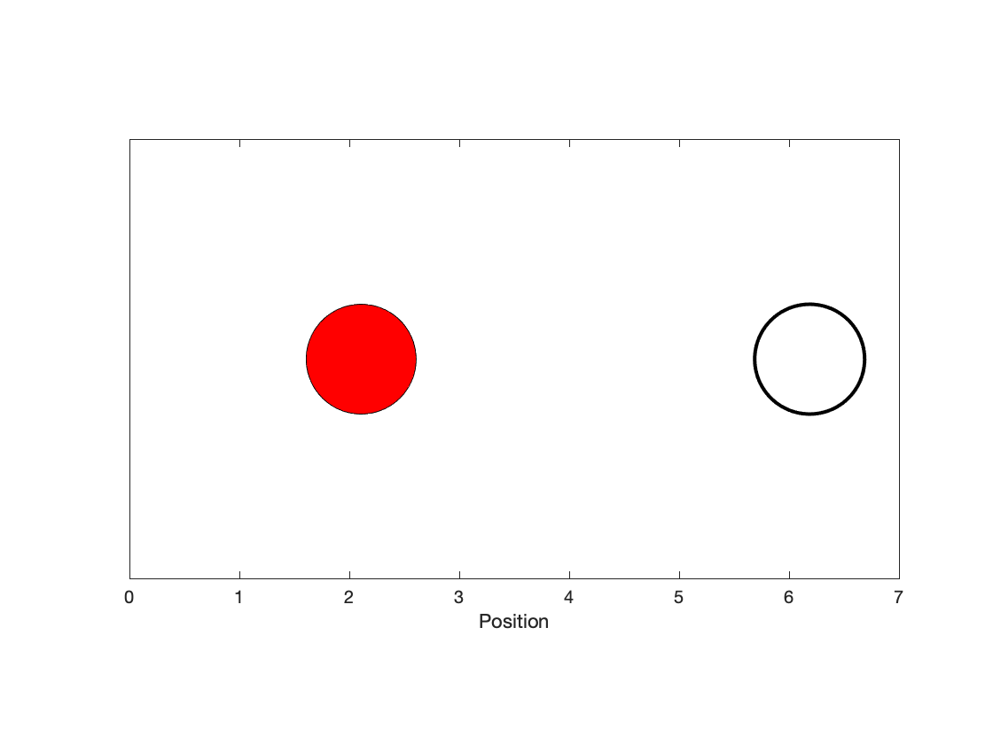

***Checkpoint goal 4***: Make the simulation run *until* the particles interact.

close all

% 1) vector representing positions of two particles

pos = [1,4];

% 2) Define particle identities.

% Particle 1 will be infected

% Particle 2 will intiially be healthy

% 3) Produce visualization of each particle

g1 = axes;

axis image

xlim([0,7])

ylim([-2,2])

set(g1, 'ytick', [])

set(g1, 'Box', 'on')

xlabel('Position')

% Plot both particles initial positions

p1 = rectangle('Position',[pos(1),-0.5,1,1],'Curvature',[1,1],'FaceColor','r');

p2 = rectangle('Position',[pos(2),-0.5,1,1],'Curvature',[1,1],'FaceColor','w','LineWidth',2);

% Step through the simulation. In each step, update the particles positions

while abs(pos(1) - pos(2)) >=1

% A) Create vector determining particle step

d_k = (rand(1,2)-0.5);

% B) Update particle position

pos = pos + d_k;

% C) Ensure particle doesn't move out of bounds

pos = max(min(pos,6),0);

% Check if the particles interact

if abs(pos(1) - pos(2)) < 1

p2.FaceColor = 'r';

end

% D) Update visualization

p1.Position(1) = pos(1);

p2.Position(1) = pos(2);

% E) Pause Matlab

pause(0.2)

end

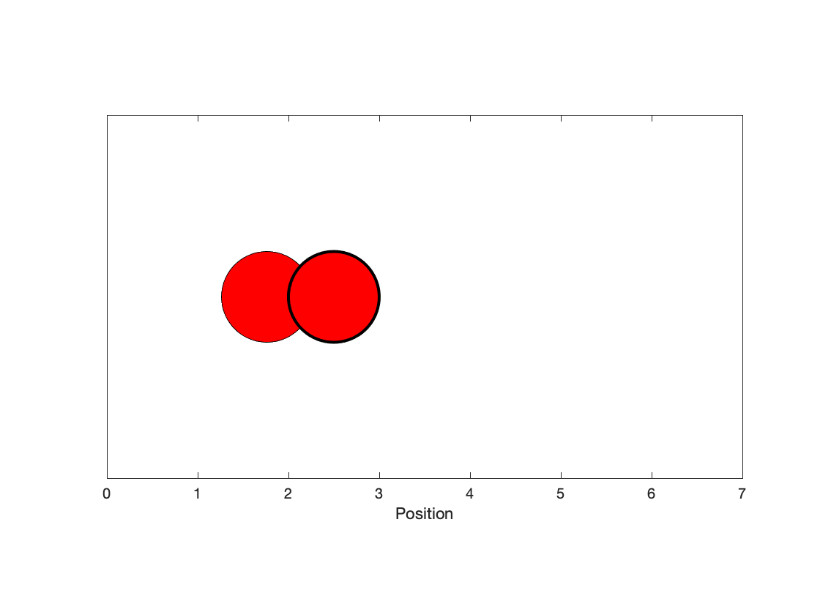

***Checkpoint goal 5***: We've produced a visualization of particle simulation. Ultimately, this visualization is not important. Since we will eventually compare normal particles to "socially distancing particles," we really just want to know the time required until the infection occurs.

close all

% 1) vector representing positions of two particles

pos = [1,4];

% 2) Define particle identities.

% Particle 1 will be infected

% Particle 2 will intiially be healthy

% Number of time steps until infection occurs

numSteps = 0;

% Step through the simulation. In each step, update the particles positions

% Step through the simulation. In each step, update the particles positions

while abs(pos(1) - pos(2)) >=1

% A) Create vector determining particle step

d_k = (rand(1,2)-0.5);

% B) Update particle position

pos = pos + d_k;

% C) Ensure particle doesn't move out of bounds

pos = max(min(pos,6),0);

% D) Update Counter

numSteps = numSteps + 1;

end

disp(numSteps)

108

***Checkpoint goal 6***: Adapt the code so that we can observe the distribution of times until an infection occurs when 100 sets of simulations are performed.

% Number of simulations

numSim = 1000;

% Preallocate storage vector

numSteps = zeros(1,numSim);

% Repeat simulation numSim times

for k = 1:numSim

%1) Vector representing positions of two particles

pos = [1,4];

% 2) Define particle identities.

% Particle 1 will be infected

% Particle 2 will intiially be healthy

% Step through the simulation. In each step, update the particles positions

while abs(pos(1) - pos(2)) >=1

% A) Create vector determining particle step

d_k = (rand(1,2)-0.5);

% B) Update particle position

pos = pos + d_k;

% C) Ensure particle doesn't move out of bounds

pos = max(min(pos,6),0);

% D) Update Counter

numSteps(k) = numSteps(k) + 1;

end

end

% Create visualization

histogram(numSteps)

xlabel('Number of steps')

ylabel('Counts')

xlim([0,700])

ylim([0,400])

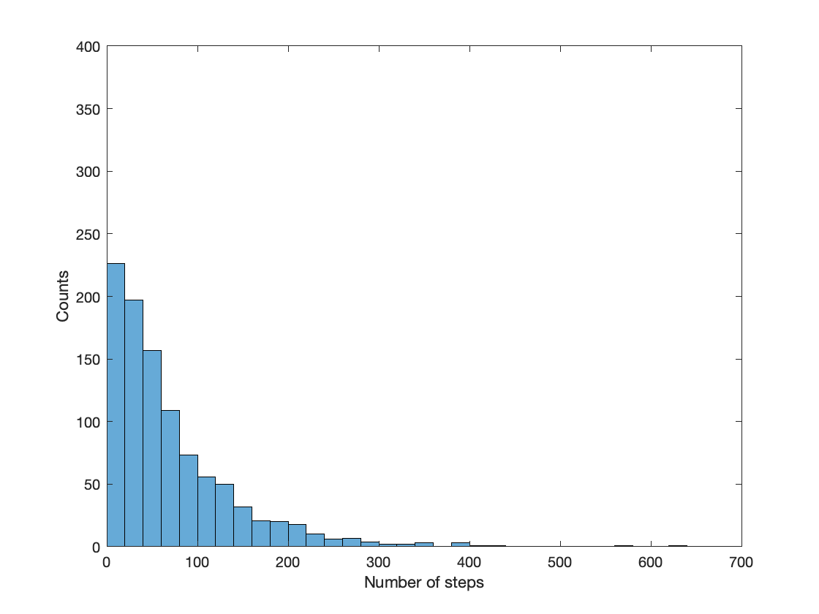

***Checkpoint goal 7***: Adapt the code so that we can observe the distribution for if one particle is **social distancing**. That is, assume the infected particle does not move in this simulation

% Number of simulations

numSim = 1000;

% Preallocate storage vector

numSteps = zeros(1,numSim);

% Repeat simulation numSim times

for k = 1:numSim

%1) Vector representing positions of two particles

pos = [1,4];

% 2) Define particle identities.

% Particle 1 will be infected

% Particle 2 will intiially be healthy

% Step through the simulation. In each step, update the particles positions

while abs(pos(1) - pos(2)) >=1

% A) Create vector determining particle step

d_k = (rand(1,2)-0.5).*[0,1];

% B) Update particle position

pos = pos + d_k;

% C) Ensure particle doesn't move out of bounds

pos = max(min(pos,6),0);

% D) Update Counter

numSteps(k) = numSteps(k) + 1;

end

end

% Create visualization

histogram(numSteps)

xlabel('Number of steps')

ylabel('Counts')

xlim([0,700])

ylim([0,400])

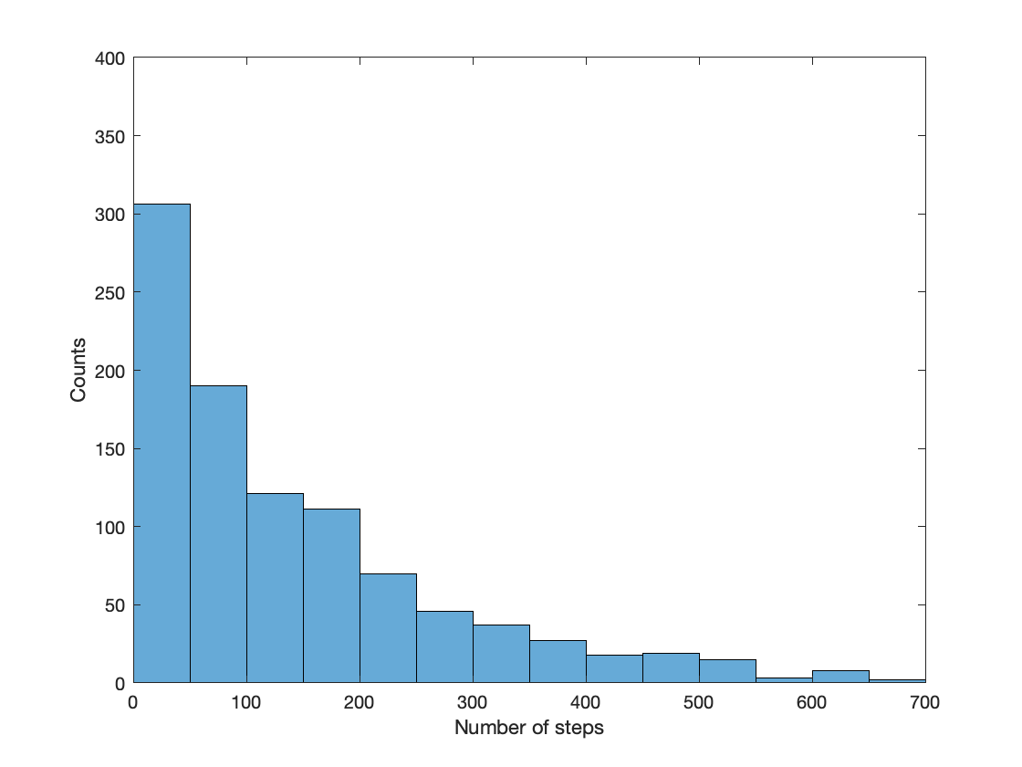

***Checkpoint goal 8***: Consolidate the above into one piece of code for comparing social distancing.

*Create a relevant function:*

% Number of simulations

numSim = 500;

% Preallocate storage vector

numSteps_norm = zeros(1,numSim);

numSteps_quar = zeros(1,numSim);

% Repeat simulation numSim times

for k = 1:numSim

% Simulate normal

numSteps_norm(k) = simulateDisease([1,1]);

% Simulate quarantine

numSteps_quar(k) = simulateDisease([0,1]);

end

% create visualization

h1 = histogram(numSteps_norm);

hold on

h2 = histogram(numSteps_quar);

hold off

% Visualization

xlabel('Number of steps')

ylabel('Counts')

h1.BinWidth = 50;

h2.BinWidth = 50;

h1.DisplayStyle = 'stairs';

h2.DisplayStyle = 'stairs';

h2.LineWidth = 2;

h1.LineWidth = 1;

h2.EdgeColor = 'r';

h1.EdgeColor = 'k';

xlim([0,700])

ylim([0,400])

axis square

legend('Normal case', 'Quarantine', 'Location', 'Northeast')

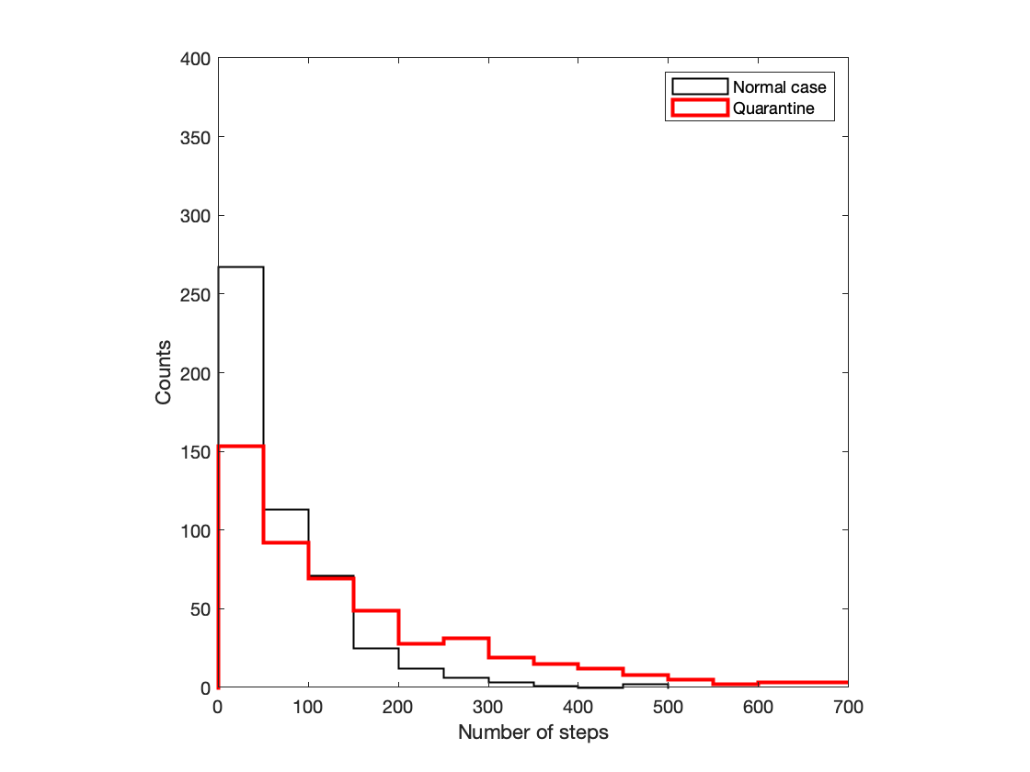

**Takeaways**:

* We have thus simulated how group dynamics can influence the spread of an infectious disease!
* How does this relate to what we might expect?
* When approaching problems, **start small and work up to a solution**.

# TOPIC 21: Callbacks and simple interfaces

ENGR105, 11/12/20

### Miscellaneous information: changing the directory and accessing all files in the current folder

* The **current directory** can be retrieved using cd. This will save the directory as a character array.

currDir = cd;

disp(currDir)

/Users/raribidesi/Desktop/ENGR 105/Class Notes/Final Participation

* You can use cd with a character input to navigate to a **different directory**

cd(currDir)

* dir retrieves the list of files in a given directory. If assigned to a variable, it will store the information as a structure array, where each structure corresponds to one file.

dirFiles = dir;

* You can **retrieve a list of file names** from the name field. This can be converted to a cell array using {}

files = {dirFiles.name};

size(files)

ans = 1×2

1 21

files{5}

ans = 'L18_TrackingData.txt'

**Note**: this enables automated processing of a large number of files in a given directory.

### Reminder: keyboard callbacks (key press)

In Lecture 20/Topic 19, we produced an example where we can use the arrow keys to move a ball across the screen, while 'q' closes the figure window. The following callback function is located at the end of the LiveScript document.

**Example 1**: Moving ball

function DoWhenKeyIsPressed(~,eventdata,hBall)

% Utilizes keypresses to move the x/y coordinates of the

% ball or closes the figure.

% Movement increment

inc = 0.3;

% Move up

if strcmp(eventdata.Key,'uparrow')

hBall.Position(2) = hBall.Position(2)+inc;

% Move down

elseif strcmp(eventdata.Key,'downarrow')

hBall.Position(2) = hBall.Position(2)-inc;

% Move left

elseif strcmp(eventdata.Key,'leftarrow')

hBall.Position(1) = hBall.Position(1)-inc;

% Move right

elseif strcmp(eventdata.Key,'rightarrow')

hBall.Position(1) = hBall.Position(1)+inc;

% Close figure

elseif strcmp(eventdata.Key,'q')

close()

% Display invalid keystroke

else

disp('Key not mapped')

end

end

% Initialize the figure and assign the keyboard callback

% function.

hFig = figure('Position',[200,200,1000,500]);

% Specify plot formatting

text(10,0,{'up arrow = move up','down arrow = move down', ...

'left arrow = move left','right arrow = move right','q = quit'})

axis square

xlim([-10,10])

ylim([-10,10])

% Create a "ball" and place it at [0,0] initially

hBall = rectangle('Position',[0,0,1,1],'Curvature',[1,1]);

hBall.FaceColor = 'k';

% Assign a keyboard call back

hFig.KeyPressFcn = {@Topic21DoWhenKeyIsPressed,hBall};

% Set figure to visible -> have it pop out so we can input the keyboard

% call backs

set(hFig,'Visible','on')

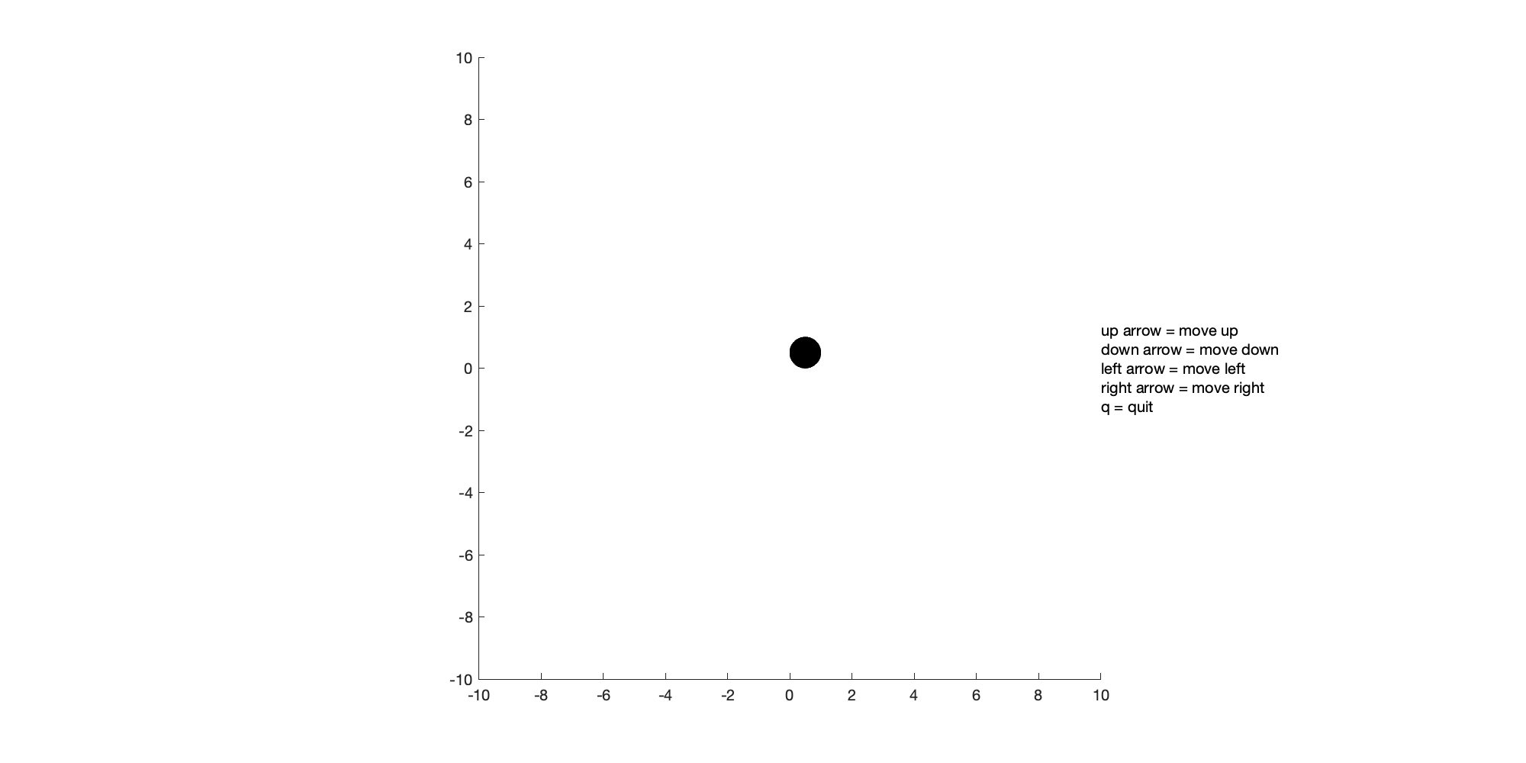

**Note**: callback functions do not support outputs.

### Keyboard callbacks (key release)

In the above example, something happens when we *press a button*. We can have something happen when we release a button. This can be specified using the 'KeyReleaseFcn' field of the graphics object for the current figure.

**Example 2.** **Produce a game where you must keep moving the ball.** If the player doesn't move for ~ 1 second, display "Game Over." Furthermore, make the "ball" become "whiter" as the game approaches the end game scenario.

To create this solution, we must create:

* A function to be assigned to the *key press*

function ex3_keyPress(~,eventdata,hBall)

% Utilizes keypresses to move the x/y coordinates of the

% ball or closes the figure.

% Movement increment

inc = 0.3;

% Reset FaceColor to be black

hBall.FaceColor = [0,0,0];

% Move up

if strcmp(eventdata.Key,'uparrow')

hBall.Position(2) = min(hBall.Position(2)+inc,9);

% Move down

elseif strcmp(eventdata.Key,'downarrow')

hBall.Position(2) = max(hBall.Position(2)-inc,-10);

% Move left

elseif strcmp(eventdata.Key,'leftarrow')

hBall.Position(1) = max(hBall.Position(1)-inc,-10);

% Move right

elseif strcmp(eventdata.Key,'rightarrow')

hBall.Position(1) = min(hBall.Position(1)+inc,9);

% Close figure

elseif strcmp(eventdata.Key,'q')

close()

% Display invalid keystroke

else

disp('Key not mapped')

end

end

* A function to be assigned to the *key release*

function ex3_keyRelease(~,~,hBall)

% Function to be executed when key is released. Takes a graphics object

% corresponding to the ball as an input

% Increase the whiteness of the ball until it becomes fully white

while hBall.FaceColor(1) < 0.9

% Make FaceColor whiter

hBall.FaceColor = min(hBall.FaceColor + 0.1,1);

% Pause for 100 ms

pause(0.1)

end

% If ~1 second passes without moving, game over

t1 = text(-10,0,'GAME OVER');

t1.FontSize = 50;

t1.Color = 'r';

end

close all % Close previous windows

% Initialize the figure and assign the keyboard callback

% function.

hFig = figure('Position',[200,200,1000,500]);

% Specify plot formatting

text(10,0,{'up arrow = move up','down arrow = move down', ...

'left arrow = move left','right arrow = move right','q = quit'})

axis square

xlim([-10,10])

ylim([-10,10])

% Create a "ball" and place it at [0,0] initially

hBall = rectangle('Position',[0,0,1,1],'Curvature',[1,1]);

hBall.FaceColor = 'k'; % Default color is black

% Assign a keyboard call back for when a buttom is pressed

hFig.KeyPressFcn = {@ex3_keyPress,hBall};

% Assign a keyboard call back for when a button is release

hFig.KeyReleaseFcn = {@ex3_keyRealease,hBall};

% Set figure to visible -> have it pop out so we can input the keyboard

% call backs

set(hFig,'Visible','on')



**Challenge**. Can you create modifications to the code so that:

* The radius of the ball resets on a key press but increases as the color becomes whiter?
* You want the ball to avoid regions of the playable area?
* At the end ot the game, the game window closes and the new window appears that says "Game Over?" Or the user cannot further move the ball.

**Takeaway note:** *in these cases (and below), callback functions are not compatible with outputs.*

### Mouse callbacks

Similarly to assigning keyboard callbacks, one can assign callback functions to **mouse operations** as function handles to the appropriate field of a **graphics handle object**. In particular, we will discuss the following fields associated with mouse operations:

* WindowButtonMotionFcn - the mouse pointer is moved
* WindowButtonDownFcn - the mouse button is pressed
* WindowButtonUpFcn - the mouse button is released

**Example 3**. Create a script that tracks the mouse cursor across a figure windows and reports the x and y position at the tip of the cursor.

*Callback function:*

function moveText(~,~,g1)

% The mouse button motion callback.

% Get the current mouse location.

pos = get (gca, 'CurrentPoint');

x = pos(1,1); y = pos(1,2);

% Update the text object readout to the current location

% and place its location at the cursor tip.

g1.String = ['x = ',num2str(x),', y = ',num2str(y)];

g1.Position = [x, y, 0]; % position 0 in 3rd dimension

end

This will utilize a callback associated with the 'WindowButtonMotionFcn' field, which **executes whenever motion on the figure is detected**.

**Note**: this utilizes get(gca,'CurrentPoint') in the callback function, which reports the location of the mouse button as a 2x3 matrix:

* The 1st row, 1st column of the matrix is the x position of the click
* The 1st row, 2nd column of the matrix is the y position of the click

*Incorporating this into a script:*

close all % close previous figures

% Create a figure to be associated with the mouse callback

hFig1 = figure('Visible','on');

axis equal

xlim([0,10])

ylim([0,10])

% Initialize a text object for displaying coordinates

g = text(5,5,'x = NaN, y = NaN');

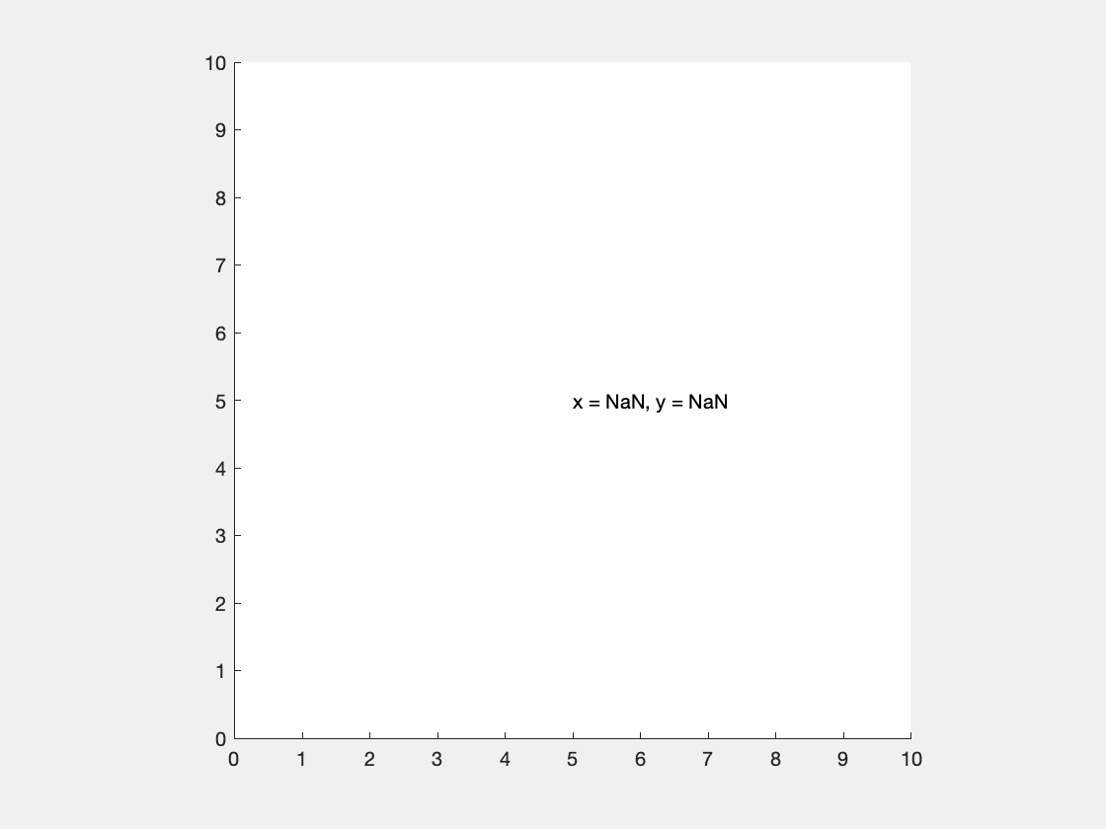

% Assign mouse callback function

hFig1.WindowButtonMotionFcn = {@moveText,g};

**Mouse button clicks** can be registered in a figure window using the WindowButtonDownFcn callback.

**Example 4**. In the following, you can observe the SelectionType for different mouse clicks.

function click(h,~)

% The callback for a mouse button press. Print the mouse

% button identifier to the command window.

h.SelectionType

end

close all

% Create a figure and establish the callback associated with a

% mouse button press.

figure('WindowButtonDownFcn',@click,'Visible','on')

* 'normal' - left mouse button click
* 'alt' - right mouse button click
* 'extend' - middle mouse button click
* 'open' - double click

**Example 5**. Create an **interactive plot** where points can be added to the plot based on the location of the mouse cursor when pressing any mouse button.

*Callback function:*

function plotPoints1(~,~,h)

% Call back function for updating a plot

% Get the current mouse location

pos = get(gca,'CurrentPoint');

% Update the plot with the new position

h.XData(end+1) = pos(1,1);

h.YData(end+1) = pos(1,2);

drawnow

end

**Note**: the above uses drawnow. drawnow is equivalent to pause(*<shortest time based on your computer's processor>*) and updates figures and processes any pending callbacks. Use this command if you modify graphics objects and want to see the updates on the screen immediately.

*Incorporating this into a script:*

close all

% Create a figure with mouse button press callback and plot

% NaNs (nothingness) on the figure.

hFig2 = figure('Visible','on');

h = plot(NaN,NaN,'ro-','MarkerFaceColor','r','MarkerSize',5);

% Assign callback function

hFig2.WindowButtonDownFcn = {@plotPoints1,h}

hFig2 =

Figure (1) with properties:

Number: 1

Name: ''

Color: [0.9400 0.9400 0.9400]

Position: [561 529 560 420]

Units: 'pixels'

Show all properties

% Graphical parameters

axis equal

xlim([0,10])

ylim([0,10])

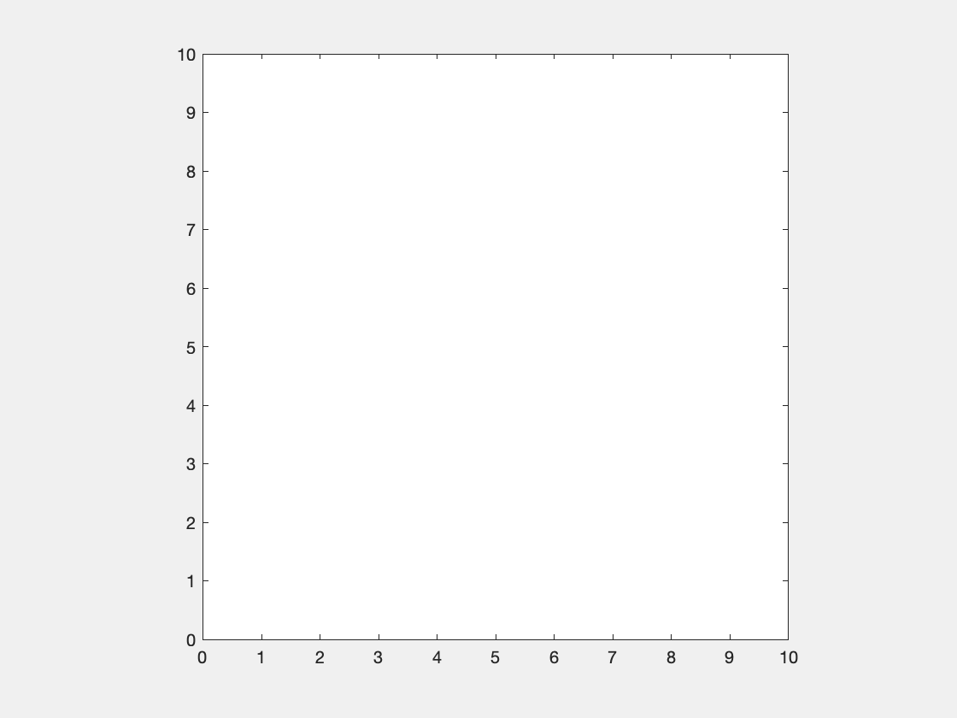

**Example 6**. Create an similarly **interactive plot that** populates **lines of different colors** depending on if the left or right mouse button is clicked.

*Callback function:*

function plotPoints2(h,~,hRed,hGreen)

% Callback function for updating a plot with multiple colored points

% Get the current mouse location.

pos = get(gca, 'CurrentPoint');

% If a left click: add to the red plot

if strcmp(h.SelectionType,'normal')

% Add to the data in the red plot

hRed.XData(end+1) = pos(1,1);

hRed.YData(end+1) = pos(1,2);

drawnow

% If a right click: add to the green plot

elseif strcmp(h.SelectionType,'alt')

% Add to the data in the red plot

hGreen.XData(end+1) = pos(1,1);

hGreen.YData(end+1) = pos(1,2);

drawnow

end

end

*Incorporating into a script:*

close all % Delete previous

% Create a figure with mouse button press callback

hFig3 = figure('Visible','on');

% Plot each color line, initially as NaN. The first plot (handle = hRed)

% hold the red points and the second plot (handle = hGreen) hold

% the green points.

hRed = plot(NaN,NaN,'ro-','MarkerFaceColor','r','MarkerSize',5);

hold on

hGreen = plot(NaN,NaN,'go-','MarkerFaceColor','g','MarkerSize',5);

hold off

% Assign callback function

hFig3.WindowButtonDownFcn = {@plotPoints2, hRed, hGreen};

axis square

xlim([0,10])

ylim([0,10])



### Storing data in an interface with guidata

In the above example, we **add points** to one of two data sets. What if we want to ***remove points*** in reverse order? This is difficult because callback functions **do not** return outputs. That is, we cannot store the order of the points added.

* To address this issue, guidata() can be used to pass variables among callbacks in figures and interfaces.
* guidata is used to update a **structure** variable that is associated with a given figure or interface.
* The following depicts the syntax for guidata(). handles is a common representation for a data structure that can store information. The name comes from the application of guidata in creating graphical user interfaces using the built-in guide designer.

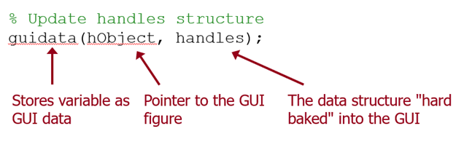

**Note**: guidata is used to both **store** and **retrieve** the data structure.

**Example 7**. For an interactive plot created in Example 6, add a functionality such that

*Updated callback function:*

function plotPoints3(h,~,hRed,hGreen)

% Callback function for updating a plot with multiple colored points

% Get the current mouse location.

pos = get(gca, 'CurrentPoint');

% Load GUI information

handles = guidata(h);

% If a left click: add to the red plot

if strcmp(h.SelectionType,'normal')

% Add to the data in the red plot

hRed.XData(end+1) = pos(1,1);

hRed.YData(end+1) = pos(1,2);

drawnow

% Specify that the most recent point was red

handles.order{end+1} = 'r';

% If a right click: add to the green plot

elseif strcmp(h.SelectionType,'alt')

% Add to the data in the red plot

hGreen.XData(end+1) = pos(1,1);

hGreen.YData(end+1) = pos(1,2);

drawnow

% Specify that the most recent point was red

handles.order{end+1} = 'g';

% If a middle click (and note empty: delete the most recent point

elseif strcmp(h.SelectionType,'extend') && ~isempty(handles.order)

% If last point was red

if strcmp(handles.order{end},'r')

% Remove last data poitn

hRed.XData(end) = [];

hRed.YData(end) = [];

drawnow

% Delete last entry

handles.order(end) = [];

% If last point was green

else

% Remove last data poitn

hGreen.XData(end) = [];

hGreen.YData(end) = [];

drawnow

% Delete last entry

handles.order(end) = [];

end

end

% Update the guidata with the data structure

guidata(h,handles);

end

*Incorporating into a script:*

close all % Delete previous

% Create a figure with mouse button press callback

hFig3 = figure('Visible','on');

% Create a data structure to store the order of moves

handles.order = cell(0);

% Update the guidata with that data structure

guidata(hFig3,handles);

% Plot each color line, initially as NaN. The first plot (handle = hRed)

% hold the red points and the second plot (handle = hGreen) hold

% the green points.

hRed = plot(NaN,NaN,'ro-','MarkerFaceColor','r','MarkerSize',5);

hold on

hGreen = plot(NaN,NaN,'go-','MarkerFaceColor','g','MarkerSize',5);

hold off

% Assign callback function

hFig3.WindowButtonDownFcn = {@lotPoints3, hRed, hGreen};

axis square

xlim([0,10])

ylim([0,10])



### Example: Revisiting Tic Tac Toe

In lectures 9 - 11 and in Homework #6, we created an environment for playing Tic Tac Toe.

function ticTacToe(compStrategy)

% Define initial variables and arrays

gameboard = zeros(3,3); % gameboard that we will populate

% Repeat: alternate for players

player = 1; % player one

% Logical variable to determine if game should stil be playing

gameStillGoing = 1;

% Iterate until someone has won (or the game is a draw)

while gameStillGoing

% Player 1: human player. If it is player 1's turn, specify a

% position to be played

if player == 1

% Logical variable corresponding if the move is valid

invalidMove = 1;

% Make player pick a valid position

while invalidMove

% Position to play, in single index notation

playPos = input('Select a position to play...');

if ~isempty(playPos)

% Determine if move is allowable

invalidMove = all((gameboard(:) == 0)'.*(1:9) ~= playPos);

end

end

% Player 2: computer player. If it is player 2's turn, determine the

% position played based on the algorithm contained within compStrategy().

else

% Call a function that will output a position based upon the

% strategy defined for the computer

playPos = compStrategy(gameboard);

end

% Update the gameboard

gameboard(playPos) = player;

% Step 3: display game board

disp(gameboard)

% Step 4: evaluate stopping condition -> did someone win?

gameStillGoing = checkEndGame2(gameboard, player);

% Step 5: change player

player = mod(player,2)+1;

end

end

% Play tic tac toe against AI player who plays randomly

ticTacToe(@playRandom)

1 0 0

0 0 0

0 0 0

1 0 0

0 0 0

0 0 2

1 1 0

0 0 0

0 0 2

1 1 0

0 0 2

0 0 2

1 1 1

0 0 2

0 0 2

1 wins!

**Goal**: we want to create a user interface for playing Tic Tac Toe.

*Our previous methodology:*

1. Initialize settings and gameboard
2. Sequentially loop through turns as long as a end condition is not satisfied
3. If it is the player's turn, input an index number.
4. If it is the computer's turn, pick the next position according to some strategy.
5. Update gameboard and evaluate end game conditions.
6. Iterate as long as necessary

*One possible new methodology:*

1. Create a graphics object (a figure)
2. On mouse click: the player makes a move, the gameboard is updated, and end game conditions are evaluated
3. On mouse release: the computer will make a move, the gameboard is updated, and end game conditions are evaluated
4. Once end game conditions are satisfied, the game ends.

**Question**: what variable will need to be "updated" throughout all of this? The gameboard. For this reason, we should anticipate using guidata to store and retrieve the current gameboard.

% Create figure objects

h1 = figure('Visible','on');

g1 = axes;

% Plot grid lines

plot([-1,-1],[-4,4],'k-')

hold on

plot([1,1],[-4,4],'k-')

plot([-4,4],[1,1],'k-')

plot([-4,4],[-1,-1],'k-')

hold off

% Modify graphical parameters

xlim([-3,3])

ylim([-3,3])

g1.XColor = 'none';

g1.YColor = 'none';

g1.Position(3:4) = 0.75*g1.Position(3:4);

g1.OuterPosition(1) = 0.125;

axis square

% Create two empty text containers. On every turn, we will update the the

% position of either the next X or next O marker from NaN to the

% appropriate coordinates

x1 = text(NaN(5,1),NaN(5,1),'X','FontName','Arial','FontSize',50,'FontWeight','bold');

x2 = text(NaN(4,1),NaN(4,1),'O','FontName','Arial','FontSize',50,'FontWeight','bold');



% Create data structure to store gameboard

handles.gameboard = zeros(3);

% Store data structure

guidata(h1,handles);

% Assign callback function for mouse click

h1.WindowButtonDownFcn = {@placeX,x1};

% Assign callback function for mouse release

h1.WindowButtonDownFcn = {@place0,x2,@playRandom}

h1 =

Figure (1) with properties:

Number: 1

Name: ''

Color: [0.9400 0.9400 0.9400]

Position: [561 529 560 420]

Units: 'pixels'

Show all properties

### Creating figure UI objects using uicontrol

Interactive elements may be added directly to a figure using uicontrol. For a list of interactive objects, please see the [MATLAB documentation](https://www.mathworks.com/help/matlab/ref/uicontrol.html). Briefly, the types of objects to be incorporated include:

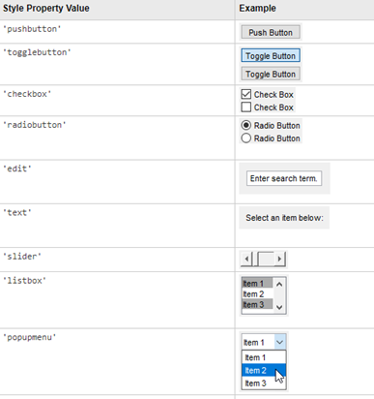

**Example.** Update the Tic Tac Toe code to include a button that resets the game.

% Create figure objects

h1 = figure('Visible','on');

g1 = axes;

% Plot grid lines

plot([-1,-1],[-4,4],'k-')

hold on

plot([1,1],[-4,4],'k-')

plot([-4,4],[1,1],'k-')

plot([-4,4],[-1,-1],'k-')

hold off

% Modify graphical parameters

xlim([-3,3])

ylim([-3,3])

g1.XColor = 'none';

g1.YColor = 'none';

g1.Position(3:4) = 0.75*g1.Position(3:4);

g1.OuterPosition(1) = 0.125;

axis square

% Create two empty text containers. On every turn, we will update the the

% position of either the next X or next O marker from NaN to the

% appropriate coordinates

x1 = text(NaN(5,1),NaN(5,1),'X','FontName','Arial','FontSize',50,'FontWeight','bold');

x2 = text(NaN(4,1),NaN(4,1),'O','FontName','Arial','FontSize',50,'FontWeight','bold');

% Create data structure to store gameboard

handles.gameboard = zeros(3);

% Store data structure

guidata(h1,handles);

% Assign callback function for mouse click

h1.WindowButtonDownFcn = {@placeX,x1};

% Assign callback function for mouse release

h1.WindowButtonUpFcn = {@placeO,x2,@playRandom};

% Pushbutton to subtract 1 from the current value of the counter

u1 = uicontrol('Style','pushbutton','Units','Normalized','Position',...

[0,0.4,0.2,0.2],'String','New Game');

u1.Callback = {@resetGame,h1,x1,x2,@placeX,@placeO,@playRandom};

u1.FontSize = 14;

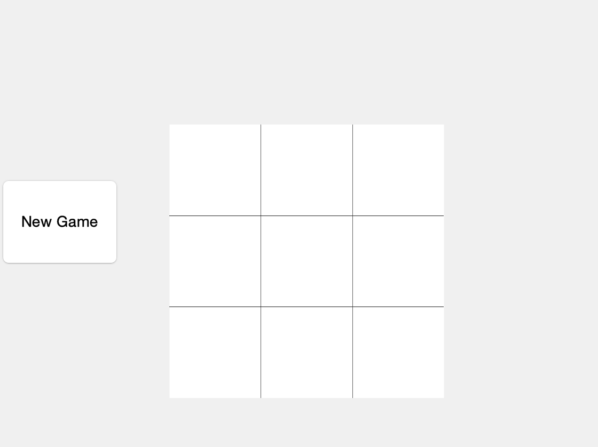

# TOPIC 22: Calculus in MATLAB

ENGR105, 11/12/20

### Practice problem: diagnosing sickle cell disease

Sickle cell disease is an inherited red blood cell disorder that affects millions of people worldwide and approximately 1 in 3,000 Americans. Normally, red bloods cells are round and flexible: these can easily move through one’s blood vessels. In sickle cell disease, however, red bloods are shaped like “sickles” and are rigid: these diseased cells can slow or block blood flow and oxygen to parts of the body, leading to pain, anemia, a compromised immune system, and other complications.

Sickle cell disease is caused by a *point mutation* in the gene for hemoglobin, the iron-rich compound that gives blood its red color and enables *red blood cells* to carry oxygen from your lungs to the rest of your body. A point mutation is when *one letter* of a nucleotide sequence ***differs from what is found in a “normal” or healthy sequence***. In this problem, we will consider the *mRNA sequence* of the hemoglobin gene. Recall from lecture that an **mRNA sequence is *just* a sequence of letters (text)**, where each position could be one of four potential letters: **A, U, C, or G**. Each letter corresponds to a different nucleotide, which in turn corresponds to a chemical structure in the mRNA molecule. This sequence of letters represents information about *how* the corresponding protein will be constructed.

Consider the **first 24 nucleotides of the mRNA sequence for the hemoglobin gene**, shown below. *Normally*, the 20th nucleotide is an “**A**,” corresponding to the adenine nucleotide:

AUGGUGCACCUGACUCCUG**A**GGAG

*In a person carrying the sickle cell trait* (and therefore at risk for either having the disease or passing it on to their children), the 20th nucleotide is often instead a “**U**,”, corresponding to the uracil nucleotide:

AUGGUGCACCUGACUCCUG**U**GGAG

**Question**. Produce a script that loads the data and evaluates how well the test works.

% Step 1: Read data from text file. We will use readcell

patientData = readcell('patientData.txt');

% Step 2: Prepare and preallocate necessary vectors

trueResult = zeros(size(patientData,1),1); % Blood test result

diagResult = zeros(size(patientData,1),1); % Diagnostic

% Step 3: Loop through each row (data point / patient) of the collected data

for k = 1:size(patientData,1)

% Evaluate if patient has sickle cell disease based on sequence. Will

% return 1 if they have sickle cell, 0 if they do not

trueResult(k) = patientData{k,1}(20) == 'U';

% Evaluate what the diagnostic predicts. Will return 1 if diagnostic

% indicates sickle cell disease, 0 if it does not.

diagResult(k) = strcmp(patientData{k,2},'sicklecell');

end

% Determine "accuracy" of diagnostic result

% accuracy1: simply finds proportion of predicted true relative to absolute

% true

accuracy1 = sum(diagResult(trueResult == 1))/length(trueResult(trueResult == 1))

accuracy1 = 0.7302

% accuracy2 (better): determines the proportion of test results that the

% diagnostic accurately classified as having sickle cell or not

accuracy2 = sum(trueResult == diagResult) / length(trueResult)

accuracy2 = 0.8759

**A simpler solution**. A 3 line solution can be created using cellfun, which applies any specified function to each entry in a specified cell.

* *First input*: function handle
* *Second input*: cell array

% Determine patients that have the disease

trueResult = cellfun(@(y) y(20) == 'U', patientData(:,1));

% Result of diagnostic

diagResult = cellfun(@(x) strcmp(x,'sicklecell'),patientData(:,2));

% Determine accuracy, as above

accuracy1 = sum(diagResult(trueResult == 1))/length(trueResult(trueResult == 1))

accuracy1 = 0.7302

accuracy2 = sum(trueResult == diagResult) / length(trueResult)

accuracy2 = 0.8759

**Takeaway**: always remember to consider vectorization. We've shown that this typically produces more efficient solutions.

## Calculus in MATLAB

MATLAB can be used to tackle calculus problems (integration, differentiation, numerical evaluation of ordinary differential equations)

### 

### 1-D Differentation

Many problems in engineering revolve around answering questions related to changes:

* What is the tendency of a function at some point?
* What is the slope of a surface or the normal to a surface?
* What is the incremental value of a cost function?

These inquiries may be answered using differentiation – numeric/discrete differentiation may be achieved using diff()

% Vector

v = [1,5,15,50,100,200]

v = 1×6

1 5 15 50 100 200

% Numeric derivative

dv = diff(v)

dv = 1×5

4 10 35 50 100

**Note**: dv contains 1 fewer element than v because it calculates the *difference* between entries.

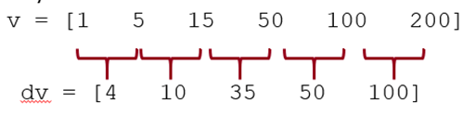

### Example: Usain Bolt and the 100 m

In the 2009 World Championships in Athletics, Usain Bolt ran a record 9.58s 100 meter sprint. The positional information for this run is contained in the file L23_UB_data.xlsx. Compute Usain Bolt's **velocity** and **acceleration** during this sprint.

**Side note**: note the file format. Microsoft Excel files can be loaded using importdata(). However, a simpler function for this specific file type is xlsread.

% Load the data from the excel file

[data,headers] = xlsread('L23_UB_data.xlsx');

The time and position data for this event can be read into MATLAB from a excel file and differentiated to obtain velocity and acceleration. Specifically we need to calculate:

* velocity

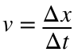

* acceleration

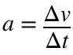

% 1) Place the data in time and position vectors

t = data(:,1);

pos = data(:,2);

% 2) Calculate the velocity and acceleration as a

% function of time

v = diff(pos)./diff(t);

a = diff(v)./diff(t(2:end));

Having calculated each parameter, we can plot. Note the following shows how you can create multiple axes in a single figure **without** using subplot.

close all

% Produce a plot depicting all results

fs = 12; % Font size

ms = 16; % Marker size

% First plot: position vs. time

g1 = axes;

g1.Position = [0.15,0.15,0.7,0.22];

plot(t,pos,'k.-','MarkerSize',ms);

xLim = xlim;

xlabel('Time (s)')

ylabel('Pos. (m)')

g1.FontSize = fs;

% Second plot: velocity vs. time

g2 = axes;

g2.Position = [0.15,0.44,0.7,0.22];

plot(t(2:end),v,'k.-','MarkerSize',ms);

ylabel('Vel. (m/s)')

axis tight

xlim(xLim)

g2.XTick = [];

g2.FontSize = fs;

% Third plot: acceleration vs. time

g3 = axes;

g3.Position = [0.15,0.73,0.7,0.22];

plot(t(3:end),a,'k.-','MarkerSize',ms);

hold on

plot(xLim,[0 0],'k-')

hold off

set(gca,'FontSize',fs)

ylabel('Acc. (m/s^2)')

axis tight

xlim(xLim)

g3.XTick = [];

g3.FontSize = fs;

title('Usain Bolt''s world record 100m sprint')

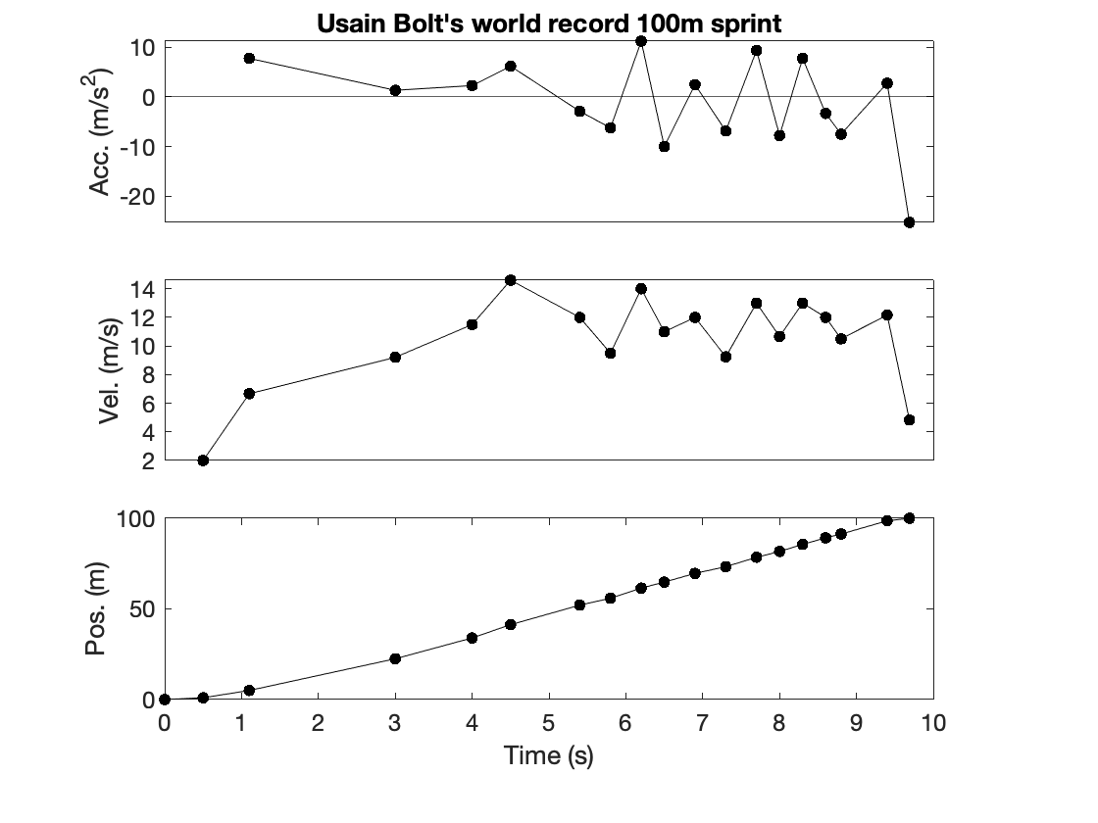

**Note**: if you use diff on a matrix, be sure to specify a dimension. You can also specify an "order" of the difference.

% Declare 2-D array

A = [4,5,6;3,2,1]

A = 2×3

4 5 6

3 2 1

% Difference over rows

diff(A,1,1)

ans = 1×3

-1 -3 -5

% Difference over columns

diff(A,1,2)

ans = 2×2

1 1

-1 -1

### Visualizing and creating multi-dimensional derivatives

"Vector fields" (and 3D data) may be represented using meshgrid. meshgrid creates matrices of numbers that have as many columns as length(x) and as many rows as length(y) with x repeated along rows and y repeated along columns X and Y represent the x and y values at each index.

% X values

x = -3:0.5:3;

% Y values

y = -2:0.5:2;

% Create meshgrid

[X,Y] = meshgrid(x,y)

X = 9×13

-3.0000 -2.5000 -2.0000 -1.5000 -1.0000 -0.5000 0 0.5000 1.0000 1.5000 2.0000 2.5000 3.0000

-3.0000 -2.5000 -2.0000 -1.5000 -1.0000 -0.5000 0 0.5000 1.0000 1.5000 2.0000 2.5000 3.0000

-3.0000 -2.5000 -2.0000 -1.5000 -1.0000 -0.5000 0 0.5000 1.0000 1.5000 2.0000 2.5000 3.0000

-3.0000 -2.5000 -2.0000 -1.5000 -1.0000 -0.5000 0 0.5000 1.0000 1.5000 2.0000 2.5000 3.0000

-3.0000 -2.5000 -2.0000 -1.5000 -1.0000 -0.5000 0 0.5000 1.0000 1.5000 2.0000 2.5000 3.0000

-3.0000 -2.5000 -2.0000 -1.5000 -1.0000 -0.5000 0 0.5000 1.0000 1.5000 2.0000 2.5000 3.0000

-3.0000 -2.5000 -2.0000 -1.5000 -1.0000 -0.5000 0 0.5000 1.0000 1.5000 2.0000 2.5000 3.0000

-3.0000 -2.5000 -2.0000 -1.5000 -1.0000 -0.5000 0 0.5000 1.0000 1.5000 2.0000 2.5000 3.0000

-3.0000 -2.5000 -2.0000 -1.5000 -1.0000 -0.5000 0 0.5000 1.0000 1.5000 2.0000 2.5000 3.0000

Y = 9×13

-2.0000 -2.0000 -2.0000 -2.0000 -2.0000 -2.0000 -2.0000 -2.0000 -2.0000 -2.0000 -2.0000 -2.0000 -2.0000

-1.5000 -1.5000 -1.5000 -1.5000 -1.5000 -1.5000 -1.5000 -1.5000 -1.5000 -1.5000 -1.5000 -1.5000 -1.5000

-1.0000 -1.0000 -1.0000 -1.0000 -1.0000 -1.0000 -1.0000 -1.0000 -1.0000 -1.0000 -1.0000 -1.0000 -1.0000

-0.5000 -0.5000 -0.5000 -0.5000 -0.5000 -0.5000 -0.5000 -0.5000 -0.5000 -0.5000 -0.5000 -0.5000 -0.5000

0 0 0 0 0 0 0 0 0 0 0 0 0

0.5000 0.5000 0.5000 0.5000 0.5000 0.5000 0.5000 0.5000 0.5000 0.5000 0.5000 0.5000 0.5000

1.0000 1.0000 1.0000 1.0000 1.0000 1.0000 1.0000 1.0000 1.0000 1.0000 1.0000 1.0000 1.0000

1.5000 1.5000 1.5000 1.5000 1.5000 1.5000 1.5000 1.5000 1.5000 1.5000 1.5000 1.5000 1.5000

2.0000 2.0000 2.0000 2.0000 2.0000 2.0000 2.0000 2.0000 2.0000 2.0000 2.0000 2.0000 2.0000

**Note** the definitions of X and Y, above. X corresponds to rows, Y corresponds to columns.

### Visualizing velocity fields: quiver plots

Using data in the above format, you can assign **x and y components of velocity**. Note that the velocity component in a given index location corresponds to the X and Y positional entries in the corresponding indices of X and Y.

% Specify X component of velocity

VX = Y/max(Y,[],'all');

% Specify Y component of velocity

VY = -X/max(X,[],'all');

close all

% Visualize the velocity profile

q = quiver(X,Y,VX,VY);

q.Color = 'k';

set(gca,'YAxisLocation','Origin')

set(gca,'XAxisLocation','Origin')

set(gca,'Box','off')

axis square

title('Velocity Field')

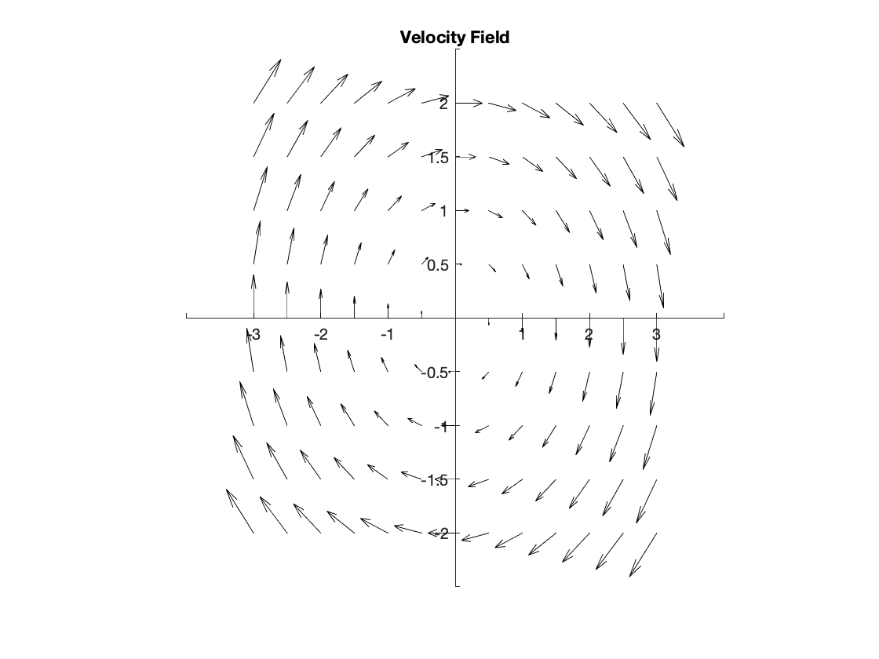

### Visualizing velocity fields: surface plots

An alternative, surface produces a 3D shaded surface of a matrix or surface with a top down view.

close all

% Plot the X component of the velocity

figure

surface(X,Y,VX)

axis square

title('VX')

xlabel('X')

ylabel('Y')

colorbar

colormap('jet')

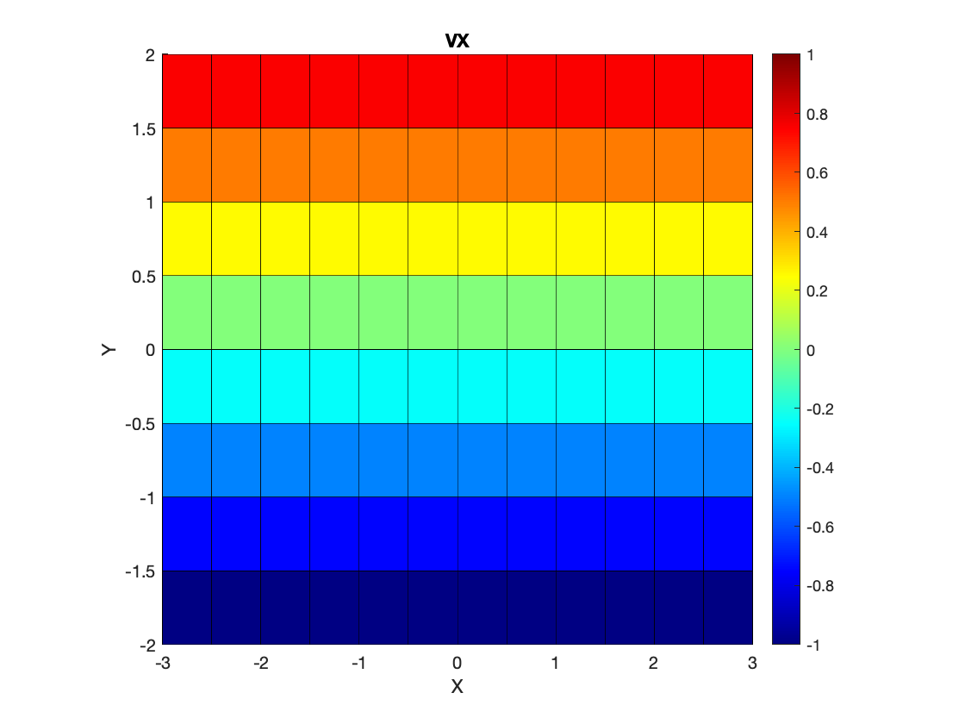

% Plot the Y component of the velocity

figure

surface(X,Y,VY)

axis square

title('VY')

xlabel('X')

ylabel('Y')

colorbar

colormap('jet')

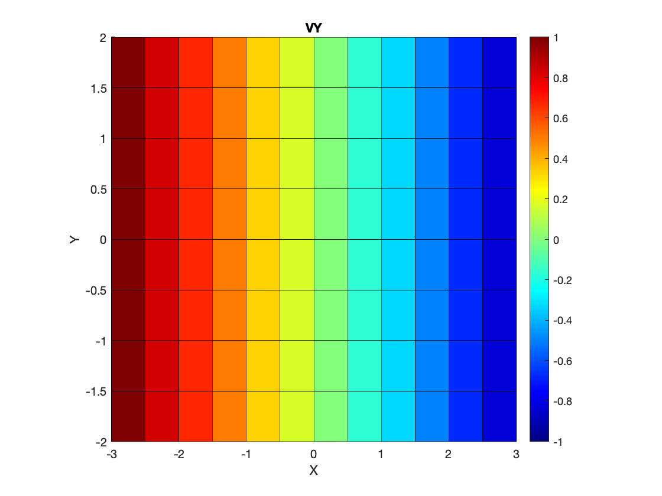

% Plot the magnitude of the velocity

figure

surface(X,Y,sqrt(VY.^2+VX.^2))

axis square

title('|V|')

xlabel('X')

ylabel('Y')

colorbar;

colormap('jet')

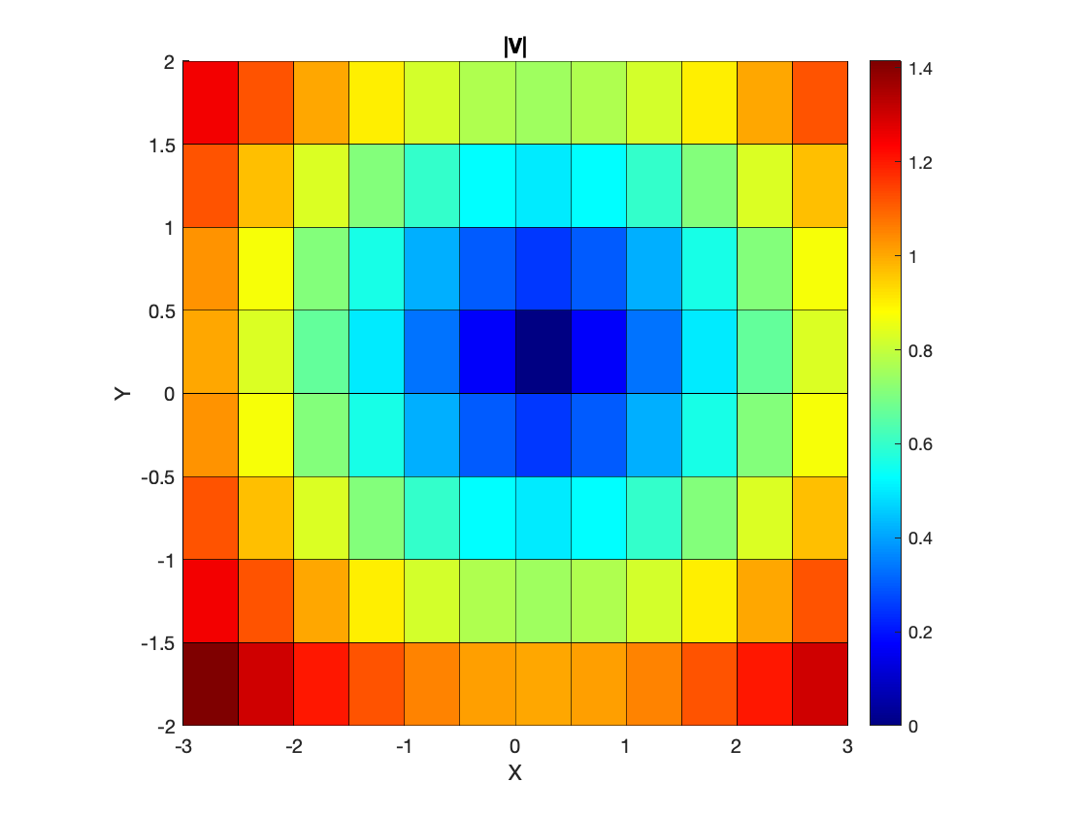

**Note**: The above code adds colorbars using the colorbar function. The purpose of this is serve as a "color scale."

### Multi-dimensional differentiatial calculus

In addition to 1-D differentiation, MATLAB can handle multivariable and vector calculus derivatives.

* curl, ∇⨯*F*
* gradient, ∇*F*
* divergence, ∇⋅*F*

Where ∇ = nabla = del operator = 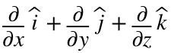

**Curl.** The curl of a vector is the cross product of the del operator and the vector and can be invoked using the curl function in MATLAB. **Note that the curl of a vector returns a vector.**

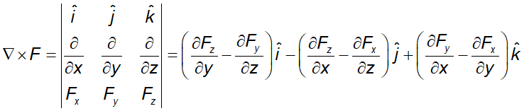

close all

% Compute the curl and angular velocity of the above vector field

[CURLZ, CAV]= curl(X,Y,VX,VY);

% Plot the X component of the velocity

surface(X,Y,CURLZ)

axis square

title('Curl (Z component)')

xlabel('X')

ylabel('Y')

colorbar

colormap('jet')

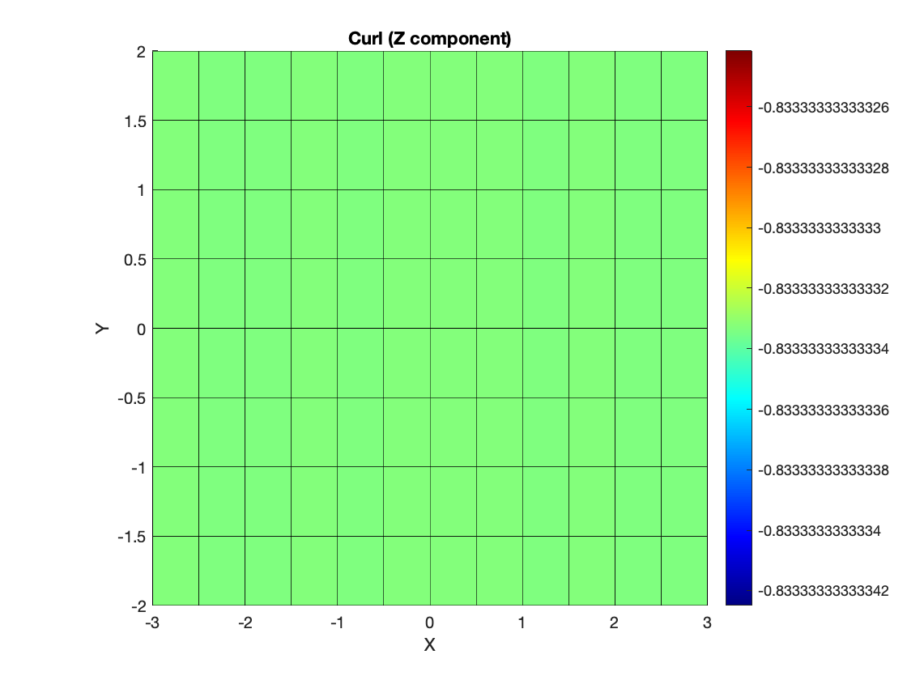

**In physical systems**, the curl can be thought of as the circulation around an infinitesimal point - the direction of the vector describes the direction of rotation via the right hand rule.

**In this example**: the entire field is rotating around one point. Thus the curl (and angular velocity) is the same everywhere.

**Gradient**. The gradient of a function is the result of passing a function through the del operator and may invoked using the gradient function in MATLAB. **Note that the gradient of a vector returns a vector.**

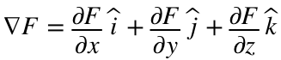

close all

% Compute the curl and angular velocity of the above vector field

[GX,GY] = gradient(sqrt(VX.^2+VY.^2),0.5,0.5);

% Plot the X component of the velocity

q = quiver(X,Y,GX,GY);

axis square

xlim([-3,3])

ylim([-3,3])

q.Color = 'k';

set(gca,'YAxisLocation','Origin')

set(gca,'XAxisLocation','Origin')

set(gca,'Box','off')

axis square

title('Gradient of Velocity field')

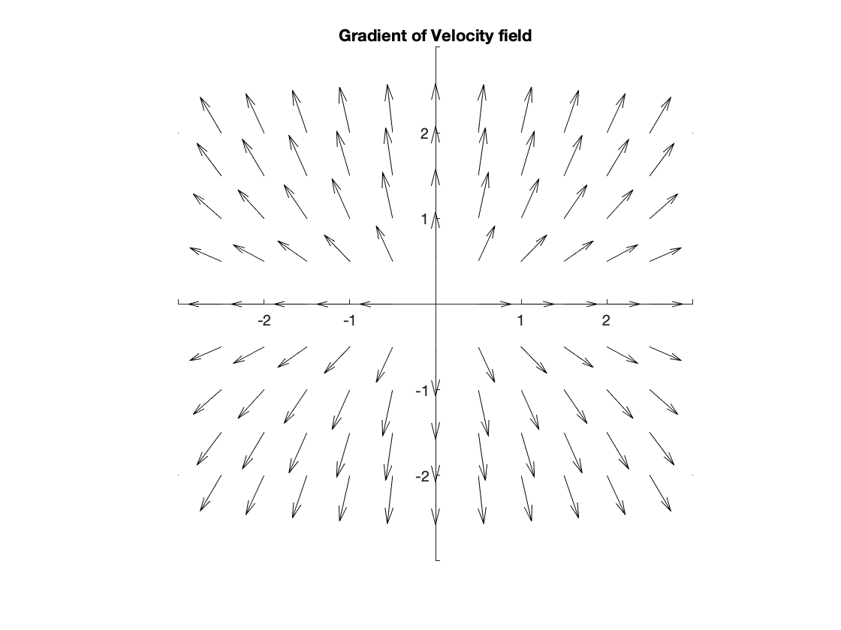

**In physical systems**, the gradient be thought of as a vector in the direction of the **steepest slope** of the function at the point of evaluation

**In this case**, the gradient of the velocity is a function of **position**.

**Divergence**. The divergence of a vector is the result of the dot product of the del operator and the vector and may invoked using the divergence function in MATLAB. **Note that the divergence of a vector returns a scalar**.

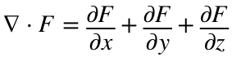

close all

% New variable C

CX = cos(X);

CY = sin(Y);

quiver(X,Y,CX,CY)

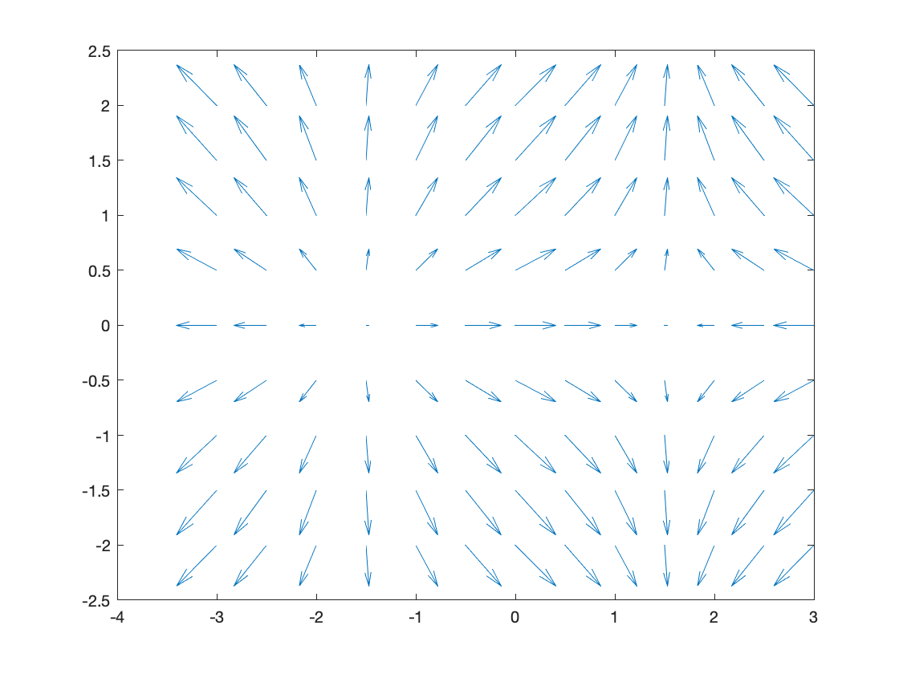

figure

% Calculate the divergence

DIV = divergence(X,Y,CX,CY);

% Plot the X component of the velocity

surface(X,Y,DIV)

axis square

title('Divergence')

xlabel('X')

ylabel('Y')

colorbar

colormap('jet')

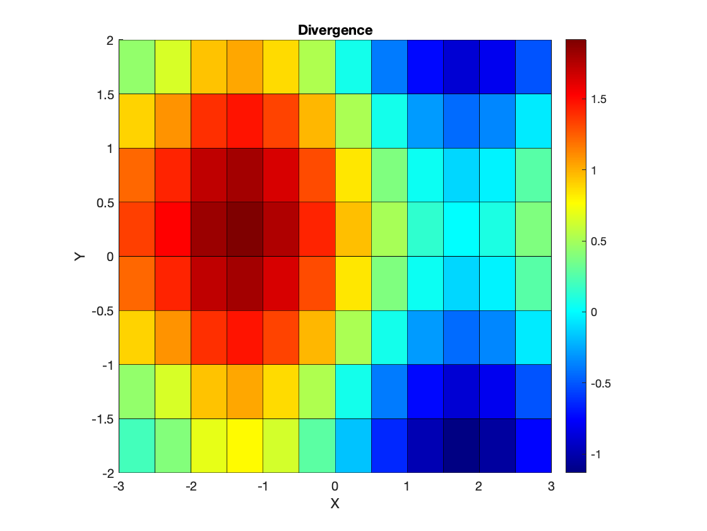

**In physical systems**, the divergence may be thought of as the flux rate out of an infinitesimal region (+ for flux outward)

### Integration

MATLAB offers the ability to perform **numerical integration** using the following functions (in order of increasing accuracy).

**Note**: these are **numerical** methods -- the integral can approximated from **evaluations of the original function**.

* Rectangle method:no built-in implementation in MATLAB

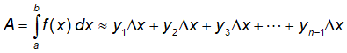

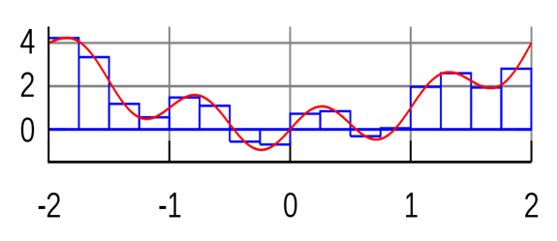

* Trapezoidal integration: accessed using the trapz function

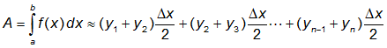

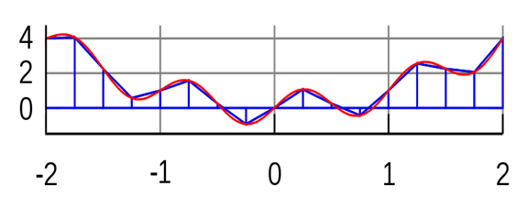

close all

% Define X and Y variables

x = 0:0.1:10;

y = -sin(x);

% Calculate definite integral over time

Y = zeros(size(y));

for k = 2:length(y)

Y(k) = trapz(x(1:k),y(1:k));

end

% Plot the function and its *definite* integral

plot(x,y,'k-')

hold on

plot(x,Y,'r-','LineWidth',2)

hold off

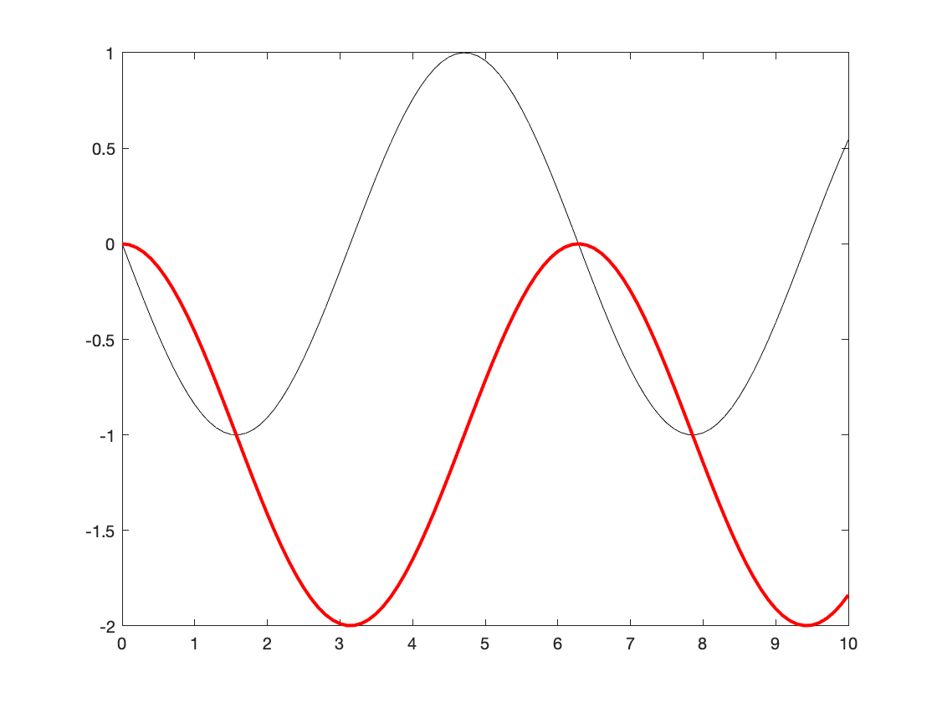

* Quadrature integration: accessed using the integral function

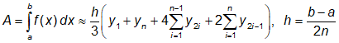

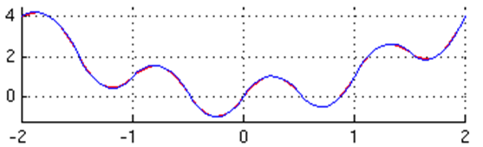

Numerical integration is most often approached in MATLAB using the integral function, which requires input as an anonymous function.

% Create function handle for function of interest

F = @(x) -sin(x)

F = *function_handle with value:*

@(x)-sin(x)

% Calculate integral

q = integral(F,0,pi)

q = -2.0000

### Engineering example: controllers

When describing (biological, chemical, mechanical, electrical) engineering systems, the engineer is often interested in how a given **output** results from a given **input**.

*Examples of systems:*

* A medical device for regulating blood sugar levels
* A chemical reactor for producing acetylene
* A prosthetic hand

*Examples of inputs:*

* A voltage (related to amount of insulin to be injected into the patient).
* Calcium carbide reagent entry into a reactor
* An electrical signal applied to a mechanical actuator

*Examples of outputs:*

* A voltage from a sensor that is proportional to blood glucose levels
* Material and energy produced from chemical reaction.
* Change in position of prosthetic fingers

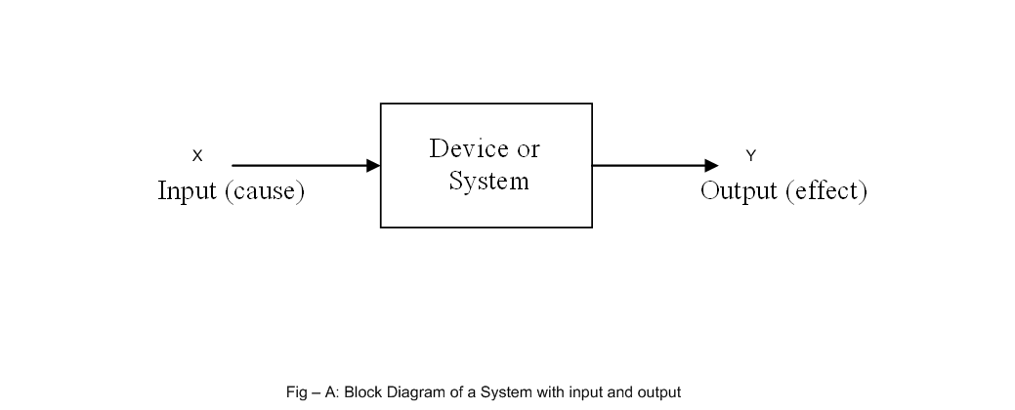

For example, consider the following code that represents some system. You can assume the following represents a device, in which it can be read (in real time) how an **output voltage** changes in response to the **input voltage.**

close all

% Create figure

h1 = figure;

plot([0,20],3.5*[1,1])

hold on

% Output "sensor" data

g_out = plot(0,0,'ko');

hold on

% Input "sensor" data

g_in = plot(0,0,'ro');

hold off

% Graphical parameters

xlim([0,20]);

ylim([0,5]);

axis square

ylabel('Sensor signals')

xlabel('Time (s)')

legend('System output','System Input','Location','NorthEast')

% Counter to store time

time = 0;

outError = 0;

% Plot in real time for 20 seconds

while time < 20

% Pause for 100 ms

pause(0.1);

% Update time

time = time + 0.1;

% The following describes how the system responds to a given input

% Assume the system drifts in some time dependent fashion

outError = outError + (abs(mod(time,1)) < 0.1)*(rand - 0.5);

% Function describing how output responds to input

y = @(x) sqrt(x) + 2 + 0.5*outError;

% Update vector to contain input information

g_in.XData = [g_in.XData,time];

g_in.YData = [g_in.YData,2];

% Update vector to contain input information

g_out.XData = [g_out.XData,time];

g_out.YData = [g_out.YData,y(g_in.YData(end))];

end

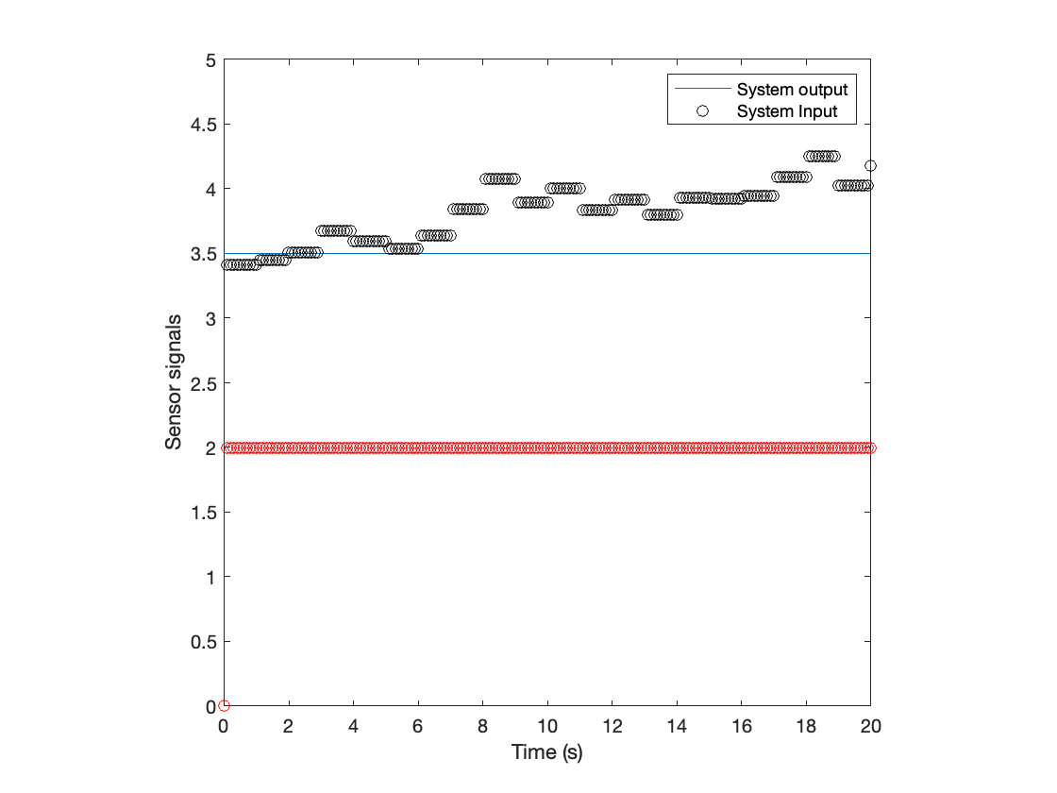

Instead of simply observing how an output changes in reponse to a given input, engineers seek to **control** how the output varies in time. For example, a chemical process engineer wants to ensure that a chemical system is safely operating within the constraints providing by the equipment, process of interest, etc.

One way to implement this process control is to integrate a **feedback controller**. As shown in the following diagram, feedback control enables one to **adjust an input depending on how the output is changing** over time.

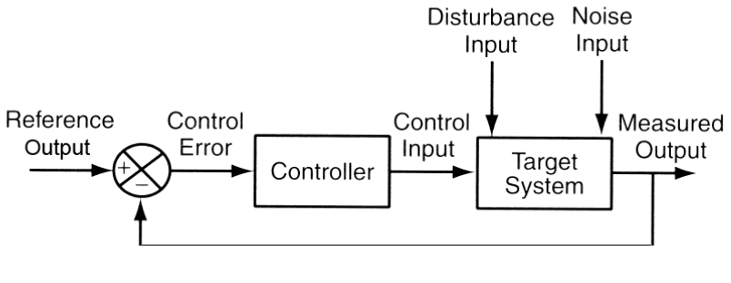

*Common types of controllers:*

* **Proportional**: the control input is proportional to the difference between the actual ouput and the set point.
* **Integral**: the conrol input is proporitional to the integrated difference between the actual output and the set point
* **Differential**: the control input is proportional to the differentiated difference between the actual output and the set point

Controllers can integrate multiple control strategies: **PI** controllers, **PID** controllers, etc.

**Goal**. Create a **Proportional** and **PI** controller and observe the signal in real time.

close all

% Create figure

h1 = figure;

% Determine our goal set point

ysp = 3.5;

plot([0,20],ysp*[1,1],'k--')

hold on

% Output "sensor" data

g_out = plot(0,0,'ko');

% Input "sensor" data

g_in = plot(0,0,'ro');

plot(xlim,ysp,'k-')

hold off

% Graphical parameters

xlim([0,20]);

ylim([0,5]);

axis square

ylabel('Sensor signals')

xlabel('Time (s)')

legend('Set point','System output','System Input','Location','NorthEast')

% Counter to store time

time = 0;

outError = 0;

% Declare a variable to represent the error from the set point

x_err = 0;

% Plot in real time for 20 seconds

while time < 20

% Pause for 100 ms

pause(0.1);

% Update time

time = time + 0.1;

% The following describes how the system responds to a given input

% Assume the system drifts in some time dependent fashion

outError = outError + (abs(mod(time,1)) < 0.1)*(rand - 0.5);

% Function describing how output responds to input

y = @(x) sqrt(x) + 2 + 0.5*outError;

% DEFINE CONTROLLER HERE

if time > 0.1

end

% Update vector to contain input information

g_in.XData = [g_in.XData,time];

g_in.YData = [g_in.YData,max(0,x_err)];

% Update vector to contain input information

g_out.XData = [g_out.XData,time];

g_out.YData = [g_out.YData,y(g_in.YData(end))];

end

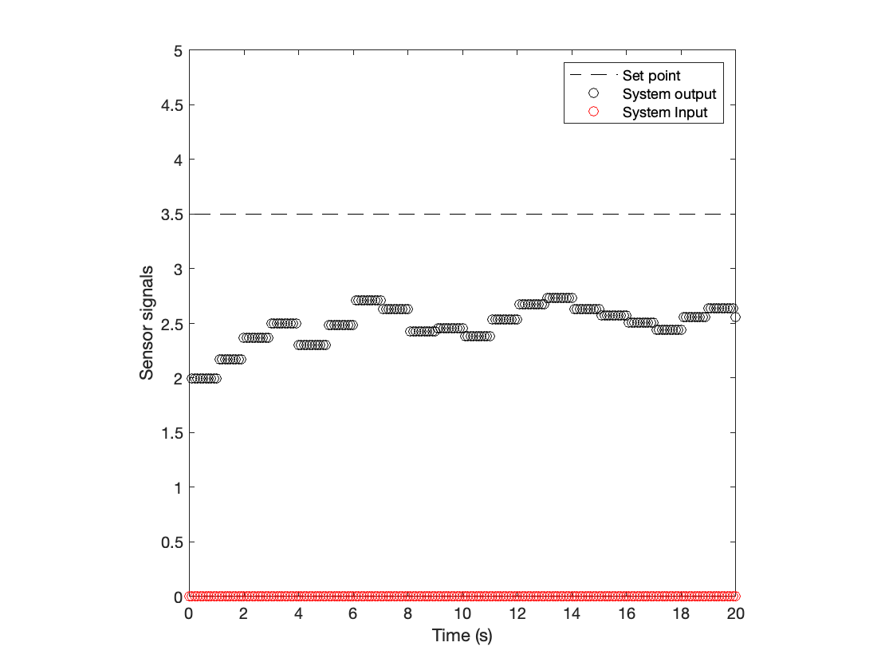

# TOPIC 23: Differential equation solvers and other numerical methods

ENGR105, 11/19/20

## Solving ordinary differential equations (ODEs)

ODEs desribe a relationship between derivatives with respect to a single variable. For example, a common **first order ODE** relates the time derivative of a function, 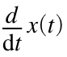, to the function itself, 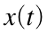, and the independent variable:

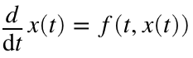

The **order** of an ODE is the highest order derivative. **Higher-order ODEs** relate higher-order derivatives to lower order derivatives, the dependent variable / function, and the independent variable.

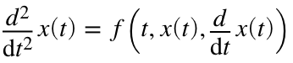

**Remember**: to solve an ODE, the number of initial conditions must be same as the order.

Systems of ordinary differential equations appear in many engineering and science disciplines:

* Robotics and systems control
* Weather systems
* Population growth, logistics, and radioactive decay
* Dynamics of physical and electronic systems
* Many more ...

For **simple cases**, ODEs can be solved analytically by direct integration.

* Example 1

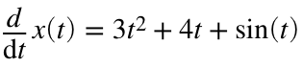

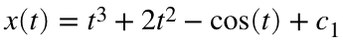

* Example 2

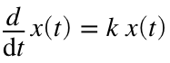

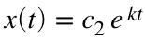

However, many (if not most) ODEs can be solved more easily using a **numerical algorithm**.

### Taylor series approximations

An underrated and extremely useful approximation for engineers involves the Taylor series representation of a function. A **one-dimensional** Taylor series is an expansion of a real function about a point **a** given by:



This is **extremely useful** because it allows us to represent an arbitrary function in terms of an infinite polynomial. In many cases (especially in engineering), we **approximate** a function by only considering the **first order term** in the Taylor series expansion:

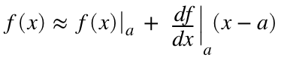

**Example**. Compare the first, second, and third order approximations of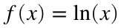 at x = 1

% x range of interest

x = 0.5:0.1:2.5;

% Actual function

f = log(x);

% Taylor series approximations

f_ts1 = x-1;

f_ts2 = x-1 - 1/2*(x-1).^2;

f_ts3 = x-1 - 1/2*(x-1).^2 + 1/3*(x-1).^3;

subplot(1,3,1)

plot(x,f,'k-',x,f_ts1,'r-')

axis square

ylim([-1,2])

title('First order')

subplot(1,3,2)

plot(x,log(x),'k-',x,f_ts2,'r-')

axis square

ylim([-1,2])

title('Second order')

subplot(1,3,3)

plot(x,log(x),'k-',x,f_ts3,'r-')

axis square

ylim([-1,2])

title('Third order')

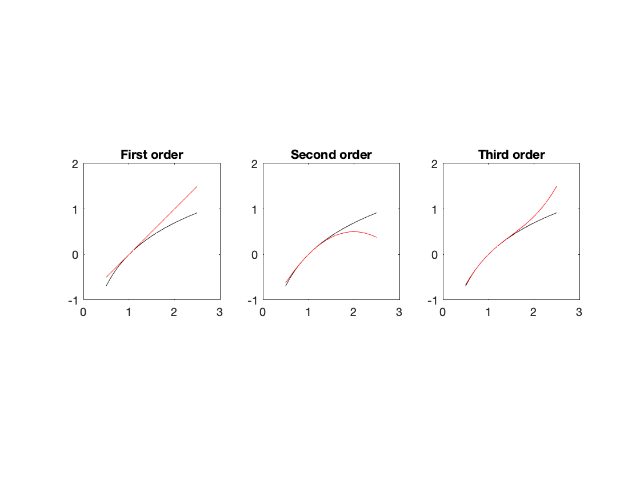

**Takeaway:** the **more terms** that are included, the *better* the approximation will be.

### 

### Euler method: simple approximation of an ODE solution

Consider first order differential equation:



The solution to this ODE is 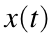. By performing a Taylor series expansion about , we can approximate the value of the solution after some time interval:

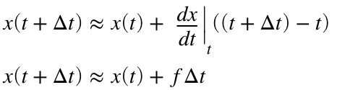

This representation is known as **Euler's method**. It provides a first-order approximation for the next state of the system and **an approximate solution** can be created by **numerically** calculating the "next" point. As can be seen above, the **accuracy** of this approach is strongly determined by the **size of the time step**, 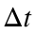.

**Example**. Consider the following differential equation. Use the **Euler method** to find a numerical solution.

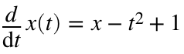, where 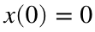

This can be solved using an *analytical technique* (*e.g.* with a Laplace Transform) to produce the solution:

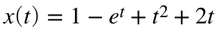

*Applying the Euler method:*

close all

% Time vector

t = 0:0.1:3;

% The function representing the RHS of the differential equation. This is

% defined by the problem

f = @(T,X) X-T^2+1;

% Analytical solution

x_an = (1-exp(t))+t.^2+2*t;

% Use Euler method

% Define the time step

dt = 1;

% Preallocate vector to store

t_approx = 0:dt:3;

x_euler = zeros(size(t_approx));

% Calculate each entry in the Euler approximation

for k = 1:length(x_euler)-1

% Apply the Euler method

% Calculate the next value of the solution

x_euler(k+1) = x_euler(k) + f(t_approx(k),x_euler(k))*dt;

end

% Plot the solution

plot(t,x_an,'k-',t_approx,x_euler,'ro-')

axis square

legend('Analytical solution','Euler approximation','location','southwest')

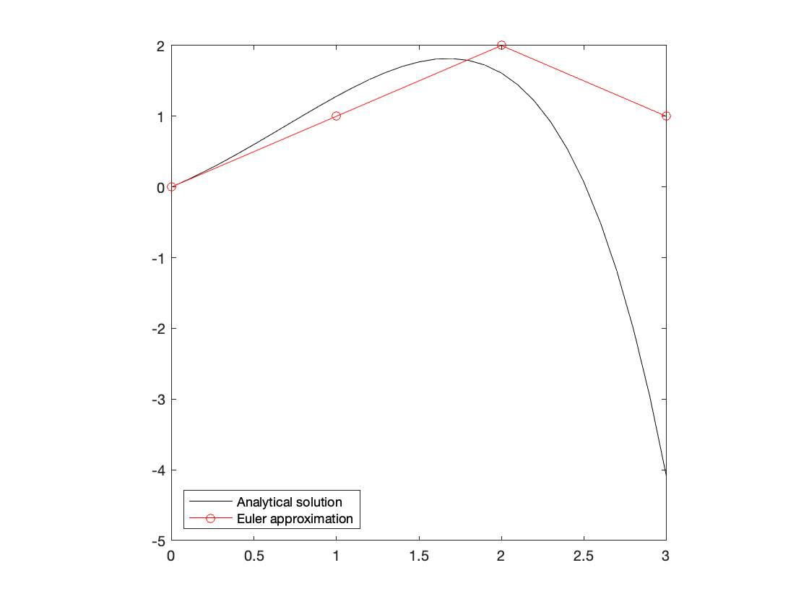

**Note**: there is a tradeoff between accuracy and computational cost.

### Predictor-corrector method: better approximation of a solution

A better approximation than Euler can be achieved using the predictor-corrector method. Here, consider again:



If we include some more *higher order terms in the Taylor Series approximation*, we would expect to achieve a better approximation. The predictor-corrector method does that, effectively estimating the derivative at the beginning () and end () of an interval

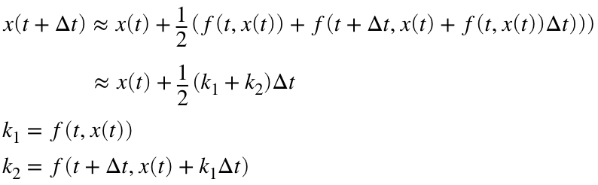

*Applying predictor-corrector and comparing to the above:*

close all

% Define the time step

dt = 0.1;

% Preallocate vectors to store

t_approx = 0:dt:3; % Time vector for all

x_euler = zeros(size(t_approx)); % Euler

x_pc = zeros(size(t_approx)); % Predictor corrector

% Calculate each entry in the Euler approximation

for m = 1:length(x_euler)-1

% Use Euler method

% Calculate the next value of the solution

x_euler(m+1) = x_euler(m) + f(t_approx(m),x_euler(m))*dt;

% Use predictor-corrector method

k1 = f(t_approx(m),x_pc(m));

k2 = f(t_approx(m)+dt,x_pc(m)+k1*dt);

end

% Plot the solutions

plot(t,x_an,'k-', ...

t_approx,x_euler,'ro-',...

t_approx,x_pc,'mo-.')

axis square

legend('Analytical solution','Euler approximation','Predictor-corrector',...

'location','southwest')

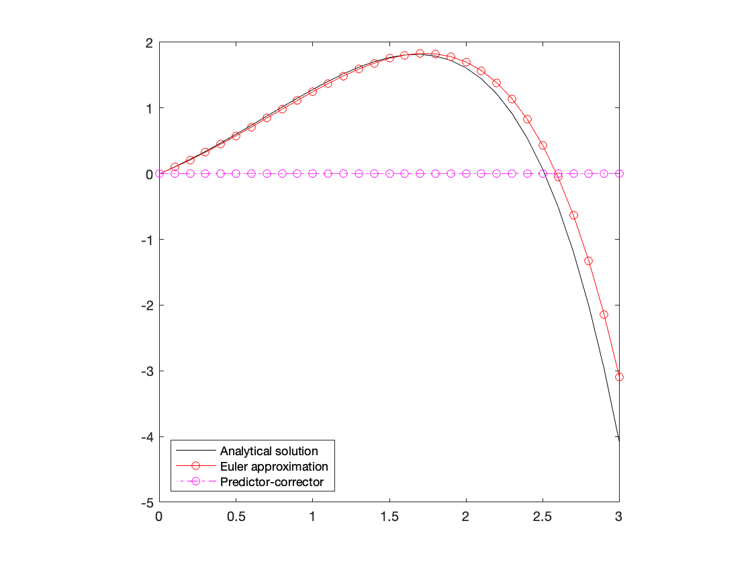

### Runge-Kutta solutions to differential equations

Including even more terms, the **Runge-Kutta** method provides a better approximation than predictor-corrector. Runge-Kutta can also be thought of as "following the *logic of the predictor-corrector method,*" where the accuracy of the estimate can be improved by evaluating the derivative at *multiple points* along an interval.

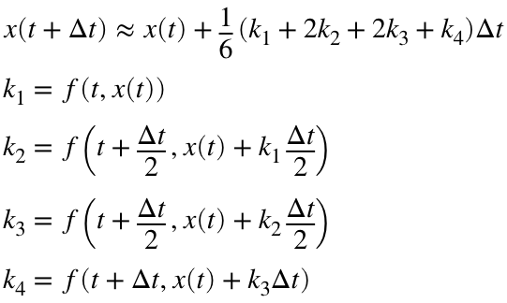

Here,  corresponds to the derivative at the beginning of the interval,  and  are two estimates for the derivative at the midpoint of the interval, and  is an estimate of the derivative at the end of the interval.

The above is a **Runge-Kutta approximation of rank 4** (RK4).

*Applying Runge-Kutta and comparing to the above:*

close all

% Time vector

t = 0:0.1:7;

% Analytical solution

x_an = (1-exp(t))+t.^2+2*t;

% Define the time step

dt = 1;

% Preallocate vectors to store

t_approx = 0:dt:7; % Time vector for all

x_euler = zeros(size(t_approx)); % Euler

x_pc = zeros(size(t_approx)); % Predictor corrector

x_rk = zeros(size(t_approx)); % Runge-Kutta

% Calculate each entry in the Euler approximation

for m = 1:length(x_euler)-1

% Use Euler method

% Calculate the next value of the solution

x_euler(m+1) = x_euler(m) + f(t_approx(m),x_euler(m))*dt;

% Use predictor-corrector method

k1 = f(t_approx(m),x_pc(m));

k2 = f(t_approx(m)+dt,x_pc(m)+k1*dt);

x_pc(m+1) = x_pc(m) + 1/2*(k1+k2)*dt;

% Use Runge-Kutta method

K1 = f(t_approx(m),x_pc(m));

K2 = f(t_approx(m)+dt/2,x_pc(m)+K1*dt/2);

K3 = f(t_approx(m)+dt/2,x_pc(m)+K2*dt/2);

K4 = f(t_approx(m)+dt,x_pc(m)+K3*dt);

x_rk(m+1) = x_rk(m) + 1/6*(K1 + 2*K2 + 2*K3 +K4)*dt;

end

% Plot the solutions

plot(t,x_an,'k-', ...

t_approx,x_euler,'ro-',...

t_approx,x_pc,'mo-.')

hold on

plot(t_approx,x_rk,'bo-','MarkerFaceColor','b')

hold off

axis square

legend('Analytical solution','Euler approximation','Predictor-corrector',...

'Runge-Kutta','location','southwest')

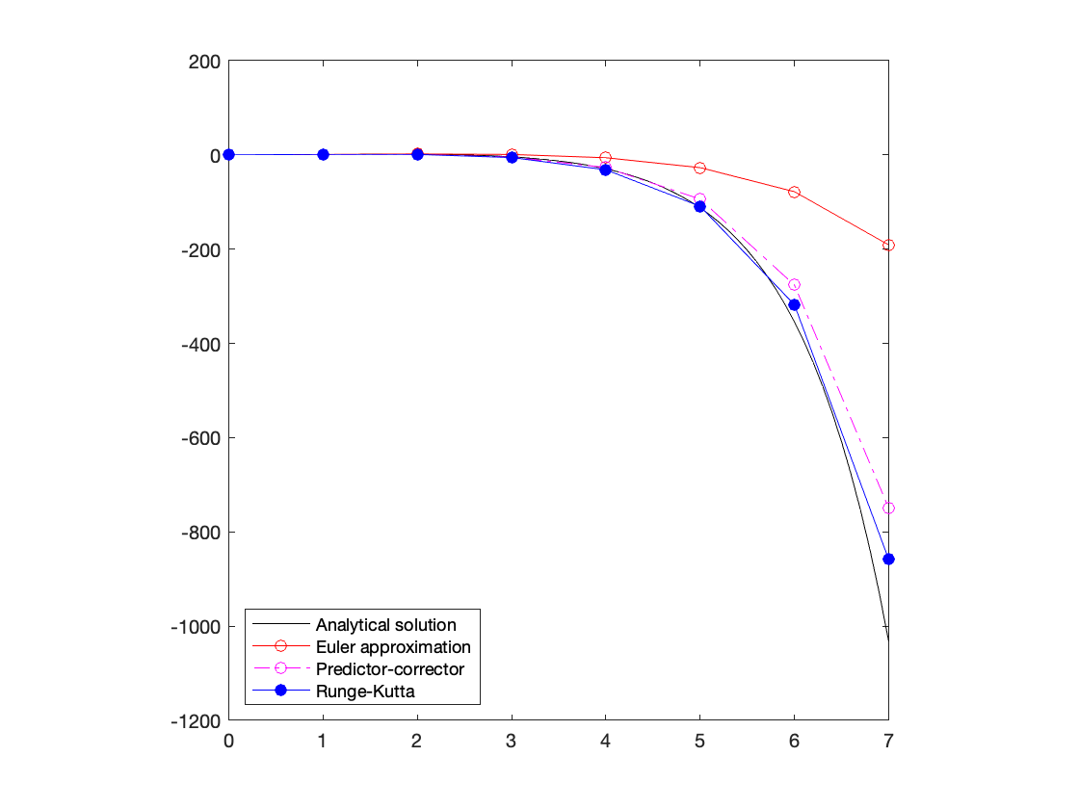

**Runge-Kutta ODE solvers of RK23 and RK45** are most often used in MATLAB and can be accessed with the commands ode23() and ode45()

**Note**: How do we ever know when we have the ‘right’ numerical solution? We don’t - the best we can do is increase the accuracy of the numerical method until no further wild changes occur over the interval of interest.

Like in the previous examples, we would decrease the time step and/or increase the solution accuracy ('AbsTol' and 'RelTol') to achieve to see when the solution settles

### Differential equation solvers in MATLAB

MATLAB offers a wide array of differential equation solvers - each has their own application set or unique “personality.” The two most popular, ode23() and ode45() are based on the **Runge-Kutta** algorithm (with *additional* numerical details as well).

**Note**: ode45() should be your default ODE solver for most applications.

Like our previous numerical methods, these built-in functions require an input function containing the differential equation to be solved for.

**Revisiting Newton-Raphson.** Consider our numerical root-finding algorithm that we created in Topic 12. This function takes an input function (F), an initial guess (xn), and a user defined tolerance (tol) that determines how long the iterative method should be repeated. *The input function is repeatedly evaluated during the iterative process.*

function xn = newtonSolve(F,xn,tol)

% Function for using the Newton-Raphson method to solve for f(x)

% Step 1: specify initial guess

xprev = inf; % Variable to store previous xn value -> ensure it is

% not xn to enter while loop

% Step 2: iterate until xn -> xn+1

while abs(xn - xprev) > tol

% Step 3: evaluate function and derivative at xn

f = F(xn);

% Instead of calculating the "next" x value, store the previous xn

% value

xprev = xn;

% Step 3b: update xn to next value for the iteration

xn = xn - f(1)/f(2);

end

end

An example input function:

function F = originalEqn(x)

% Function of interest

F(1) = x^4 + 2*(x-2)^2 - 20;

% Derivative of function of interest

F(2) = 4*x^3 + 4*(x-2);

end

Our function would be called as:

% Determine root of original f(x)

rootF = newtonSolve(@originalEqn,-5,10^-5)

In the above case, the solver function repeatedly interacts with the equation function during the "solving process." ode45 requires similar formatting - namely representation of the differential equations in state space and the use of function handles

[t,out] = ode45(function, domain, initial conditions, options, input parameters/constants...)

* outputs ([t, out]): time and corresponding position(s), velocity, etc.
* function: handle to function containing the description of the ODE
* domain: the analysis time, a 1x2 row vector [t_min,t_max]
* initial conditions: initial position(s), velocity, etc. - a 1 x n row vector depending on how many ODEs are being solved.
* options: user specified accuracy, resolution, etc.
* parameters/constraints: constants used during the evaluation of the ODE

**Example**. Consider the example above

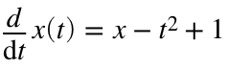, where 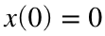

This ODE can be stored in the following function to be used with ode45

function dxdt = myODE(t,x)

dxdt = x(1) - t^2 + 1;

end

*Notes:*

* Analagously to Newton-Raphson, the numerically-solved differential function is stored as its **own MATLAB function**
* It is important that a variable representing **time** **appears as the first input** to the ODE function even if not *explicitly* referenced in the ODE function

*Solving the ODE:*

close all

% Solve ODE using ode45

[ts,xs] = ode45(@myODE,[0,7],[0]);

% Compare to analytical solution

plot(t,x_an,'k-',ts,xs,'ro')

axis square

legend('Analytical solution','ode45','location','southwest')

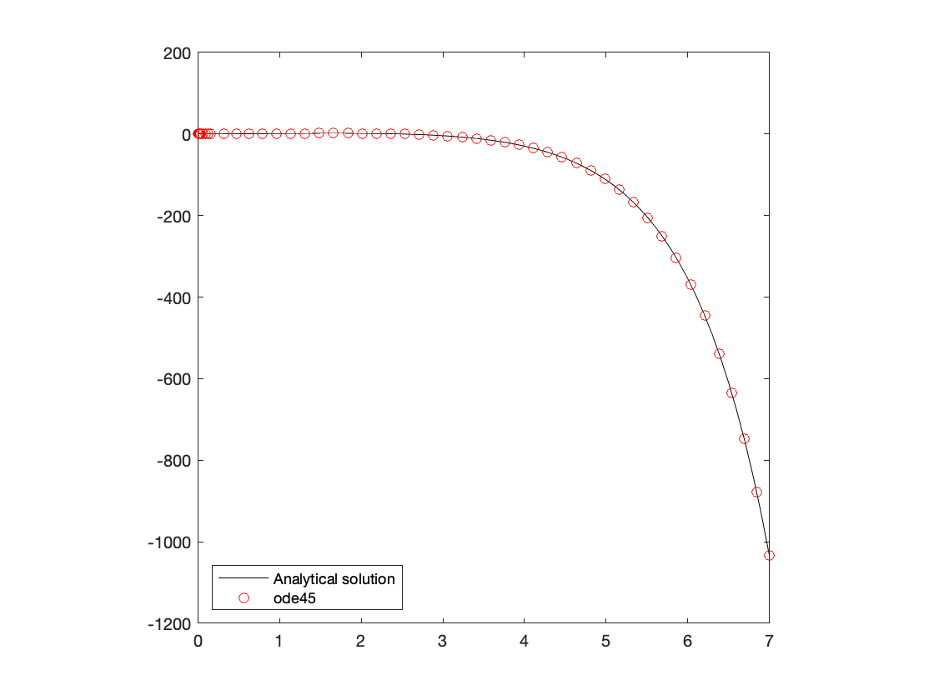

*Notes:*

* ode45 requires inputs of time and initial conditions, and returns a vector or matrix of solutions to the differential equation
* Instead of input start and end points of a time domain, you can also **enter a vector of time points to evaluate the function at**.

### Example: chemical reaction kinetics

Consider an arbitrary set of chemical reactions.

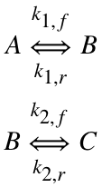

**Queston.** If 1 mol of A is initially present, how does the composition of the system evolve over time? In this case, assume the reaction has following rate constants: 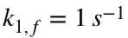, 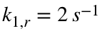,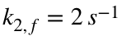,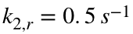

First observation: we are dealing with a **set of differential equations**. Applying our knowledge of chemistry and substituting in the rate constants produces the following system of differential equations:

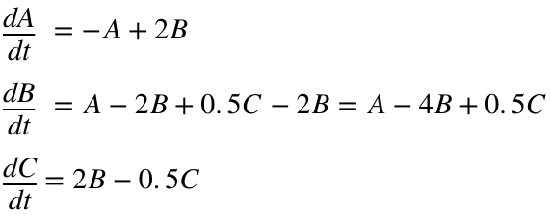

This set of differential equations can be encapsulated into a function. In this case, there a multiple inputs and multiple outputs. Each input corresponds to the amount of one chemical, and each output coresponds to the differential equation relating the change of that variable.

**Note**: the derivatives have to be returned as a **column vector**

function dxdt = rxnEqns(t,x)

% x(1) : A

% x(2): B

% x(3): C

% Preallocate output column vector

dxdt = zeros(3,1);

dxdt(1) = -x(1) + 2*x(2);

dxdt(2) = x(1) - 4*x(2) + 0.5*x(3);

dxdt(3) = 2*x(2) - 0.5*x(3);

end

close all

% Solve ODE using ode45

[t,moles] = ode45(@rxnEqns,[0,10],[1,0,0]);

% Plot time-dependent profiles

plot(t,moles(:,1),'k-')

hold on

plot(t,moles(:,2),'r-','LineWidth',2)

plot(t,moles(:,3),'b-')

hold off

% Graphical parameters

axis square

legend('Species A','Species B','Species C','location','northeast')

ylim([0,1])

ylabel('Amount of chemical (moles)')

xlabel('time (s)')

title('Temporal profile of chemical reaction')

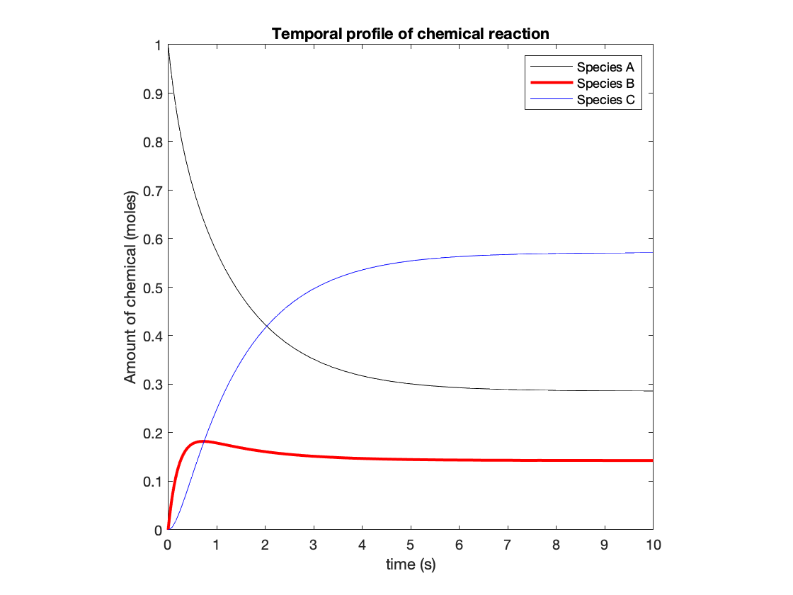

### ODEs of higher orders

The previous example was a system of **first order** ODEs. To solve a higher order ODE using ode45, we need to convert it to a **system of first order ODEs**.

**Example: formulating a system of first order ODEs from a third-order linear ODE.** Say we have an equation of the form:

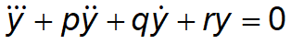

This would be input into MATLAB as a series of differential equations of first order using the following method.

1. Define a new variable
2. Rearrange the ODE so that the highest order derivative is on the left hand side of the equation and all other terms are on the right hand side of the equation
3. Rewrite the ODE from (2) substituting in the generalized variables
4. Relate the lower order derivatives to the higher order derivatives

1) We start by assigning generalized variables (say *x*) to derivatives of *y* of increasing order as such

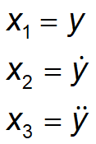

2) Next, we **rearrange the ODE** to get the derivative of highest order on the left side of the equation

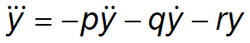

3) Now, we **substitute the new variables** into the ODE

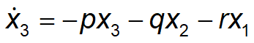

4) Finally, we establish relationships between lower order derivatives and non-differentiated terms

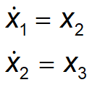

***Summary***. The original third-order ODE was:



And has been converted to the following set of linear first-order ODEs for input into a MATLAB ODE solver

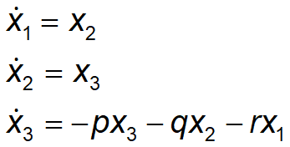

**MATLAB implementation**.

When it is in the correct format (system of differential equations), the set of equations can then be input into a function definition of the ODE for use in MATLAB.

function dxdt = thirdOrderODE(t,x)

% Parameters

p = 2;

q = 1.5;

r = 0.1;

% Note:

% x(1) corresponds to y

% x(2) corresponds to y'

% x(3) corresponds to y''

% Preallocating the output as a column vector

dxdt = zeros(3,1);

dxdt(1) = x(2);

dxdt(2) = x(3);

dxdt(3) = -p*x(3)-q*x(2)-r*x(1);

end

*Notes:*

* As before, time and x values serve as inputs
* As before, derivatives of the generalized variables have to be returned as a **column vector**

We can then solve the function by calling the ode45 solver and pointing to the function that contains the state space representations of the ODE.

* Here, specify the following initial conditions: x(1) = 10, x(2) = 1, x(3) = 2.
* The number of initial conditions should equal the order of the ODE

% Solve system of linear ODES

[t,x] = ode45(@thirdOrderODE,[0,10],[10,1,2]);

% Plotting system

p = plot(t,x(:,1),'k-',...

t,x(:,2),'b-',...

t,x(:,3),'r-');

set(p,'LineWidth',3)

set(gca,'FontSize',12)

axis square

xlabel('t (s)')

ylabel('pos. (m), vel. (m/s), acc. (m/s^2)')

legend({'Position (y(t))','Velocity (y''(t))','Acceleration (y''''(t))'},'location','southoutside')

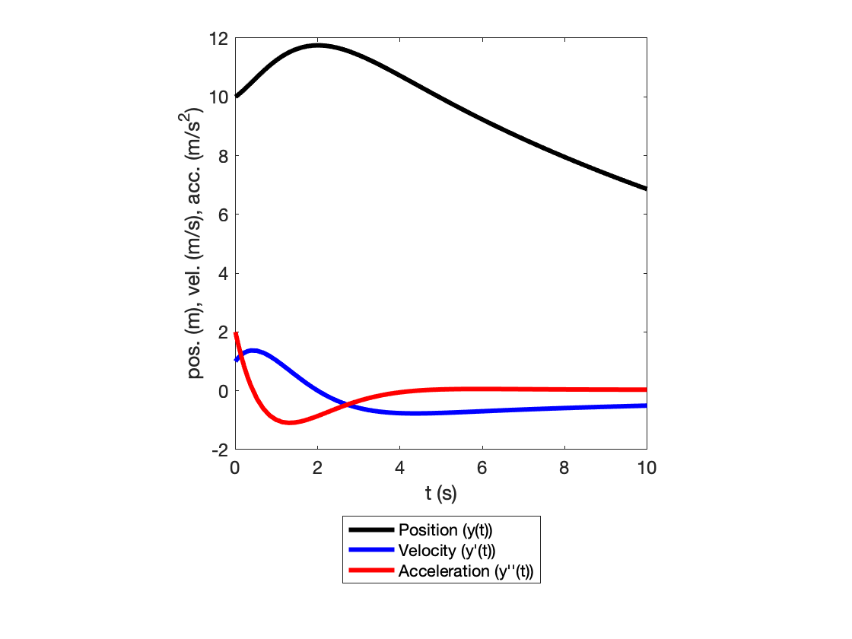

### Supplying additional arguments to ode45

The values of *p*, *q*, and *r* were defined in the ODE function - we can also supply these values when calling the solver. The function must be modified to take three additional inputs.

function dxdt = thirdOrderODE_extraInputs(t,x,p,q,r)

dxdt = zeros(3,1);

dxdt(1) = x(2);

dxdt(2) = x(3);

dxdt(3) = -p*x(3)-q*x(2)-r*x(1);

end

p = 2;

q = 1.5;

r = 0.1;

% Solve the ODE

[t,x] = ode45(@thirdOrderODE_extraInputs,[0,10],[10,1,2],[],p,q,r);

* The empty set takes the place of any options (solution tolerance) we might enforce.
* Additional inputs into the ODE function are specified at the end.

% Plotting system

p = plot(t,x(:,1),'k-',...

t,x(:,2),'b-',...

t,x(:,3),'r-');

set(p,'LineWidth',3)

set(gca,'FontSize',12)

axis square

xlabel('t (s)')

ylabel('pos. (m), vel. (m/s), acc. (m/s^2)')

legend({'Position (y(t))','Velocity (y''(t))','Acceleration (y''''(t))'},'location','southoutside')



### Example problem: creating an interactive physics simulator

In Topic 6, we analytically solved for the motion of a projectile. Here, we will solve consider the differential equations representing this motion, which can be obtained from a force balance:

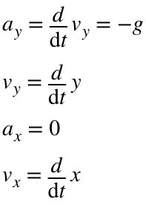

**Produce an interface that enables you to interactively "launch" a projectile.**

***Step 1: Plot the trajectory of the ball***

% Specify angle and velocity of the ball

th = 45;

v = 20;

vx = v*cosd(th);

vy = v*sind(th);

Writing the function to describe the ODEs:

function dz = ball_2D(t,z,vx)

% Compute the x and y position of a ball subject to gravity and

% in a vacuum. This function is called upon by MATLAB's ODE

% solvers. t = time (s), z = [y-position, y-velocity, x-position]

% in units of (m, m/s, m), and dz = [y-velocity; y-acceleration;

% x-position] in units of (m/s, m/s^2, m).

dz(1,1) = z(2); % z(1): y-position

dz(2,1) = -9.81;% z(2): y-velocity

dz(3,1) = vx; % z(3): x-position

end

**Important note**: even though x and y are not explicitly related, **they describe the same system and must be incorporated into one set of ODEs.** If you (erroneously) call separate instances of ode45 for each, your solution is subject to the time points the solver selects and these time points may not overlap.

% Solving the set of ODEs. Note the additional input (x velocity)

[~,state] = ode45(@ball_2D,[0,5],[0,vy,0],[],vx);

x_ode = state(:,3); % x values

y_ode = state(:,1); % y values

figure

% Plot the height as a function of time

plot(x_ode,y_ode,'k-')

ylim([0,15])

xlabel('Distance (m)')

ylabel('Height (m)')

axis square

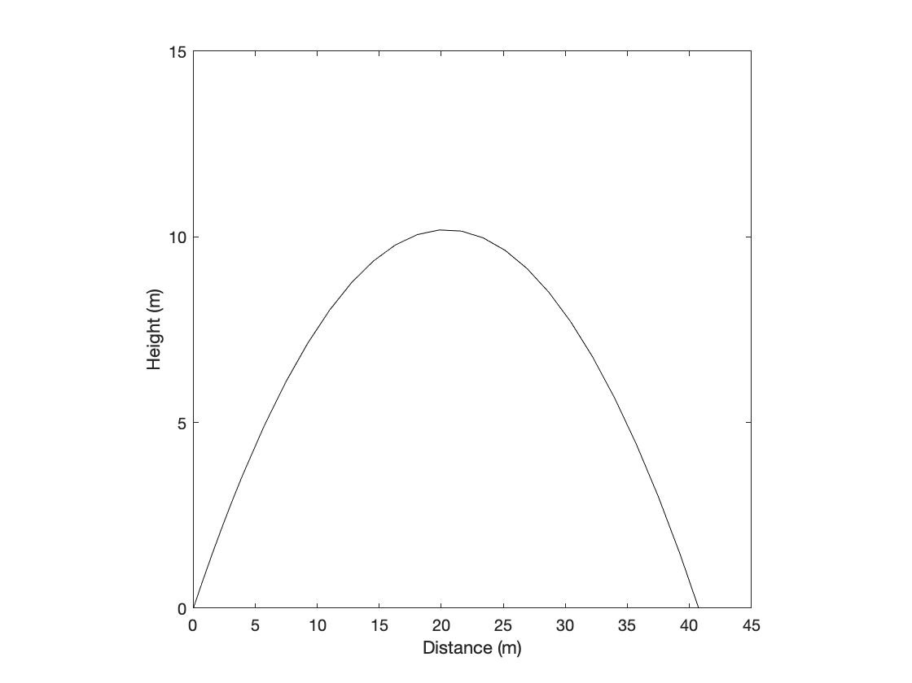

**Step 2: visualize trajectory of "moving ball"**

% Phyiscal parameters, as before

th = 60;

v = 15;

vx = v*cosd(th);

vy = v*sind(th);

g = 9.81;

% Estimate time to landing

t_end = 1.5*2*vy/g;

% Solve system of differential equations. Specify the time points to solve

% for

[t,state] = ode45(@ball_2D,[0:0.05:t_end],[2,vy,0],[],vx);

txy = [t,state(:,3),state(:,1)];

% Select time points corresponding to the ball not yet landing

txy = txy(txy(:,3) > 0,:);

**Note**: we explicitly specify the time points to be solved for in the input to ode45.

To produce visual motion. we will use the following algorithm:

1. Solve the system of ODEs to obtain the ball's x and y position as a function of time.
2. Select data points that correspond to the ball having not landed
3. In each iteration, replot the ball position and add its position to the traveled points (trajectory)

close all

% Produce figure. Specify the plots of interest and the graphical

% parameters

h1 = figure('Visible','on');

hTrajectory = plot(txy(1,2),txy(1,3),'r--');

hold on

hBall = plot(txy(1,2),txy(1,3),'ro','MarkerFaceColor','r','MarkerSize',8);

hold off

ylim([0,15])

xlim([-5,20])

xlabel('Distance (m)')

ylabel('Height (m)')

axis square

% Loop through all ball positions and update plot

for k = 2:size(txy,1)

% Update plot of ball and trajectory tracer

hBall.XData = txy(k,2);

hBall.YData = txy(k,3);

hTrajectory.XData(k) = txy(k,2);

hTrajectory.YData(k) = txy(k,3);

% Pause for specified amount of time consisted with time points solved

% for

pause(0.05);

end

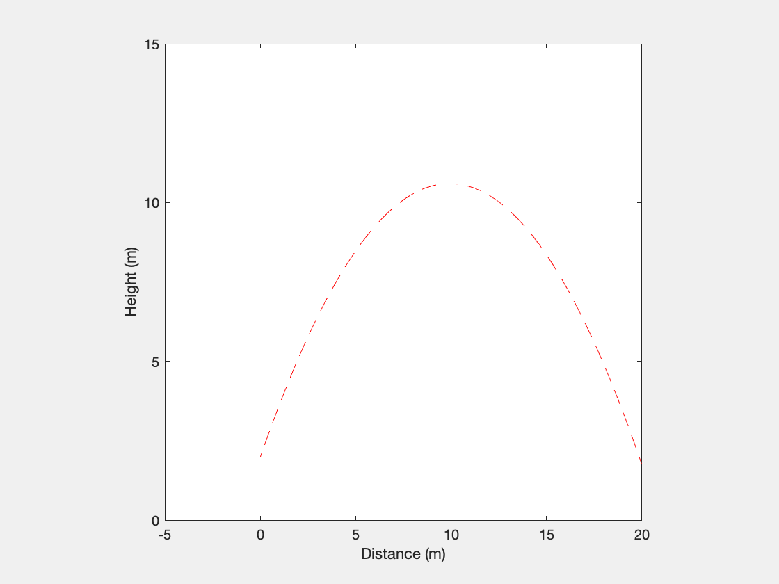

**Step 3: produce an interface**

Qualitatively, we want the following:

1. The location where the user clicks will determine both the angle and initial velocity of the ball.
2. Upon releasing the click, we wish to solve the ODE based on the initial parameters specified by the user click.
3. Upon releasing the click, we also to visualize the trajectory of the ball.

close all

% Create a figure

h1 = figure('Visible','on');

% Create and store GUI data structure

handles.h0 = 2;

guidata(h1,handles);

% Define plots for trajectory, ball, and aiming line

hTrajectory = plot(0,handles.h0,'r--');

hold on

hBall = plot(0,handles.h0,'ro','MarkerFaceColor','r','MarkerSize',8);

hAim = plot(0,handles.h0,'k-','LineWidth',2);

hold off

% Graphical parameters

ylim([-5,15])

xlim([-5,20])

xlabel('Distance (m)')

ylabel('Height (m)')

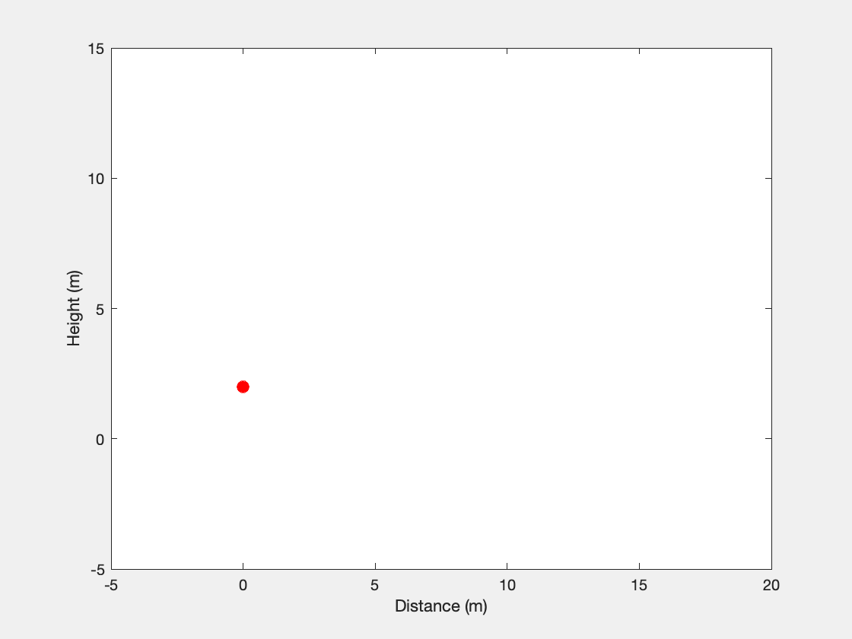

% Assign callback function for mouse click

h1.WindowButtonDownFcn = {@determineStart,hBall,hTrajectory,hAim};

% Assign callback function for mouse release

h1.WindowButtonUpFcn = {@throwBall,hBall,hTrajectory};

# TOPIC 24: Symbolic variables, equations, and functions

ENGR105, 11/24/20

**Note**: for these notes, you will need the **Symbolic Math Toolbox** installed.

## Symbolic math in MATLAB

* According to Mathworks, LiveScript documents are the recommended documents for performing symbolic operations.
* Symbolic math in MATLAB is based on the MuPAD computational engine.
* [Reference documentation on changing output from symbolic operations](https://www.mathworks.com/help/symbolic/modify-output-of-symbolic-results.html)
* help symbolic for MATLAB help documentation

In addtion to its capabilities with numerical processing, MATLAB provides built-in capabilities for solving, plotting, and manipulating symbolic math equations. **A main difference** between data types symbolic and double is that symbolic numbers are **exact**, whereas double values have **floating point precision** (see Lecture 15 / Topic 14).

**Example**. Calculate 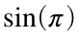

% Using the numerical calculation, as before

sin(pi)

ans = 1.2246e-16

% Using symbolic

sin(sym(pi))

ans =

0

Here, we create a *symbolic number* by using sym.

**Important note**: while the numeric calculation does not return the exact result, it much more accurate than what we typically "need."

### Declaring symbolic numbers and variables

You can create symbolic variables by using either syms or sym, or by assigning the **output from a symbolic expression** to a new variable.

* syms - use syms to symbolic **variables** that can be manipulated in symbolic expressions.

% Declare symbolic variables

syms x y

% Inspect properties of variables

whos x y

Name Size Bytes Class Attributes

x 1x1 8 sym

y 1x1 8 sym

* sym – use sym to create **symbolic numbers**

% Create symbolic numbers

sym(5)

ans =

5

sym(pi)

ans =

*π*

sym(sqrt(2))

ans = 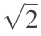

1+sym(pi)

ans = 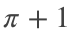

**Note**: use sym on the "innermost" number only to create an exact number. Otherwise, the sym operator will be applied to the product of a floating point (numerical) operation.

% Correct: convert pi to symbolic, then operate on it.

sqrt(sym(pi))

ans = 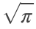

% Incorrect: Convert the output from sqrt(pi) to a symbolic representation

sym(sqrt(pi))

ans =

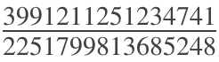

* Assign an output from symbolic manipulations to a new variable.

% Create symbolic variable phi, also known as the "golden ratio"

phi = (1 + sqrt(sym(5)))/2

phi =

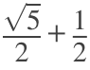

**Note**: a symbolic number can be converted to double by using the double command

% Convert symbolic to double

double(phi)

ans = 1.6180

### Symbolic expressions and functions

The above variable, phi, is created using a symbolic expression. You can now perform subsequent operations on phi.

% Operation 1

f1 = phi^2 - phi - 1

f1 =

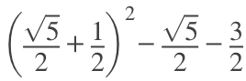

% Operation 2

f2 = phi^2 + 1

f2 =

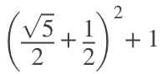

**Simplifying expressions**. Use simplify to simplify an expression

% Simplify f1

simplify(f1)

ans =

0

% Simplify f2

simplify(f2)

ans =

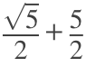

**Symbolic expressions with symbolic variables** are useful when you wish to perform mathematical manipulations on an equation.

% Create original equation

syms x

g = x^3 + 6*x^2 + 11*x + 6

g = 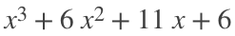

% Manipulate equation by dividing it by (x+3)

g2 = g/(x+3)

g2 =

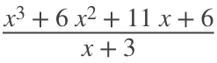

% Simplify equation

g2 = simplify(g2)

g2 = 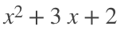

**Note**: to substitute a number in for a variable, you must use the subs command

% Parenthesis cannot be used to substitute for a variable

g2(1)

ans = 

% Instead, use subs to evaluate for particular values

subs(g2,x,1)

ans =

6

% Note: the original equation is unchanged

g2

g2 = 

**Symbolic functions**. If you intend to perform repeated evaluations, create a **symbolic function** instead. This can be declared using the syms function.

clear

syms f(x)

% Specify function. NOTE: must define f(x)

f(x) = x^2-1+sqrt(sym(pi));

% the function f(x) will be displayed if either f or f(x) is called

disp(f(x))

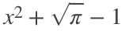

disp(f)



% In this case, direct substitution can occur with parenthesis

f(1)

ans = 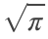

f(2)

ans = 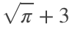

### Plotting symbolic functions

**Plot symbolic equations using fplot**. The most common method for plotting symbolic functions is to use fplot(). fplot() takes the following inputs:

* *First input*: function to be plotted
* *Second input*: time domain,
* *Third input*: line specifications

clear

% Declare symbolic variables

syms x

% Plot sin(x) over the domain [0,10]

fplot(sin(x), [0,10], 'r--')

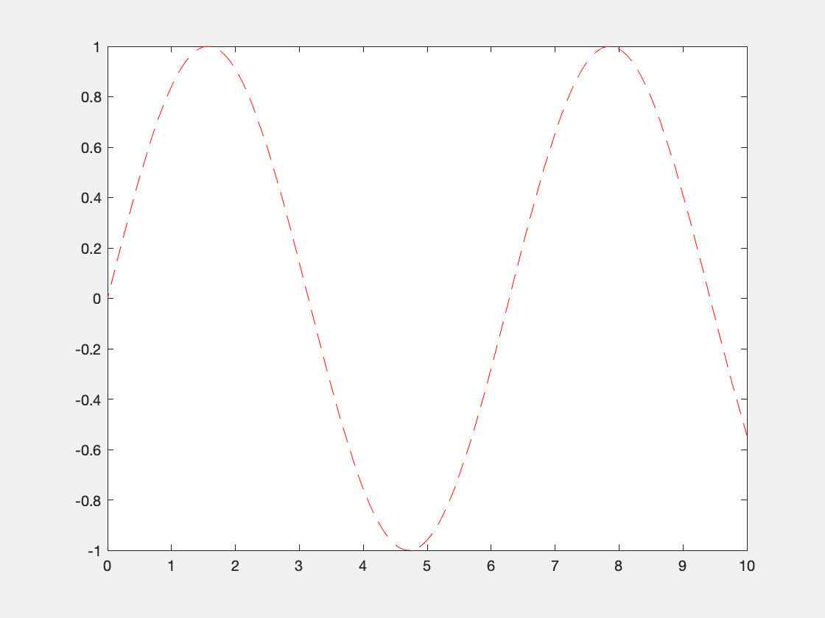

Plots of symbolic functions can also be modified as **graphics handle objects**.

% Declare symbolic variable

syms t

% Plot function and specify parameters

h1 = fplot(t^2,[-2,2]);

h1.LineWidth = 2;

h1.Color = 'g';

axis square

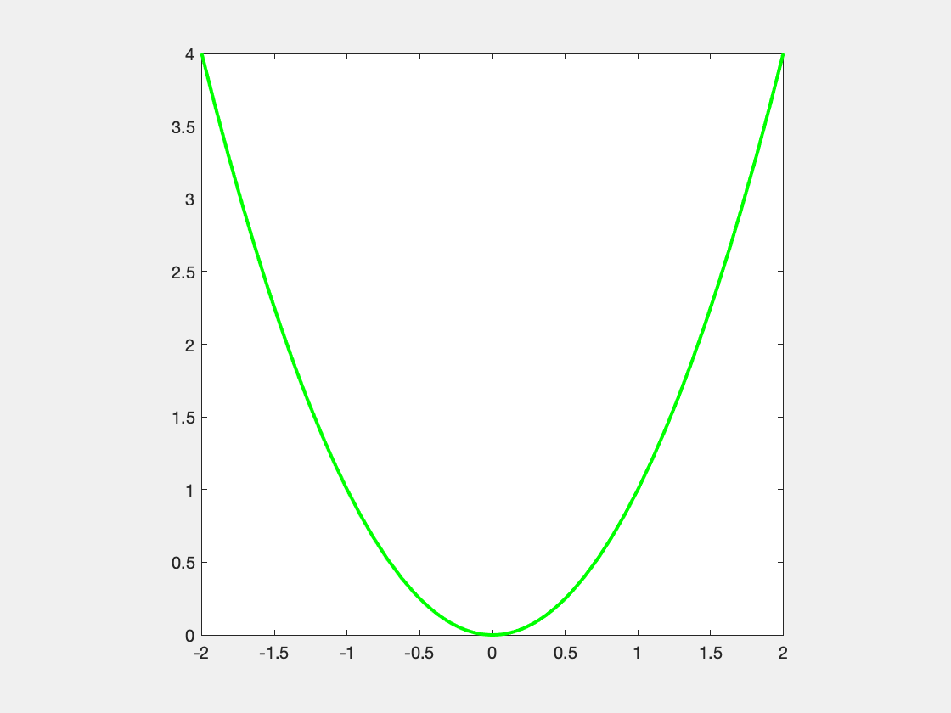

**Important note**: symbolic functions are **not** plotted with infinite precision. When you plot a symbolic function, the following happens:

1. MATLAB automatically **creates vectors of x and y data** spanning the specified domain.
2. MATLAB **plots those two vectors** and assigns the specified formatting.

The x and y data that is created can be accessed using the graphics handle object.

% Acquire data vectors that were plotted to create the above plot.

xdata = h1.XData;

ydata = h1.YData;

Thus, you could produce an **equivalent plot** using the standard plot() function.

% Equivalent plot

plot(xdata,ydata,'g-','LineWidth',2)

axis square



**Note:** you can also plot **anonymous functions** using fplot.

clear

% Produce a plot of cos(x) between 0 and 4*pi

fplot(@(x) cos(x),[0,4*pi])

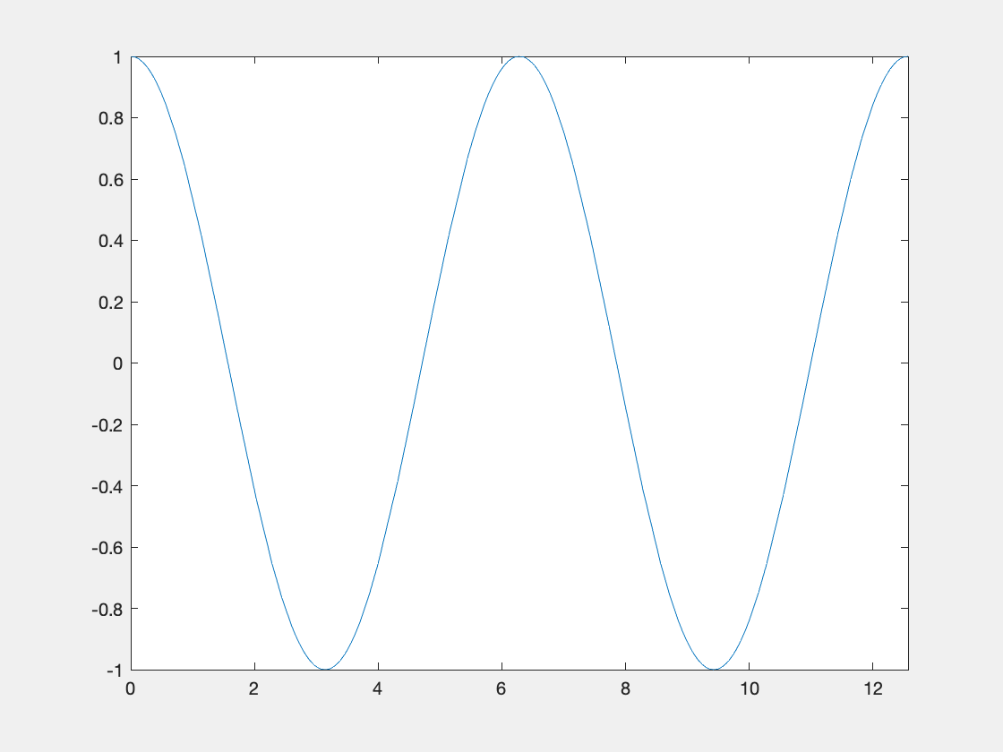

**Plot symbolic equations in 3D using fplot3**. The symbolic analog to plot3() is fplot3(), which can be used to plot parametric curves.

**Example**. plot the curve given by  for 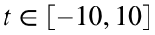

% Declare symbolic variable

syms t

% Produce a 3D plot corresponding to the above

fplot3(t,sin(t),cos(t),[-10,10])

xlabel('x')

ylabel('y')

zlabel('z')

% Add constant rotation to the plot

for k = 1:360

% Update the view point

view(k,30)

% Pause MATLAB for 100 ms

pause(0.1)

end

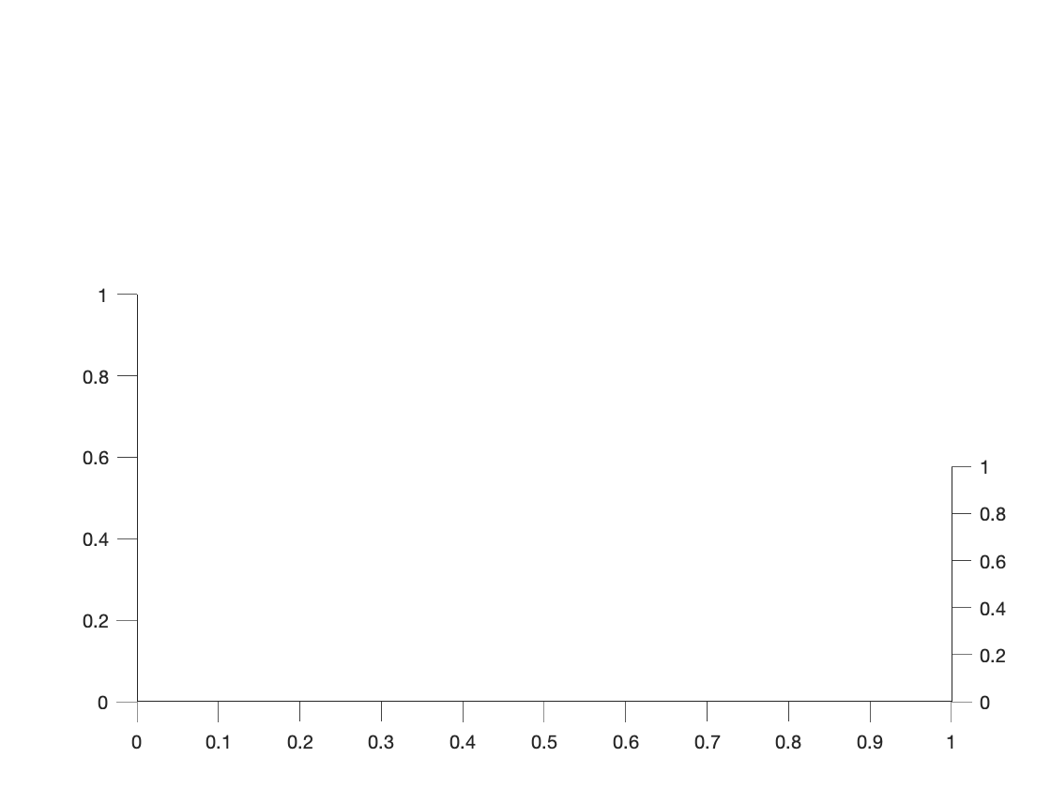

**Plot implicit relationships using fimplicit**. When you cannot easily solve for one variable in terms of another, you can plot the implicit form of the relationship.

**Example**. Plot 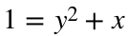

syms x y

fimplicit(1==y^2+x,[-2,2])

set(gca,'XAxisLocation','Origin')

set(gca,'YAxisLocation','Origin')

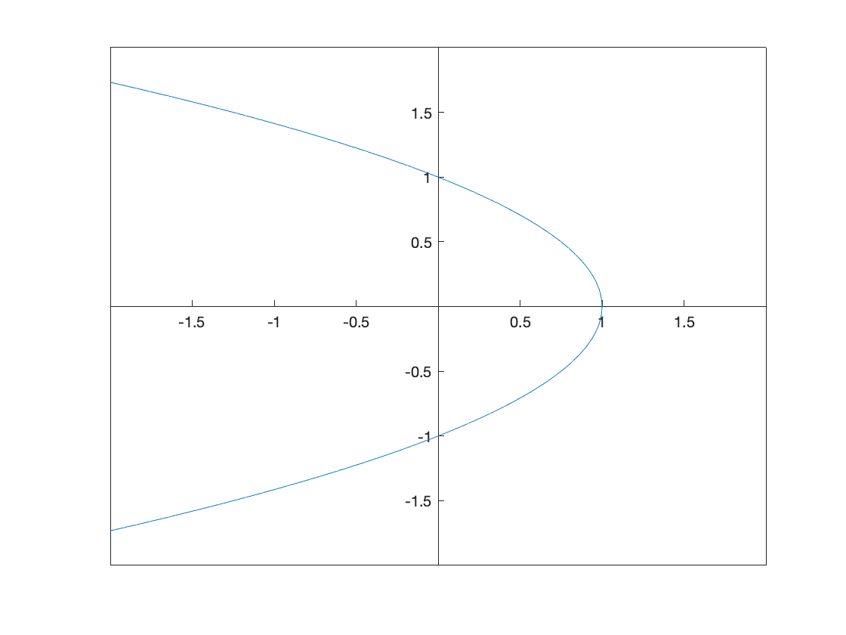

**Notes:**

* The variable that comes **first** in alphanumeric order is assigned to the **x variable**.
* The above example specifies the **x domain** to be plotted over.

### Solving equations of one variable

Exact solutions to an equation may be obtained using the solve() function.

clear

syms x % Declare symbolic variable

% Example 1

solve(5*x == 1)

ans =



% Example 2: multiple solutions are present

solve(x^2 - 1 == 0)

ans =

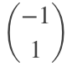

% Example 3: can obtain complex solutions

solve(x^2 + 1 == 0)

ans =

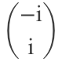

### Solving sets of linear equations

Consider the system of two equations used previously in Lecture 4:



**To solve the set of equation,** each equation can be assigned to a symbolic variable.

clear

syms x y % declare variables as symbolic

eqn1 = y==2*x-3; % first equation

eqn2 = y==x; % second equation

**Note:** the double equals (==) says that two symbolic expression are equal to one another.

Use solve() to determine the **solution to the system of equations**. In this case, the output res is a data structure. The ".x" and ".y" are simply used to call the solution value to each variable.

res = solve([eqn1,eqn2],[x,y]);

xSol = res.x % retrieve the x solution

xSol =

3

ySol = res.y % retrieve the y solution

ySol =

3

**Comparison to linear algebra**. Consider the set of linear equations from **example 2** in **Lecture 3 / Topic 4.**



Solve the following system of equations using symbolics and linear algebra.

**1) Using symbolic variables**

tic

syms x1 x2 x3

% Define equations

eqn1 = x1 + 3*x2 + x3 == 1;

eqn2 = 2*x1 + 2*x2 - x3 == 2;

eqn3 = x1 + x2 + x3 == -2;

% Solve set of linear equations

res = solve([eqn1,eqn2,eqn3],[x1,x2,x3]);

% Display the solution for each variable

disp(res.x1)

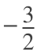

disp(res.x2)



disp(res.x3)

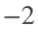

toc

Elapsed time is 0.227022 seconds.

**2) Using linear algebra**

tic

% Step 1: convert to matrix format

A = [1,3,1;2,2,-1;1,1,1]; %Coefficient matrix defined above

b = [1;2;-2]; % Constant matrix

% Step 2: solve for x

x = A\b

x = 3×1

-1.5000

1.5000

-2.0000

toc

Elapsed time is 0.022148 seconds.

**Takeaway**: both work fine, but even for this *simple* set of 3 equations, the linear algebra approach is quicker by 1-2 orders of magnitude! **You will have to use linear algebra to solve large sets of equations**.

### Solving sets of nonlinear equations

Sets of (simple) nonlinear equations can also be readily solved using the solve() function. Consider the following set of equations:

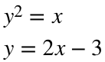

Especially when solving sets of nonlinear equations, it is advisable to plot them to get an idea of where the solutions should be.

* Use fimplicit() to plot symbolic equations in the form we defined above.

% Declare variables and equations

syms x y

eqn1 = y^2==x;

eqn2 = y==2*x-3;

% Plot equations on the interval for x and y of [-6,6]

fimplicit([eqn1,eqn2],[-6,6,-6,6])

axis square

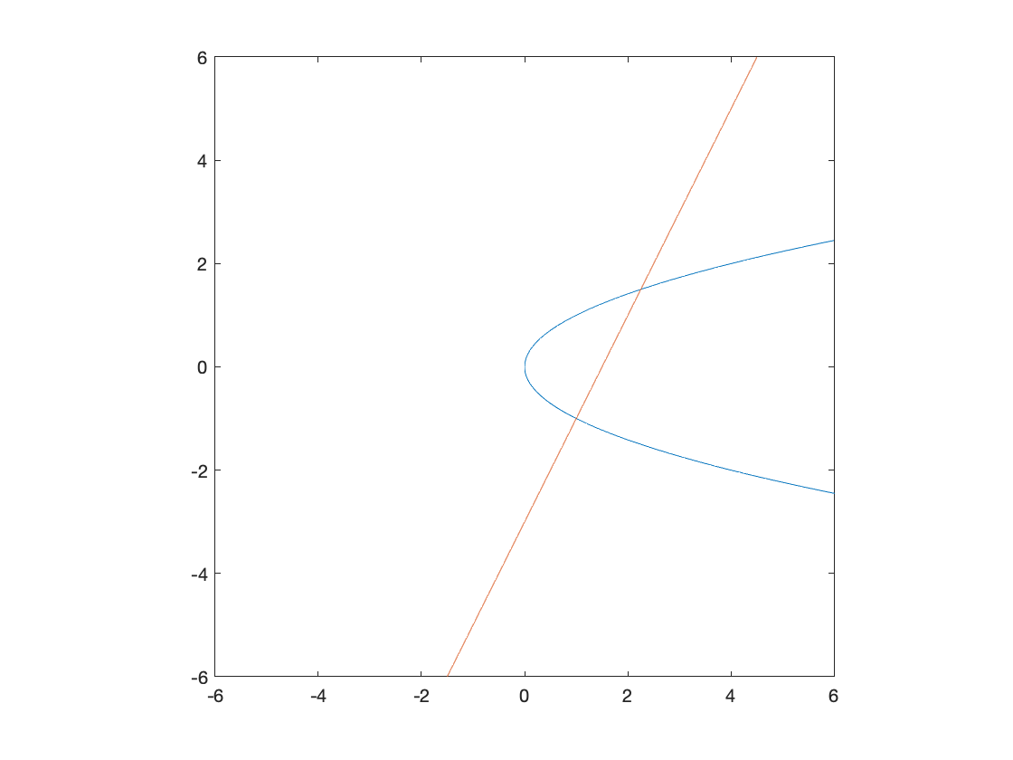

* As before, we can solve the system of equations using solve().

% Solve system of nonlinear equations

res2 = solve([eqn1,eqn2],[x,y]);

xSol2 = res2.x % retrieve the x solution

xSol2 =

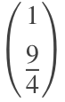

ySol2 = res2.y % retrieve the y solution

ySol2 =

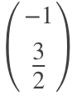

**Comparison to numerically solving**. Consider the following, slightly more nonlinear set of equations. We can plot it by running the same code as before.



% Declare variables and equations

syms x y

eqn1 = y^2==x;

eqn2 = y==2*x^2-3;

% Plot equations on the interval for x and y of [-6,6]

fimplicit([eqn1,eqn2],[-6,6,-6,6])

axis square

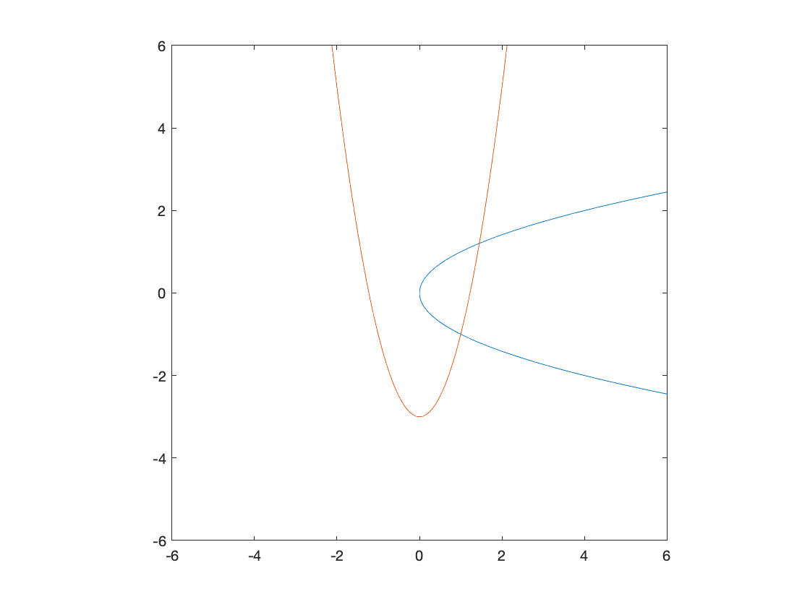

**1) Solve using symbolic math**

% Solve system of nonlinear equations

res3 = solve([eqn1,eqn2],[x,y]);

xSol3 = res3.x % retrieve the x solution

xSol3 =

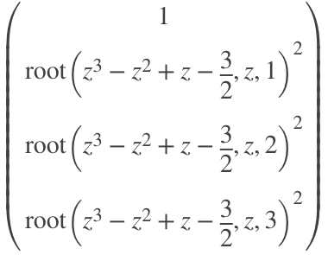

ySol3 = res3.y % retrieve the y solution

ySol3 =

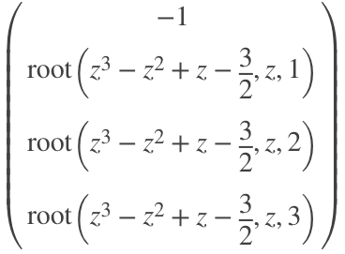

The solver returns the **exact** solution, which isn't necessarily useful.

**2) Solve using numerical method.** Using fsolve as before, we can solve this set of nonlinear equations.

% Determine solution 1

sol_1 = fsolve(@eqnSet,[0,0]);

Equation solved.

fsolve completed because the vector of function values is near zero

as measured by the value of the function tolerance, and

the problem appears regular as measured by the gradient.

<stopping criteria details>

% Determine solution 2

sol_2 = fsolve(@eqnSet,[1,1]);

Equation solved.

fsolve completed because the vector of function values is near zero

as measured by the value of the function tolerance, and

the problem appears regular as measured by the gradient.

<stopping criteria details>

disp(sol_1)

1.0000 -1.0000

disp(sol_2)

1.4498 1.2041

**Takeaway**: solve() is trying to find an exact solution, which is not always very useful. Often a numerical solution is *more than accurate enough* for a given application.

**For more information** on modifying outputs from symbolic manipulations, see the [reference documentation from MATLAB](https://www.mathworks.com/help/symbolic/sympref.html?searchHighlight=display%2520symbolic%2520with%2520floating%2520point&s_tid=srchtitle#mw_1464af98-5a29-4ac0-b0a7-3d101ea82566)

### Calculus

**Univariate symbolic differentiation** can be accomplished by using the diff command.

* By directly inputting a symbolic function

syms x

diff(sin(x), x)

ans = 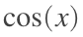

* Assigning an expression to new variable

F = sin(x);

diff(F,x)

ans = 

* Calculating a second derivative

diff(F,x,2)

ans = 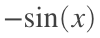

**Multivariate symbolic differentiation** using the diff command

* Differentiation with respect to *x*

syms x y

diff(sin(x)*cos(y),x)

ans = 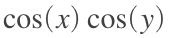

* Differentiation with respect to y

diff(sin(x)*cos(y),y)

ans = 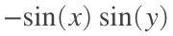

* Differentiate with respect to x and then y

diff(x*sin(x*y), x, y)

ans = 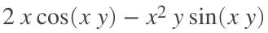

**Integration**. Symbolic integration/antidifferentiation may be achieved using the int() function.

syms x % declare x symbolic

% Integrate x^2 + x

res1 = int(x^2+x)

res1 =

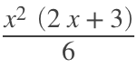

% Expand the polynomial

res1 = expand(res1)

res1 =

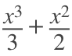

**Integrating a multivariate function** with respect to *y* and then *x*

syms x y z

res = expand(int(int(x^2+x+y^3+z^(1/2),y),x))

res =

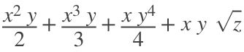

**Note**: the variable to be integrated by is contained within each function call of int().

Definite integration using int(). int() achieves numerical integration by evaluating the values of the indefinite integrals at each bound, equivalent to the following.

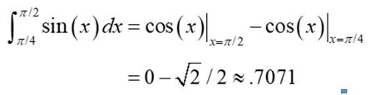

syms theta

res = int(sin(theta),[pi/4 pi/2])

res =

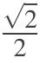

Some functions do not yield a useful analytical form under integration - i.e. MATLAB returns a solution in integral notation.

syms x

int(sin(sinh(x)), x)

ans =

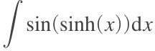

This highlights that some functions can only be **numerically integrated** (using numerical integration methods) or approximated using a Taylor expansion

### Differential equations

Differential equations can be solved using the dsolve function. This function takes an input of symbolic variable corresponding to the differential equation to be solved.

**Solving first order ODEs.** The diff function (used for differentiating symbolic expressions) is used to create the differential equation.

clear

% Declare symbolic variables

syms y(t) a

% Define differential equation

eqn = diff(y,t) == a*y;

S = dsolve(eqn)

S = 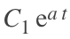

**Note**: we **do not specify initial conditions** and so MATLAB produces a *general solution* to the ODE.

**Initial conditions** can be provided as a second input.

% Define initial conditions

cond = y(0) == 5;

ySol(t) = dsolve(eqn,cond)

ySol(t) = 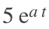

**Second order ODEs** can be created by using the diff function and specifying the second order derivative.

% Define second order ODE. % Note the additional input to diff() to create

% a second order derivative.

eqn = diff(y,t,2) == a*y;

% Solve for general solution to differential equation

ySol(t) = dsolve(eqn)

ySol(t) = 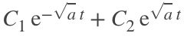

% Specify initial conditions

% Define the first derivative so that it can be used as an initial

% condition

Dy = diff(y,t)

Dy(t) =

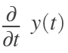

syms b

% Define vector containing initial conditions

cond = [y(0)==b, Dy(0)==1];

% Solve for the specific form of the ODE solution

ySol(t) = dsolve(eqn,cond)

ySol(t) =

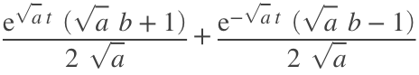

**Solving sets of differential equations.** Explicit solutions to sets of ODEs can be solved by inputting a vector of ODEs into dsolve.

% Define ODEs

syms y(t) z(t)

% Define vector of ODEs

eqns = [diff(y,t) == z, diff(z,t) == -y];

% Find solution

S = dsolve(eqns);

S.z

ans = 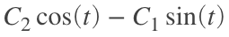

S.y

ans = 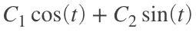

Assigning initial conditions

S = dsolve(eqns,[y(0) == 1,z(0) == 0]);

S.z

ans = 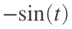

S.y

ans = 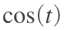

### Example problem: Harmonic oscillator

Consider a 1 cm (radius) carbon ball in water that is attached to linear spring, which is attached to a surface, as shown below. Assuming 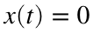 is the equilibrium position and the ball is pulled back to 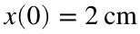 and released, plot the  position of the ball as a function of time for spring constants of 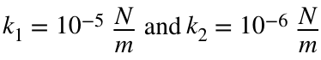.

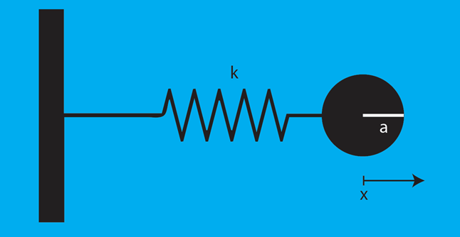

Consider only 1-D motion in the x direction, neglect any forces in the y-direction (*e.g.* related to gravity), and ignore mass of the spring.

**Step 1:** Write down what we know and determine the differential equation describing the system.

*Values that we know:*

* Radius of ball: 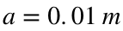
* Density of carbon: 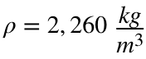
* Viscosity of water: 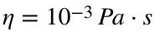

*Creating the differential equation:*

From our knowledge of **physics**, we know that the force exerted by a linear spring is directly proportional to the displacement of the spring. This corresponds to the well-known **Hooke's law**:

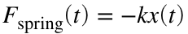

From **fluid mechanics**, we know that the drag force exerted by a sphere in some fluid can be represented by **Stokes's law**. This relationship states that the drag force is directly proportional to the velocity of the sphere, the sphere's radius (), and the viscosity of the fluid:

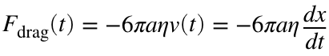

From **Newton's second law of motion**, we can thus relate all forces acting on the object:

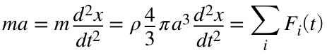

Simplifying this differential equation:

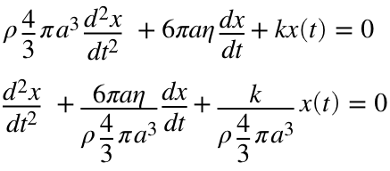

Or, by definining and substituting variables  and :

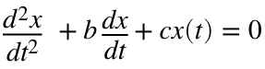

**Step 2:** Convert the above to code

%Step 1: Setup

%write down parameters

a = 0.01; % m

eta = 10^-3; % Pa*

rho = 2260;

k1 = 1*10^-5;

k2 = 1*10^-6;

%declare symbols

%x(t): position of ball

% b: coefficient in front of first derivative

% c: coefficient in front of x(t)

syms x(t) b c k

%coeffiecent in front each derivative

b = 6*sym(pi)*a*eta/(rho*4/3*sym(pi)*a/3);

c = k/(rho*4/3*sym(pi)*a^3);

**Step 3a:** solve differential equation for one value of k

% Define first derivative of x

Dx = diff(x,t);

eq = diff(Dx,t) + b*Dx +c*x == 0

eq(t) =

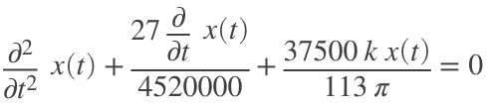

%substitute in one vale

eq1 = subs(eq,k,k1)

eq1(t) =

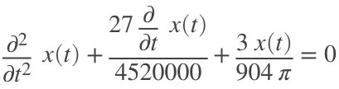

sol1 = dsolve(eq1,[x(0) == 0.2, Dx(0) == 0])

sol1 =

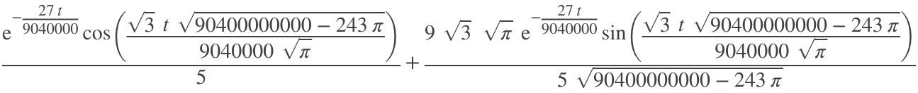

**Step 3:** Solve the differential equation

% Solve differential equation

% IC: x(0) = 0.02

% IC: dx/dt(0) = 0 (the ball does not have any initial velocity

col = {'k','r'};

kval = [k1,k2];

for m = 1:2

% Substitute in the variable

eq1 = subs(eq,k,kval(m));

% Solve the differential equation

sol1 = dsolve(eq1, [x(0) == 0.02, Dx(0) == 0]);

% Plot the solution over time

fplot(sol1,[0,1000],col{m});

hold on

end

hold off

legend('k = 10e-5', 'k = 10e-6')

ylim([-0.02, 0.02])

axis square

ylabel('x position')

xlabel('time')

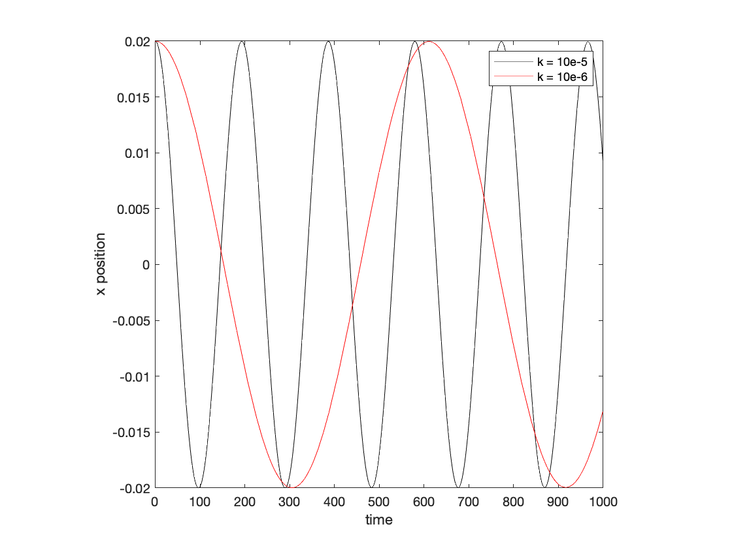

**Question**: how can we solve the above using ode45?

Start by **changing variables** to convert the higher order ODE into a set of first order ODEs.

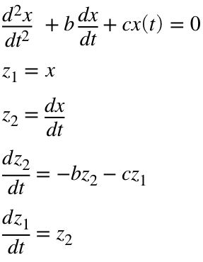

clear

% STEP 1: Setup

% Write down paramters describing the system

a = 0.01; % m

eta = 10^-3; % Pa*s

rho = 2260;

k1 = 1*10^-5;

k2 = 1*10^-6;

% Coefficient in front of each derivative

b = 6*(pi)*a*eta/(rho*4/3*(pi)*a^3);

c = [k1,k2]/(rho*4/3*(pi)*a^3);

for m = 1:2

[t,out] = ode45(@springProblem,[0,1000],[0.02,0],[],b,c(m));

plot(t,out(:,1),'k-')

hold on

end

hold off

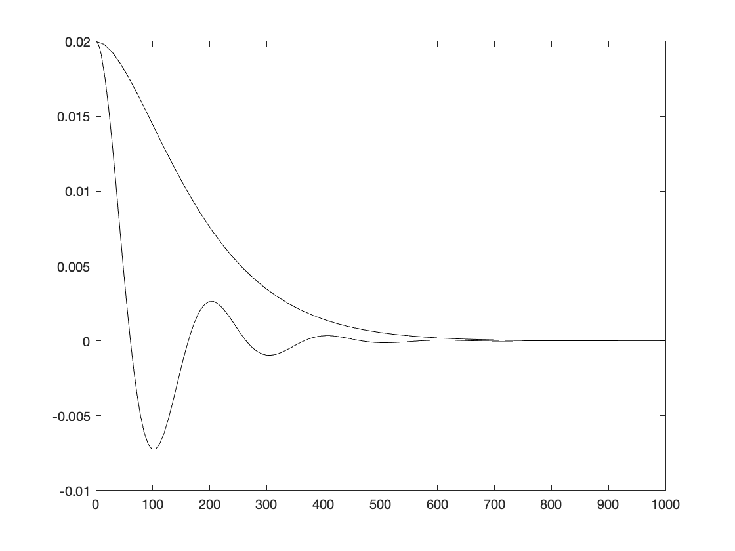

# TOPIC 25: Animations

ENGR105, 11/30/20

### Reminder: animating simple graphical objects

So far, we have produced visualizations and simulations involving the movement of simple **graphics handle objects**, such as **circles** and **squares**. For example, in Topic 20 we produced a particle-based simulation to represent the spread of infectious disease. The code for this is shown here.

*Key features:*

* The objects that are moving are declared as **graphics handle objects**. The position and color of each is updated by changing the appropriate **fields** of the **handle**.
* The order of the code is important. In this case, it is important to first create the "background." That is, it is important to first create the axes, set the limits, etc. **In other cases, you may need to create an object first**. A useful troubleshooting approach is think about the order in which you create things.

close all

% 1) Vector representing positions of two particles

pos = [1,4];

% 2) Define particle identities.

% Particle 1 will be infected

% Particle 2 will initially be healthy

% 3) Produce visualization of each particle

g1 = axes;

axis image % Setting this ensures that the x and y scales are equal on the resulting image

xlim([0,7]) % X limits

ylim([-2,2]) % Y limits

set(g1,'ytick',[]) % Turn off y tick marks

set(g1,'Box','on')

xlabel('Position') % X label

% Plot both particles initial position

p1 = rectangle('Position',[pos(1),-0.5,1,1],'Curvature',[1,1],'FaceColor','r');

p2 = rectangle('Position',[pos(2),-0.5,1,1],'Curvature',[1,1],'FaceColor','w','LineWidth',2);

% Step through the simulation. In each step, update the particles positions

while abs(pos(1)-pos(2)) >= 1

% A) Create vector determining particle step

d_k = (rand(1,2)-0.5);

% B) Update particle position

pos = pos + d_k;

% C) Ensure particle doesn't move out of bounds

pos = max(min(pos,6),0);

% If difference between particles is less than one diameter, an

% infection has occurred

if abs(pos(1)-pos(2)) < 1

p2.FaceColor = 'r';

end

% D) Update visualization

p1.Position(1) = pos(1);

p2.Position(1) = pos(2);

% E) Pause MATLAB

pause(0.2)

end

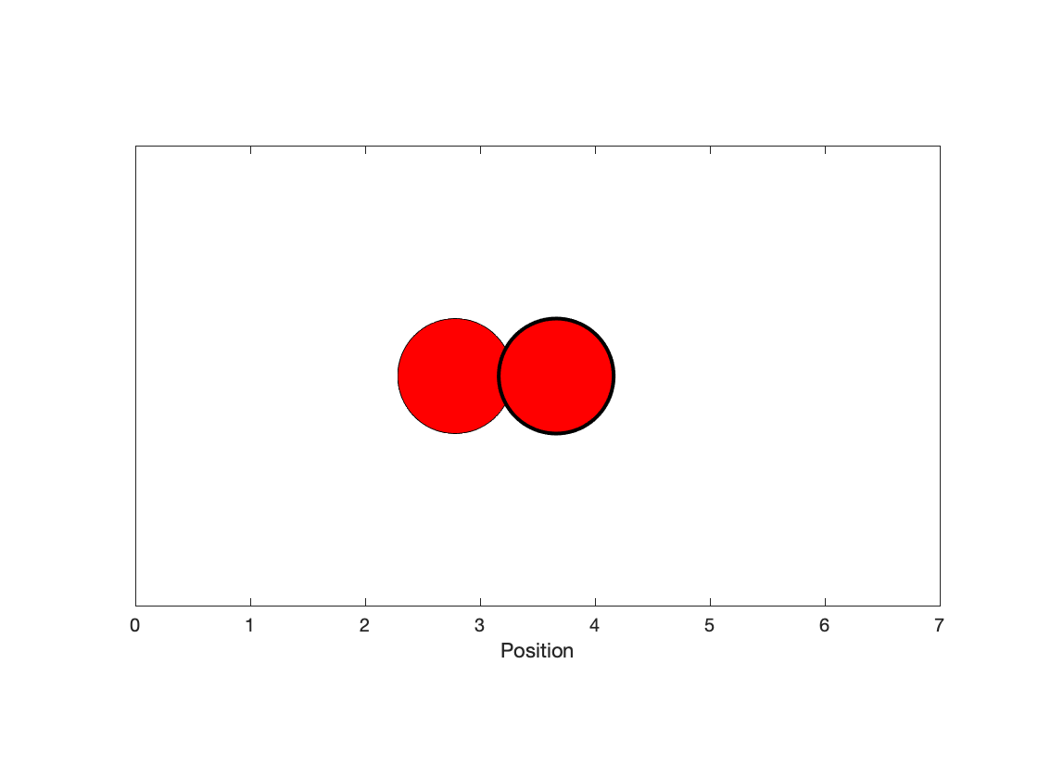

Thoughts on creating more sophisticated objects from combinations of objects:

* It is possible to group objects together.
* However, remember that a graphics handle object (whether an individual or group) can only be modified by changing *fields* of the handle object. When in doubt, use get() to retrieve possible fields to change.
* If a field is not available (e.g. for a group), you will need to change the desired field for each of the individual objects.

**Takeaway**: use get() to help troubleshoot possible modifications to an object.

### Reminder: the flow of information in an interface

Furthermore, remember that consideration must be put into *how* information is transferred between objects and functions within an interface object.

***Graphics objects we've discussed so far:***

1. figure objects
2. axes objects
3. plot/bar/(data visualization) objects
4. rectangle objects
5. uicontrol objects
6. text objects
7. legend objects
8. ylabel, xlabel, title, xlim, ylim objects
9. Others?

* **Rule of thumb**: *if it creates something visual on a graph, plot, figure window, etc., then it can be stored and modified as a graphics handle object.*

**Interfaces are based on a figure object.** **The figure is the parent** that *contains* axes, uicontrols, text, callback functions, etc.

**Example**. updating a "score" counter

* **Rule of thumb:** wherever you pass a callback function (*e.g.* mouse, keyboard, uicontrol, timer, etc.), you can specify additional arguments by passing a cell array that contains the function and additional inputs, e.g. with {}.

**Note**: this example uses uicontrols, which we discussed in Topic 21 / Lecture 22.

% Initialize the figure/gui window and center

ss = get(0,'ScreenSize');

fig = figure('Visible','on','Position',ss.*.5);

movegui(fig,'center')

% Initialize the counter value

cVal = 0;

% Add an "edit text" box to show the current value of the counter

hedit = uicontrol('Style','edit','Units','Normalized','Position',...

[0.3 0.05 0.4 0.2],'FontSize',30,'String',cVal);

% Pushbutton to subtract 1 from the current value of the counter

uicontrol('Style','pushbutton','Units','Normalized','Position',...

[0.2 0.4 0.2 0.2],'String','Subtract 1','Callback',{@subtractVal,cVal,hedit});

% Pushbutton to add 1 to the current value of the counter

uicontrol('Style','pushbutton','Units','Normalized','Position',...

[0.6 0.4 0.2 0.2],'String','Add 1','Callback',{@addVal,cVal,hedit});

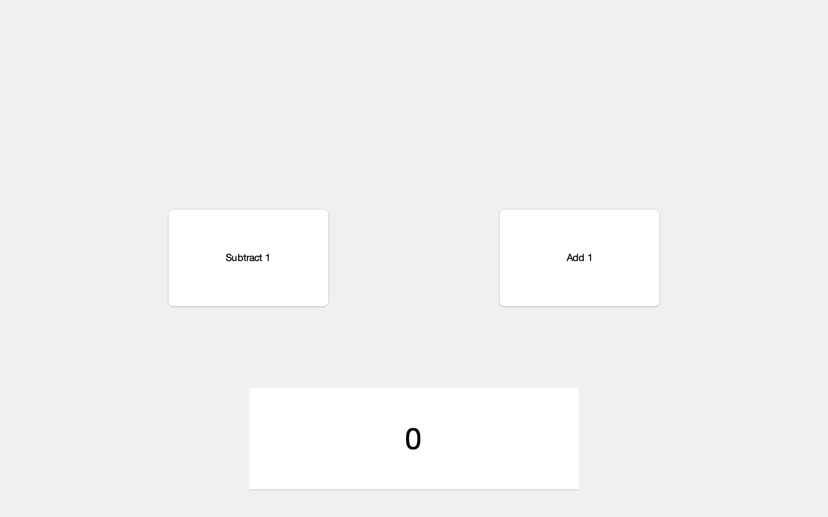

**Issue**: information is passed to the appropriate objects, but the counter is not actually stored anywhere. Remember, what happens in a function, stays in a function (unless otherwise appropriately passed).

**Workaround: guidata**

* Remember that guidata can be used to store a data structure associated with a parent figure (interface).
* This data structure should be initially stored in your script, then loaded and restored inside each function.
* Storing guidata:

% Initially declare structure with a field corresponding to the counter

handles.cVal = 0;

% Store guidata

% First input: figure handle

guidata(h1,handles);

* Loading guidata inside a function:

% Load guidata to a structure array object

handles = guidata(h1);

## Animations

Whether you are designing a simulation, interactive visualization, or game, you may want to incorporate (and **animate**) more sophisticated objects than simply square, rectangles, or circles. To incorporate more sophisticated objects, you could:

* Draw them from square, circles, lines, etc. in MATLAB
* **Import images** into the plot space. We will focus on this here.

### Revisiting image processing

Recall from before:

* **images are just "integer matrices,"**  in which the each index corresponds to a unique **pixel**, and the value of the corresponding element is the **gray value** of that pixel.
* The bit depth of an image corresponds to the range of possible integer values each element can take. Color images are 3D matrices.
* An image **may be read into MATLAB** using the imread function.
* An image may be **displayed** using imshow

close all

fishPic = imread('fish.png');

imshow(fishPic)

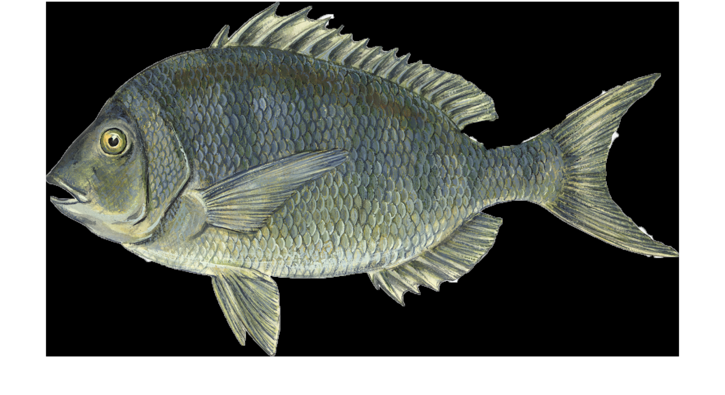

*Source: the above image is of a Porgy fish, courtesy of the Encyclopedia Britannica.*

% A color image is a 3D matrix

size(fishPic)

ans = 1×3

866 1544 3

### Images as graphical handles objects

In general, all visualizations can be stored as graphics handle objects. Images are no different and may be placed in precise **positions** on a pair of axes and **stretched** by modifying the xData and yData properties.

*In the following example, we:*

* **Create a graphics handle object** corresponding to the fish.
* **Scale the object's size** by changing the XData and YData fields.

close all

% Create figure and axes that are visible

ss = get(0,'ScreenSize');

h1 = figure('Visible','on','Position',ss.*.5);

g1 = axes;

% Create graphics handle object describing fish

hFish = imshow(fishPic)

hFish =

Image with properties:

CData: [866×1544×3 uint8]

CDataMapping: 'direct'

Show all properties

% Define scaling factor

sf = 0.25;

% Change scaling of image on axes

hFish.XData = [1,sf*hFish.XData(2)];

hFish.YData = [1,sf*hFish.XData(2)];

% Ensure axes are visible

g1.Visible = 'on';

% Reduce figure window size

h1.Position(3:4) = 0.5*h1.Position(3:4);

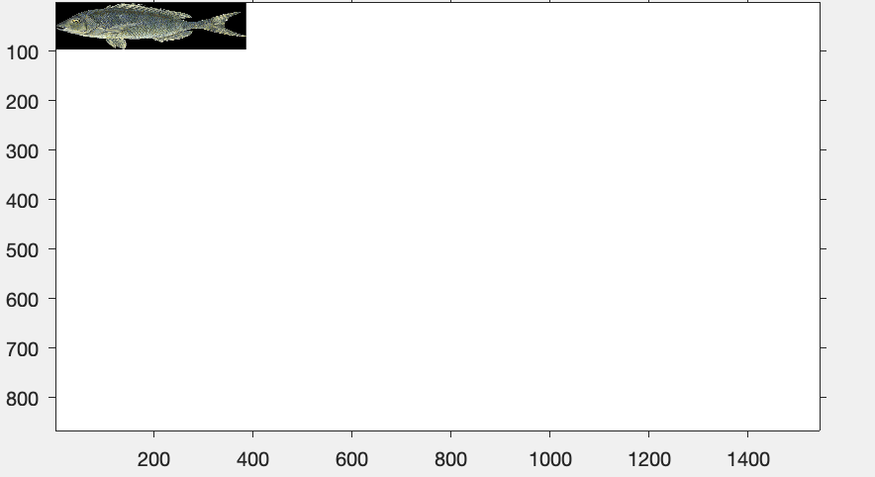

**Note**: the units of the above plot are pixels. By definition, the upper left corner is the origin at (0,0)

Furthermore, we can change the **position** of fish by translating the values in the XData and YData fields of the fish object.

% Move the object away from the origin

hFish.XData = hFish.XData + 100;

hFish.YData = hFish.YData + 100;

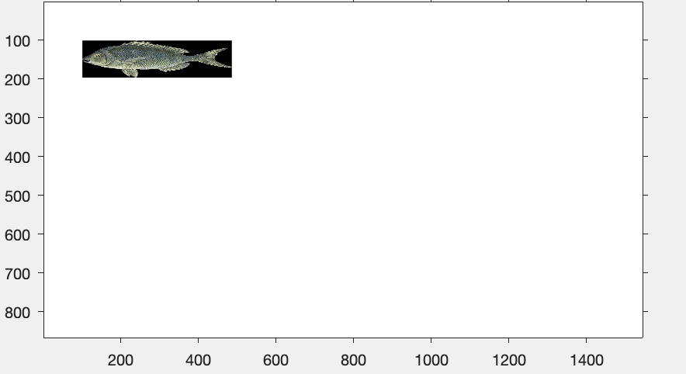

**Note**: XData and YData are two element vectors and contain the X and Y "extent" of an object. If the entries in one vector are **reversed**, the object is reversed.

* A simple way to do this is with array manipulation commands, e.g. fliplr

% Flip the orientation of the object

hFish.XData = fliplr(hFish.XData);

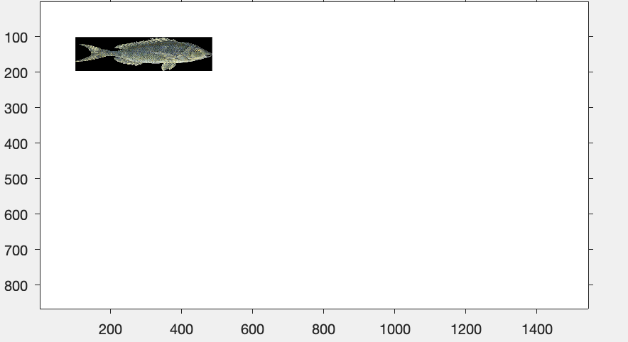

### Image transparency

Consider the above fish object. Say we want to create a visualization of fish in blue water by changing the background color of the axes object.

% Change the axes background to blue

g1.Color = [135,206,250]/255;

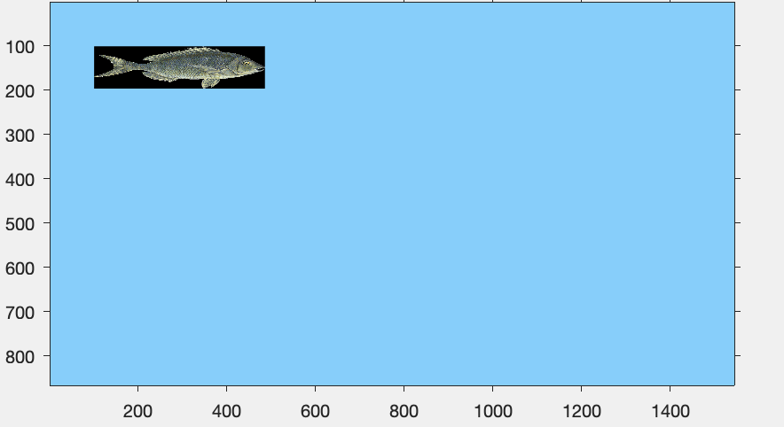

**Issue**: the black background of the fish object disrupts the overall visualization.

Fortunately, **.png images often contain transparency data** (alphaData) that can be read as the third output argument from imread().

* An AlphaData value of 0 represents a fully transparent pixel and an AlphaData value of 255 indicates an opaque (fully visible) pixel – values in between indicate a semi-transparent pixel.
* Typically, jpg, jpeg, bmp, and tif image formats do not support transparency – only png image type.

close all

% Read the fish picture and associated alpha data

[fishPic,~,alphaFish] = imread('fish.png');

subplot(1,2,1)

image(fishPic)

title('color information')

subplot(1,2,2)

image(alphaFish)

title('alpha data')

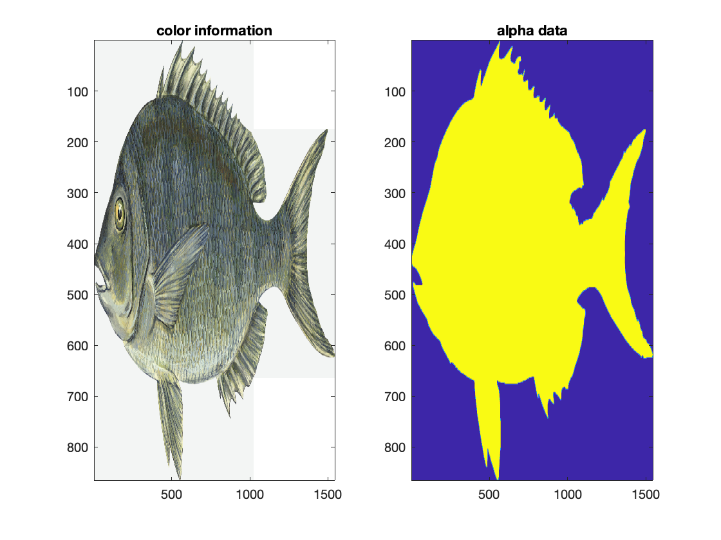

The transparency information in .png images may be used to remove image backgrounds and overlap images without the interference from background borders.

* The following code incorporates this tranparency information.
* The AlphaData field in a graphics handle object associated with an image can be used to specify the alpha data

close all

% Create figure and axes that are visible

h1 = figure('Visible','on');

g1 = axes;

% Create graphics handle object describing fish

hFish(1) = imshow(fishPic);

% Assign alpha data

hFish(1).AlphaData = alphaFish;

% Define scaling factor

sf = 0.25;

% Change scaling of image on axes

hFish(1).XData = [1,sf*hFish(1).XData(2)]+randi(500);

hFish(1).YData = [1,sf*hFish(1).YData(2)]+randi(500);

% Ensure axes are visible

g1.Visible = 'on';

% Reduce figure window size

h1.Position(3:4) = 0.5*h1.Position(3:4);

% Change the axes background to blue

g1.Color = [135,206,250]/255;

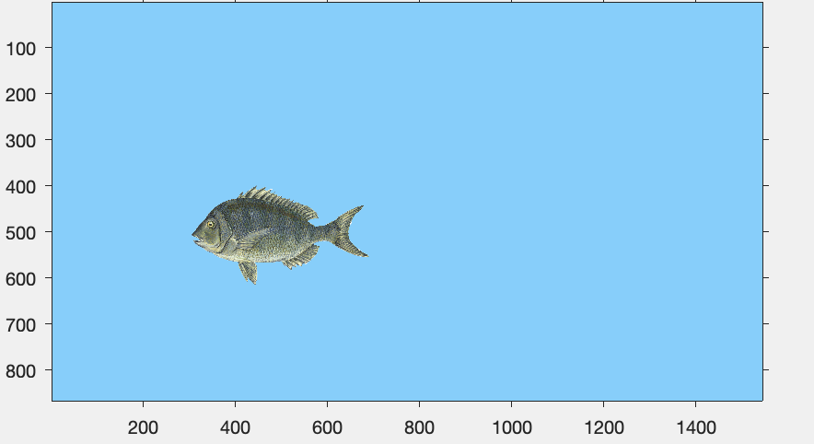

**Adding more fish to the image.** Since the only the region specified by the alpha data is depicted, you can potentially overlap many fish.

close all

% Create five fish objects

for k = 1:5

hold on

% Create graphics handle object describing fish

hFish(k) = imshow(fishPic);

% Assign alpha data

hFish(k).AlphaData = alphaFish;

% Define scaling factor

sf = 0.25;

% Change scaling of image on axes

hFish(k).XData = [1,sf*hFish(k).XData(2)]+randi(500);

hFish(k).YData = [1,sf*hFish(k).YData(2)]+randi(500);

end

hold off

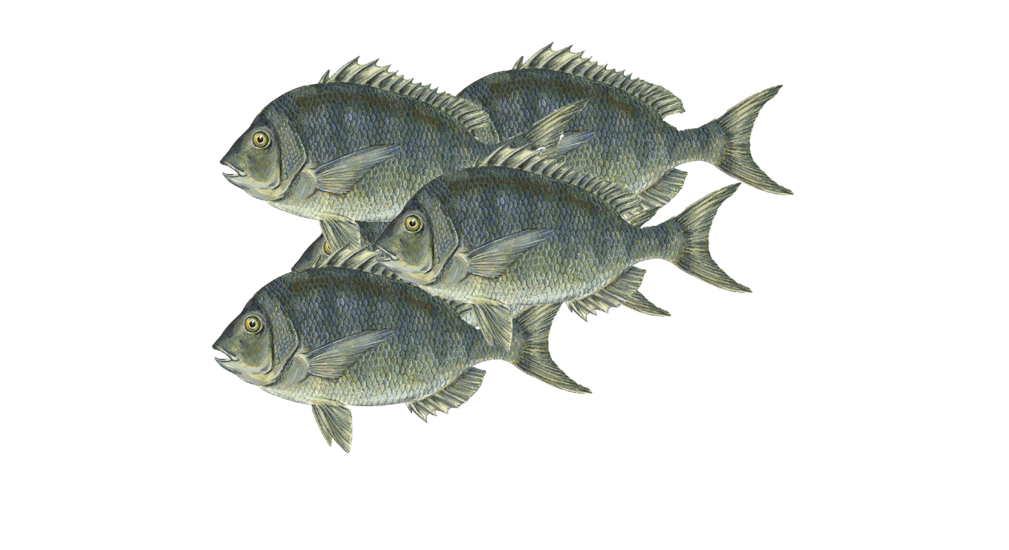

**Note**: in the above code, hold on and hold off are required to ensure that all fish objects are retained on the current axes.

### Creating your own .png images with transparency data

.png images can be created in image editing or artistic software, such as **Adobe Photoshop** or **GIMP (***https://www.gimp.org/***)**. Penn has many resources on Photoshop, including free access on campus computers. Please see the following for more information: <https://guides.library.upenn.edu/photoshop>

Adobe Photoshop can also be downloaded as a [free trial](https://www.adobe.com/creativecloud.html) from Adobe. To create a .png file in Photoshop, use the following procedure:

1. Open the image in Photoshop
2. Remove image elements using the eraser, magic lasso, box selection tool, etc
3. Disable the white background by clicking on the ***eye icon*** in the ***Layers*** panel – the background will turn into a checkerboard
4. Crop the image to remove any unnecessary pixels
5. Save the image as .png image.

**Example**. Create a .png file from a rock.

close all

% Read the fish picture and associated alpha data

[rockPic,~,alphaRock] = imread('Rock.png');

subplot(1,2,1)

image(rockPic)

title('color information')

subplot(1,2,2)

image(alphaRock)

title('alpha data')

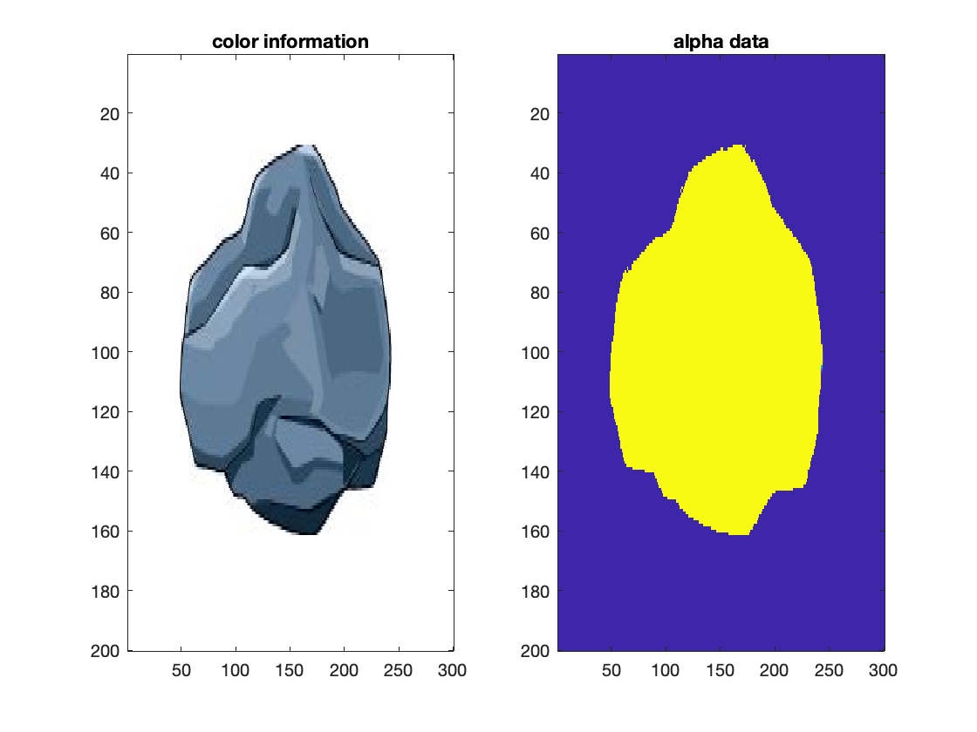

### Object animation

**Animating fish motion by programming the movement patterns**. Using the tools that we have used so far, we can program in fish motion.

*In this example, we:*

* Create three fish objects
* Enable each to move randomly through 200 ms time steps
* Change the background of the axes to be blue.

close all

% Step 1: set up figure

% Create figure and axes that are visible

h1 = figure('Visible','on');

g1 = axes;

% Create three fish objects

for k = 1:3

hold on

% Create graphics handle object describing fish

hFish(k) = imshow(fishPic);

% Assign alpha data

hFish(k).AlphaData = alphaFish;

% Define scaling factor

sf = 0.25;

% Change scaling of image on axes

hFish(k).XData = [1,sf*hFish(k).XData(2)]+randi(500);

hFish(k).YData = [1,sf*hFish(k).YData(2)]+randi(500);

end

hold off

% Ensure axes are visible

g1.Visible = 'on';

% Reduce figure window size

h1.Position(3:4) = 0.5*h1.Position(3:4);

% Change the axes background to blue

g1.Color = [135,206,250]/255;

xlim([-200,1500])

ylim([-200,1000])

% Step 2: loop through 50 simulation time steps

for m = 1:25

% For each fish, update position

for k = 1:3

% Change position of image on axes

hFish(k).XData = hFish(k).XData + randi(100) - 50;

hFish(k).YData = hFish(k).YData + randi(100) - 50;

end

pause(0.1)

end

**Note**. The fish move, but it looks a little silly how they "back up" when moving to the right. One option to improve this would be to flip the image when it moves to the right.

**Animating fish motion by keyboard callback**. Using the techniques described in Topic 20 and 21, we can create a keyboard callback object to move the fish in response to arrow key keystrokes.

function DoWhenKeyIsPressed(h1,eventdata,hFish)

% Utilizes keypresses to move the x/y coordinates of the

% ball or closes the figure.

% Load GUI data

% Create field to store the current xy direction of fish

handles = guidata(h1);

% Movement increment

inc = 10;

% Move up

if strcmp(eventdata.Key,'uparrow')

hFish.YData = hFish.YData - inc;

% Move down

elseif strcmp(eventdata.Key,'downarrow')

hFish.YData = hFish.YData + inc;

% Move left

elseif strcmp(eventdata.Key,'leftarrow')

% If the current direction is set to move left

if handles.moveDir == "left"

hFish.XData = hFish.XData - inc;

% Otherwise, flip the orientation of the fish

else

hFish.XData = fliplr(hFish.XData) - inc;

handles.moveDir = "left";

end

% Move right

elseif strcmp(eventdata.Key,'rightarrow')

% If the current direction is set to move left

if handles.moveDir == "right"

hFish.XData = hFish.XData + inc;

% Otherwise, flip the orientation of the fish

else

hFish.XData = fliplr(hFish.XData) + inc;

handles.moveDir = "right";

end

% Close figure

elseif strcmp(eventdata.Key,'q')

close()

% Display invalid keystroke

else

disp('Key not mapped')

end

% Store the data structure as GUI data

guidata(h1,handles);

end

close all

% Create figure

% Create figure and axes that are visible

h1 = figure('Visible','on');

g1 = axes;

% Create data structure to store info about interface

handles = struct;

% Create field to store the current xy direction of fish

handles.moveDir = "left";

% Store the data structure as GUI data

guidata(h1,handles);

% Create fish object

% Create graphics handle object describing fish

hFish = imshow(fishPic);

% Assign alpha data

hFish.AlphaData = alphaFish;

% Define scaling factor

sf = 0.25;

% Change scaling of image on axes

hFish.XData = [1,sf*hFish.XData(2)]+randi(500);

hFish.YData = [1,sf*hFish.YData(2)]+randi(500);

% Specify additional graphical parameters

% Ensure axes are visible

g1.Visible = 'on';

% Reduce figure window size

h1.Position(3:4) = 0.5*h1.Position(3:4);

% Change the axes background to blue

g1.Color = [135,206,250]/255;

xlim([-200,1500])

ylim([-200,1000])

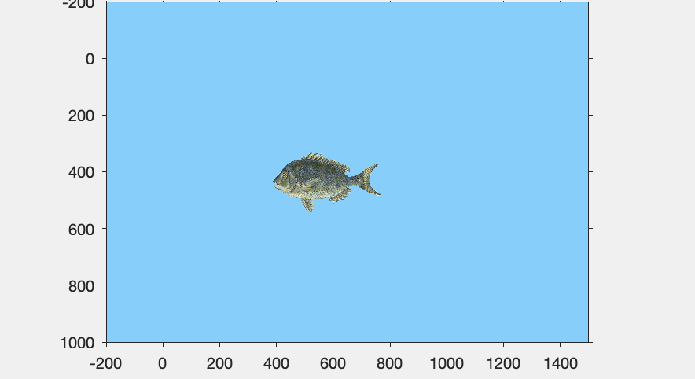

% Assign key press function

h1.KeyPressFcn = {@Topic25DoWhenKeyIsPressed,hFish};

### 

### Animation with timer objects

Events can be timed/initiated at specific intervals using [tic/toc](https://www.mathworks.com/help/matlab/ref/tic.html), [clock](https://www.mathworks.com/help/matlab/ref/clock.html), or **timer objects**.

* tic/toc and clock are effective when code naturally involves loops, but timer objects can initiate events even without a loop
* [Timer objects](https://www.mathworks.com/help/matlab/matlab_prog/use-a-matlab-timer-object.html) are not loops, run independently "in the background", and allow for more precise timing/execution of events.
* Just like when creating mouse and keyboard callbacks, timers utilize callbacks to perform actions

**Example.** Print Hello person! to the command line 5 times after a 2 second delay and in 3 second intervals using a timer object.

% Set up the timer object t.

t = timer('TimerFcn', @sayIt, 'StartFcn', @startItUp, 'StopFcn', @stopIt, 'ExecutionMode', 'fixedRate', 'StartDelay', 2, 'Period', 3, 'TasksToExecute', 5);

% start timer

start(t)

The timer associates local functions (subfunctions) with the start ('StartFcn'), firing ('TimerFcn'), and stop ('StopFcn') of the timer

* In the above, the following function is executed **at timer start**:

function startItUp(~,~)

% Timer StartFcn callback.

disp('A timer has been started.')

disp('It will wait 2 seconds to fire the first time...')

disp('and then it will fire every 3 seconds for 5 rounds!')

end

* In the above, the following function is the "TimerFcn" who is called based on the commands in the timer

function sayIt(~,~)

% Timer function callback.

disp('Hello person!')

end

* In the above, the following function is executed **at timer end**. Note: the timer is deleted at the end.

function stopIt(t,~)

% Timer StartFcn callback.

disp('The timer ''StopFcn'' just executed.')

disp(['It utilizes the first input of the callback, '...

'the handle of the timer, to stop the timer.'])

disp('Always delete timers after you are done using them.')

delete(t)

end

**Note:** as with all objects, the fields can be modified using dot notation.

**IMPORTANT:** ALWAYS STOP AND DELETE TIMERS WHEN DONE WITH THEM - NOT DOING SO CAN LEAD TO A LOT OF TIMERS LEFT RUNNING IN THE BACKGROUND AND SUCKING COMPUTER RESOURCES

Specific timers can be stopped by reference to their handles

stop(<timer_handle>)

delete(<timer_handle>)

All timers can be stopped and deleted by specifying

stop(timerfindall)

delete(timerfindall)

### Example problem: rock simulator

Animate a sequence of falling rocks in water based on a **timer object**.

*This code should:*

* Create a timer that makes a rock fall three times, with one rock falling every 4 seconds
* Create one rock object that falls multiple times
* Use material properties where possible to ensure that the simulation is physically reasonable

**Step 1: Plan, pseudocode, and prepare**. Write down what we know. Assume the stone is **granite** and treat it as a sphere of radius **150 m**.

*Values that we know:*

* Density of granite: 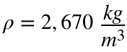
* Density of water: 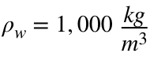
* Viscosity of water: 
* Radius of rock: 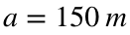

*Creating the differential equation:*

From our knowledge of **physics**, we know that the force exerted on an object by gravity (and including buoyancy) is given by the following equation, where  is the acceleration due to gravity and  is the volume of the rock (assumed to be a sphere).

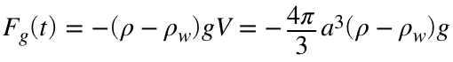

Last Tuesday, we used **Stokes's law** to describe the drag force induced by a liquid on a sphere. We will use this relationship again here:

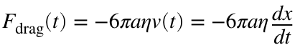

From **Newton's second law of motion**, we can thus relate all forces acting on the object:

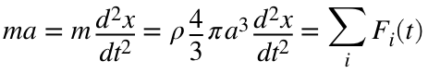

Simplifying this differential equation:

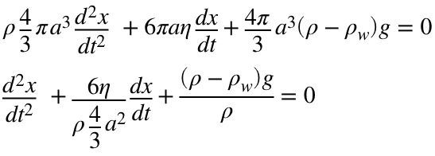

Or, by definining and substituting variables  and :

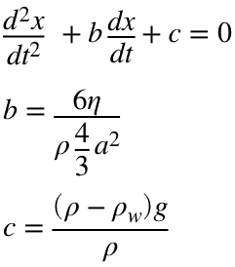

**Step 2: Create a "base" visualization (that does not include the physics)**

This code should incorporate a timer and timer function that drops a rock every four seconds. The timer callback function is given here:

function dropRock(~,~,hRock,hRockSize)

% Timer function that is called everytime the rock should be dropped

% Reset the rock's initial position to be above the water line

hRock.XData = [1,hRockSize(1)] + randi(1000);

hRock.YData = [-hRockSize(2),-1];

% Ensure rock is visible

hRock.Visible = 'on';

% Loop through time steps and move the rock down by some known amount

% of time

for k = 1:50

hRock.YData = hRock.YData + 100;

pause(0.1)

end

end

close all

% Create figure

% Create figure and axes that are visible

h2 = figure('Visible','on');

g2 = axes;

% Create rock object using the previously loaded rock

% Create graphics handle object describing rock

hRock = imshow(rockPic);

hRock.Visible = 'off';

% Assign alpha daya

hRock.AlphaData = alphaRock;

% Store XY dimmensions of rock

hRockSize = [hRock.XData(2), hRock.YData(2)];

% Ensure axes are visible

g2.Visible = 'on';

% Change the axes background to blue

g2.Color = [135,206,250]/255;

xlim([-200,1500])

ylim([-200,1000])

h2.Position = [672,238,941,698];

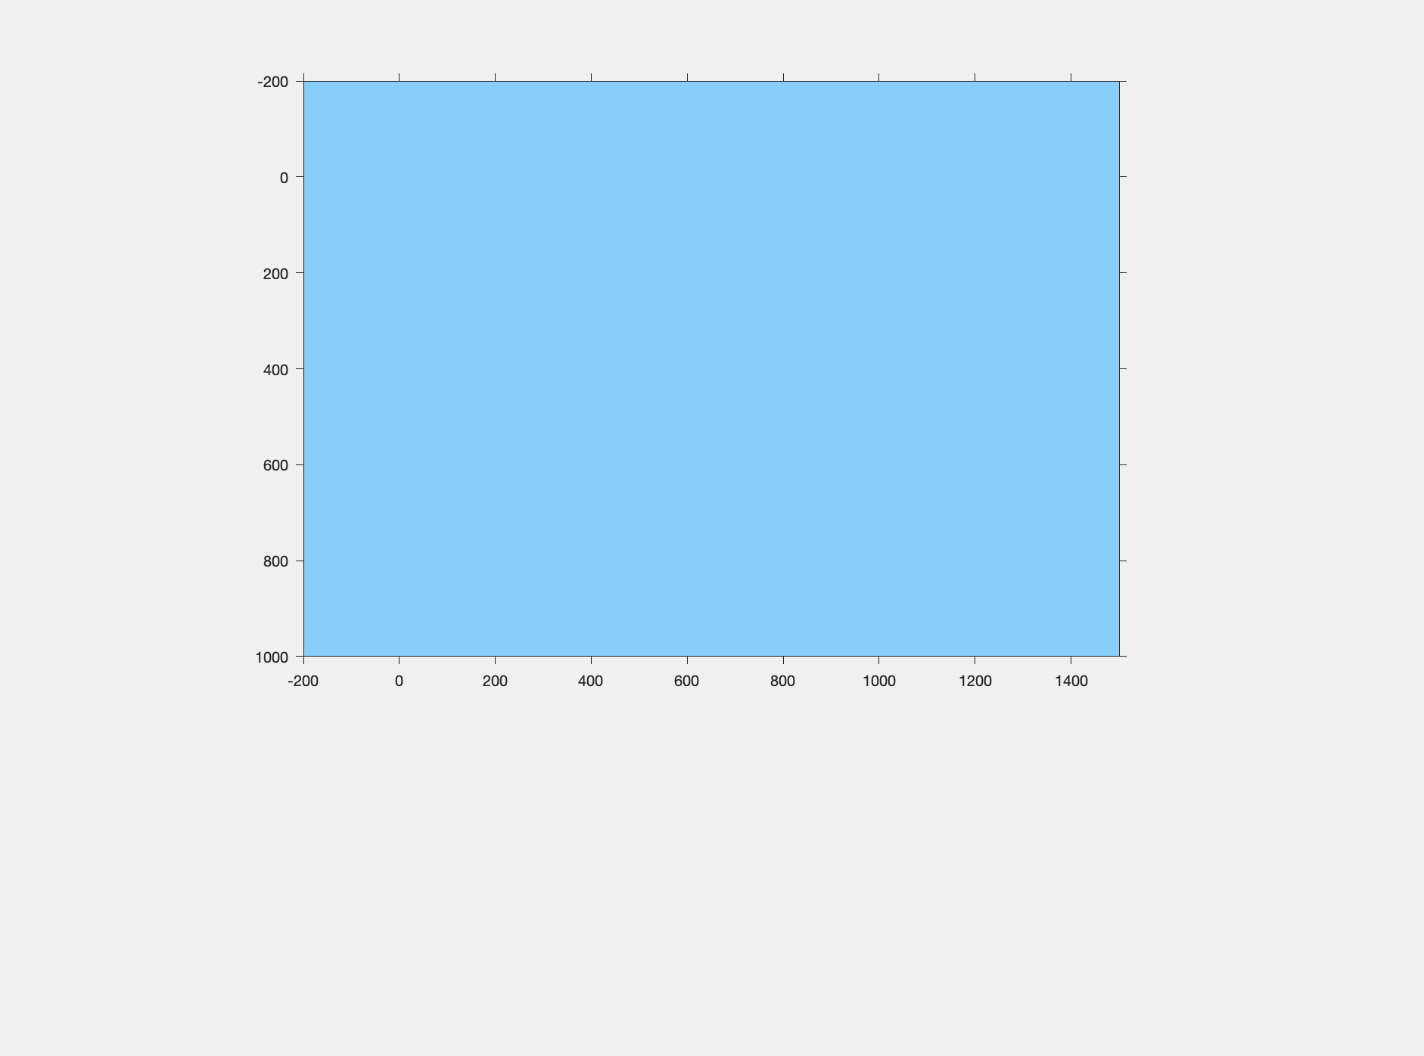

**Note**: the above code uses the the same stopIt function as above to ensure that the timer is deleted once it runs to completion

**Step 3: Incorporate the physics**

To solve using ode45, a higher order differential equation must be rewritten as a set of differential equations. Here, the differential equation is:

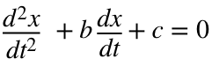

Defining new variables:

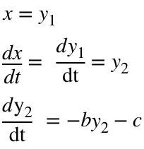

Thus, we can use the following function to represent the system of ODEs:

function dYdt = rockODE(t,y,b,c)

dYdt = zeros(2,1);

dYdt(1) = y(2); % y(1) = x

dYdt(2) = -b*y(2) - c; % z(2) = dy/dt

end

close all

% Create figure

% Create figure and axes that are visible

h2 = figure('Visible','on');

g2 = axes;

% Physical parameters

rho_g = 2670;

rho_w = 1000;

eta = 10^-3;

a = 150;

g = 9.81;

% Constants

b = 6*eta/(rho_g*4/3*a^2);

c = (rho_g - rho_w)*g/rho_g;

% Estimate time to stop ODE calculation

t_end = 5*sqrt(1000/c);

%Solve ODE

[t,out] = ode45(@rockODE, 0:0.05:t_end, [0,0], [],b,c);

out = -out;

y = out(out(:,1)<600);

t = t(out(:,1)<600);

% Create rock object using the previously loaded rock

% Create graphics handle object describing rock

hRock = imshow(rockPic);

hRock.Visible = 'off';

% Assign alpha data

hRock.AlphaData = alphaRock;

% Store XY dimmensions of rock

hRockSize = [hRock.XData(2),hRock.YData(2)];

% Ensure axes are visible

g2.Visible = 'on';

% Change the axes background to blue

g2.Color = [135, 206, 250]/255;

xlim([-200,1500])

ylim([-200,500])

h2.Position = [672,238,941,698];

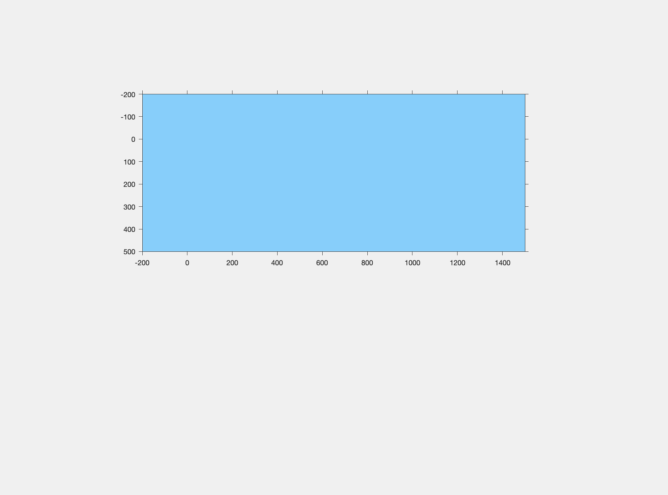

function dropRock_2(~,~,hRock,hRockSize,y_data)

% Timer function that is called everytime the rock should be dropped

% Reset the rock's initial position to be above the water line

hRock.XData = [1,hRockSize(1)] + randi(1000);

hRock.YData = [-hRockSize(2),-1];

initialPos = hRock.YData;

% Ensure rock is visible

hRock.Visible = 'on';

% Loop through time steps and move the rock down by some known amount

% of time

for k = 1:length(y_data)

hRock.YData = initialPos + y_data(k);

pause(0.05)

end

end

### Example problem: drag and drop

A useful feature of interfaces in the capability for "drag-and-drop" user interactions. Produce a script that enables the user to "drag-and-drop" circles on an interface.

*This script requires mouse callbacks to perform the following operations:*

* Left click within the boundary of the nearast marker to grab it
* Use the 'WindowButtonMotionFcn' call back to move it
* Release the mouse button releases control of the marker

close all

% Establish the figure and the button down/up and motion

% callbacks.

h1 = figure('Visible','on');

% The diameter of the markers.

D = 1;

% 'ind' will be used to track the index of the marker that is to

% be moved when a mouse movement is detected. An empty set

% indicates that no index has been selected.

handles.ind = [];

% Store guidata

guidata(h1,handles);

% Initialize the center locations of 10 markers.

x = (10-D)*rand(1,10)+D/2;

y = (10-D)*rand(1,10)+D/2;

% Plot the markers.

p = plot(x,y,'ko');

% Adjust the axis scaling so that the radius of the markers is

% scaled to the size of the axes.

axis equal

axis([0 10 0 10])

ax = gca;

ax.Units = 'points';

p.MarkerSize = D/diff(xlim)*ax.Position(3);

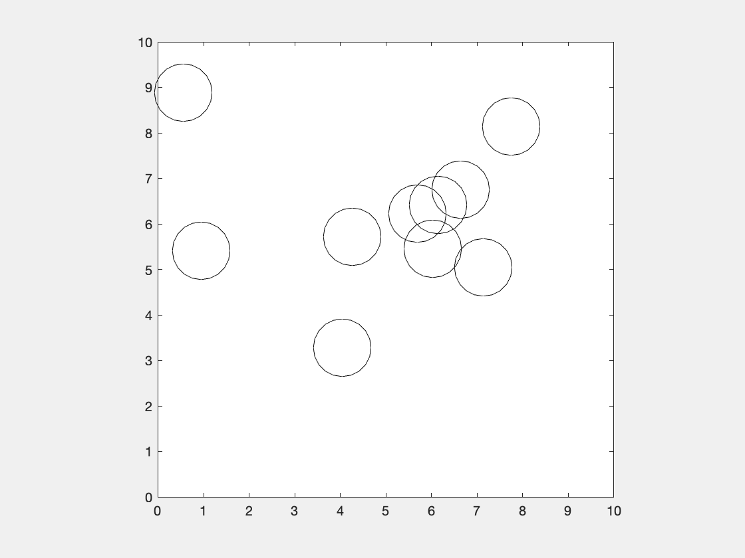

% Declare callback functions

h1.WindowButtonDownFcn = {@pick,D,p};

h1.WindowButtonMotionFcn = {@move,p};

h1.WindowButtonUpFcn = @place;

# Functions

## Topic 1 Functions:

function c = Pythagorean(a,b)

% Compute c for the relation

% a^2+b^2=c^2.

% a, b, and c are scalars.

% Compute c.

c = sqrt(a^2+b^2);

end

## Topic 3 Functions:

function [p,s] = myFunction(a,b,c)

% p and s are computed within the function

p = a+b;

s = b*c;

end

* Unused, but contained here

function out = mySquareRoot(a)

% Returns the square root of a scalar,

% vector, or multidimensional array

% input, a, to out

% M. Siedlik

% 9/6/2020

% Calculates the square root

% of the inputout = sqrt(a);

out = sqrt(a);

end

* To be used with line 63

function out = returnOddElements(v)

% Select the odd indices of the input vector

out = v(1:2:end);

end

* To be used with line 65

function F = eqnSet(x)

% System of two non linear equations

% F(1) and F(2): "equation" 1 and 2, respectively

% x(1) and x(2): variable 1 and 2, respectively

F(1) = x(2)-2*x(1)^2+3;

F(2) = x(2)^2-x(1);

end

## Topic 7 Functions

function [n, diceVal] = diceRollSimulator(max_n, n_sides)

%H1 help line, running a simulation until any number comes up max_n times

%in a row

%Simpler: roll dice until 3 1's land in a row

%roll one dice

n = 0;

numInARow = 0;

%previous value not 1-6

preDiceVal = 0;

%evaluate dice face value

% If dice face = 1 it is good unless restart

%continue to iterate until true

while numInARow < max_n

%have a variable to hold the pervious dice value

diceVal = randi(6);

if diceVal == preDiceVal

numInARow = numInARow + 1;

else

numInARow = 1;

preDiceVal = diceVal;

end

%counter

n = n+1;

end

end

## Topic 8 Functions

function out = checkEndGame(gameboard,player)

%check to see if any player has one

out = 1; %check if game is still going

%checks the first column

if prod(gameboard(1:3) == player)

disp(strcat(num2str(player), "wins"))

out = 0;

elseif prod(gameboard(4:6) == player)

disp(strcat(num2str(player), "wins"))

out = 0;

elseif prod(gameboard(7:9) == player)

disp(strcat(num2str(player), "wins"))

out = 0;

elseif prod(gameboard([1,4,7]) == player)

disp(strcat(num2str(player), "wins"))

out = 0;

elseif prod(gameboard([2,5,8]) == player)

disp(strcat(num2str(player), "wins"))

out = 0;

elseif prod(gameboard([3,6,9]) == player)

disp(strcat(num2str(player), "wins"))

out = 0;

elseif prod(gameboard([1,5,9]) == player)

disp(strcat(num2str(player), "wins"))

out = 0;

elseif prod(gameboard([3,5,7]) == player)

disp(strcat(num2str(player), "wins"))

out = 0;

end

end

## Topic 11 Functions

function res1 = square_add1(a,b)

% Example function. In this case there are two inputs and one

% output.

res1 = a^2 + b^2 + 1;

end

function res2 = operateOnKnownValues(fxn)

% Example function: input 1 is another function

res2 = fxn(1,2);

end

function res3 = exampleA(fxn,A)

% Example function: input 1 is a function, input 2 is an array

res3 = fxn(A) + 1;

end

function res4 = exampleB(fxn,A)

% Example function: input 1 is a function, input 2 is an array

res4 = fxn(A) - 1;

end

Functions for Spring example

function force = springForce1(delta)

% Calculate the force required to cause a deformation of delta

% Spring constant = 0.5

force = 0.5*delta;

end

function force = springForce2(delta)

% Calculate the force required to cause a deformation of delta

% in a nonlinear spring

force = .2*delta^2 + .5*delta;

end

function force = parallelSprings(spring1,spring2,delta)

% Force for two springs loaded in parallel config.

% spring1 = handle to force/deflection eqn for spring 1

% spring2 = handle to force/deflection eqn for spring 2

% delta = displacement of springs

force = spring1(delta) + spring2(delta);

end

## Topic 12 Functions

**Functions stored at the end of the document.**

function fxn1(f,x)

% Example function

output = f(x);

disp(strcat('The output of this function is... ',num2str(output)));

end

**Functions for practice problem: Newton-Raphson example**

% % Script for using the Newton-Raphson method to solve for f(x)

% function xn = newtonSolve(F, xn, tol)

% % Step 1: specify initial guess

% xn = 5; % initial guess

% xprev = inf; % Variable to store previous xn value -> ensure it is

% % not xn to enter while loop

%

% % Step 2: iterate until xn -> xn+1

% while abs(xn - xprev) > 10^-5

%

% % Step 3: evaluate function at xn

% f = F(xn);

% % Step 3a: evaluate derivative at xn

% f_prime_n = 4*xn^3 + 4*(xn-2);

%

% % Instead of calculating the "next" x value, store the previous xn

% % value

% xprev = xn;

%

% % Step 3b: update xn to next value for the iteration

% xn = xn - f(1)/f(2);

% end

% disp(xn)

%

% end

function F = originalEqn(x)

%function

F(1) = x^4 + 2*(x-2)^2 - 20;

%derivative of function

F(2) = 4*x^3 + 4*(x-2);

end

function G = newEqn(x)

% Function of interest

G(1) = x + exp(-x) - 4;

% Derivative of function of interest

G(2) = 1 - exp(-x);

end

**Function examples for recursion**

function out = recursiveAdd(in)

% Adds a number to the input up to

% a value of 5

if in<5

in = in + 1;

out = recursiveAdd(in);

else

out = in;

end

end

function x = recursiveFib(x,maxVal)

% Function using recursion to create a Fibonacci sequence vector

% If the last element is less that maxVal, add the next element of the

% Fibonacci sequence to the vector

if x(end-1) + x(end) < maxVal

% Calculate next entry

x(end+1) = x(end)+x(end-1);

% Use recursion to repeat the process

x = recursiveFib(x,maxVal);

end

end

function y = fact(n)

% Recursive function for determining the factorial

% Specify the number we are interested in solving the factorial for

y = n;

% Specify the "lower limit" in the factorial calculation

if n == 0

y = 1;

else

% We multiply by all the integers before the input,

% one at a time...

y = y*fact(n-1);

end

end

## Topic 14 (Legrange Function)

function pn = legendreP(x,n)

%calculate the n-th vector legendre polynomial

%vector 1: vector of positions

%vector 2: order of legendre polynomial

%n = 0 -> pn should be n for all x

if n == 0

%make a vector full of ones based on the size of x

pn = ones(size(x));

% if n = 1 -> pn = x

elseif n == 1

pn = x;

%pn depends on previous values

else

pn = 1/n*((2*n-1)*x.*legendreP(x,n-1) - (n-1)*legendreP(x,n-2));

end

end

## Topic 15 Functions

**Practice problem: Reactor cooling**

function xn = newtonSolve(F,xn,tol)

% The purpose of this function is to apply the Newton-Raphson method to

% solve any arbitrary function, specified in an input F.

% Inputs:

% F: function and derivative

% x: initial guess

% tol: specified tolerance

% Step 1: specify initial guess

% Input xn -> initial guess

xprev = inf; % Variable to store previous xn value -> ensure it is

% not xn to enter while loop

% Step 2: iterate until xn -> xn+1

while abs(xn - xprev) > tol

% Apply input function to algorithm. NOTE: first output is function

% evaluated at xn, the second output is the derivative of the

% function evaluated at xn

f = F(xn);

% Instead of calculating the "next" x value, store the previous xn

% value

xprev = xn;

% Step 3b: update xn to next value for the iteration

xn = xn - f(1)/f(2);

end

end

function xn = newtonSolveReturnXvalues(F,xn,tol)

% The purpose of this function is to apply the Newton-Raphson method to

% solve any arbitrary function, specified in an input F.

% Inputs:

% F: function and derivative

% x: initial guess

% tol: specified tolerance

% Step 1: specify initial guess

% Input xn -> initial guess

xprev = inf; % Variable to store previous xn value -> ensure it is

% not xn to enter while loop

% Step 2: iterate until xn -> xn+1

while abs(xn(end) - xprev) > tol

% Apply input function to algorithm. NOTE: first output is function

% evaluated at xn, the second output is the derivative of the

% function evaluated at xn

f = F(xn(end));

% Instead of calculating the "next" x value, store the previous xn

% value

xprev = xn(end);

% Step 3b: update xn to next value for the iteration

xn(end+1) = xn(end) - f(1)/f(2);

end

end

function G = quiz3(t,h)

% These two equations represent a function and its derivative that can

% be solved by

% G(1): function

% G(2): derivative of function

G(1) = 50*(1./(t+1) + 5*(t+1).^(-4*h)) + 300 - 400;

G(2) = 50*(-1*(t+1).^-2 + 5*(-4*h)*(t+1).^(-4*h-1));

end

## Topic 19 Functions

function FctnToCall(~,eventdata)

if strcmp(eventdata.Key,'w')

disp('Pressed a w!')

end

end

* Moving ball example

function DoWhenKeyIsPressed(~,eventdata,hBall)

% Utilizes keypresses to move the x/y coordinates of the

% ball or closes the figure.

% Movement increment

inc = 0.3;

% Move up

if strcmp(eventdata.Key,'uparrow')

hBall.Position(2) = hBall.Position(2)+inc;

% Move down

elseif strcmp(eventdata.Key,'downarrow')

hBall.Position(2) = hBall.Position(2)-inc;

% Move left

elseif strcmp(eventdata.Key,'leftarrow')

hBall.Position(1) = hBall.Position(1)-inc;

% Move right

elseif strcmp(eventdata.Key,'rightarrow')

hBall.Position(1) = hBall.Position(1)+inc;

% Close figure

elseif strcmp(eventdata.Key,'q')

close()

% Display invalid keystroke

else

disp('Key not mapped')

end

end

## Topic 20 Functions

function numSteps = simulateDisease(moveModifier)

% Inputs:

% [0,1]: particle 1 is in quarantine

% [1,1]: particles can move freely

% [1,0]: particle 2 is in quarantine

% 1) vector representing posititions of two particles

pos = [1,4];

% 2) Define particle identities

% Particle 1 will be infected

% Particle 2 will initially be healthy

% Define counter for steps

numSteps = 0;

% Step through the simulation. in each step update the particles

% positions

while abs(pos(1) - pos(2)) >=1

% A) Create vector determining particle step

d_k = (rand(1,2)-0.5).*moveModifier;

% B) Update particle position

pos = pos + d_k;

% C) Ensure particle doesn't move out of bounds

pos = max(min(pos,6),0);

% D) Update counter

numSteps = numSteps + 1;

end

end

## Topic 21 Functions

**Functions for this Lecture**

* **Example 1**. Moving ball example (from before)

function Topic21DoWhenKeyIsPressed(~,eventdata,hBall)

% Utilizes keypresses to move the x/y coordinates of the

% ball or closes the figure.

% Movement increment

inc = 0.3;

% Move up

if strcmp(eventdata.Key,'uparrow')

hBall.Position(2) = min(hBall.Position(2)+inc,9);

% Move down

elseif strcmp(eventdata.Key,'downarrow')

hBall.Position(2) = max(hBall.Position(2)-inc,-10);

% Move left

elseif strcmp(eventdata.Key,'leftarrow')

hBall.Position(1) = max(hBall.Position(1)-inc,-10);

% Move right

elseif strcmp(eventdata.Key,'rightarrow')

hBall.Position(1) = min(hBall.Position(1)+inc,9);

% Close figure

elseif strcmp(eventdata.Key,'q')

close()

% Display invalid keystroke

else

disp('Key not mapped')

end

end

* **Example 2**. Key press function

function ex3_keyPress(~,eventdata,hBall)

% Utilizes keypresses to move the x/y coordinates of the

% ball or closes the figure.

% Movement increment

inc = 0.3;

% Reset FaceColor to be black

hBall.FaceColor = 'k';

% Move up

if strcmp(eventdata.Key,'uparrow')

hBall.Position(2) = min(hBall.Position(2)+inc,9);

% Move down

elseif strcmp(eventdata.Key,'downarrow')

hBall.Position(2) = max(hBall.Position(2)-inc,-10);

% Move left

elseif strcmp(eventdata.Key,'leftarrow')

hBall.Position(1) = max(hBall.Position(1)-inc,-10);

% Move right

elseif strcmp(eventdata.Key,'rightarrow')

hBall.Position(1) = min(hBall.Position(1)+inc,9);

% Close figure

elseif strcmp(eventdata.Key,'q')

close()

% Display invalid keystroke

else

disp('Key not mapped')

end

end

* **Example 2.** key release function

function ex3_keyRelease(~,~,hBall)

% Function to be executed when key is released. Takes a graphics object

% corresponding to the ball as an input

% Increase the whiteness of the ball until it becomes fully white

while hBall.FaceColor(1) < 0.9

% Make FaceColor whiter

hBall.FaceColor = min(hBall.FaceColor + 0.1,1);

% Pause for 100 ms

pause(0.1)

end

% If ~1 second passes without moving, game over

t1 = text(-10,0,'GAME OVER');

t1.FontSize = 50;

t1.Color = 'r';

end

* **Example 3**. Mouse callback - Depict position of mouse on screen

function moveText(~,~,g)

% The mouse button motion callback.

% Get the current mouse location.

pos = get(gca, 'CurrentPoint');

x = pos(1,1); y = pos(1,2);

% Update the text object readout to the current location

% and place its location at the cursor tip.

g.String = ['x = ',num2str(x),', y = ',num2str(y)];

g.Position = [x, y, 0]; % position 0 in 3rd dimension

end

* **Example 4**. Mouse callback - display selection type, depending on mouse click

function click(h,~)

% The callback for a mouse button press. Print the mouse

% button identifier to the command window.

h.SelectionType

end

* **Example 5**. Mouse callback - select points and plot on a graph

function plotPoints1(~,~,h)

% Call back function for updating a plot

% Get the current mouse location

pos = get(gca,'CurrentPoint');

% Update the plot with the new position

h.XData(end+1) = pos(1,1);

h.YData(end+1) = pos(1,2);

drawnow

end

* **Example 6**. Mouse callback - select points and plot depending on right click or left click

function plotPoints2(h,~,hRed,hGreen)

% Callback function for updating a plot with multiple colored points

% Get the current mouse location.

pos = get(gca, 'CurrentPoint');

% If a left click: add to the red plot

if strcmp(h.SelectionType,'normal')

% Add to the data in the red plot

hRed.XData(end+1) = pos(1,1);

hRed.YData(end+1) = pos(1,2);

drawnow

% If a right click: add to the green plot

elseif strcmp(h.SelectionType,'alt')

% Add to the data in the red plot

hGreen.XData(end+1) = pos(1,1);

hGreen.YData(end+1) = pos(1,2);

drawnow

end

end

**Example 7**. Mouse callback - removing last point

function plotPoints3(h,~,hRed,hGreen)

% Callback function for updating a plot with multiple colored points

% Get the current mouse location.

pos = get(gca, 'CurrentPoint');

% Load GUI information

handles = guidata(h);

% If a left click: add to the red plot

if strcmp(h.SelectionType,'normal')

% Add to the data in the red plot

hRed.XData(end+1) = pos(1,1);

hRed.YData(end+1) = pos(1,2);

drawnow

% Specify that the most recent point was red

handles.order{end+1} = 'r';

% If a right click: add to the green plot

elseif strcmp(h.SelectionType,'alt')

% Add to the data in the red plot

hGreen.XData(end+1) = pos(1,1);

hGreen.YData(end+1) = pos(1,2);

drawnow

% Specify that the most recent point was red

handles.order{end+1} = 'g';

% If a middle click (and note empty: delete the most recent point

elseif strcmp(h.SelectionType,'extend') && ~isempty(handles.order)

% If last point was red

if strcmp(handles.order{end},'r')

% Remove last data poitn

hRed.XData(end) = [];

hRed.YData(end) = [];

drawnow

% Delete last entry

handles.order(end) = [];

% If last point was green

else

% Remove last data poitn

hGreen.XData(end) = [];

hGreen.YData(end) = [];

drawnow

% Delete last entry

handles.order(end) = [];

end

end

% Update the guidata with the data structure

guidata(h,handles);

end

* **Tic Tac Toe code from HW 6**

function ticTacToe(compStrategy)

% Define initial variables and arrays

gameboard = zeros(3,3); % gameboard that we will populate

% Repeat: alternate for players

player = 1; % player one

% Logical variable to determine if game should stil be playing

gameStillGoing = 1;

% Iterate until someone has won (or the game is a draw)

while gameStillGoing

% Player 1: human player. If it is player 1's turn, specify a

% position to be played

if player == 1

% Logical variable corresponding if the move is valid

invalidMove = 1;

% Make player pick a valid position

while invalidMove

% Position to play, in single index notation

playPos = input('Select a position to play...');

if ~isempty(playPos)

% Determine if move is allowable

invalidMove = all((gameboard(:) == 0)'.*(1:9) ~= playPos);

end

end

% Player 2: computer player. If it is player 2's turn, determine the

% position played based on the algorithm contained within compStrategy().

else

% Call a function that will output a position based upon the

% strategy defined for the computer

playPos = compStrategy(gameboard);

end

% Update the gameboard

gameboard(playPos) = player;

% Step 3: display game board

disp(gameboard)

% Step 4: evaluate stopping condition -> did someone win?

gameStillGoing = checkEndGame2(gameboard, player);

% Step 5: change player

player = mod(player,2)+1;

end

end

function out = checkEndGame2(gameboard,pl)

% The purpose of this function is to determine if anyone has won the

% game or if a draw has occured.

% Input 1, gameboard: matrix containing moves

% Input 2, which player's turn is it

% Default condition: game needs to keep going

out = 1;

% Each row represents a different way in which the player could win

testMatrix = [gameboard;gameboard';diag(gameboard)';diag(rot90(gameboard))'];

if any(all(testMatrix==pl,2))

disp(strcat(num2str(pl),' wins!'))

out = 0;

elseif sum(gameboard(:)>0) == 9

disp('Draw!')

out = 0;

end

end

function posPlayed = playRandom(gameboard)

% This function contains code describing the computer player's strategy

% Note: Students should optimize this and ensure it is well commented

% Determine available positions to play

availablePos = (gameboard(:) == 0)'.*(1:9);

positions = availablePos(availablePos > 0);

% Return a random (available) position. This code thus has the computer

% play randomly based upon the available positions

posPlayed = positions(randi(length(positions)));

end

* **Tic Tac Toe user interface**

function placeX(h1,~,x1)

% The purpose of this function is assign an X once a player has clicked

% an appropriate location

% Retrieve current X and Y coordinates

pos = get(gca,'CurrentPoint');

pos = pos(1,1:2);

% Convert the mouse click location into one of 9 possible game play

% positions. NOTE: this is based on the visual gameboard created in the

% above script

% If click corresponds to index position 3

if pos(1)<-1 && pos(2)<-1

playPos = 3;

% Update position vector. This is what will be assigned to the

% text that will be added to the figure panel

pos = [-2.5,-2];

% If click corresponds to index position 2

elseif pos(1)<-1 && pos(2)<1

playPos = 2;

pos = [-2.5,0];

% If click corresponds to index position 1

elseif pos(1)<-1

playPos = 1;

pos = [-2.5,2];

% If click corresponds to index position 6

elseif pos(1)<1 && pos(2)<-1

playPos = 6;

pos = [-0.5,-2];

% If click corresponds to index position 5

elseif pos(1)<1 && pos(2)<1

playPos = 5;

pos = [-0.5,0];

% If click corresponds to index position 4

elseif pos(1)<1

playPos = 4;

pos = [-0.5,2];

% If click corresponds to index position 9

elseif pos(2)<-1

playPos = 9;

pos = [1.5,-2];

% If click corresponds to index position 8

elseif pos(2)<1

playPos = 8;

pos = [1.5,0];

% If click corresponds to index position 7

else

playPos = 7;

pos = [1.5,2];

end

% Load gameboard information

handles = guidata(h1);

% Update internal gameboard. Note: the click corresponds to player 1

handles.gameboard(playPos) = 1;

% Evaluate stopping condition -> did someone win?

% NOTE: no output is necessary

checkEndGame3(handles.gameboard,1,h1);

% Create a matrix containing positional information for all text that

% has been played

textPos = reshape([x1.Position],3,5)';

% Use the above matrix to determine the turn number from the non NaN values

numTurn = 6-sum(isnan(textPos(:,1)));

% Update the plot with the new position

x1(numTurn).Position(1:2) = pos;

% Save data

guidata(h1,handles);

end

function placeO(h1,~,x2,compStrategy)

% The purpose of this function is assign an O once a player has clicked

% an appropriate location

% Load gameboard information

handles = guidata(h1);

% Determine position to play based on input strategy

playPos = compStrategy(handles.gameboard);

% Update internal gameboard

handles.gameboard(playPos) = 2;

% Determine where to place text

% Note: this is determined entirely by figure that was created

if playPos == 1

pos = [-2.5,2];

elseif playPos == 2

pos = [-2.5,0];

elseif playPos == 3

pos = [-2.5,-2];

elseif playPos == 4

pos = [-0.5,2];

elseif playPos == 5

pos = [-0.5,0];

elseif playPos == 6

pos = [-0.5,-2];

elseif playPos == 7

pos = [1.5,2];

elseif playPos == 8

pos = [1.5,0];

else

pos = [1.5,-2];

end

% Create a matrix containing positional information for all text that

% has been played

textPos = reshape([x2.Position],3,4)';

% Use the above matrix to determine the turn number from the non NaN values

numTurn = 5-sum(isnan(textPos(:,1)));

% Update the plot with the new position

x2(numTurn).Position(1:2) = pos;

% Step 4: evaluate stopping condition -> did someone win?

checkEndGame3(handles.gameboard,2,h1);

% Save data

guidata(h1,handles);

end

function checkEndGame3(gameboard,pl,h1)

% The purpose of this function is to determine if anyone has won the

% game or if a draw has occured.

% Input 1, gameboard: matrix containing moves

% Input 2, which player's turn is it

% Input 3, graphics object handle corresponding to figure window

% Each row represents a different way in which the player could win

testMatrix = [gameboard;gameboard';diag(gameboard)';diag(rot90(gameboard))'];

% If any three in a rows have happened

if any(all(testMatrix==pl,2))

% Remove click press and release function handles

h1.WindowButtonDownFcn = '';

h1.WindowButtonUpFcn = '';

% Add text saying that the player won

x3 = text(-5,5,['Player ',num2str(pl),' wins!']);

x3.FontSize = 50;

x3.Color = 'r';

% If nine turns have occured, then the game is a draw

elseif sum(gameboard(:)>0) == 9

% Remove click press and release function handles

h1.WindowButtonDownFcn = '';

h1.WindowButtonUpFcn = '';

% Add text saying that the player won

x3 = text(-2,5,['Draw!']);

x3.FontSize = 50;

x3.Color = 'r';

end

end

* User interface control object to reset game

function resetGame(~,~,h,x1,x2,f1,f2,f3)

% To be assign to some pushbutton for resetting the game

% Create data structure to store gameboard

handles.gameboard = zeros(3);

% Store data structure

guidata(h,handles);

% Create two empty text containers. On every turn, we will update the the

% position of either the next X or next O marker from NaN to the

% appropriate coordinates

for k = 1:4

x1(k).Position(1:2) = nan(1,2);

x2(k).Position(1:2) = nan(1,2);

end

x1(5).Position(1:2) = nan(1,2);

% Assign callback function for mouse click

h.WindowButtonDownFcn = {f1,x1};

% Assign callback function for mouse release

h.WindowButtonUpFcn = {f2,x2,f3};

end

## Topic 23 Functions

### Functions for Topic 23 stored here:

**Example 1: simple ODE**

function dxdt = myODE(t,x)

dxdt = x(1) - t^2 + 1;

end

**Example 2: coupled chemical reactions**

function dxdt = rxnEqns(t,x)

% Here, x(1) : A

% x(2): B

% x(3): C

dxdt = zeros(3,1);

dxdt(1) = -x(1) + 2*x(2);

dxdt(2) = x(1) - 4*x(2) + 0.5*x(3);

dxdt(3) = 2*x(2) - 0.5*x(3);

end

**Example 3: third order ODE**

function dxdt = thirdOrderODE(t,x)

% Parameters

p = 2;

q = 1.5;

r = 0.1;

% Note:

% x(1) corresponds to y

% x(2) corresponds to y'

% x(3) corresponds to y''

% Preallocating the output as a column vector

dxdt = zeros(3,1);

dxdt(1) = x(2);

dxdt(2) = x(3);

dxdt(3) = -p*x(3)-q*x(2)-r*x(1);

end

**Example 4: third order ODE, specifying additional inputs**

function dxdt = thirdOrderODE_extraInputs(t,x,p,q,r)

dxdt = zeros(3,1);

dxdt(1) = x(2);

dxdt(2) = x(3);

dxdt(3) = -p*x(3)-q*x(2)-r*x(1);

end

**Example 5: third order ODE, specifying additional inputs**

function dz = ball_2D(t,z,vx)

% Compute the x and y position of a ball subject to gravity and

% in a vacuum. This function is called upon by MATLAB's ODE

% solvers. t = time (s), z = [y-position, y-velocity, x-position]

% in units of (m, m/s, m), and dz = [y-velocity; y-acceleration;

% x-position] in units of (m/s, m/s^2, m).

dz(1,1) = z(2); % z(1): y-position

dz(2,1) = -9.81;% z(2): y-velocity

dz(3,1) = vx; % z(3): x-position

end

**Example 6: mouse click function**

function determineStart(hObj,~,hBall,hTrajectory,hAim)

% Mouse click: determine kinematics parameters

% Load information associated with a data structure

handles = guidata(hObj);

% Get the current mouse location

pos = get(gca,'CurrentPoint');

pos = pos(1,1:2);

% Specify the inital x and y positions

hBall.XData = 0;

hBall.YData = handles.h0;

hTrajectory.XData = 0;

hTrajectory.YData = handles.h0;

% Calculate difference in x and y values

dy = abs(pos(2) - handles.h0);

dx = abs(pos(1) - 0);

% Calculate angle to throw

handles.th = atan2d(dy,dx);

% Define initial velocity to be proportional to distance away clicked

handles.v = 3*sqrt(dy^2 + dx^2);

% Create a line showing aim

hAim.XData(2) = pos(1);

hAim.YData(2) = pos(2);

% Store object data

guidata(hObj,handles);

end

**Example 7: mouse release function**

function throwBall(hObj,~,hBall,hTrajectory)

% Mouse release: calculate and visualize trajectory

% Load GUI data

handles = guidata(hObj);

th = handles.th;

h0 = handles.h0;

v = handles.v;

% Calculate parameters

vx = v*cosd(th);

vy = v*sind(th);

g = 9.81;

t_end = 2*2*vy/g;

% Solve system of differential equations. Specify the time points to solve

% for

[t,state] = ode45(@ball_2D,[0:0.05:t_end],[2,vy,0],[],vx);

txy = [t,state(:,3),state(:,1)];

% Select time points corresponding to the ball not yet landing

txy = txy(txy(:,3) > 0,:);

% Loop through all ball positions and update plot

for k = 2:size(txy,1)

% Update plot of ball and trajectory tracer

hBall.XData = txy(k,2);

hBall.YData = txy(k,3);

hTrajectory.XData(k) = txy(k,2);

hTrajectory.YData(k) = txy(k,3);

% Pause for specified amount of time consisted with time points solved

% for

pause(0.05);

end

end

## Topic 24 Functions:

% function F = eqnSet(x)

% % System of two non linear equations

% % F(1) and F(2): "equation" 1 and 2, respectively

% % x(1) and x(2): variable 1 and 2, respectively

% F(1) = x(2)-2*x(1)^2+3;

% F(2) = x(2)^2-x(1);

% end

function dZdt = springProblem(t,z,b,c)

dZdt = zeros(2,1);

dZdt(1) = z(2); % z(1) = x

dZdt(2) = -b*z(2) - c*z(1); % z(2) = dx/dt

end

## Topic 25 Functions

**Functions for Topic 25 stored here:**

* **Example: GUI with counter**

function subtractVal(hObj,~,hedit,h1)

% Subtract 1 from the counter value

handles = guidata(h1);

cVal = handles.cVal - 1;

set(hedit,'String',cVal)

guidata(handles,h1);

end

function addVal(hObj,~,hedit,h1)

% Add 1 to the counter value

handles = guidata(h1);

cVal = handles.cVal + 1;

set(hedit,'String',cVal)

guidata(handles,h1);

end

* **Example: animating a fish**

function Topic25DoWhenKeyIsPressed(h1,eventdata,hFish)

% Utilizes keypresses to move the x/y coordinates of the

% ball or closes the figure.

% Load GUI data

% Create field to store the current xy direction of fish

handles = guidata(h1);

% Movement increment

inc = 10;

% Move up

if strcmp(eventdata.Key,'uparrow')

hFish.YData = hFish.YData - inc;

% Move down

elseif strcmp(eventdata.Key,'downarrow')

hFish.YData = hFish.YData + inc;

% Move left

elseif strcmp(eventdata.Key,'leftarrow')

% If the current direction is set to move left

if handles.moveDir == "left"

hFish.XData = hFish.XData - inc;

% Otherwise, flip the orientation of the fish

else

hFish.XData = fliplr(hFish.XData) - inc;

handles.moveDir = "left";

end

% Move right

elseif strcmp(eventdata.Key,'rightarrow')

% If the current direction is set to move left

if handles.moveDir == "right"

hFish.XData = hFish.XData + inc;

% Otherwise, flip the orientation of the fish

else

hFish.XData = fliplr(hFish.XData) + inc;

handles.moveDir = "right";

end

% Close figure

elseif strcmp(eventdata.Key,'q')

close()

% Display invalid keystroke

else

disp('Key not mapped')

end

% Store the data structure as GUI data

guidata(h1,handles);

end

* **Example: timer function 1**

function startItUp(~,~)

% Timer StartFcn callback.

disp('A timer has been started.')

disp('It will wait 2 seconds to fire the first time...')

disp('and then it will fire every 3 seconds for 5 rounds!')

end

function sayIt(~,~)

% Timer fxn callback.

disp('Hello person!')

end

function stopIt(t,~)

% Timer StopFcn callback.

disp('The timer ''StopFcn'' just executed.')

disp(['It utilizes the first input of the callback, '...

'the handle of the timer, to stop the timer.'])

disp('Always delete timers after you are done using them.')

delete(t)

end

* **Example: falling rock**

function dropRock(~,~,hRock,hRockSize)

% Timer function that is called everytime the rock should be dropped

% Reset the rock's initial position to be above the water line

hRock.XData = [1,hRockSize(1)] + randi(1000);

hRock.YData = [-hRockSize(2),-1];

% Ensure rock is visible

hRock.Visible = 'on';

% Loop through time steps and move the rock down by some known amount

% of time

for k = 1:50

hRock.YData = hRock.YData + 100;

pause(0.1)

end

end

function dYdt = rockODE(t,y,b,c)

dYdt = zeros(2,1);

dYdt(1) = y(2); % y(1) = x

dYdt(2) = -b*y(2) - c; % z(2) = dy/dt

end

function dropRock_2(~,~,hRock,hRockSize,y_data)

% Timer function that is called everytime the rock should be dropped

% Reset the rock's initial position to be above the water line

hRock.XData = [1,hRockSize(1)] + randi(1000);

hRock.YData = [-hRockSize(2),-1];

initialPos = hRock.YData;

% Ensure rock is visible

hRock.Visible = 'on';

% Loop through time steps and move the rock down by some known amount

% of time

for k = 1:length(y_data)

hRock.YData = initialPos + y_data(k);

pause(0.05)

end

end

* **Example: drag and drop**

function pick(h1,~,D,p)

% Mouse button down callback. Determines if the mouse was

% clicked within the limits of a marker and, if so, takes

% control of the marker.

handles = guidata(h1);

% Get the location of the mouse.

pos = get(gca,'CurrentPoint');

xMouse = pos(1,1);

yMouse = pos(1,2);

% Determine which marker centerpoint the mouse is closest

% to and record the vector index number.

[distance,minInd] = min(sqrt((xMouse-p.XData).^2+(yMouse-p.YData).^2));

% If the mouse is within a radius of the marker, then

% take control of the x/y marker centerpoint index and

% calculate the difference between the centerpoint of the

% marker and where the user actually clicked.

if distance <= D/2

handles.ind = minInd;

end

guidata(h1,handles);

end

function move(h1,~,p)

% Mouse motion callback. Moves the marker centerpoint

% held in x/y index 'ind' if 'ind' is not an empty set.

% Updates visuals accordingly.

handles = guidata(h1);

ind = handles.ind;

% Get the location of the mouse.

pos = get(gca,'CurrentPoint');

xMouse = pos(1,1);

yMouse = pos(1,2);

% Update the x/y centerpoint corresponding to 'ind'.

p.XData(ind) = xMouse;

p.YData(ind) = yMouse;

drawnow

end

function place(h1,~)

% Mouse up callback. Release control of 'ind'.

handles = guidata(h1);

handles.ind = [];

guidata(h1,handles);

end